Spring 2022 Senior Design 1
Live Bolt Smart Lock

Department of Electrical and Computer Engineering
University of Central Florida
100 Page Draft
Group 22
March 25, 2022

Linda Anyosa - Electrical Engineering
Mohamed Faizel - Computer Engineering
Andrew O’Reilly - Electrical Engineering
Joel Shaw - Computer Engineering

1. Executive Summary 1
2. Project Description 2
2.1 Project Motivation and Goals 2
2.2 Objectives 2
2.3 Requirements Specifications 3
2.4 Quality of House Analysis 5
3. Research Related to Project Definition 6
3.1 Existing Similar Projects and Products 6
3.1.1 Ring Doorbell 6
3.1.2 Google Nest Doorbell 7
3.1.3 Yale Lock Integration 8
3.1.4 August Smart Lock 8
3.1.5 Nuki Smart Lock 9
3.2 Computation and Control Device 10
3.2.1 Arduino Line 10
3.2.1.1 Arduino Uno 11
3.2.1.2 Arduino Mega 11
3.2.2 Raspberry Pi Line 11
3.2.2.1 Raspberry Pi Model 3B+ 12
3.2.2.2 Raspberry Pi Model 4 12
3.2.3 Texas Instruments MSP430 Line 13
3.2.3.1 MSP430FR6989 Launchpad 13
3.2.3.2 MSP430G2553 Launchpad 14
3.2.4 ESP Wi-Fi Module Line 14
3.2.4.1 ESP32 15
3.2.4.2 ESP8266 16
3.3 Sensors 16
3.3.1 Voice/Phrase Recognition 16
3.3.2 Face Recognition 17
3.3.2.1 Computer Vision 17
3.3.2.2 Intel RealSense ID 17
3.3.2.3 Xbox Kinect 18
3.3.2.4 Smart Phone Face ID 18
3.3.3 Near-Field Communication 20
3.3.4 Infrared Sensor 20
3.3.5 Security Camera 20
3.3.6 Keypad 21
3.3.7 Fingerprint Scanner 21
3.4 Power Sources 22
3.4.1 Solar Panel 22
3.4.2 AC Power 22
3.4.3 Conventional Battery Pack 23
3.5 Locking Methods 23
3.5.1 Electric Strike Locks 24
3.5.2 Magnetic Locks 24
3.5.3 Dead bolt Locks 25
3.6 Feedback System 26
3.6.1 LED/Buzzer on Physical Device 26
3.6.2 Application Notifications 26
3.6.3 LCD Display 27
3.6.4 OLED Display 27
3.7 Parts Selection 28
3.7.1 Computation and Control Device 28
3.7.2 ReSpeaker 4-Microphone Array 28
3.7.3 Smart Phone Face Identification 28
3.7.4 HiLetgo NFC Module 29
3.7.5 HC-SR501 Infrared Sensor 29
3.7.6 ArduCam Security Camera 30
3.7.7 Keypad 30
3.7.8 Rechargeable Battery Packs 30
3.7.9 Traditional Dead-Bolt Lock 30
3.7.10 Feedback System 31
3.7.11 Parts Summary 31
4. Related Standards and Realistic Design Constraints 31
4.1 Standards 32
4.1.1 Wi-Fi Standards (802.11) 32
4.1.2 Bluetooth Standards (802.15.1) 32
4.1.3 RFID Standards 33
4.1.4 NFC Standards 33
4.1.5 Measurement Standards 34
4.1.6 Deadbolt Lock Standards 34
4.1.7 Battery Standards 35
4.1.8 Face Recognition Standards 36
4.1.9 Programming Best Practices 36
4.1.10 Apple App Store and Google Play Store Standards 37
4.1.11 Design impact of relevant standards 39
4.2 Realistic Design Constraints 40
4.2.1 Knowledge constraints 40
4.2.2 Economic constraints 41
4.2.3 Time constraints 42
4.2.4 Environmental constraints 43
4.2.5 Energy constraints 44
4.2.6 Social constraints 44
4.2.7 Political constraints 44
4.2.8 Ethical constraints 45
4.2.9 Health and Safety constraints 46
4.2.10 Sustainability constraints 46
4.2.11 Manufacturability constraints 46
5. Software Design Details 47
5.1 Initial Design Architecture 47
5.2 Mobile Application Pros and Cons 48
5.2.1 LAMP Stack 48
5.2.2 MERN Stack 48
5.2.3 MEAN Stack 49
5.3 UX Design 49
5.4 Preliminary UI Design 50
5.4.1 Application Navigation 56
5.4.2 Use Case Diagram 57
5.5 Logo Design 58
5.6 Bluetooth Pairing 59
5.6.1 Android Bluetooth APIs 60
5.6.2 react-native-bluetooth-serial Plugin 60
5.6.2 react-native-ble-plx Plugin 61
5.6.3 Classic or Low Power Mode? 62
5.7 Development Environment 62
5.8 App Store Publishing Process 62
5.9 Google Play Store Publishing Process 63
5.10 Mobile Stack Technologies 63
5.10.1 MERN Stack Reasoning 64
5.10.2 JavaScript 64
5.10.3 Ajax 64
5.10.4 jQuery 64
5.10.5 JSON 65
5.10.6 JSX 65
5.10.5 JSON Web Token 65
5.11 React Native Components 66
5.11.1 VirtualizedList 66
5.11.2 Pressable 67
5.11.3 KeyboardAvoidingView 68
5.12 Database Structure 68
5.12.1 MongoDB Creation and Syntax 70
5.13 Near Field Communication (NFC) 71
5.14 iOS FaceID/TouchID Implementation 71
5.15 Transmission Control Protocol (TCP) 73
5.16 User Datagram Protocol (UCP) 74
6. Hardware Design Details 74
6.1 Preliminary Hardware Design 75
6.2 Hardware Selections 76
6.2.1 Arduino Keypad 76
6.2.2 Raspberry Pi 77
6.2.2.1 Raspberry Pi Microphone 78
6.2.2.2 Arducam Camera Module 78
6.2.3 PIR Motion Sensor 79
6.2.4 High Torque – Metal Gear Servo 80
6.3 Power Distribution 81
6.4 3D Printing 82
6.5 Electronics Placement/ CAD Models 82
6.5.1 Lock Box Prototype 83
6.5.1.1 Lock Box CAD Model 84
6.5.2 Security Box Prototype 85
6.5.2.1 Security Box CAD Model 86
6.6 Summary of Design 88
7. Printed Circuit Board Integrated Schematics 89
7.1 PCB Terminology 89
7.2 PCB CAD Software 91
7.2.1 KiCad 91
7.2.2 EAGLE 91
7.2.3 CAD Software Decision 92
7.3 Printed Circuit Board Designs 92
7.3.1 Security PCB Design 93
7.3.2 Lock PCB Design 95
7.4 PCB Vendor and Assembly 97
8. Project Prototype Testing Plan 99
8.1 Hardware Test Environment 99
8.2 Hardware Specific Testing 99
8.2.1 MCU Testing 100
8.2.2 Deadbolt Knob Design Testing 101
8.2.3 Electrical Components Testing 104
8.2.3.1 ESP8266/Arduino Programming 104
8.2.3.2 ESP Wi-Fi Communication 105
8.2.3.3 HC-SR501 IR Sensor 106
8.2.3.4 Membrane Keypad 107
8.2.3.5 HiLetgo NFC Module 107
8.2.3.6 High Torque Servo Motor 108
8.2.3.7 Arducam 109
8.2.3.8 Phrase Recognition 109
8.2.4 Battery Testing 111
8.3 Software Test Environment 111
8.4 Software Specific Testing 112
8.4.1 Types of Testing 112
8.4.2 Testing Frameworks 113
8.4.3 Jest 114
8.4.4 Mocha 114
8.4.5 Cypress 114
8.4.6 Jasmine 115
8.4.7 Selenium 115
9. Administrative Content 116
9.1 Milestone Discussion 117
9.2 Software Development Gantt Chart 118
9.3 Hardware Development Gantt Chart 119
9.4 Budget and Finance Discussion 120
Appendices 1
Appendix A: References 1
References 1

1. Executive Summary
It’s every homeowner’s dream to discover an all-in-one security system with affordability to the consumer’s access. With a growing and competitive market of security systems, there is a lack of cost flexibility of how much security would be provided to the consumer. What makes this project different than other security systems is it incorporates home monitoring and entry available through a phone application or at door entrance. This will be accomplished by designing an Android/IOS application to pair with the module and grant access to home monitoring and real-time automated lock to the homeowner deadbolt. Hence the introduction of the project, Live Bolt.

One of our main objectives we’d like to accomplish in creating Live Bolt would be to ideally have a functioning system to present in our senior design showcase. Ensure that there’s no bugs and it able to operate and provide home monitoring to future users. To create interest in our project, we want to create an application aesthetically presentable with user friendly compatibility. As a team, we know that installation of any home system requires handy tools, so we are designing both the security and home monitoring box to have installation ease with an enclosed placement to harness the electronics. Further objectives to building Live Bolt will have its own section and be explained into more details.

Building the mechanism and harnessing the compatibility to a phone application would require having components in mind. To share the data between the hardware and software of the system, a Raspberry pi and an MCU will satisfy these requires. Although these components don’t consist of the whole system, it would bring together the data exchanged to control the open/close lock and push notifications for home monitoring. Other hardware and software design choice will be elaborated further given the research done to execute our goal.

After developing the ideal design, we’ll overcome realistic design constraints which are factors that’ll alter the systems performance. This is including wireless range access for entrance, weather suitable, aesthetic presentation of the system, and ease of battery change. Ethical challenges from the construction of the system would also have to align with the path of preventing security breach. External data will be for citational and referenced purposes only to keep the consumers privacy secured.

As a group we provide variety of experience ranging of two computer and two electrical engineers. We want to challenge ourselves in different ranges of developing an application, creating a PCB, learning about CAD, and implementing IoT to our understanding. Developing Live Bolt will give us that gateway to design and explore engineering concepts we want to learn.

2. Project Description

2.1 Project Motivation and Goals
The main motivation for creating this project was from our individual experience in package theft. In an instance that a package has been labeled delivered but, not within the front door or close radius of a home can be bothersome to a customer. A package is ideally something of a need or want from a consumer. Why not monitor/ report any front door activity through a security system? In this question, we came with the idea of building a security system to monitor and allow front door access to delivery workers with a one-pin code to reliably deliver the package within a home. Although this idea grants entrance, there must be an automated lock to open and close the door for a home. Therefore, we decided to expand upon this project to include variety of access control for the consumer. It’ll logically make sense to not only have a locking mechanism for delivery worker but to include forms of entrances for the consumers own usage. We want to introduce a software application to harness the numeral access control to a consumer at their own usage of a cell phone. Additionally, this motivation of creating an application would challenge and utilize the team’s software skills in building a reliable security system that could potentially be used in industry. Our goal is to create a reliable low-cost security system with multiple methods of home/ package safety for the consumers of tomorrow. We want to challenge the current security market by creating a new set up with an app and hardware systems interface. In doing so, we would keep the system as user-friendly as possible while keeping it as secure as possible. We will achieve these goals by creating a lightweight security system that can be placed in desired monitoring areas (e.g., home, shed, garage), distributing power to electronic hardware, and establishing a connection between the lock and phone application. It is also a goal for us to keep costs of hardware low while maintaining quality to make this product accessible to low-income families.

2.2 Objectives
Our main objective for the project is to design an innovative security and integrated lock system that combines the features of available systems in the market into a package. To have our project stand out, we plan to offer the most features in access control and home monitoring for the best price while ensuring optimal quality, functionality, and aesthetics to our customers home and style. How we plan to target these objectives is by researching existing home security and locking systems in the market. In access control we will also scope upon versatility about how a homeowner would like to open their front door. In security measures, we’d like to research forms of home monitoring and reaction to keeping a property secured. While these two would create most of the hardware for the project, we need to make it available through a mobile application for the customers convince. Objectives to execute that action would be to adhere to commonly held design standards to usability, have an always-online internet connection, and include tools like voice recognition to incorporate accessibility. Additionally, we’d like to make this system small and applicable to every home door. Creating a compact/portable system will be our priority when engineering the smart lock design through choice of buying electrical/mechanical parts. For the requirement of including a designed PCB, we will try to make this compact as possible to achieve our objective of a compact system. From the team’s knowledge and capabilities, we will ensure through testing that we will deliver a fully functioning product that our customers will love.

2.3 Requirements Specifications
For the design of our Live Bolt product, we’d like to incorporate a mixture of all the following research we’ve conducted on home security and access control devices. The list below in Table 1, Table 2, Table 3, and Table 4 will include requirement specifications on hardware and software execution of our senior design project. We split these requirements to security system, access control, application, and design. They each will respectfully go over the requirement, solution, and ways we plan on verifying these specifications.

Table 1: Requirement specifications for Security System Features
SECTION | REQUIREMENT | SOLUTION | VERIFICATION
Security System (SS)
SS.1 | Notifying motion sense to consume | Controlled through a MCU (IR motion detector) | Integrate sensors to application
SS.2 | Home monitoring | 5 Megapixel, 2592 x 1944 image resolution, 1080p video resolution | Viewable video stream sent from camera
SS.3 | Time stamps unlock attempts | Sensing | Send message to user when attempts are made
SS.4 | Single use PIN numbers for guests/ delivery workers | Application interface for one-use code | Send a text message to guest with one-use code
SS.5 | Alarm system | Integrate LEDs and buzzers | Send message to app when alarm system is triggered

Table 2: Requirement specifications for Access Control Features
SECTION | REQUIREMENT | SOLUTION | VERIFICATION
Access Control (AC)
AC.1 | Accessibility to consumer with ease | Android/iOS application | Publish to App Store/Google Play Store
AC.2 | Application unlocking system | 4-to-6-digit PIN number, unlock remotely via mobile application, face detection through application, NFC | Notification sent when door is locked/unlocked
AC.3 | Hardware unlocking system | Voice recognition, PIN code access | Door can be opened without interference

Table 3: Requirement specifications for Application Features
SECTION | REQUIREMENT | SOLUTION | VERIFICATION
Application (A)
A.1 | Simple and user-friendly UI/design | Adhere to commonly held design standards for usability | Use a variety of methods to test code, including end-to-end tests
A.2 | Live Bolt must be always-online to mobile application | Use a React API to monitor internet connection | Display message to user if connection is lost
A.3 | Accessibility | Tools like VoiceOver or TalkBack | Integrate TTS in user interface

Table 4: Requirement specifications for Design Features
SECTION | REQUIREMENT | SOLUTION | VERIFICATION
Design (D)
D.1 | Locking door system | High torque servo to turn lock, 10 kg*cm with about 170 degrees range of motion. 3D Printed cover for deadbolt turn knob | Servo is successfully able to turn the knob cover enough to lock/unlock door every time
D.2 | Harness electronic parts in casing | Select a durable printing filament | Research different filaments PLA, ABS, PETG
D.3 | Rechargeable Batteries | Design a reliable battery system to change AA batteries and/or recharge a battery pack | Understand power requirements for electronic parts

2.4 Quality of House Analysis
Before constructing Live Bolt, we created a house of quality for our system to ensure the highest quality of our product between engineering requirements and marketing requirements. The House of quality matrix, shown in Table 5, allows us to identify the level of importance and devise a strategy on how to achieve our requirements. Before beginning to identify the importance for each requirement, creating a legend for the correlation, relationship, and improvement of direction for our system is indicated below the table. In our table we highlighted what wad stated in our goals such as portability, security protection, sensors, battery life, etc., in engineering requirements. Now this must align with customer requirements within the quality or product and user preferences. This would market to customers with the understanding that our team puts their usability/ flexibility first. With the weight column ranging from 1-10, we identify cost and user interface as top priority to make it accessible and user-friendly as possible to be purchased by a larger audience.
Engineering and customer requirements go together when finding the direction of improvement needed to be done in our system. As engineers, the house of quality outlines ways we can improve our design why considering a consumer desire. With Live Bolt, we intent to maximize improvement although intuitively we could overcome engineering constraints.
Table 5: House of Quality for Live Bolt
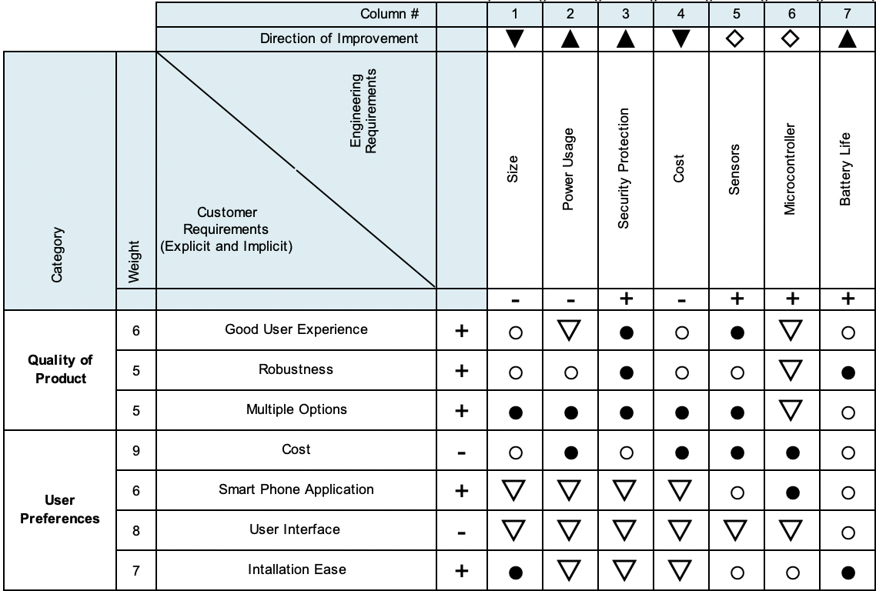
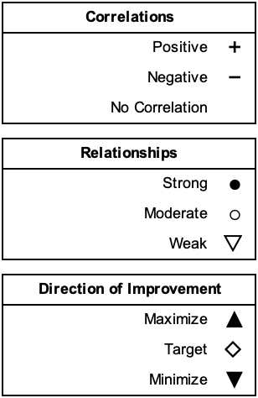

3. Research Related to Project Definition

3.1 Existing Similar Projects and Products
Home security and access control integrated in homes today are at an abundant. With this growing market, we would like to formally research about existing products and seek improvement in their systems. This research will inspire the design for Live Bolt.

3.1.1 Ring Doorbell
Ring video doorbell provides variety in the sense that there are different features of home monitoring installation: wired, battery powered, and bundles leading to solar power or security included. Ring doorbell is customized to reach as many consumers as possible no matter the circumstance of the front door, hence the variety of options. Additionally, with Ring’s growing reputation, they provide flexibility to consumers with different option in monitoring their home. From buying one of their products, it includes motion detection; application integration of notifying the consumer of front door activity; and see, hear, speaking que to visitors in real time.

There are some downsides to including one of the Ring video doorbell to one’s home. One main reason being that there are so many options to choosing a reliable doorbell into one’s home. With that comes variety of options for how to determine one’s monitoring. Many options include variety but could be overwhelming to a customer. Additionally, to use one of their products it includes a monthly subscription plan from additionally purchasing the device. Another problem with ring doorbell is that it requires a strong Wi-Fi connection that essentially must be provided by the consumer. Information exchange between the device and application will be hindered if not provided with a strong network. This research is great notes on how to make our Live Bolt system enhanced and more available to the public. We would like to obtain features that the Ring doorbell incorporates like motion sensing and application availability while subtraction the subscription plan. Live Bolt differs since there’ll also be access control of entering a home through the application. We also take reference of the Ring application to apply towards our application user interface.

3.1.2 Google Nest Doorbell
Another product like Live Bolt is the Google Nest Doorbell, Google’s attempt at a home security monitoring system. It has many features such as a camera, doorbell, sound detection and familiar face detection. Moreover, the setup is wired to configure with an existing doorbell system or can run wirelessly. Google has made it possible to integrate the doorbell with the rest of the Google Nest environment. Features the Nest Doorbell that Live Bolt will include are the camera monitoring system, face detection, and app integration. However, unlike the Nest Doorbell, Live Bolt allows for multiple unlock methods and gives the user can unlock log report through the application interface. It additionally differs in that it is a door locking security system compared to Nest Doorbell which only offers video and audio monitoring. Through this comparison between the two systems, we can see clearly that Live Bolt is the more cost-effective option than the Nest Doorbell. The Nest Doorbell only offers Doorbell monitoring of your existing system while Live Bolt steps up the security of your system.

3.1.3 Yale Lock Integration
Google Nest Doorbell has the capability to interface with the Yale electronic door lock. The Yale lock is a keyless smart lock, similar to Live Bolt, that incorporates a digital keypad. Yale allows for a passcode you can give to people you trust that you can disable at any time. It also offers self-locking features, and the ability to lock/unlock through a phone application. With Live Bolt, we will combine features from both the Nest Doorbell and Yale Lock to enhance safety and security in a single product.

3.1.4 August Smart Lock
The August Lock is a Smart Lock system like many of the others we researched which integrates directly onto an existing deadbolt system. It does require some unscrewing to integrate however August does include videos to guide users through the process. One benefit is that the August lock doesn’t prevent you from using your traditional key so that option is still available to use. It includes an Auto Lock and Auto Unlock feature which allows for geofencing to be used to determine if the user is leaving or heading toward the home. It also allows for the ability to use a smartwatch to lock and unlock the door without having to bring out your phone.

The lock has a mobile app which allows many features including controlling multiple locks, inviting other people to manage the locks, temporary guest keys, an activity timeline, and additional security with the option of mobile bio authentication through the smartphone. These are useful features and many of which we are including in our Live Bolt system to strengthen its security and usability. Additionally, the August Lock does have multiple models to choose allowing customers to choose what locking system works best for them. The pricing of their most costly locking system, the Wi-Fi Smart Lock, comes to 229 USD which is comparable to the wired version of the Google Nest Doorbell. Additionally, if customers end up getting a cheaper model and want to add the August Wi-Fi Bridge to get all the features the total cost is the same as or less than the cost of the Wi-Fi Smart Lock.

There are downsides to August’s Smart Locks. For one the newest generation released by August, although smaller and less bulky than the previous generation, has a smaller battery life. The 3rd generation had a battery life ranging from 6 to 12 months where the current 4th generation has a battery life from 3 to 6 months. Additionally, the batteries for the 4th generation are not the standard AAA or AA batteries and are instead CR123A batteries. These batteries are both more difficult to find and expensive to purchase than normal replaceable batteries. A drawback from August lock comes to auto unlocking connectivity. Auto lock works well for when the lock is able to connect to Bluetooth easily. However, it doesn’t work as well when it fails to connect before the User reaches the door making them wait.

Another issue can happen when the door unlocks but the user takes too long to open it. If the user lives in an area where they must climb stairs or use an elevator the door can unlock and then relock before the user reaches. This also becomes a convenience issue for the user as it could force them to use their key or have to unlock the lock again from their phone. Another issue with the August lock and most other smart locks is the lack of RFID and Near-Field Communication (NFC). The August Lock already supports smartwatch integration and allowing for NFC unlocking would be a useful feature. It would eliminate the need to take out your phone or open the app allowing for the user's device to be held close to the lock to open. With Live Bolt we plan on incorporating both RFID and NFC to give users more options to unlock the system and ease of access.

3.1.5 Nuki Smart Lock
The Nuki Smart Lock is another product that caught our attention as we were researching for our project. It is a smart lock system that directly integrates onto an existing locking system. There is no need for screwdrivers or other tools to install the system as it uses a physical key to lock and unlock the door as if a person was turning the lock themselves. This way of integrating the system allows for it to be compatible with many door locks. Nuki has recently revamped their product line with the 3.0 series offering a normal and pro model. Both share many of the same features aside from the pro having a Wi-Fi module in addition to its Bluetooth module, and a rechargeable battery where the normal uses 4 AA batteries. In our Live Bolt system, we will be providing only one product so users will not have to worry about product tradeoffs like with Nuki’s products. Nuki also provides a smartwatch integration in addition to their mobile app allowing for you to unlock your door from your smartwatch. They also allow the ability to create and assign digital keys to family and friends which is similar to a feature we will include in the Live Bolt system.
We did see downsides to the Nuki Smart Lock 3.0 series which we have taken note of in designing the Live Bolt system. The first is that not all locks work with Nuki’s system so customers will need to check their compatibility guide before purchasing a lock. Another is that for the normal lock model any Wi-Fi actions the user wants to do will need the Nuki Bridge, one of Nuki’s many accessories. The Nuki Bridge has a Wi-Fi module allowing for the base model lock to connect to Wi-Fi. The Pro model comes with this feature in the box. Without the Wi-Fi module in the Pro or Nuki Bridge with the base model users lose out on features like Smart assistants, and Remote management. This significantly limits the users experience and these are features we plan to implement into Live Bolt without the need for accessories.

Another downside of the Nuki is cost. The base model is 149 € which is 169 USD, and the Pro is 249 € which is 305 USD. This is already a high cost for the system, and it doesn’t take into account the price of the many accessories Nuki offers to enhance the Smart Lock experience. From a Keypad to open your door with a code to the Door Sensor which enhances the sensing of the system, Nuki offers many accessories which can feel vital to a better experience. Lastly, the Nuki system does not include a camera for both models. Lacking this feature makes seeing who is at your door impossible however Nuki does include an activity report in the app for monitoring. This is limited however to Nuki products that can connect to Wi-Fi. The Live Bolt system will have a camera for viewing activity outside the door allowing for the user to know what is always happening.

3.2 Computation and Control Device
To execute our objective for Live Bolt, there’ll need to be control and wireless communication between the servo and/or sensors to the application. Choosing the right control device will play a large role to our design; therefore, we will dive into the various options to what control devices are on the market and their characteristics for delivering performance.

3.2.1 Arduino Line
The Arduino line of microcontrollers operate from an ATmega chip. The specific model of Arduino varies depending on the application. The two that we have narrowed down to are the Arduino Uno and Arduino Mega. Both operate at 5V, are programmed via USB A/B; however, they have a lot more differences than similarities that will be outlines below. Figure 1 shows the Uno and Mega boards side by side while Table 6 outlines the main differences between each board.

Table 6: Arduino Uno vs Arduino Mega Comparisons
Characteristic | Uno | Mega
Cost | $20 | $42
Size | 68.58 mm x 53.34 mm | 101.6 mm x 53.34 mm
Processor | Atmega328p | ATmega2560
Clock Speed | 16MHz | 16MHz
Flash Memory | 32kB | 256kB
Pin Count | 20 | 70

3.2.1.1 Arduino Uno
The Arduino Uno is a smaller microcontroller, with a size of 68.58 millimeters by 53.34 millimeters. Since it is physically smaller, it has fewer pins, with 14 digital pins and 6 analog pins. The Arduino Uno also has a 16MHz Atmega328p processor and 32kB of flash memory. These microcontrollers can be purchased in the range of $20.

3.2.1.2 Arduino Mega
The Arduino Mega is physically much larger than the Arduino Uno, at 101.6 millimeters by 53.34 millimeters. Since it is longer it has more pins, 54 digital pins and 16 analog pins, 50 more pins than the Uno. It has a 16MHz ATmega2560 processor and 256kB of flash memory. These models are usually around $42.

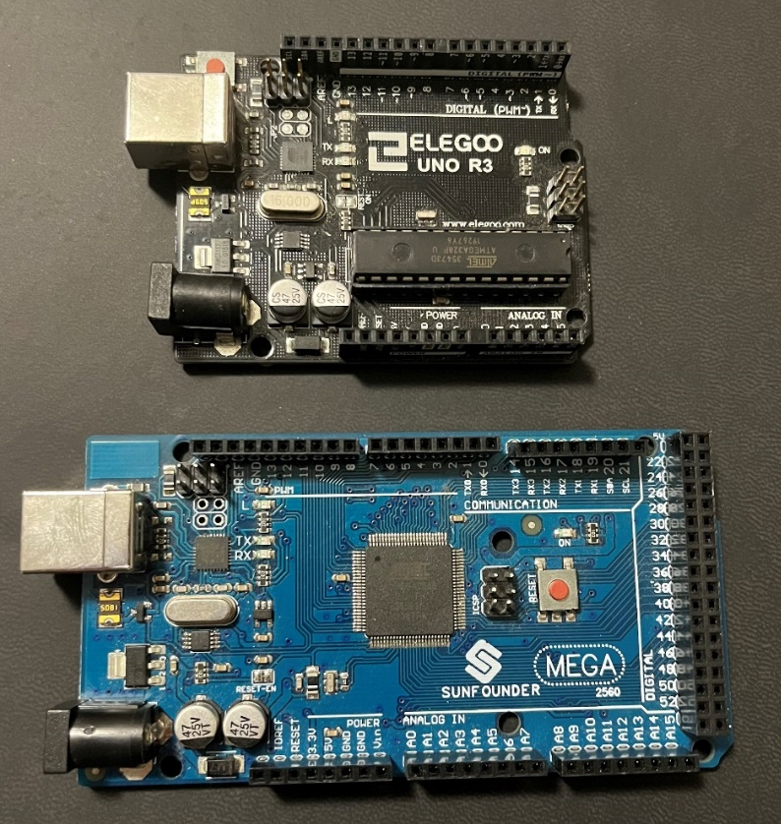
Figure 1: Reproduction Arduino Uno (Top) and Arduino Mega (Bottom) running ATmega architecture

3.2.2 Raspberry Pi Line
The Live Bolt System will need a more powerful processor to host the application and process voice recognition. The Raspberry Line of computation devices would easily serve this need. A Raspberry Pi is essentially a small computer and can run an operating system and programs. The two Raspberry Pi boards we will look at are the Model 3B+ and the newer Model 4. Both are 85.09 millimeters by 55.88 millimeters, house 40 GPIO pins, and operate off 5V. They are also capable of Wi-Fi natively. Figure 2 shows each board side by side while Table 7 outlines the main differences between each board.

3.2.2.1 Raspberry Pi Model 3B+
The Model 3B+ is an older model, but not obsolete by any means. With a 1.5GHz Quad-Core Broadcom BCM2837B0 processor and 1GB DDR2 RAM, the Model 3B+ can handle multiple processes at once. It has one HDMI port, four USB 2.0 ports, and ethernet. It is also powered through either a micro-USB or a GPIO pin header to supply power. These models usually cost around $35.

Table 7: Raspberry Pi 3B+ vs Raspberry Pi 4 comparisons
Characteristic | Model 3B+ | Model 4
Cost | $35 | $45
Size | 85.09 mm x 55.88 mm | 85.09 mm x 55.88 mm
Processor | Broadcom BCM2837B0 | Broadcom BCM2711
Clock Speed | 1.5GHz | 1.5GHz
Flash Memory | 1GB DDR2 RAM | 1GB, 2GB, 4GB DDR4
Pin Count | 40 | 40
Input/Output | 1 HDMI, 4 USB 2.0, Ethernet | USB-C,2 micro-HDMI, 1 HDMI, 2 USB 2.0, 2 USB 3.0

3.2.2.2 Raspberry Pi Model 4
The Model 4 is the successor to the Model 3B+. It has improvements to the processor, now a 1.5 GHz Broadcom BCM2711. The RAM has also been updated to DDR4, with options for 1GB, 2GB, and 4GB. The power is now supplied through a GPIO pin or USB-C and there are two micro-HDMI ports rather than one full HDMI port. Two of the four USB 2.0 ports were also replaced with two USB 3.0 ports. The 2GB model costs about $45.

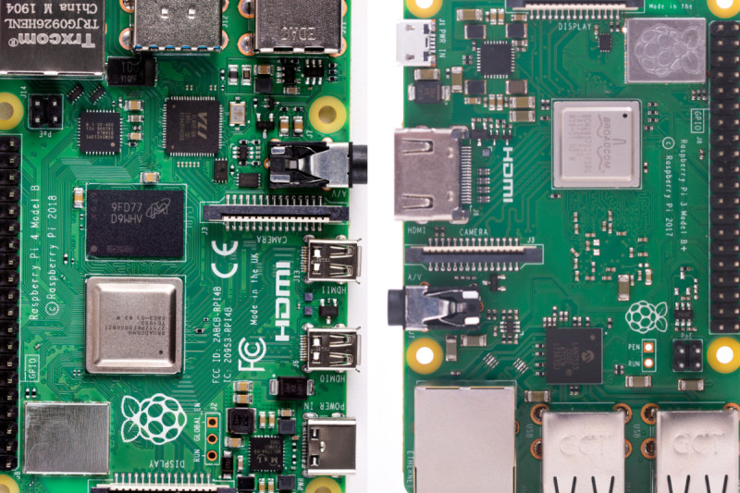
Figure 2: Raspberry Pi 4 (Left) and Raspberry Pi 3B+ (Right) [1]

3.2.3 Texas Instruments MSP430 Line
Texas Instrument microcontrollers offers one of the best analog in the industry with affordability as its best option. The MSP430 line is 16-bit MCU including flexible, integrated analog components, such as ADCs, DACs, and Op-amps; Integrated LCD controllers for displaying information; and devices with USB2.0 for communication with PC or application updates. As undergraduate engineering students at UCF, our classes have introduced two known microcontrollers from TI: MSP430FR6989 and MSP430G2553. Figure 3 shows each board side by side while Table 8 outlines the main differences between each board.

Table 8: MSP430FR6989 Launchpad vs MSP430G2553 Launchpad comparisons
Characteristic | MSP430FR6989 | MSP430G2553
Cost | $24-$60 | $40
Size | 76.2 mm x 50.8 mm | 69 mm x 51 mm
Processor | MSP430FR6989 | MSP430G2553
Clock Speed | 16 MHz | 16MHz
Flash Memory | 16KB | 128KB
Pin Count | 83 | 24
Input/Output | LCD, I2C, SPI, Micro USB | Micro USB

3.2.3.1 MSP430FR6989 Launchpad
The MSP430FR6989 provides ultra-low-power FRAM platform uniquely embedded and a holistic ultra-low-power system architecture to increase performance at lowered energy budgets. Additionally, the MSP430FR6989 includes features of a 16-Bit RISC architecture up to 16-MHz Clock, integrated LCD driver with 320 segments, and multifunction input/output ports. The board is 76.2 millimeters by 50.8 millimeters. A few parameters from this microcontroller (MC) include a 128 kB non-volatile memory, 2 KB of RAM, 12-bit SAR ADC, No USB port, 2 I2Cs and 4 SPI. Due to high demand, these are currently out of stock in the TI website, but alternative websites offer this microcontroller from $24 - $50.

3.2.3.2 MSP430G2553 Launchpad
The MSP430G2553 is like the FR6989 MC from the fact that it is also an ultra-low-power missed signal MC with a built in 16-bit timer. It has low supply-voltage range of 1.8 V to 3.6 V. The G2553 is a 16-bit RISC architecture and a basic clock module configuration with a 24 capacitive touch enabled I/O pins. This board is 69 millimeters by 51 millimeters. There is no LCD driver or USB port in this MC. Note that an online purchase will equate to the price of just a chip but, the whole controller would summarize to $40.

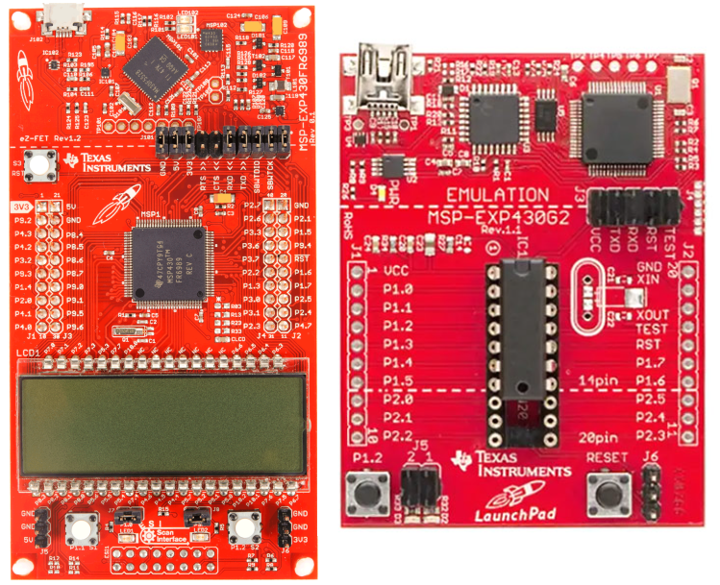
Figure 3: MSP430FR6989 Launchpad (Left) vs MSP430G2553 Launchpad (Right)

3.2.4 ESP Wi-Fi Module Line
The ESP line of microcontrollers are low-cost controllers with wireless capabilities that are great for internet-of-things and home automation projects, like the Live Bolt. If we choose to include Wi-Fi into the microcontrollers of the Live Bolt system, it might be better to opt for an ESP device over another microcontroller since Arduino and MSP430 do not have Wi-Fi natively. Both modules come with Wi-Fi and are programmed via the Arduino integrated development environment (IDE). Figure 4 shows each board side by side while Table 9 outlines the main differences between each board. We will use this table to determine which would be more ideal to move forward in our design and begin testing outcomes we might desire with the ESP Wi-Fi module line. Comparing the two models will show importance to not only price and functionality but to how we can easily integrate this our Live Bolt system. Meaning the use of the PCB and compartment for this project.

3.2.4.1 ESP32
The ESP32 is a very powerful development board with a 160MHz clock frequency, 34 GPIO pins, 16 PWM channels, SRAM, and Flash RAM. These models also include a touch sensor, temperature sensor, and hall effect sensor. It operates on the HT40 40Mhz spectrum of a 2.4GHz Wi-Fi band. One major difference between the ESP32 and ESP8266 is that the ESP32 includes Bluetooth 4.2 and Bluetooth 5.0 with Bluetooth Low Energy (BLE). The dimensions are 54.6 millimeters by 27.94 millimeters by 13 millimeters (respective to length by width by height) and costs anywhere from $6 to $12.

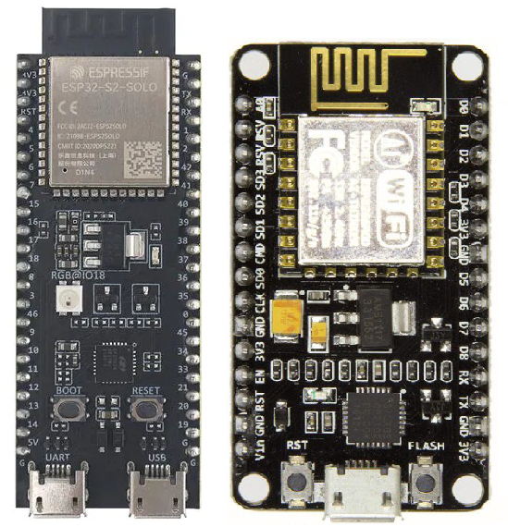
Figure 4: ESP32 (Left) vs ESP8266 NodeMCU (Right)

Table 9: ESP32 vs ESP8266 comparisons
Characteristic | ESP32 | ESP8266
Cost | $6 - $12 | $3 - $6
Size | 54.6 mm x 27.94 mm x 13 mm | 48 mm x 26 mm x 13 mm
Clock Speed | 160MHz | 80MHz
Pin Count | 50 | 25
Input/Output | Touch, temperature, hall effect sensors, micro-USB, Bluetooth 5.0, 40MHz 2.4GHz band. | Micro-USB, 20MHz 2.4Ghz band

3.2.4.2 ESP8266
The ESP8266 is less powerful than the ESP32 but is still very useful for the application of this project. There is a breakout board for development that is called the ESP8266 NodeMCU, that we will be considering. It has an 80MHz clock frequency, 17 GPIO pins, and 8 PWM channels. It lacks any Bluetooth capabilities and operates on the HL20 20MHz spectrum of the 2.4GHz Wi-Fi band. It also lacks the touch sensor, temperature sensor, and hall effect sensor that is present on the ESP32. Since it lacks some features, it is smaller and cheaper, coming in at 48 millimeters by 26 millimeters by 13 millimeters (respective to length by width by height) and $3 to $6.

3.3 Sensors
The application for including sensors within our system is to include variety in access control for unlocking a door and provide home monitoring. We will detail the options for choices that could be provided in Live Bolt.

3.3.1 Voice/Phrase Recognition
Since the Raspberry Pi is processing the voice recognition software, a microphone is needed that is compatible with the Raspberry Pi. The microphone must also produce clean voice captures to be used in Artificial Intelligence applications. The voice input will be processed, and the program will determine whatever was said. If the word is a registered trigger word, the system will unlock the door. It would be best to incorporate multiple microphones into an array to get the best voice capture.

3.3.2 Face Recognition
For increased security, we would like to include some form of biometric facial recognition on the Live Bolt system. This can be implemented in a variety of ways, which are outlined below. Our main goal is to have a system that is as accurate as possible at detecting a registered face and rejecting unregistered faces. Overall cost, size and computing time can be greatly impacted depending on the method that is decided.
Table 10 outlines the differences between explored facial recognition methods.

3.3.2.1 Computer Vision
The Live Bolt will have a feature that unlocks the door when a registered face is detected. There are a few ways to go about this. The first method considered was to use a simple webcam and incorporate computer vision image processing methods through machine learning. This method would require a very large dataset of every person using the face identification features. The datasets would need to consist of at least 1000 photos of the person to start reliably detecting. It would require even more photos at different angles and light levels to increase consistency. Once a dataset is created, the photo captured during the unlock attempt would be passed through a convolutional neural network and eventually compared to the dataset. The output of the network would be a prediction if the subject is the same one as in the training dataset. Ideally, an accuracy of 99.5% or greater would be given every time for a positive match, and as close to 0% as possible for a negative match. Due to the limitations of computing hardware and convolutional neural network training times, this method isn’t the most reliable, so it would have to be combined with another form of access like the keypad, to ensure safety.

3.3.2.2 Intel RealSense ID
The second possibility that was researched was 3D mapping technologies like Intel RealSense ID and Xbox Kinect. 3D mapping, or photogrammetry mapping, allows for something in real life to be measured and projected onto a screen in the form of a 3D map or model. The measurement consists of taking small bits of data from different points around whatever you are mapping to create a depth map. One key advantage to 3D mapping for facial recognition, besides for more reliable recognition, is that the 3D map creates depth of someone’s face. This keeps someone from simply showing a photo or model of someone else to the camera and have that be accepted as the target face. The process of using a photo of someone to trick a facial recognition system is known as spoofing.

Intel has developed a technology called RealSense ID that utilizes 3D mapping techniques to rapidly authenticate someone’s face. They have all-in-one products that are ready to be used in a variety of applications straight out of the box, such as their F455 product. They also provide their architecture for custom designs in their F450 product. The features of the F455 will be focused on for the sake of this project. The F455 is 32.5 millimeters x 62 millimeters x 11 millimeters and has a viewing angle of 56° × 78°. It needs a Window, Linux, or Android operating system to operate. These devices have a 1:1,000,000 false acceptance rate (0.0001%), a 99.76% true acceptance rate, and a spoof acceptance rate of less than 0.1%. This makes them extremely secure and fit for a security lock application. Both models come with a system on the chip (SOC) which is an integrated circuit for computing and processing. They are also equipped with two 1920x1080 resolution cameras, IR sensor, 3D dot projector, and a light for more accurate capture. The Intel RealSense ID F455 is available for about $105.

3.3.2.3 Xbox Kinect
Microsoft has developed a product called Kinect for their line of Xbox gaming consoles that also utilize 3D mapping technology, for a gaming application rather than a facial recognition application. Since it is designed for gaming, it is meant more for detecting the body’s of players for motion-based video games. The camera is equipped with a 30 frames-per-second 640x480 pixel resolution color camera and a 320x240 pixel resolution depth camera. The cameras also have a 57° × 43° viewing angle. The lower resolution isn’t best for catching finer details, like what would be on a person’s face. The way it is able to track bodies is by creating a virtual skeleton of up to two players on the screen. These skeletons have 20 joints per player and can track when the player moves one of their joints, like their legs or arms. The Xbox 360 Kinect is 76.2 millimeters x 279.4 millimeters x 76.2 millimeters. The module costs about $20 used.

A new version of the Kinect has been released for the newer Xbox One console and has an updated 1920 x 1080-pixel resolution 30 frames-per-second color camera and 512 x 424 pixel resolution depth camera that are able to track up to six active players. The newer model also has 26 joints that it tracks, rather than 20. It is smaller than the original Kinect, with a size of 66.8 millimeters x 248.92 millimeters x 66 millimeters and it costs approximately $80.

3.3.2.4 Smart Phone Face ID
The most well-known method of Face Recognition is the methods used on modern cell phones to unlock them. This section will mainly focus on the Apple iPhone Face ID and Android Face Authentication HIDL. They work similarly to the 3D depth scanner of the Intel RealSense ID technology. Since most people have a phone with face identification capabilities, this would be a good way to save space on our module while still maintaining quality face recognition. 90% of smart phones are expected to include some form of biometric facial recognition by 2024 [2]. They are also advantageous due to being able to detect someone’s face with minor differences form the training dataset, such as if they were wearing sunglasses or if they grew a beard. Both platforms also have open-source application programming interfaces (APIs) for app developers to program them. Since this method incorporates the user’s phone, there would be little to no cost associated with it. This would in turn keep the overall cost of the product lower, while also keeping the product size smaller since it would not need to house larger cameras or processors for face detection.

Since the group has an Apple iPhone 13, that phones specifications will be considered. The iPhone 13 is equipped with Apple’s TrueDepth camera technology. This includes a camera that is capable of up to 3840 x 2160 pixels (4K) photos or video recording at 60 frames-per-second. The camera relies on a dot projector, similar to the Xbox Kinect, to detect enrolled faces. Over 30,000 dots are projected onto a user’s face and it is able to detect whether the user is enrolled or not based on their facial structure. The TrueDepth camera is designed to work indoors, outdoors, or even in total darkness.

Table 10: Comparisons Between Facial Recognition Methods
Characteristic | Computer Vision | Intel RealSense ID F455 | Xbox One Kinect | Smart Phone (iPhone 13)
Depth Camera Resolution | Dependent on webcam | 1920 x 1080 pixels | 512 x 424 pixels | 30,000 dots
Color Camera Resolution | Dependent on webcam | 1920 x 1080 pixels | 1920 x 1080 pixels | 3840 x 2160 pixels
Frames per second | Dependent on webcam | 90 | 30 | 60
Detection Method | 2D Neural Network matching face to database | 3D dot projection/facial mapping | 3D Depth/joint tracking | 3D dot projection/facial mapping
Physical Size | Dependent on webcam | 32.5 mm x 62 mm x 11 mm | 66.8 mm x 248.92 mm x 66 mm | 147 mm x 72 mm x 7.65 mm
Viewing Angle | Dependent on webcam | 56° × 78° | 70.6° x 60° | 120°
Cost | Dependent on webcam | $105 | $80 | $830

3.3.3 Near-Field Communication
Near-Field Communication (NFC) is a popular use in today technology of contact-less communication from using radio frequency. This technology is used to primarily to exchange data within two devices through a touch gesture. The NFC controller needs to be connected with antenna transmit and receive all NFC communication frames to the NFC Forum Device. Using the NFC forum device will be an integration of using software in our application for Live Bolt and making sure it can recognize the chip that’ll be placed in our design. Since NFC is very flexible in operating in different modes, the most ideal application of NFC to Live Bolt would be through Host Card Emulation. Due to our idea for making it easy for the user to enter their home, having an NFC controller forward contact-less commands to the Device Host.

3.3.4 Infrared Sensor
The infrared sensor is integral to the security system because it will help to identify is someone has entered in front of the Live Bolt lock. Any Infrared sensor that is compatible with Arduino or Raspberry Pi would be fine for our application. Ideally it would have 2-5 feet of detecting distance.

Using an infrared sensor for motion detection rather than another method like computer vision or ultrasonic sensing is beneficial because it can detect changes in temperature that the other sensors cannot, and therefore can tell is a human or animal is being detected. An ultrasonic sensor would trigger whenever anything gets into range, such as leaves or other debris.

3.3.5 Security Camera
The Live Bolt system will include a security camera for the customer to view a live feed of the area in front of their door. The security camera has two main requirements: a high Field-of-View and good resolution. This way it can view the largest area with the most clarity. Since most cameras are compatible with Raspberry Pi models, we needed to compare USB cameras, like webcams, to integrated camera modules that connect to the Raspberry Pi via ribbon cables. A secondary requirement for the camera is how much space it will take up. It will need to be mounted to the outdoor module of the Live Bolt, so it would be better for it to be as small as possible while maintaining Field-of-View and resolution quality.

3.3.6 Keypad
The number keypad will be used by guests to unlock the door with a one-time code that is 4 to 6 digits. If there was a single code that always unlocked the door, those keys would begin to fade and make it easy for an intruder to guess the code. The main requirement for this keypad is for it to be weatherproof, mainly from rain since it will be on the outside module, so it must be made of waterproof plastic or metal. An alphanumeric pad could be useful for added security; however, a numeric pad would also be fine for the scope of this project. There are many types of keypads available that fit these requirements such as membrane keypads, dome-switch keypads, and capacitive keypads.

A membrane keypad is probably the most popular option for products that require labeled buttons. They work by having two layers that are separated by an air gap. When the top layer is pressed by a user, it completes the circuit and allows the computer to know which button was pressed. Dome-switch keypads are similar to membrane keypads, except they are more mechanical and provide a tactile click when pressed. The sound and touch feedback help usability. Dome-switch keypads also have incredible reliability, being able to be clicked between one and five million times. Capacitive keypads act similarly to the membrane keypad, except when you press, it charges a capacitor. The change in the capacitors charge is detected and the computer can determine which key was pressed.

3.3.7 Fingerprint Scanner
Fingerprint sensors allow for biometric scanning of a person’s unique fingerprint. This is a very safe option for a lock application since it is difficult to replicate someone else’s fingerprint. Fingerprint scanners are a great way to replace or substitute other forms of access control such as passwords or keys, which can be lost, stolen, or forgotten. Fingerprint scanners have applications for physical access control like for doors, but also for access to computers and other cyber systems. The main types of fingerprint scanners are optical scanners, capacitance scanners, and ultrasonic scanners [3].

Optical scanners are the most common form of biometric fingerprint scanning. They work by using light to create a digital copy of whatever finger is placed on the scanner. This copy is then compared to stored prints in a database to confirm whether to grant access.

Capacitance scanners work similarly to the optical scanners except instead of light creating a copy, the copy is made through voltages stored in a capacitor. An issue with optical scanners that is remedied with the capacitance scanners is that optical scanners can detect someone’s fingerprint by a copy, like on a piece of tape. This is not the case for capacitance scanners, and they are therefore more expensive.

Ultrasonic scanners use ultrasonic waves to hit the pattern on a finger and bounce the waves back to create a print. This method does not need to be included in its own sensor module either, it can be included under glass or a phone, at, or any device. This type of scanner is still being researched so there aren’t many modules available.

If we pursue a fingerprint scanner, we will most likely use an optical scanner due to the all-round effectiveness of them. There are two scanners we have researched.

3.4 Power Sources
All the computational devices we have identified operate off 5V. This means we will need a reliable power source that can output 5V for a very long time. To identify the main source of power to operate our system, we will look at a variety of options to execute its functionality.

3.4.1 Solar Panel
Powering our system from solar panels was an early goal that we wanted to research more. Since solar panels do not output their peak voltage 100% of the time, a battery pack would also need to be included to keep the system running. A panel rated for at least 5V would be required. A possible issue with using solar panels is that the lock system might be shaded from the sun, making any solar panel useless. Solar panels also use up more space, and we would like to keep the system as compact as possible.

3.4.2 AC Power
The most reliable method to power the system would be to tie it to the 120V, 60Hz, AC power used to supply power to the rest of the home. However, this would mean that when the house loses power for any reason, the lock would also lose power. This means we would need to include a supplementary battery pack anyway in case loss of power occurred. Working with 120V is also potentially dangerous for the engineers designing the system, and the customers installing it.

If we decide to use AC power supplied from a home, there will be a need for electromechanical relay switches on our PCB. Relays are essentially electromagnets and switches combined into a single module. They contain a coil that produces a magnetic field when a current is applied. This magnetic field then pulls a mechanical switch closed and allows for current to travel to the electronics. Relays have been used in applications for electronics that are tied to AC power for many years. They have been the main choice for this application due to being inexpensive, easy to use, being available at different voltage ratings, can be used with both AC and DC voltage, and they keep the original electrical signal unmodified [4]. For the case of Live Bolt, a relay module would be beneficial due to having other components pre-installed that allow for direct connection to AC voltages.

Ease of installation is something we are working hard towards and having to tie the system to a house power system may not be safe for someone who is unexperienced. This method would also not be plausible for someone living in an apartment complex.

3.4.3 Conventional Battery Pack
Including a battery pack seems like the best method to supply power to the system. Since both Arduino and the Raspberry Pi operate off 5V, a pack of at least 5V is required. Most batteries are more or less, but not exactly 5V. This means that the battery supply will most likely need to be stepped up or down to 5V to meet power consumption needs.

A major issue with batteries is that they will inevitably run out of charge and the system will lose power. We would like to make the battery packs easily swappable and rechargeable so customers can always have power to their system. Rechargeable AA batteries typically output 1.25V, so including four in series would provide us with the 5V we need. Since we want to include rechargeable batteries, something like a Lithium Polymer battery would not be the best choice for the engineers or the customer These types of batteries are very easy to mishandle by someone without experience and can lead to fire, smoke, or explosions if over or undercharged.

3.5 Locking Methods
Arguably the most important feature of this product is how it will physically lock a door and keep unwanted visitors out. The main methods that were considered for this project were electric strike locks, magnetic locking mechanisms, and traditional dead-bolt locks. Included in our objective, we want to make sure that there is a clear sense of security to the homeowner, hence the reason for including a good locking method. Something important that we are considering when looking at locks is how they behave under fail conditions. We would like the lock to remain locked if power is lost or if the program malfunctions, rather than unlocking. Below are the options we’ve discussed as a team that would be liable for improving security when designing Live Bolt.

3.5.1 Electric Strike Locks
Electric strike locks and magnetic locks are both typically incorporated into doors of most institutional and commercial buildings, like schools or shops. An electric strike lock, seen in Figure 5, operates very similarly to a dead-bolt lock, except that instead of a human turning the bolt, an electric impulse causes the bolt to strike into place. A benefit of the electric strike lock is that once it is locked, it no longer needs an electrical signal and can keep the door from opening.

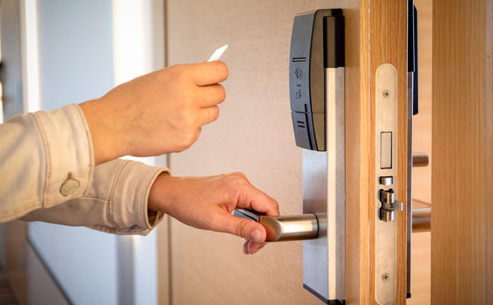
Figure 5: Example of an Electric Strike Lock on a Door [5]

3.5.2 Magnetic Locks
Magnetic locks, seen in Figure 6, feature an electromagnet on the doorframe and a piece of metal attached to the door. When the door is closed, the magnet and metal will make contact. Then, if an electrical signal is sent through the magnet, it will activate and attract the metal piece, causing the door to remain locked closed. The electrical signal for both locks can be sent via multiple methods but are typically sent from a key card reader or keypad. The magnetic lock needs a constant source of power to remain locked, or else the door will be able to be opened.
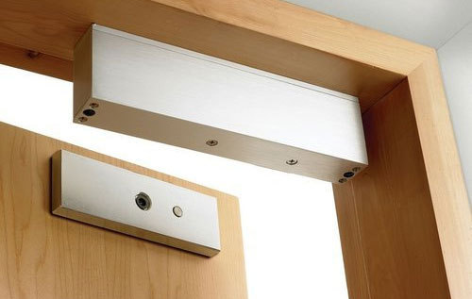
Figure 6: Magnetic Lock on Door [6]

3.5.3 Dead bolt Locks
A traditional dead bolt lock, seen in Figure 7, is what is seen in most homes. It operates by having the user manually turn a thumb knob located on the inside of the home. When this knob is turned, the bolt is struck into place, blocking the door from being opened. To automate this task for the purpose of the Live Bolt system, having a servo motor turn the bolt would be best because it allows the door to be locked or unlocked remotely without the need for a person to physically be at the door.

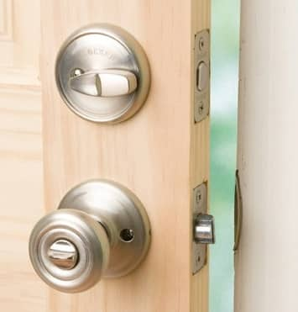
Figure 7: Traditional Dead Bolt Lock on Door [7]

Most commercial smart locks on the market opt for a method of having customers unscrew the doorknob off their door and attach a unit that houses the servo motor to the inner mechanisms of the lock. Another method requires the thumb knob to be fitted with a cover. A servo motor will then turn this cover, and therefore the knob, to unlock the door. A downside to this is that not every door thumb knob is the same shape and size, making the cover hard to replicate for different doors.

3.6 Feedback System
In creating Live Bolt, we want to ensure that there’s home monitoring within the vicinity of the home. From that outcome, it’s only logical to include a feedback system to the homeowner about any undisclosed guests within their property. This will help enhance the responsiveness and security of our system. The following feedback systems will be considered to take place in our design.

3.6.1 LED/Buzzer on Physical Device
One tactical way to prevent intruders from entering a home is through a reactive system. When an alarm goes off it typically does resign well within the situation. In our design, we essentially want to incorporate a buzzer/ flashing LEDs onto the physical device when entering through force. That way the intruder is indicated that our system is aware that there is entry and will notify the homeowner. These reactive systems may result in the intruder not entering the home which would be in favor of the customer. Visual deterrents such as these can help prevent a potential break through immediate feedback which will prove useful in our system.

3.6.2 Application Notifications
An added feature we’d like to incorporate is to provide notification through an application of someone unlocking the door, movement within the door entrance, and whether there’s been a force entrance. This will be done with the use of our sensors cooperating with the raspberry pi. This information will then be relayed to our mobile application for the user to evaluate. The user interface will have the option of being sent notification of the following home indication. With including mobile notifications, we hope to provide security to our consumers knowing that their homes will be monitored 24/7.

3.6.3 LCD Display
An onboard display might be useful to include onto the lock so the user can get feedback without taking out their phone to view the app. One option for this is a Liquid Crystal Display. These are easily found for microcontrollers and can be fixed to any housing. Some things that can be displayed would be welcome messages, an “Access granted” or “Access denied” message, and the current keycode being entered. Most text-based LCDs are based on the Hitachi HD44780 chipset. Liquid crystal displays made for microcontrollers typically can only display two rows of sixteen characters, which would limit what we are able to display. These modules have sixteen pins, including a register select pin, read/write pin, enable pin, eight data pins, Vo, +5V, GND, backlight +, and backlight -. When using an Arduino, only twelve of these pins are required to function. The display can be used in 8-bit mode, meaning it uses pins D0 – D7, or in 4-bit mode with pins D0- D3. Table 11 below shows the function of each of the pins on the board. Rather than writing to each individual register of the display, the LiquidCrystal library can be used to simplify the process [8].

Table 11: Pin functions on LCD Display
Pin name | Function
Register Select (RS) | The Register select pin controls which register in the LCD’s memory the data is being written.
Read/Write (R/W) | Changes between read or write for the LCD’s registers
Enable (E) | Enables writing to registers
8 Data Pins (D0 – D7) | The bits of the data being sent. Each pin represents high or low.
Display Contrast (Vo) | Adjust the display contrast
Voltage in (+5V) | Input voltage
Ground (GND) | Ground
LED Backlight positive (LED+) | Turn LED backlight on
LED Backlight negative (LED-) | Turn LED backlight off

3.6.4 OLED Display
Another option for a display is an Organic Light Emitting Diode (OLED) Display. OLED differs from LCD in that each pixel is individually lit, rather than all the pixels being lit by a single backlight. Because of this main difference, OLED usually has more vibrant colors and consumes less energy, it also allows for the ability to add more characters to the screen than the 32 allowed on a typical LCD display. The display we researched was the SSD1306 0.96 inch I2C OLED Display.

The SSD1306 only has four pins, compared to the 16 of the LCD display. Thee pins are Vin, GND, Serial Clock (SCL) and Serial Data (SDA). There are also libraries readily available for programming this display with Arduino. There is much more variety with what you are able to display, including shapes, colors, and words of different fonts. Each pixel can be individually updated, meaning you can even create images on the screen.

3.7 Parts Selection
After considering all the possible parts listed above, we have narrowed down what we think would best fit the design we have created. All the parts chosen are listed below. Each part and its technical specifications will be discussed further in Section 7.1 Hardware Selections. A breakdown of each components cost and where they were sourced is in Table 21: Bill of Materials.

3.7.1 Computation and Control Device
It was decided that for the computational device, that a mix of using a Raspberry Pi and ESP8266 would provide the best combination of processing power. The Raspberry Pi is responsible for interfacing with the microphone for phrase detection, the security camera for video streaming, and hosting the phone application. The ESP8266 will process the NFC scanner input, the number pad input, and the passive infrared sensor. The output for the ESP8266 will be the security system, which consists of an LED and buzzer.

3.7.2 ReSpeaker 4-Microphone Array
For the voice capture device, we opted for the Seeed Studio ReSpeaker 4-Microphone Array. This product is designed for all Raspberry Pi models. It has four microphones, one in each corner of the board. This allows for a higher quality sample to be collected and used by the Raspberry Pi for phrase detection. This board is based on the AC108 quad-channel analog-to-digital converter (ADC) for high quality voice capturing.

3.7.3 Smart Phone Face Identification
Due to cost, computing, and size constraints, it makes the most sense to utilize the Apple iPhone Face ID and Android Face Authentication HIDL that is already built into most user’s cell phones. This will mean that most of work that goes into this section will be done through the smart phone application. Both iPhone and Android have open-source libraries that can be used to include the face recognition features of their platforms on our application.

3.7.4 HiLetgo NFC Module
The HiLetgo PN532 NFC kit is made up of a key card, key ring, and the actual NFC module that supports NFC/RFID reading and writing. It operates at 5V for I2C and UART communication, and 3.3V for SPI communication. The module is very small and can easily be incorporated into the final product.

The communication protocols supported by this module are Inter-Integrated Circuit (I2C), Serial Peripheral Interface (SPI), and High-Speed Universal asynchronous receiver-transmitter (HSU). There are two switches that act on binary logic to change the communication protocol of the board. The required programming libraries and pins connected change depending on the protocol chosen. These protocol options are shown in Table 12.

Table 12: Communication protocols for NFC Reader
Protocol | Switch 1 | Switch 2
HSU | 0 | 0
I2C | 1 | 0
SPI | 0 | 1

3.7.5 HC-SR501 Infrared Sensor
The Stemedu HC-SR501 PIR Motion Sensor was chosen for the infrared sensor because it is a passive infrared sensor. This means that it can detect changes in temperature in its viewing area to see if a human or animal is in view. Passive infrared sensors are the most-used type of motion detector for security applications so this will be easily integrated into the final design. When someone enters its viewing area, it will output a high voltage level. After they leave, it will go back to a low voltage output. This sensor features an option to adjust the delay time and block time. Delay time is how long after someone leaves its sensing area that it will remain outputting a high voltage before outputting a low voltage. Block time refers to the amount of time after going back to a low voltage before it can be triggered and set to a high voltage again. The delay time can range from 0.5 seconds to 200 seconds and the block time can range from 0 seconds to over 100 seconds. These delays are adjusted via potentiometers on the board itself, which eliminates the need for any programming with a microcontroller. This sensor offers a range of about 5 meters and a viewing angle of about 100 degrees or less.

3.7.6 ArduCam Security Camera
The biggest requirement for the camera is to have a small form factor while retaining enough quality to be a good choice for security applications. The ArduCam is a camera module that interfaces with any Raspberry Pi module via the 15-pin ribbon cable on the top of most Raspberry Pis. The ArduCam offers 1080-pixel resolution at 30 frames-per-second video quality and a viewing angle of 54 degrees by 41 degrees.

3.7.7 Keypad
The group opted to go with a simple matrix membrane keypad that can interface with most microcontrollers, including the chosen ESP8266. It is a 4 x 4 pad with buttons for numbers zero through nine, letters a through d, as well as special characters for “*” and “#”. It also comes with an adhesive on the back to be easily fixed to our final design.

3.7.8 Rechargeable Battery Packs
We have opted to go with rechargeable battery packs to power each module of the design. We have decided to include rechargeable AA batteries in these packs. The technical specifications such as how many batteries in each pack and how much power they will produce will be discusses further in section 7.2 Power Distribution.

3.7.9 Traditional Dead-Bolt Lock
To keep the installation as simple as possible, it was decided to keep the traditional deadbolt design on the door and instead have a servo motor turn the thumb turn that sets/unsets the dead bolt in place. The servo motor that was chosen has a torque of 10 kg*cm and can rotate up to 170 degrees. Typically, a servo motor with at least 180 degrees turn radius is desirable, but since we only need to turn the lock 90 degrees to lock/unlock it, 170 degrees is more than enough.

The reason behind this decision was because we would like to make installation as easy as possible for customer. We felt that removing the need to unscrew the current door lock to install a new one, and instead fix the product right over an existing lock contributes to this goal.

3.7.10 Feedback System
The way the system provides feedback to the user will be in two ways. The first method will be by indicators on the physical system. If an attempt to unlock the door fails, a buzzer will beep, and an LED will flash to indicate that the attempt was unsuccessful. The second method will be via the phone application. When a attempt to unlock is made, it will send a notification to the application and indicate whether the attempt was successful or not.

3.7.11 Parts Summary
Table 13, below, provides each category of hardware that was identified for the Live Bolt, and the specific part that was chosen to fill each requirement.
Table 13: Summary of Live Bolt Hardware.

Table 13: Summary of Live Bolt Hardware
Category | Part Chosen
Computational Device | Raspberry Pi 3B+ and ESP8266
Phrase Recognition | ReSpeaker Four-Microphone Array
Face Recognition | Smart Phone Face Identification (Apple iPhone Face ID and Android Face Authentication HIDL)
Near-Field Communication | HiLetgo Near-Field Communication Module
Infrared Motion Sensor | HC-SR501 Infrared Motion Sensor
Security Camera | ArduCam Security Camera for Raspberry Pi
Number Pad | 4x4 matrix membrane keypad
Power Source | Rechargeable battery packs
Locking Method | High-torque servo controlled dead bolt
Feedback System | Phone application and physical LEDs/buzzers

4. Related Standards and Realistic Design Constraints
This section outlines all standards for common technologies that we have identified as useful to the development of Live Bolt. This section also explores realistic design constraints that we will inevitably face. These constraints must be kept in mind throughout the development process. There will be constraints specific to our project, as we have safety and security of the user in mind with our lock system.

4.1 Standards
Within the area of Engineering Design and project creation, there are several standards to follow. These standards are important because they directly affect the way we design our Live Bolt system and the technologies we will use. Our Live Bolt system will utilize a few of these standards as it operates. We will need to adhere to these standards when including Wi-Fi, Bluetooth, RFID, and NFC technologies in the Live Bolt system.

4.1.1 Wi-Fi Standards (802.11)
Originally, the first standard for Wi-Fi was created in 1997 by the Institute of Electronics Engineers (IEEE). It was called IEEE 802.11 and had a network bandwidth of only 2 Mbps. This is very slow compared to the most recently accepted Wi-Fi 6 standard, also known as 802.11ax, which can support up to 10 Gbps. Since the creation of the 802.11 standard there have been many Wi-Fi standard iterations which each have their own advantages and disadvantages. As a result of this just because a standard has been approved by IEEE does not mean that it may be the best in every situation. As such the Wi-Fi standard we choose to use will be taken into careful consideration when we design the Live Bolt system.

As mentioned before the most recent Wi-Fi standard that was approved was Wi-Fi 6 back in 2019 by IEEE. However, this is not the Wi-Fi standard that will be used primarily in our system. We will be using a Raspberry Pi in our system which uses the 802.11ac standard or Wi-Fi 5. This standard supports simultaneous connections on both 5 GHz and 2.4 GHz Wi-Fi devices. It also boasts a bandwidth of at most 1300 Mbps when using the 5 GHz connection and 450 on the 2.4 GHz. [14]

4.1.2 Bluetooth Standards (802.15.1)
Bluetooth or IEEE 802.15.1 was originally first standardized by IEEE like Wi-Fi. It was first introduced in 1998 and has since had its standard management transferred to the Bluetooth Special Interest Group (SIG). This group manages Bluetooth standards which manufacturers must follow if they want to include the technology in their devices.

Currently the only devices that will be utilizing Bluetooth in the Live Bolt Smart Lock system will be our Raspberry Pi and a smart phone connected to our system through the app. The Raspberry Pi uses Bluetooth 5 technology. Bluetooth 5 was released on December 6th, 2016 and introduced many improvements over the past generation. Bluetooth 5 provides support for Bluetooth Low Energy, or BLE, which is a subset of Bluetooth 4.0 technology that is aimed at supporting low power applications. Some of the new features of Bluetooth 5 includes options to double the speed while reducing the range and quadrupling the range at the cost of the data transmission. [17]

4.1.3 RFID Standards
RFID is a technology that uses electromagnetic fields to uniquely identify items. A typical RFID system involves the interaction between RFID tags and readers. We will be using an RFID in the Live Bolt system as a possible method to unlock the lock. There are many regulations and standards that are in place for RFID. These guidelines are in place to protect people and animals from harm that certain frequencies can cause.

There is not a central organization that manages RFID communication. Instead, there are several industries and organizations that have set their own standards for RFID communications. Additionally, each country can set its own rules for the frequency bands allowed for RFID communication. These bands are also known as the ISM, Industrial Scientific and Medical, bands on the electromagnetic spectrum. These are a portion of radio wave bands laid out on the spectrum reserved specifically for scientific, industrial, and medical purposes. We will carefully consider the various standards as we complete our design for the Live Bolt Smart Lock.

4.1.4 NFC Standards
NFC is a similar technology to RFID. It is a communication protocol set that allows two devices to communicate over a small distance, roughly 4 centimeters. NFC technologies are mainly used to facilitate contactless payment systems. However, in the Live Bolt system it will be used as an authentication technology for unlocking the lock.

The actual standards for NFC communication are based on similar standards to RFID. These standards include ISO/IEC 14443, ISO/IEC 18000-3, FeliCa, and those defined by the NFC Forum. These standards deal primarily with identification, proximity, and contact card regulations in use with NFC. ISO/IEC 14443, and ISO/IEC 18000-3 are important NFC standards as the first deals with the way identification cards can store information. The second deals with the way RFID communication can interface with NFC technology.

We will be using the HiLetgo PN532 Module kit for both our NFC and RFID communications. It supports reading and writing for both technologies. Several cards and standards work with the kit such as ISO/IEC 14443-4 cards, FeliCa cards, and Innovision Jewel cards. The kit uses I2C, SPI, and High Speed UART for communication. [16]

4.1.5 Measurement Standards
To keep the design process of the project consistent, we would like to note that our design will keep in the international System of Units (SI). This choice was determined because it used universally in technical and scientific research to avoid confusion when converting between units. This would help those unfamiliar with the imperial system since it’s less popularly used. Specifically, we would like to keep all set measurements in design to millimeters (mm) when obtaining dimensions.

4.1.6 Deadbolt Lock Standards
Every lock needs a locking mechanism, and the Live Bolt system is no different. The locking mechanism we will be using for our project will be a deadbolt lock. Deadlocks, like many other tools we will be using, have standards in place that will assist us in our design.

There are a few different ways deadbolt locks can be configured. These include the Single Cylinder Deadbolt, Double Cylinder Deadbolt, One-Sided Deadbolt with Outside Trim, and One-Sided Deadbolt Without Outside Trim. A single cylinder deadbolt is a two-sided lock where the outside side has a key slot to turn, and the inside part of the lock has a thumb turn. With the double cylinder deadbolt there is a key slot on both sides of the lock allowing a key to be used from the inside and outside of the door. A one-sided deadbolt with outside trim involves a plate being placed on the outside of the lock with a thumb turn on the inside of the lock. This allows the lock to be opened from the inside only. A one-sided deadbolt without outside trim is a configuration where there is nothing on the outside of the lock but there is a thumb turn on the inside. Like the one-sided deadbolt with outside trim configuration the lock can only be opened from the inside with the thumb turn. [15]

ANSI Grading System was formed to have a standard procedure to test the production quality of a lock. It was developed by the Builders Hardware Manufacturers Association (BHMA). There are currently 3 grades ranging from Grade 1 to Grade 3. Grade 1 is the most secure grade while Grade 3 is the least. Grade 3 locks are the least secure locks and are the locks used in many homes and residences. They also consist of a 5/8-inch latch bolt. They are the least expensive of the 3 grades and should not be used in situations that require maximum security. These locks are typically easy to fiddle with and can be picked easily to unlock.

These locks are not recommended if the customer has enough money or access to another Grade. Additionally grade 3 deadbolt locks are tested to maintain functionality for at least 800,000 cycles. They also are tested to resist 2 strikes from at least 75 pounds of force. Grade 2 locks are used on many residential houses and buildings. They are a bit more expensive than grade 3 locks but pay off with the increased security they offer. This grade is also built to withstand 800,000 cycles and is a 5/8-inch latch bolt. This grade can withstand 5 strikes from 75 at least pounds of force.

Grade 1 locks are the strongest of all 3 grades, however they are the most expensive. As such they are used in many commercial applications and applications that require the best quality locks. They are tested and certified to withstand 1,000,000 cycles for usage. This grade can handle 10 blows from at least 75 pounds of force. Similarly, to the other 2 grades this grade also is a 5/8-inch bolt lock [15]. We will be using the image in Figure 8 to continue our design process for the lock box.

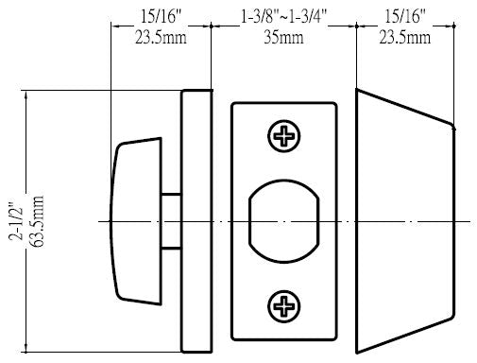
Figure 8. Deadbolt lock size standards

4.1.7 Battery Standards
When designing a system, it’ll need a source of power to have all the electronics running and functioning. Our design choice for powering the components would be through AA batteries. AA Batteries is a single cell cylindrical dry battery. It falls in the line of General Batteries with the standard number International Electrotechnical Commission (IEC) 60086. They’re commonly known for being in portable electronic devices that can be disposable or rechargeable. AA cells will typically have a 1.2 – 1.5 V terminal voltage unless specified by the manufacturer. The American National Standards Institution (ANSI) standardized AA battery size in 1947. AA cell measures 49.2 – 50.5 mm in length (with button terminal) and 13.5 – 14.5 mm in diameter. [9]

4.1.8 Face Recognition Standards
With Facial Recognition Technologies on the rise there are standards in place to regulate how they should be used. The Facial Identification Subcommittee creates standards and guidelines for facial recognition technology. The four main standards are ASTM E2916-19e1, ASTM E3115-17, ASTM E3148-18, and ASTM E3149-18. ASTM E2916-19e1 deals with the terms used for discussing digital and multimedia device testing. ASTM E3115-17 deals with guidelines for the capture of facial images within facial recognition systems. ASTM E3148-18 deals with standards relating to the taking of facial images of deceased people. ASTM E3149-18 deals with standards for comparisons between different facial images. Since facial recognition technologies are new there are still many standards currently under development for facial recognition technology.

4.1.9 Programming Best Practices
Now for a view of some specific coding standards. The following are some of the best programming practices:
1. The first is regarding limiting the use of global variables. These include rules explaining which data types should and shouldn’t be declared global variables.
2. The second is that standard headers should be used when working with different modules. This helps for easier understanding and maintenance of code. Some things that the header should contain include the name, date it was created, the modification history, and the author of the module.
3. Third are standards on naming conventions for variables, constants, and functions. They should be given meaningful and easy to understand names so that people unfamiliar with the project can understand their purpose. Global variables should use camelcase lettering with the first word having a lowercase letter and the following words being capitalized, for example localVariable. Global variables on the other hand should have the first letter of each word be capitalized, for example GlobalVariable. Constant variables should only use capital letters, for example CONSTANT.
4. Fourth is guidelines regarding indentation. Indentation is especially important due to the readability of the code.
5. Fifth is regarding handling error return values and exception handling. The general guideline is that functions encountering errors should return 0 or 1 to indicate whether an error has occurred or not.
6. Sixth is to avoid using a programming style that is hard for everyone working on the project to understand. This makes present and future development more difficult as the code is written. It also makes testing and debugging much harder later.
7. The seventh is that identifiers should not be used for multiple purposes. This means that each variable should be given its own unique name, making it distinguishable from other variables. By giving each variable its own unique name confusion can be avoided when referencing that variable.
8. Eighth is that any code written should be explained through good documentation. Comments should be provided and easily understandable to make code simple to follow.
9. Ninth is that any functions written should not be long. Long functions make code difficult to understand and follow so shorter functions are preferred.
10. Lastly avoiding the use of GOTO statements is preferred. GOTO statements ruin the structure of the code where they are placed. This makes reading the program more difficult as it is harder to follow along with where the statement jumps to. [10]

4.1.10 Apple App Store and Google Play Store Standards
We plan to release our mobile application, which will act as a Companion for our Live Bolt system, to both the Google Play and Apple App store. As such we will need to follow the standards and guidelines laid out by both corporations to get our application approved.

Google Play has several policies regarding what developers can and can’t do when developing applications for their platform. The following are the main policies listed to follow for publishing an application to the Play Store:
1. The first of which is regarding restricted content. This includes restrictions regarding child endangerment, inappropriate content, financial services, real-money gambling, illegal activities, user generated content, and unapproved substances. This group of guidelines is included primarily to protect users from illegal, inappropriate, and deceptive content.
2. The next is impersonation which includes when a new application tries to fake being an existing application. This could be something as simple as containing the same image, using the full name or part of an existing app's name. It also ranges to the extreme to an app attempting to be another app in the store. This restriction is important as it seeks to protect the user from downloading a fraudulent app that is not what it claims to be.
3. Another guideline is restrictions against intellectual property. This protects existing developers with restrictions on Copyright, Trademarks, and counterfeit content. New and existing applications are not allowed to impose on the intellectual property of an existing application.
4. The next guideline deals with user privacy and device protection. This policy deals with protecting user data and specifies how an application is allowed to use the existing technology on a device. It seeks to prevent device, network, and permissions abuses as well as deceptive behavior within applications.
5. The next policy deals with Monetization and Ads. This is a broad category that deals with paid distributions, ad-based models, in-app payments, and subscriptions. This also includes the use of Google’s billing system, free trials, introductory offers, and managing of subscriptions. It also places regulations on ads and how they can appear in applications. Ads can’t be deceptive and can’t be disruptive for the user experience. Without these restrictions users are placed at risk and Google’s reputation for safe applications would sink.
6. The next policy relates to store listings and promotions. This affects how the app appears to users, such as on the applications store page, on the google play store. This is to prevent spammy store listings, poor quality promotions, or companies finding ways to falsely boost reviews for their product.
7. The next policy deals with spam and the minimum functionality an application needs to remain on the store. An application needs to function well and not include unfinished content to prevent the user from using it. Apps that crash and degrade the user experience or spam the user with content are not appropriate for release on the store.
8. The next policy deals specifically with malware. Specifically, applications that contain any malicious content such as viruses, binaries, framework modifications, and potential harmful applications.
9. The last policy for google applications is regarding unwanted software. This deals with software that is maliciously placed to download alongside an application, send information against the user while using the application, or fails to be completely transparent with the user about applications intentions. [11]

Apple similarity to Google has several policies in place to ensure the safety of its app store. The guidelines include:
1. App Store Review Guidelines which cover policies related to design, safety, performance, business, and legal information.
2. App Store Identity Guidelines relating to guidelines involved in using marketing tools that lead back to the Apple Store product page. It also covers using Apple App Store badges in all marketing material to link back to the app page.
3. The next policy deals with App Store Promo Artwork Guidelines which only applies to applications that decide to create their own promotional artwork. These included guidelines on creating original artwork and submitting promotional artwork for review to Apple before they can be used.
4. The next policy deals with Apple Wallet Guidelines. This deals with using the Apple Wallet and Add to Apple Wallet buttons in apps, as well as other material related to the app.
5. Human Interface Guidelines are next. They deal with integrating UI resources to create a smooth and Universal experience across Apple’s many platforms.
6. The final set of policies are regarding Apple Pay Marketing Guidelines. This policy deals with the ways and methods developers can let customers know they can use Apple Pay. This can be both through marketing as well as the application itself. [12]

4.1.11 Design impact of relevant standards
When designing our system many of the standards we have discussed will limit our design in some capacity. As such we will need to consider these standards closely when designing our product.

One instance of this are the standards previously talked about in section 4.1.1 based on technology that must communicate wirelessly. As such the limitations of wireless technology compared to wired technology will impact our system. Wi-Fi may limit the time it takes for our Raspberry Pi with our mobile application. Although we are using a recent version of the Wi-Fi standard it is fallible. As such we will be limited to the normal constraints of Wi-Fi based on the connectivity of our devices, interference mediums, and congestion. These constraints could be reduced by using a wired connectivity medium such as ethernet, however this becomes more inconvenient for the user to use. Additionally, although Wi-Fi 5 will be used in our design we will not be losing much in terms of functionality when compared to Wi-Fi 6. Wi-Fi 6, although newer and faster than the previous generation, is still relatively new in its adoption. As such until Wi-Fi 6 reaches wider adoption there is no reason to upgrade over Wi-Fi 5.

As previously discussed, Bluetooth 5 will be used in our Live Bolt system. Bluetooth is a type of Personal Area Network, or PAN, which is a type of computer network designed to operate within the space around a person. As such Wi-Fi holds an advantage over Bluetooth in terms of connectivity. However, the introduction of Bluetooth 5 brought significant improvements to the range and connectivity over Bluetooth 4.0. This will help with connecting with mobile devices that use Bluetooth 5.

Both RFID and NFC work over a set distance like Bluetooth. NFC has a set range of 4 centimeters or less which is ideal for close communication. This is a bit different than the range of RFID tags and readers which can vary greatly. NFC unlocking of the lock will require the device to be in very close proximity to the Live Bolt system. The range of NFC is really it’s only downside however this downside also provides a huge benefit. NFC is more secure than RFID because of its restricted range which prioritizes the secure connection made. For NFC if someone wanted to interfere with the connection, they would need to be very close to the devices that are communicating. With RFID data can be read from potentially many feet or yards away. This is already a problem with RFID readers which can detect information from credit and debit cards left out in the open. We want to avoid security issues like this as much as possible in our system.

4.1.12 Printed Circuit Board Standards
Like most design processes, are there are standard put in place for PCB design by the Institute of Princted Circuit (IPC) that can be applied to designs. The Instistitute of Printed Circuit maintains the standards for PCB design that thousands of people and companies comply with. There are many small aspects of a design that may be overlooked, such as planes, pad sizes, thermal considerations, and trace distance. The most important standard would be the IPC-2221 standard. This is a very generic standard that goes over most of the aspects of PCB design in a general sense. We can use some of the standards within IPC-2221, like component mounting and multilayer rules, when creating the printed circuit board for Live Bolt. IPC-2222 is also important as it goes into those often-overlooked things like hole size, mechanical properties, board assembly, planes, and scoring the board.

4.2 Realistic Design Constraints
Seeing as we will be designing a Smart Lock system, we know that we will be up against several design constraints. These constraints will have an inevitable impact on the overall development of our product.

4.2.1 Knowledge constraints
One of the biggest constraints on our design will be our current knowledge. No one in our group has designed a Smart Lock system before so it will be a new learning experience for us all. Additionally, our team is made up of 2 computer and 2 electrical engineers with varied levels of experience. We also plan to integrate a wide variety of communication technologies as unlocking mechanisms for the lock. These technologies include Bluetooth, NFC, RFID, fingerprint scanning, and face unlock to name a few. Getting the connections to be established and function the way we would like will involve some research. We will be integrating the mobile application to act as a companion for the Smart Lock system. Not all of us have worked with a Raspberry Pi and interfacing it with an application. That is a whole other area that we will have to explore while we plan our development. We will also be using an Arduino Uno which we all have varied levels of experience with. Another important aspect that we will need to research is testing our design once we have completed it. This is something that we will not need to worry about immediately but in the future when we must submit our design it will be particularly important. With that both the hardware and software elements of our design will need to be tested to ensure accuracy. We wouldn’t want to justify software bugs or hardware breakdowns just because this is our first time designing this system. We do expect that our classes and previous work experiences have laid a solid foundation for us to build upon when tackling these issues.

4.2.2 Economic constraints
Of course, economic concerns are going to come into play when working on a project like this where funding will be provided by the team. We happen to also be an unsponsored team so the funding will come from our own pockets. As such the price of the project can’t be very expensive. The more expensive our project is the more money we will have to pay out of pocket. This is a significant constraint as if we had a high budget, we would have more room for experimentation and a better-quality product overall.

As of right now we have been able to keep our budget down to 200 to 300 dollars overall. Our estimated total is 242 dollars which comes out to about 61 dollars per team member. This is a very good theoretical cost as it is low enough that each member of the team can afford it. It also leaves flexibility that if a bit more money is required, such as with parts that fluctuate slightly in price, it should not cause an issue. We are currently sourcing the parts now and will see how much the price fluctuates when we have everything. We also were able to exclude some items that we already have from our price list. These items include the Arduino Uno, a Pin Pad, Wires, LEDs, the Buzzer, and other minor electrical components. This helped reduce the price while helping the cost of the project to not become a major constraint.

Another economic constraint involves the Covid-19 pandemic. Although it has nearly been 2 years since the virus broke out and the quarantine began, we are still feeling the effects. Most notably is the chip shortage among different technological sectors. Likewise, the demand for many different commercial items that use silicon chips has still not been met like previously before the pandemic. This has driven up the prices of things that rely on these chips. Although the automobile and interactive entertainment industries have been notably affected, they are not the only ones. When searching for parts for our project we ran into a couple parts that had been affected. These products were the Raspberry Pi 4 and the Jetson Nano. Both product versions came out around the beginning of pandemic and were readily available when things shutdown. However now as one of the aftereffects of the pandemic it is difficult to get them both for several reasons. The most significant is the price increase for them both. For instance, the Raspberry Pi 4 is set to retail at around 45 dollars for the 2 GB model. However, upon comparing online sellers like Amazon, eBay, and Newegg we were able to see listings for the same model anywhere from 80 dollars and up. For the Jetson Nano the situation is worse. The Jetson Nano originally cost 59 dollars for the 2 GB model and 99 dollars for the 4 GB model at launch. When looking at online retailers, now the prices have gone up from 200 to 500 for both models. Additionally, at many of these retailers’ stock is sold out, making obtaining both harder. If this were before Covid-19 obtaining these would be more readily available. Ultimately, we went with the Pi due to the cheaper price and goals of our project. We hope as we continue to purchase the parts, we will be using in our Live Bolt system we will not be further affected by price increases from Covid-19.

4.2.3 Time constraints
Time will also be a big constraint as we attempt to design our Smart Lock. The first major constraint with time will be how long we have to complete our project. We only have the remainder of this spring semester and the following fall semester to finish our project. We have realized that this is not a lot of time, roughly 3 to 6 months. We plan to circumvent this by trying to gather our parts early, researching parts of our design, and designing some fundamental components before fall this year. The best that we can do is to get ahead with what needs to be complete for our project to combat the time crunch. The constraint of time may also cause us to need to cut out or modify features if we are unable implement them within the time frame given. We have already begun doing this while we are still planning and researching our design. We originally wanted to use facial detection using a camera we would include in our Smart lock system. However, this would require training a model for facial detection as well as testing that model for anticipated behavior. This would already be a decent chunk of time that we would have to work on our project. When talking about it again as a group we decided to just use the face unlock through the mobile device. This is much easier to implement since the feature is already built into the mobile device. We would just have to prompt the user to scan their face on their mobile device which would be a better time tradeoff. We plan to do the same with fingerprint scanning. We hope that these will help us save time while keeping the original features we intended to implement.

Another reason why time may become a constraint is due to our schedules. Our team has 4 different people all with varying lives. We all have certain class schedules, work schedules, personal obligations, clubs, and other activities going on in our lives. Additionally, our schedules will inevitably change when we continue into Senior Design 2 in the fall semester. As such we can’t all always be available when we need each other. Working around each other’s schedules will be something that we will need to keep in mind when we begin to build our project. We plan to get around this by trying to meet regularly in Senior Design 2. For now, we are meeting about once a week as we work on our paper. For now, this is working for us planning, researching, and writing the paper. Unfortunately, we can’t predict what will happen in the future, however we plan to stay ahead to prepare for any unforeseen circumstances.

A significant factor affecting our time is due to the pandemic. Previously in the economics section we discussed how Covid-19 has led to an increase in prices that can be seen especially with devices that use chips. Many of these products are sold out which can make it difficult to find places that still do have them in stock. Waiting for a product to come back in stock will take time. Many times, it is unknown when they will come back in stock and often, they tend to be popular enough to sell out again quickly. This leads to price increases like the ones that we discussed in the Economics section. As such we are starting to collect our components earlier so that we can try and get around these inconveniences. Another issue that goes along with this are shipping times. Shipping times can vary largely depending on the seller. Availability as we discussed earlier can also influence shipping times as they can cause them to become extended. These delays can be anywhere from a little inconvenience of a few weeks to as great as a few months. The amount of time that a part takes to come will delay us from being able to work with that component. At the worst case it can cause us to reconsider working with that component even to the extent of removing it from our design or considering another technology. Unfortunately shipping times are out of our control so we can only do our best to obtain the parts earlier so we can plan accordingly later.

Another time constraint we will need to be aware of is workload management and deadlines. There will be differing degrees of work and tasks as we begin constructing our design. There will be both hardware and software components that will need to be developed for us to be successful in our design. We plan on having the electrical engineers in our group work on the hardware while the computer engineers work on the software. Of course, there will be some overlap as we all would like to know about the various parts of the system. As for managing the workload we plan to use a Gantt chart for mapping out where we should be in our project over time. This will keep us on track and help us to know where we should be and what we should be working. We will be using a task board like Trello to help us keep track of tasks that need to be done and priorities for each task. By getting higher priority tasks which are crucial to our design done first we can add in the things we absolutely need for our project. This may even allow us room to add in stretch goals and other things we wanted to add if given a bit more time. Workflow management will be crucial, especially as deadlines begin to get closer. The better we are at managing the work we need to do to complete our task the easier it will be to meet the expectations for each deadline. For example, our Senior Design 1 paper will be made easier by dividing the number of pages we should have by our members and then us writing pages over the course of the entire semester.

4.2.4 Environmental constraints
Environmental constraints refer to a way which the product will interact with and change the environment around it. Since this lock will be fastened to a home’s door, it will not take up lots of space. It will also be relatively quiet and won’t make enough sound to contribute to sound pollution. The main source of negative environmental impact will come from the battery power source. Batteries need to be carefully disposed of, or they can decay and leak acids into landfills. This acid can eventually find its way to water sources and contaminate them. Solutions to this battery waste problem will be discussed in the next section, Energy Constraints.

4.2.5 Energy constraints
As previously mentioned, incorporating batteries into our design has the potential to create negative environmental effects. To solve this problem, we will include rechargeable batteries that can easily be swapped out with other batteries once they run out of power. The next energy constraint that was identified is extending the battery life as much as we can to maximize the time between needing to change out the battery pack. This can be done by incorporating low power mode functions into our microcontrollers. Low power mode is like putting the device to sleep, and waking it up with a certain trigger action, like pressing a button. Since the lock only needs to be used a few times a day, it can be in low power mode for the remainder of the time it is not in use. This should significantly increase the time each battery pack can be in use.

4.2.6 Social constraints
Social constraints refer to how our product will impact customers and society. Things to consider are cultural norms and customs in the areas we will be using our product. A specific social constraint for Live Bolt comes from its face recognition capabilities. Some people may be uncomfortable with the use of face recognition technologies due to their possible malicious uses around the world. The Live Bolt phone application will allow the ability to toggle face recognition on or off to remedy this situation. Live Bolt also come with the social constraint of trusting smart systems. With an evolving technology era, more homes are becoming smart but, some customers are traditional. Although this won’t reach older audiences, we do have to recognize the coming generation prepared for smart homes. Live Bolt will be a representative for evolving smart homes through security and access control.

4.2.7 Political constraints
Political constraints refer to our product’s impact on any governmental bodies. This product should have no impact, positive nor negative, on any government body, nation, or group, and therefore has no political constraints associated with it.

4.2.8 Ethical constraints
Maintaining proper ethical standards is just as important to being an engineer as technical knowledge is. A great standard to follow is the code of ethics developed by the Institute of Electrical and Electronics Engineers. The codes are as follow:
We, the members of the IEEE, in recognition of the importance of our technologies in affecting the quality of life throughout the world, and in accepting a personal obligation to our profession, its members and the communities we serve, do hereby commit ourselves to the highest ethical and professional conduct and agree:

I. To uphold the highest standards of integrity, responsible behavior, and ethical conduct in professional activities.
1. to hold paramount the safety, health, and welfare of the public, to strive to comply with ethical design and sustainable development practices, to protect the privacy of others, and to disclose promptly factors that might endanger the public or the environment.
2. to improve the understanding by individuals and society of the capabilities and societal implications of conventional and emerging technologies, including intelligent systems;
3. to avoid real or perceived conflicts of interest whenever possible, and to disclose them to affected parties when they do exist;
4. to avoid unlawful conduct in professional activities, and to reject bribery in all its forms;
5. to seek, accept, and offer honest criticism of technical work, to acknowledge and correct errors, to be honest and realistic in stating claims or estimates based on available data, and to credit properly the contributions of others;
6. to maintain and improve our technical competence and to undertake technological tasks for others only if qualified by training or experience, or after full disclosure of pertinent limitations;
II. To treat all persons fairly and with respect, to not engage in harassment or discrimination, and to avoid injuring others.
7. to treat all persons fairly and with respect, and to not engage in discrimination based on characteristics such as race, religion, gender, disability, age, national origin, sexual orientation, gender identity, or gender expression;
8. to not engage in harassment of any kind, including sexual harassment or bullying behavior;
9. to avoid injuring others, their property, reputation, or employment by false or malicious actions, rumors or any other verbal or physical abuses;
III. To strive to ensure this code is upheld by colleagues and co-workers.
10. to support colleagues and co-workers in following this code of ethics, to strive to ensure the code is upheld, and to not retaliate against individuals reporting a violation. [13]

The group will strive to follow these guidelines to the best of our ability and integrity. This code of ethics will remain in the back of our minds during each major stage of the project. Since the Live Bolt is a door lock, we need to ensure the safety of the customer and their belonging. Specific safety constraints will be discussed in the next section.

4.2.9 Health and Safety constraints
Health and Safety Constraints refer to the consideration of the health and safety of not only the customer but also the engineers developing the product. Constraints identified for customers are ensuring that only the customer and people they allow, such as friends or delivery workers, can unlock the lock. Under no other circumstances should the door be able to unlock. This is important because if unauthorized users can enter someone’s home, the customers’ belongings and well-being could be in danger. A safety constraint identified for both the engineers and the customer is related to the battery pack. If exposed to extreme climates, like heat or weather, the batteries and other electrical components may malfunction and cause unwanted issues like leakage or fires. The engineers will keep this in mind while designing and building the product, and test to make sure the product is safe for consumer use.

4.2.10 Sustainability constraints
Sustainability constraints refer to the longevity and robustness of the product. Since a portion of the product (the camera, IR sensor, microphone, and keypad) will be placed on the outside of the door, the product will need to be able to withstand most environmental factors. Since the engineers are based in Florida, there are specific requirements that need to be considered for the casing of the product. It will need to be waterproof to withstand rain and humidity in the air and have proper airflow to prevent overheating components. A solution to these constraints is to make the housing out of some waterproof material, such as plastic or corrosion resistant metal.

4.2.11 Manufacturability constraints
Manufacturability constraints refer to issues that may arise while building the product. Our design relies on a cover placed around the thumb knob to turn it. A major issue identified with this project is that most locks do not have the same shape of thumb knob. We will work to design a universal knob cover that is able to be placed on any knob. If we are unable to achieve this, we can also include multiple covers for different lock shapes. This constraint plays into a bigger constraint we have identified, being that the product should be easy to install for the consumer. We chose the knob cover so that the customer will not have to unscrew and dismantle portions of their lock, which is seen in most commercial smart locks. Our team would also like to make the product as small and compact as possible. We do not want it to look too bulky and intrusive on consumers' doors. This will be achieved by designing a compact PCB and housing for all the sensors and other components.

Due to the design choice of not unscrewing the door at all during installation, it will be difficult to connect the inside module and outside modules since we cannot pass wires through the hole that the lock is normally set in. We will need to create a solution to this problem, most likely through the use of wireless communications like Wi-Fi or Bluetooth so that each module can communicate with each other and the home network.

Another manufacturability constraint is access to lab equipment to design and create the product. A portion of our design will likely be 3D printed, and this will cost both time and money. There are many services online and locally that provide access to 3D printers. These services will be expanded on in a later section.

5. Software Design Details

5.1 Initial Design Architecture
The initial design for the logic of the mobile application is displayed below in Figure 9. When the user first opens the app, they are asked to either log in with their account credentials or create a new account. To create an account, a valid email address is required as well as providing their phone number for alerts. A confirmation email is sent to their account after creating the account, to ensure that the account information is secure. Once they successfully login, the user is sent to the home page and can use the app.

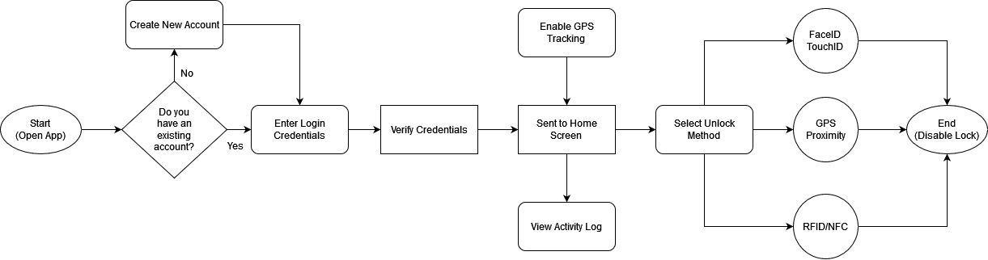
Figure 9: Lock/Unlock Flowchart

The primary function of this application is the ability to disable the lock via RFID or PIN number. Additionally, the user will be able to access a log of previous lock and unlock attempts by logging in to their account. The application will be available on both Android and iOS, with the iOS version utilizing the facial recognition hardware present in newer iPhones for easier access control.
Another planned feature is the ability to enable GPS proximity unlocking which will track the location of the user’s phone and disable the lock when it is determined that the user is outside the door. This feature is heavily inspired by a similar function of the previously mentioned August Smart Lock, which uses both Bluetooth and GPS technologies to track the user’s device when leaving the house. To protect the user’s privacy, our application will only use this feature once the user enables it.

5.2 Mobile Application Pros and Cons
While the decision to include a companion app to Live Bolt was a simple one, there are many kinds of mobile application frameworks to use, each with different combinations of various technologies. This section will give some information on some commonly used full stack applications, as well as any advantages and disadvantages that would come from using those technologies for our application.

5.2.1 LAMP Stack
A LAMP stack is a full stack application comprised of a Linux operating system, an Apache web server, a MySQL database, and can use either Python or PHP as its programming language. Some team members have had experience creating a LAMP stack, so the learning curve would not be as high as opposed to using a more complex stack type. Python as a programming language is very simple to use and has no shortage of support libraries to use. However, Python completely lacks any sort of native mobile framework to use for our application. If we were to use a LAMP stack, we would need to use a framework that has cross-platform functionality such as Kivy or BeeWare. Another problem is the difficulty that comes from using two programming languages when creating the application, Python/PHP for the server-side and JavaScript for the client-side. Switching between two languages can add some unexpected challenges for us on the software end that could be resolved by using a different type of stack.

5.2.2 MERN Stack
On the other hand, a MERN stack uses Node.js as its runtime environment and Express.js as its server-side framework. React is used as the client-side framework with a MongoDB database. Since MongoDB is a NoSQL database, it does not use schemas, but instead stores entries as binary JSON objects. This gives us an additional measure of flexibility when creating our database of users. Using React as the JavaScript library has its benefits as well, with the React Native framework being well suited for mobile development. Since Node.js uses JavaScript for the backend, our team only needs to use a single programming language for our application. This will reduce the time needed to learn any new technologies since anyone with a solid grasp of JavaScript will be able to contribute to the development process. This also applies to Express since it is simply a web framework built off Node.js.

5.2.3 MEAN Stack
A MEAN stack is very similar to the previously mentioned MERN stack but uses AngularJS as its framework instead of React. AngularJS differs from React by being an actual MVC framework, opposed to React simply being a JavaScript library. Instead of using components like React, Angular uses directives to teach the browser new syntax. Angular is also continuously maintained by Google, ensuring that there are many resources at our disposal if we plan to use this framework. Angular also uses HTML in its development process, which some team members already have experience working with. However, this makes the learning curve of Angular much steeper when compared to React, which was designed to only use JavaScript.

5.3 UX Design
When designing our user experience, our team’s philosophy was focused on readability and consistency. Our aim was to create an app that felt like a natural extension of the capabilities of the physical Live Bolt. We initially considered creating a web application instead of a published mobile app in order to save time on development. However, there are many issues to consider when creating a web app meant to be accessed by phones. Since many phones have unique screen sizes, the native web app would have to adjust to every screen size in order to provide consistency. This would be difficult to achieve without using a CSS library that automatically scales UI elements, such as Bootstrap. Even so, our team determined that using a native web app was not worth the tradeoff in customizability. There are many smart lock companion apps on both the Google Play Store and the App Store, so we desired to create an experience that would be immediately recognizable and unique for the consumer.

Even so, original ideas are exceedingly rare to come by. During the design process, our team studied apps of various functions, on both the App Store and Google Play Store. Most, if not all, apps use the same core principles and tools when it comes to the user experience. Above all, apps that are considered to have good UX design are created with the user first and foremost. The user must be able to navigate the app without being confused or overwhelmed by its layout and any interactive elements must be clearly defined such that the user immediately knows that they can interact with them. Adhering to such accessibility principles ensures that users are not excluded from using our app for any reason.

As mentioned in Section 3.1, many smart locks nowadays come with their own companion apps. For example, products such as the August Smart Lock and Nuki Smart Lock have unique mobile apps. These apps usually allow the user to perform the same function of enabling and disabling the lock remotely. Additionally, most apps track the activity of the physical device as a viewable log. Since our team intends to include similar functionality in our mobile application, we have taken inspiration from these kinds of apps to create our own unique user experience.

5.4 Preliminary UI Design
As of the initial design for the UI home page, we plan to have the initial mockup for Figure 10 to inspire the drafting for the whole application. The Live Bolt application design will take influence from existing home access/ monitoring applications to formulate simplicity to the user.

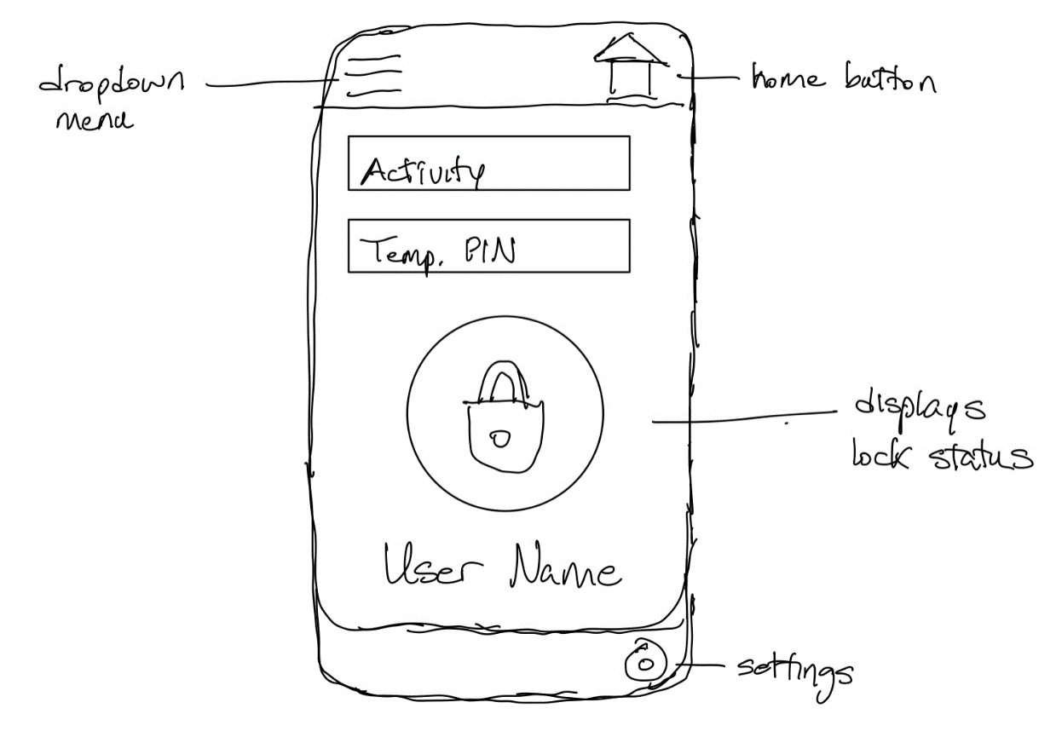
Figure 10. Initial Sketch of Application Main Interface

5.4.1 Preliminary Design 1
At the beginning of development, our team used Figma to create rough designs for several of the pages for our app. Figma is a web-based graphical tool that can be used to create both app designs and prototypes. Using the free starter level functions, our team was able to come up with a variety of potential user interfaces. Additionally, Figma also has a companion app on iOS and Android that allows users to see how their designs look on phone screens. The initial color palette chosen for design one is shown in Figure 11.

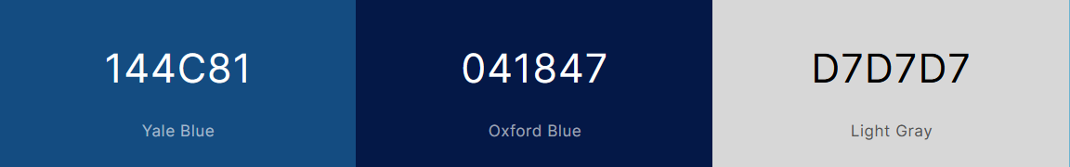
Figure 11: Color Palette 1

Below in Figure 12, the screen on the left represents the Login page of the Live Bolt companion app, while the right screen is the page that users are taken to if they select the Sign up here prompt. As mentioned before, this layout is very commonly used for login pages for apps on both the App Store and the Google Play Store. Additionally, if the user forgets their password for whatever reason, they can recover their account by selecting the Forgot your password? prompt on the bottom of the screen.

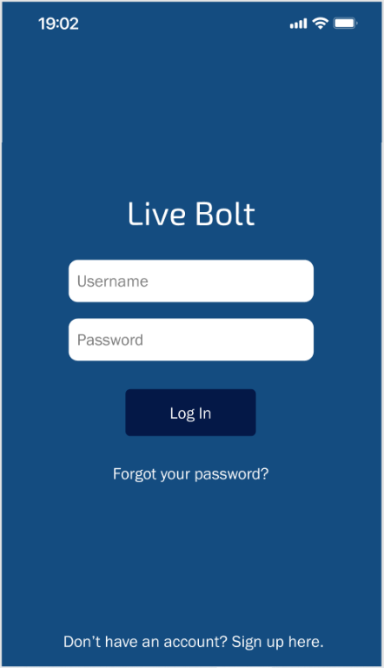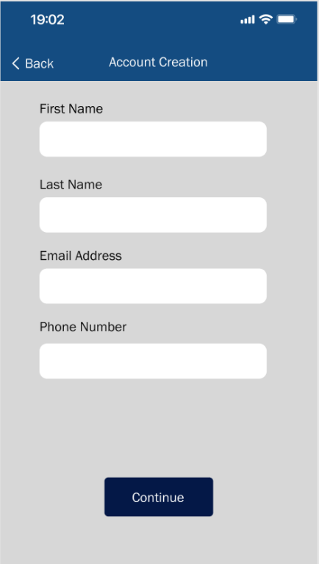
Figure 12: Sample Login/Register Page 1

The first screen a user is taken to depends on whether they are a new or existing user, also modeled in the use case diagram shown earlier. An existing user will be taken to the lock screen, shown on the right of Figure 13, where they can then access any nearby Live Bolt devices.

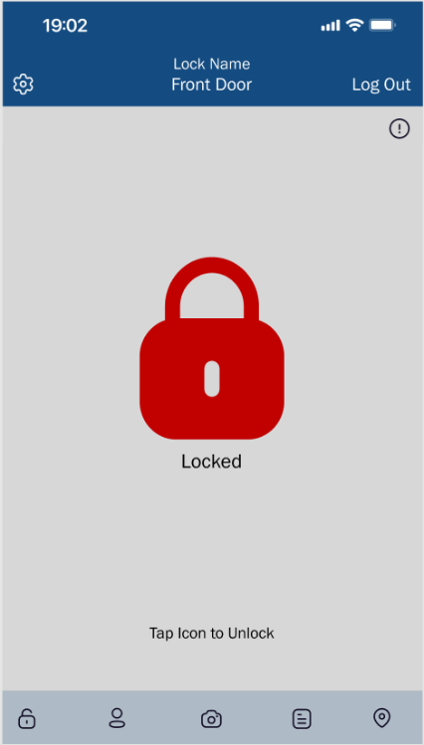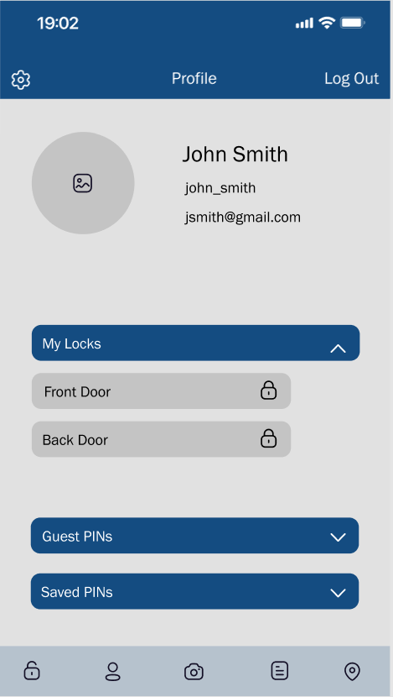
Figure 13: Sample Home/Profile Page 1

The screen will then show the status of the lock, with a green icon designating a deactivated lock and a red icon designating an activated lock. The profile screen is where the user is taken after login if they are on a freshly made account. The screen displays the user’s contact information, along with an optional profile picture. Here, the user will be asked to enter any additional information that will be needed along with a short tutorial showing the functions of the Live Bolt app. As the user continues using the app, the profile will store more information, including used Live Bolt locks, saved PINs, and guest PINs currently being used. The version of the profile screen shown also displays the status of nearby locks for added convenience.

Our team plans to implement a method of modifying a user’s account credentials through the profile page. The planned method is to have the user select the field that they wish to be changed, such as the username or the email address, and then be taken to a page where they must first enter their password before being able to enter in the new value of the field.

The version of the settings page shown in Figure 14 displays all of the planning user options that will be included in the companion application. Our team will add more functions if needed as the development process continues. As shown above, the settings page also includes a search bar for ease of use. Selecting one of the bars below the search bar will send the user to a separate page with more options depending on the subject selected.

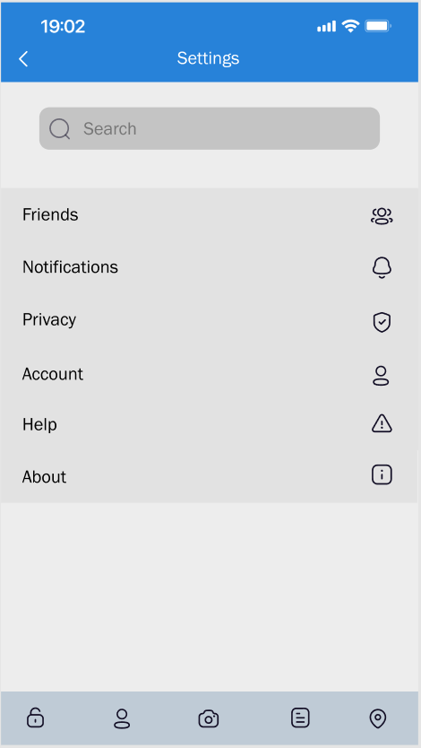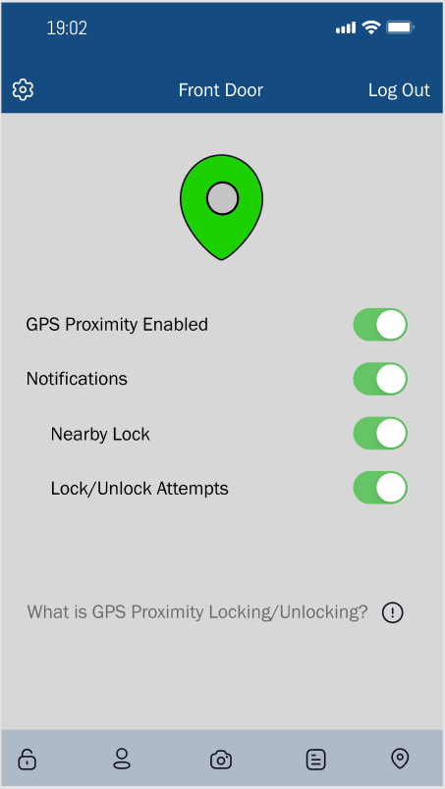
Figure 14: Setting/GPS Proximity Pages 1

The GPS Proximity page can be navigated to by selecting the icon on the far right of the action bar on the bottom of the app. The status of the GPS Proximity function is displayed by the GPS icon on the top of the screen, with a green icon representing the feature being enabled and a red icon meaning the opposite. Additionally, the user has the option of enabling notifications for this specific feature. The user can further customize their notifications with an option only allowing alerts when they are close to a valid Live Bolt device that can be unlocked, or when other users attempt to use the GPS Proximity feature on a Live Bolt device of their own.

5.4.2 Preliminary Design 2
The second design is shown below. The color palette, shown in Figure 15, for this design is shades of pink rather than shades of blue, like used in the first design. The color palette we decided to use for our app was meant to be visually pleasing, yet distinctive enough to make an impression on our users. Blue is a very non-aggressive color for many people and is well rendered on most mobile devices, even on older devices with limited color capabilities. For text rendering, gray works quite well due to its contrast with darker colors without being overly bright and unreadable. An alternative color scheme was also created before we decided on our main color scheme, which is also shown above.

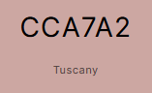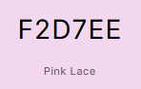
Figure 15: Color Palette 2

Figure 16, Figure 17, and Figure 18 are the new mock ups for the second design. Most of the features remain the same as the first design. It is important to note that this version of the login page does not include the Live Bolt logo and instead has a placeholder, since the logo was not finalized at the time of creation.

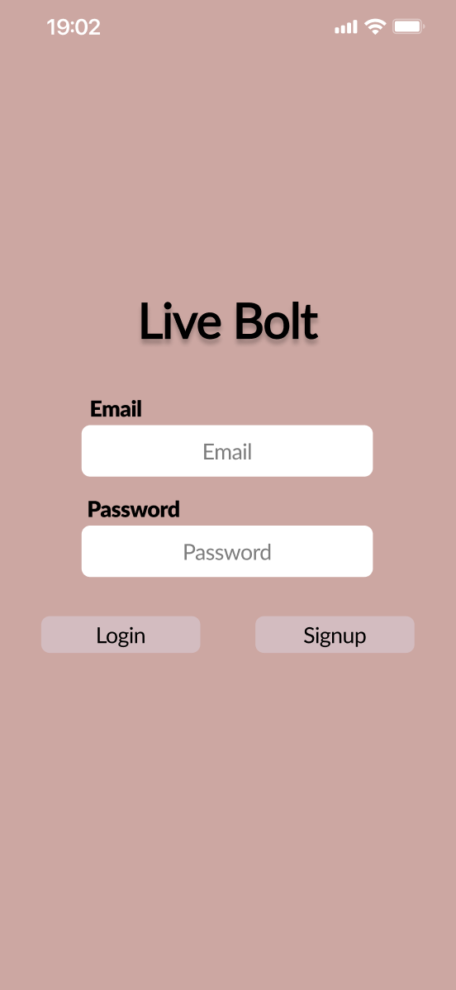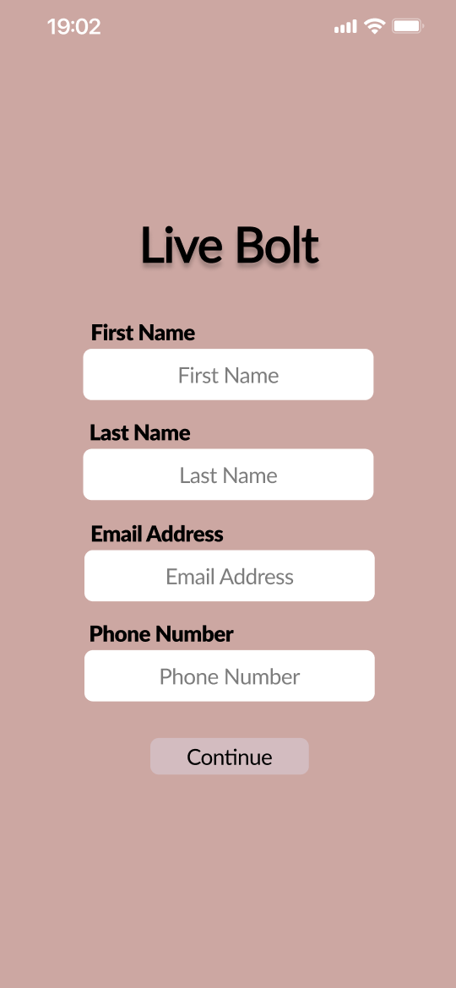
Figure 16: Sample Login/Register Page 2
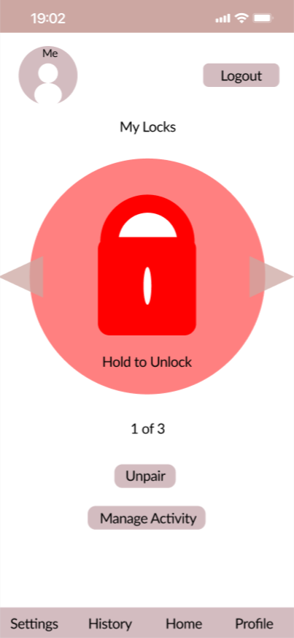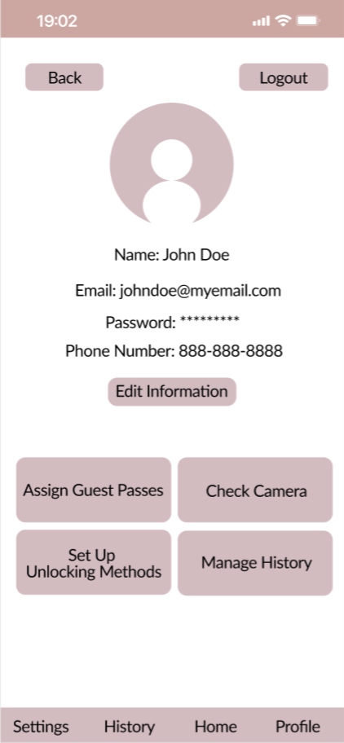
Figure 17: Sample Home/Profile Page 2

The alternate version of the Home and Profile pages shown here sport a different layout then the previous version, opting to use more text instead of icons to inform the user of the application’s functionality. It is also important to note that the GPS Proximity function is not available through the action bar on the bottom of the screen and is now accessed through the Set Up Unlocking Methods button on the Profile Page. This version of the Home page also has the unpairing function as a button as opposed to an option in the Settings page like the previous version implemented.

The Check Camera and Set Up Unlocking Methods buttons are not included in the other design, as that version was created prior to those features being a part of the Live Bolt device. However, the companion app will include these features regardless of the app design chosen. Manage History is also a new button added to the Profile screen which takes over the spot of the Activity Log button that was located on the action bar at the bottom of the screen.

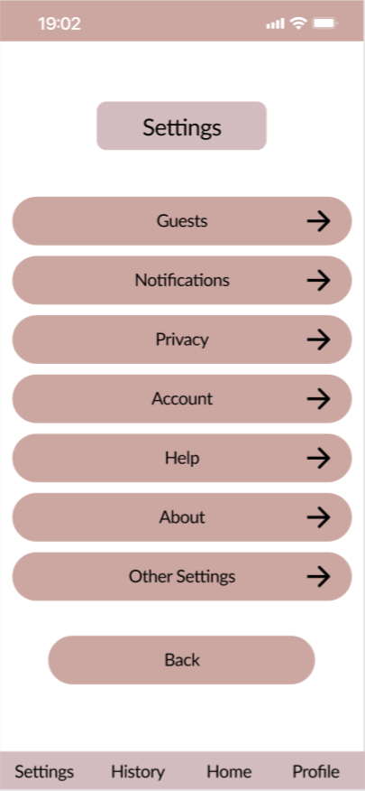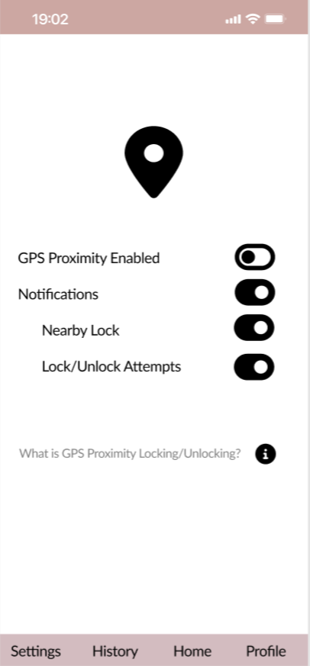
Figure 18: Settings Page 2

The settings page also sports an alternate design, using more defined bars and arrows instead of icons. It also lacks a search bar, but our team plans to add one if the options in the Settings page exceed the length of the screen at any point. The GPS Proximity page maintains the same layout as the previous design, except now having a black and white color scheme for added contrast.

5.4.1 Application Navigation
When designing our application, we wanted to make our application as intuitive as possible. We took much inspiration from other Smart Lock systems currently available on the market as discussed in Section 3.1. We decided to create flowcharts to demonstrate the intended functionality of each page of our application to clarify what our goals were. The flowcharts were created using diagrams.net, a free tool for creating diagrams and charts.

Figure 19 shows the functionality when loading up the application to reaching the home screen. The user will navigate through the different options when the user is opening the app and going to the login page. In our diagram we represent the mixture of the login and signup flowchart to what page will be showed next following error in login, signup, or access after login.

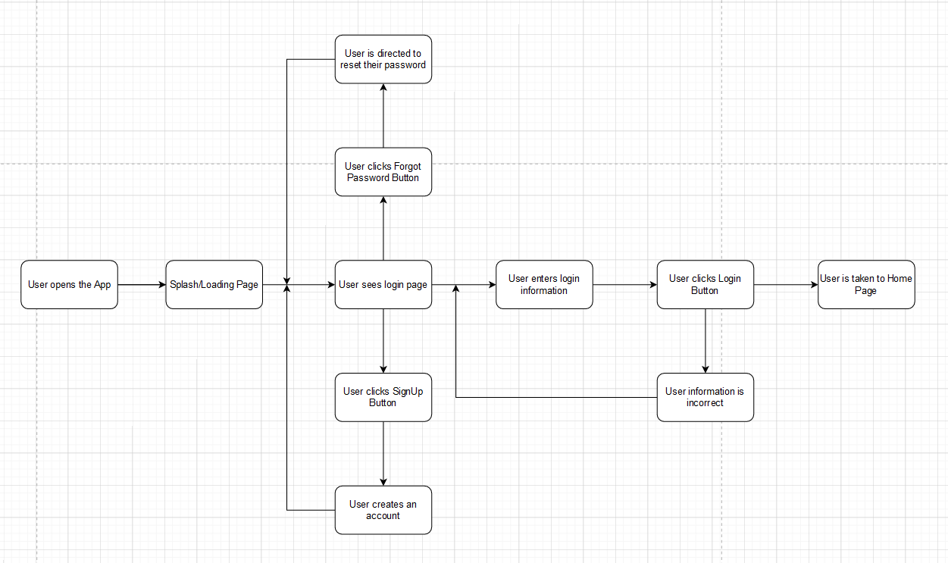
Figure 19: Login and Signup Navigation Flowchart
The Login page will have to two options, either the user forgot their password or login page to enter their credentials. In the option of the forgetting the password, the user will then be redirected to reset the password to because there was a change in the password. In the case of login (with a previously returning user), they will enter their login information, hit the login button, and then finally will be taken to the home page.

When a user is signing up, the diagram is referenced downward to what will be introduced afterward when the user sees login page. As formality when creating a new account, the user clicks signup button, creates an account with username and password, and will be redirected to the user login page.

This concluded the overall diagram flow chart before the user enters the main home page of the application. This portion of the diagram adds value to the portion of not only the back end but the front end of where the user will be direction for each action taken.

5.4.2 Use Case Diagram
A Use Case Diagram is used to describe and model the way actors interact with your system. The diagram for Live Bolt is shown in Figure 20.

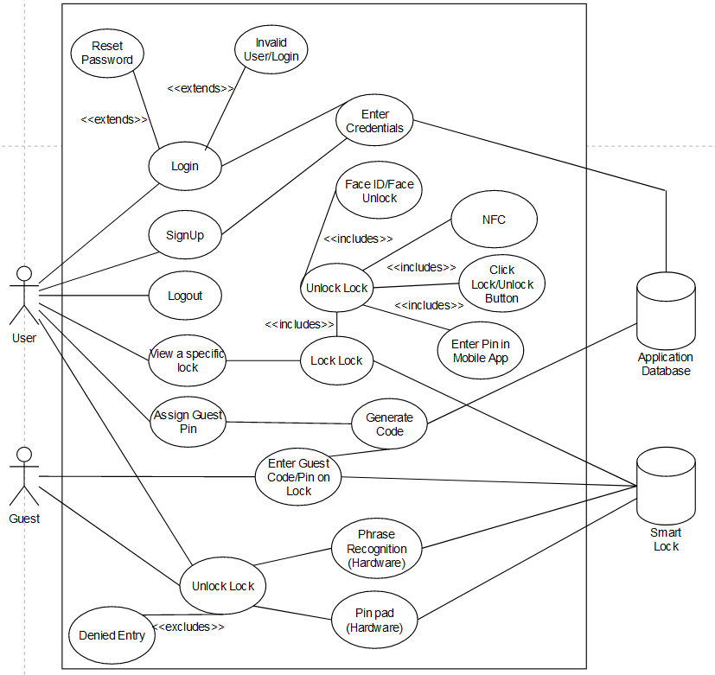
Figure 20: Use Case Diagram of Application including both Hardware/Software Unlocking Mechanisms

5.5 Logo Design
When creating a logo for any sort of product, the aim is to produce a unique design that reflects the brand or product that is being sold to consumers. Our team sought to create a logo that was simple and appealing in design, while accurately conveying the function of the Live Bolt Smart Lock to consumers. This section will contain several preliminary concepts that were created before our team decided on a final selection.

Most of these logos were created using the Adobe Express tool and Inkscape with some slight adjustments made in GIMP. The preliminary sketch is given in Figure 21 while the one with GIMP adjustments is given in Figure 22.

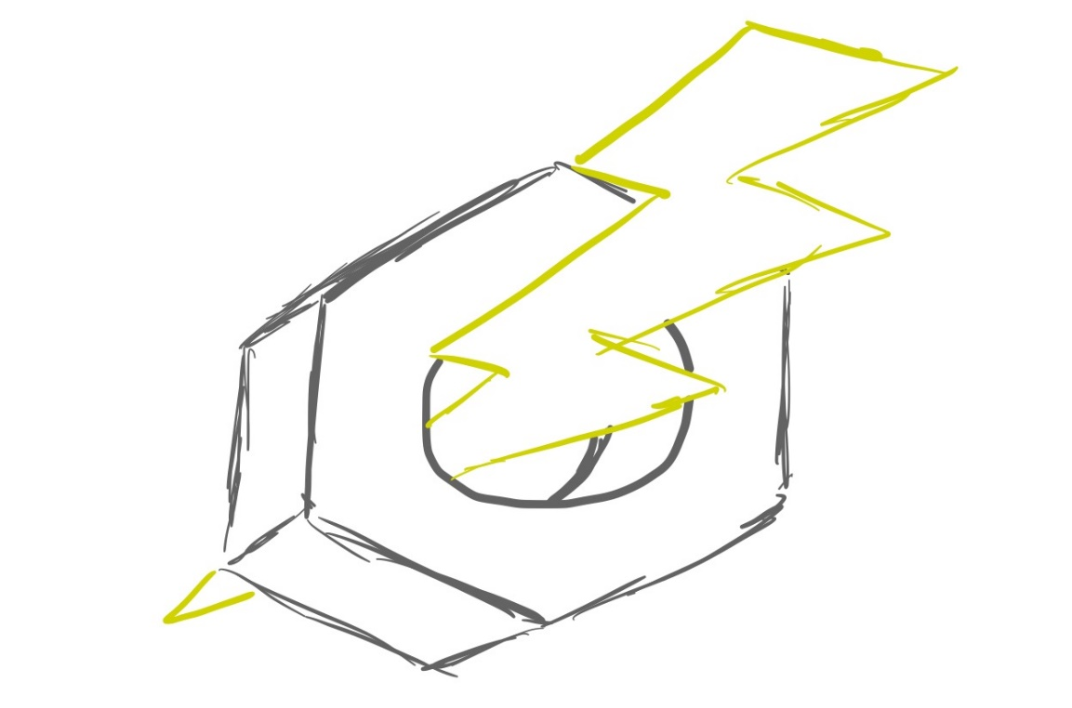
Figure 21: Sample Application Initial Logo Sketch

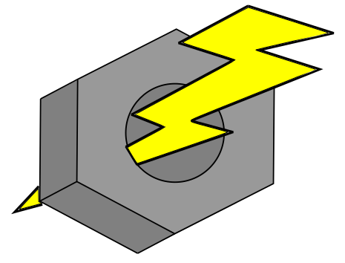
Figure 22: Sample Application Logo Mockup in Inkscape

5.6 Bluetooth Pairing
For a user to connect to a physical Live Bolt lock using the companion app, the app will need to be able to use Bluetooth pairing. According to the Android Developers website, there are three steps when a mobile application seeks to make a Bluetooth connection [2].

- Find nearby Bluetooth devices.
- Connect to a particular Bluetooth device.
- Transfer data with the connected device.

While the website talks about Bluetooth functionality in an Android environment, these steps are general enough to also apply to web and iOS applications. Since data will be transferred between the physical lock and the user’s phone, the connection must be secure to maintain the device’s integrity and security.
Additionally, the GPS proximity feature will use Bluetooth in tandem with the phone’s physical location to automatically disable the lock when the user comes within a set distance. In order to perform these functions, our app will need to use an available plugin or API to get Bluetooth functionality. Since this app is meant to be cross-platform, there are several options that can be used. This section will highlight APIs and plugins that provide Bluetooth functionality, as well as discussing any design choices that were made concerning this subject.

5.6.1 Android Bluetooth APIs
The Android development platform provides several APIs for developers to use when creating applications for the Google Play Store. The development process is further streamlined by having all Bluetooth APIs available in the android.bluetooth package. The Android Developers website includes all the key classes and interfaces needed to implement Bluetooth functionality in any mobile application [14].

5.6.2 react-native-bluetooth-serial Plugin
The React Native framework does not include any native libraries or components for Bluetooth connectivity. Instead, there are a wide variety of 3rd party components that are available to use for mobile developers. Most of the popular components are plugins that have been ported over to React Native, such as the react-native-bluetooth-serial plugin. This component allows React Native applications running on any version past 0.25 to connect to other Bluetooth devices and transfer data. This plugin works for both iOS and Android, however as of the time of writing this paper, services are still not configurable for iOS devices. The GitHub page provides the installation procedure for both iOS and Android, as well as all the methods available for use [15].

5.6.3 react-native-ble-plx Plugin
Another popular React Native component to use for Bluetooth communication is the react-native-ble-plx plugin. The main difference between this component and the previously mentioned one is compatibility with Bluetooth Low Energy (BLE) devices. The Github page details the functionality of this plugin in addition to any events that can be used [6]. Since this is the plugin that our team decided to use for our companion app, we also created a UML class diagram to easily
Another popular React Native component to use for Bluetooth communication is the react-native-ble-plx plugin. The main difference between this component and the previously mentioned one is compatibility with Bluetooth Low Energy (BLE) devices. The Github page details the functionality of this plugin in addition to any events that can be used [6]. Since this is the plugin that our team decided to use for our companion app, we also created a UML class diagram to easily communicate the various classes and methods of the plugin. Figure 23 displays the five major classes of the API: Services, Descriptors, Characteristics, Devices, and the BLE Manager.
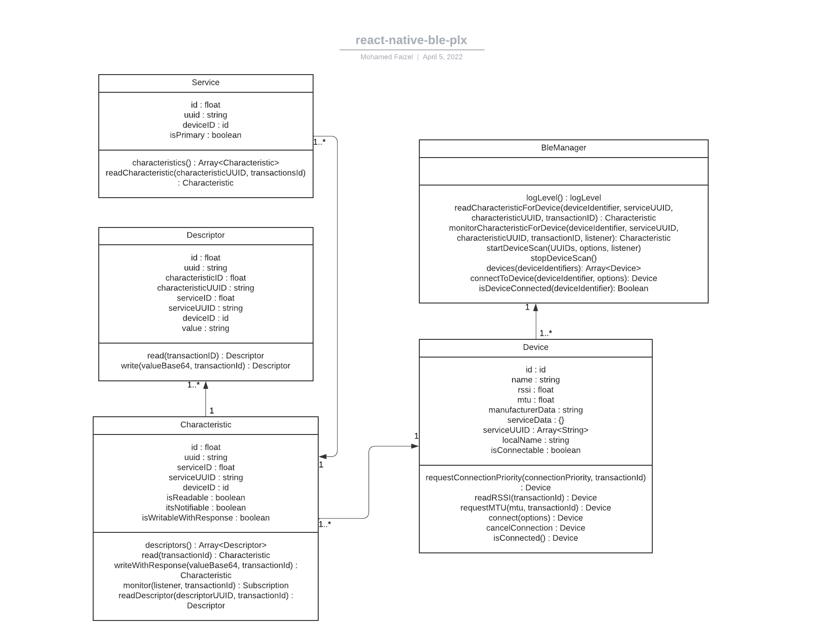
Figure 23: API for react-native-ble-plx
The first section of each class contains all the relevant attributes it contains, while the second section displays the methods belonging to that class. Since BLE Manager is always the first class that is instantiated whenever a device needs to be connected, it contains no attributes of its own. A Device class contains several Characteristic classes, which are comprised of Descriptor and Service classes. It is also important to note that the BLE Manager or Device class is usually the one to call methods and that most methods listed in the other classes are only partial versions of methods available in Device or BLE Manager classes. However, these methods are still included in this UML class diagram to streamline the structure of the diagram.

5.6.4 Classic or Low Power Mode?
As mentioned earlier in Section 4.1.2, there are two standards of Bluetooth currently in use: Classic and Low Power. Since the physical lock will use the Raspberry Pi 4 to communicate with the user’s phone, the API or component used for Bluetooth functionality needs to be usable with the Pi 4. Fortunately, the Pi 4 is compatible with both Classic and BLE devices.

5.7 Development Environment
When creating a program of any sort, a development environment is needed for programmers to edit and debug their source code in an easy-to-use space. While it is possible to edit code straight from the command line or using a simple text editor, using a development environment allows for us to fix syntax errors and track variables. Nowadays, many integrated development environments (IDEs) also include compliers to debug code.

Due to its simplicity and abundance of native tools for React development, we decided to use the Expo CLI development environment and the Virtual Studio Code IDE for editing source code. Expo CLI is a command line application that can be installed on any terminal of choice and serves as an interface between the developer and the React app. On the other hand, Visual Studio Code (VScode) is a text editor created and supported by Microsoft that is available on Windows, MacOS, and Linux. VScode includes support for both JavaScript and Node.js, making it a very desirable choice for our team. The installation instructions and documentation of both the Expo CLI environment and the VScode IDE are provided in the references section below [16].

5.8 App Store Publishing Process
As with any online platform or marketplace, the Apple App Store has its own unique guidelines and recommendations for developers who seek to publish their apps. Most of these standards are described above in Section 4.1.8 and will be referenced throughout this section. In addition to adhering to proper programming standards, our app must also adhere to the various design, compatibility, and legal standards detailed in the App Store Review Guidelines [6]. After we have determined that our app is fit to be reviewed, we will submit our app along with any metadata via App Store Connect. According to the Apple Developer website, 50% of submitted apps are reviewed in under 24 hours and over 90% are reviewed after 48 hours.

To avoid potential issues with submitting our app for review, we will continuously test and debug our app and ensure that it runs well on all available platforms. Additionally, we will adhere to the App Store’s privacy guidelines by always asking our users for permission to use their data in a clear and understandable manner. To avoid a rushed schedule, we will submit our app well ahead of our planned release date to account for any unexpected issues that may arise during the review process.

5.9 Google Play Store Publishing Process
The publishing process for the Google Play Store differs from the App Store process in several ways. The platform used for publishing to the Play Store is Google Play Console, which is used for development, review, and publishing. In order to start the review process, we must first publish a draft version of the application. To proceed to the review stage, the app must not have any detected errors. Just like the App Store process, our app will be rigorously tested to ensure that our users will not encounter bugs or crashes.

Additionally, there are two types of publishing our app can undergo: standard publishing and managed publishing. Standard publishing allows any updates or changes to all existing apps, with a waiting period of up to 7 days for review. Managed publishing lets the developer control where any changes are published after their app has been successfully cleared for release, allowing for greater version control over the standard method. The Google Play Console Help page also details every possible status for an app or update [7]. Since we are planning for a cross-platform release, we would like our app to be reviewed and given the status for production in order to ensure that both releases occur in the same timeframe.

5.10 Mobile Stack Technologies
After researching and analyzing various stack types, those of which were mentioned in Section 6.2, our team eventually decided what stack application our mobile app would be. This section details the reasons behind our decision, as well as any technologies being used that have not been mentioned so far.

5.10.1 MERN Stack Reasoning
Ultimately, we chose to create our application using a MERN stack for a variety of reasons, many of which are described above in Section 5.6.2. As mentioned earlier, a MERN stack comprises of a MongoDB database, a Node web server, an Express web framework, and a React client-side. Since most of our team has a measure of familiarity with developing a MERN stack in previous classes, namely in Processes of Object-Oriented Development, there will not be as much learning required to create our app using a MERN stack.

5.10.2 JavaScript
JavaScript, along with HTML and CSS, are the main building blocks for any kind of web application. It is a high-level language, along with languages such as C#, Ruby, Python, and Java. It is important to maintain that Java and JavaScript are separate languages, though they share similarities in syntax. JavaScript is also incredibly popular, with over 97% of websites using the language client-side for web page behavior [8]. This code usually executes client-side to load new pages, generate user results, and control web page animations. The amount of JavaScript libraries is incredibly large and several of them control large parts of the web development process. Many of them will be used in our app which are further explained below.

5.10.3 Ajax
While Ajax is not a library, it is an important technology that is often used in web development. Short for Asynchronous JavaScript and XML, it is the method the XMLHttpRequest object uses to communicate with the web server. Most important about Ajax is its ability to operate asynchronously, meaning that it can exchange data and update a web page without needing to reload the page. Additionally, the data that is sent and received can be in several formats, including JSON, XML, and even text files [9]. The Mozilla Developers website contains the documentation of Ajax, along with an introductory article through which most of this data was taken from.

5.10.4 jQuery
jQuery is a cross-platform JavaScript library that simplifies Document Object Model (DOM) traversal and manipulation. A DOM is an interface that converts an XML or HTML document into a tree structure, allowing a web page to be dynamically generated via JavaScript code. jQuery also boasts Ajax functionality which is used by the XML object to effectively communicate with the web server. It is important to note that there is a version of jQuery made to work with mobile devices, called jQuery Mobile. Unlike the standard jQuery API, jQuery Mobile is a complete UI framework, which means it needs to be built upon as a starting point. This conflicts with our preference towards using React Native as a framework, so this prevents us from fully using the jQuery Mobile API. For this reason, we will only be using version 3.6.0 jQuery API for our mobile application.

5.10.5 JSON
JavaScript Object Notation (JSON) is a data-interchange format based on the conventions of the JavaScript programming language. While it does use much of the syntax used in JavaScript, JSON is completely language-independent and can be used with any programming language, though it commonly sees uses in high-level object-oriented languages. JSON usually is comprised of two kinds of data structures: a collection of name/value pairs and an ordered list of values. In most programming languages, these are both realized as arrays or lists. Due to its simple and effective structure, JSON is used for all sorts of data transfer operations in web development.

5.10.6 JSX
JSX is simply a syntax extension of JavaScript that is commonly used with React. Though it contains elements of HTML syntax, JSX still has all the benefits of JavaScript without sacrificing the benefits of a template language such as HTML or CSS. The main function of JSX is to produce React elements, which are the main building blocks of any React application. JSX uses rendering in order to implement React elements into browser DOMs, which has several advantages over the traditional method of DOM traversal and manipulation. Unlike browser DOM objects, React elements are plain objects and much cheaper to make. These developer-created elements work together to form React components, which can be described as the React equivalent of JavaScript functions. Like a function, these components accept certain properties (or props) as parameters and generate a React element to be used in the user interface. These components can be used in other React applications in the same way a JavaScript function can be used in a different program.

5.10.7 JSON Web Token
With our mobile application having several technologies communicating with each other, it is important to also maintain data integrity during the development process. JSON Web Token (JWT) is an open standard that defines a compact way for securely transferring information between entities as a JSON object [reference needed]. There are many reasons to use JWT as a method of securing data, such as verifying the identity of a sender or recipient of data and authorizing specific users to use an application.

The structure of a JWT consists of three parts: a header, payload, and signature. The header contains the token type and algorithm, which in most cases would be JWT and a standard signing algorithm such as HMAC SHA256 respectively. The payload usually contains information concerning the user and the type of claim being made. Lastly, the signature ensures that none of the contents of the token were altered in any way. The result after encoding is three URL strings separated by dots, a format that is easily passed through in HTML and HTTP settings.

5.11 React Native Components
As mentioned in previous sections about React Native, components are an extremely important feature of the Native framework. Components that are commonly used in cross-platform applications include the View, Text, Image, and StyleSheet components [17].These are the most basic units of React Native development and can be further modified to suit any application’s needs. React Native also provides OS specific components for iOS and Android only apps, though our team will not be utilizing them due to our app’s cross platform nature. This section will describe some of the more specific or unique components that our app will use.

5.11.1 VirtualizedList
The VirtualizedList component is a convenient alternative to the traditional FlatList and SectionList components. According to the React Native documentation, VirtualizedList is recommended for use with immutable data instead of plain arrays [18]. This makes this component a perfect fit for the Account Settings page since the options available to the user will be constant regardless of account status. VirtualizedList also has the advantage of improving memory consumption and performance by only rendering the items currently displayed on the screen. Our app has a large variety of options available, so being able to only render the relevant options for the user will improve the user experience. Figure 24 shows an example of what our options menu would look like on an iOS device using the VirtualizedList component. Memory optimization
and app performance are especially important to our team and is reflected throughout our development process.
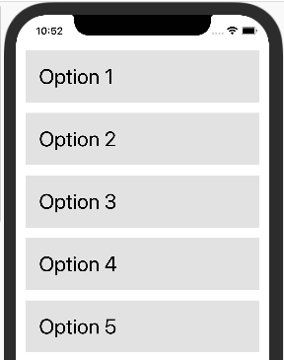

Figure 24: Virtualized List on iPhone Example

5.11.2 Pressable
The Pressable component is a recent addition to React Native, first introduced in version 0.63 [19]. More specifically, Pressable is a component wrapper that can detect states of interaction on a defined element or its children. For example, a button can implement this wrapper to be able to detect a user holding a touch input for a specified amount of time. Our team is planning to use this component for our lock activation/deactivation function on our Lock Status Screen. To prevent accidental inputs, our app will require the user to hold the lock icon for three seconds to enable or disable their Live Bolt device. Figure 25 displays all the possible use states of the Pressable component.

The diagram shows that not only does the Pressable component track the amount of time that the user spends holding a selection, but also tracks the moment that the user releases the selection as well. The state that Pressable uses to distinguish simple button presses and button holds is the onLongPress state. The component takes a timestamp and starts out in the onPressIn state when a selection is detected. If a certain amount of time passes before the Pressable switches back to the onPressOut state, it will detect the user is holding the button and change the state to the onLongPress state until it detects that the user is no longer holding the button.
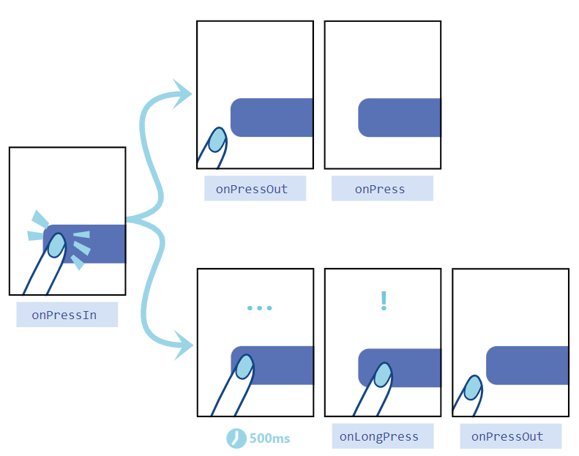
Figure 25: Pressable State Diagram, courtesy of React Native

5.11.3 KeyboardAvoidingView
The KeyboardAvoidingView component helps with the screen formatting of an application when the touch keyboard is needed by adjusting the screen’s height and padding. Many of the screens in our companion app have search bar functionality, making this component an easy and effective way to maintain the overall feel of the app layout without compromising on general functionality. It is important to note, however, that this component behaves differently on iOS and Android devices. The React Native documentation recommends using the behavior attribute to prevent any unwanted effects from using the KeyboardAvoidingView component [20].

5.12 Database Structure
The database our application will use will need to contain several types of user data including logins, passwords, user activity, emails. It must be structured in a manner that our app will be able to efficiently search for any information it needs at a moment’s notice. A well-designed database typically has the following traits [18]:

- Efficient access to data
- Supports long-term maintenance of data integrity
- Clean and consistent structure
- Avoids redundant storage
- Accurately reflects the structure of the problem

To create a database with these principles in mind, our team first created a preliminary entity relationship diagram of the database. An entity relationship diagram (ERD) is used to map out the structure and relationships present in the database. The ERD modeling of our database is shown below in Figure 26, complete with variable types and entity relationships.

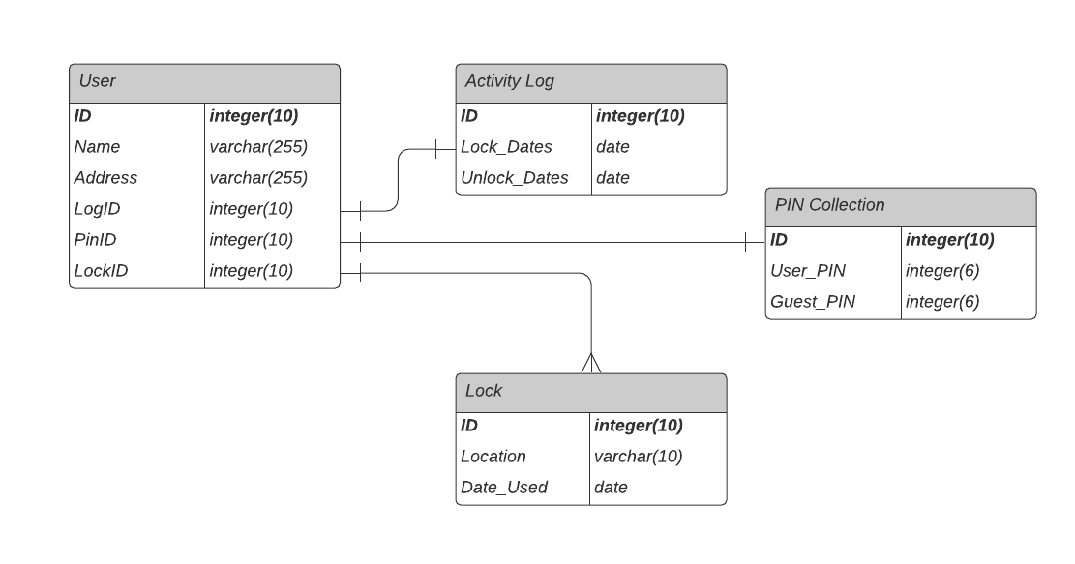
Figure 26: Entity Relationship Diagram

Outlining an ERD before designing the actual database comes with many benefits to the overall creation process. For example, making changes with an ERD is far easier than having to modify the database’s data directly, especially since adjusting data can be very risky as the scale of the database increases. Additionally, the creation of a visual aid helps with keeping track of all the needed data in one easy-to-read diagram, which makes it useful for gathering requirements and specifications.

As shown above, the database for our companion app consists of four entities: users, activity logs, PIN collections, and locks. A user entity contains relevant information such as their name and address, as well as a unique ID. The user entity also has three foreign keys which reference an activity log, a PIN collection, and a Lock. It is important to note that all attributes in bold are primary keys, all of which are IDs in the case of this database. The data type is also listed next to its corresponding attribute, mostly comprising of integers and character strings. Of course, this diagram was made early in the project so changes may need to be made as development progresses.

5.12.1 MongoDB Creation and Syntax
Before creating a MongoDB database, a cluster must first be established and granted access to through the MongoDB shell. Once that is done by the user, the database can store new objects by inserting them through the Command Line Interface (CLI). For those who wish to use a more accessible interface, the MongoDB Compass is a GUI which can perform the same functions as the CLI. While our team was comfortable with using the CLI as our main interface, we decided to use Compass in order to manage our database more intuitively, as it is more complex than any other our team has worked on.

As mentioned before in previous sections, MongoDB is not an SQL language, meaning that we can store objects without restrictions as fields will be dynamically created to store any objects with new or unique fields. While in MySQL, an object with a new field had to wait for the user to manually create the field before being stored. Doing otherwise in this scenario would generate an error for the user. For example, the command to insert a user with the attributes included in would look something like this:

db.user.insert({id: 123456, name: "Joe Smith", address: “123 Fake Street”})

In the case of this command, ‘db’ is the name of the database and ‘user’ is the name of the table. Of course, this only includes the ID, name, and address of the user but can be modified to add the other required fields using the same format displayed. Figure 27 displays two BSON objects, a User and an ActivityLog, in the MongoDB Compass interface.

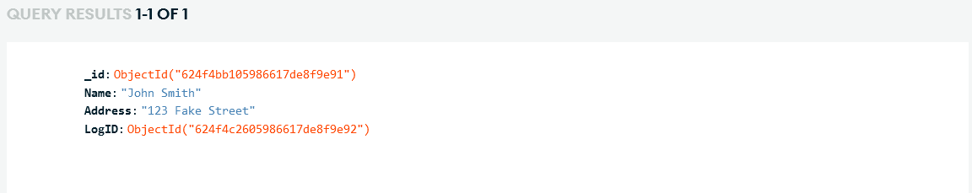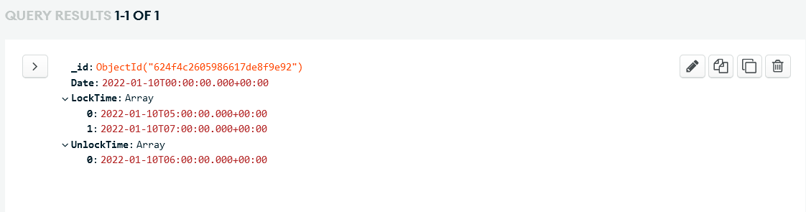
Figure 27: User and ActivityLog Objects

Both have an ObjectID field which serves as both an index and a foreign key for other objects. The LogID field in the User object is the ObjectID of the ActivityLog object, relating both objects together for quick and reliable access. This method of foreign key relation is also used for the PinID and LockID objects.

5.13 Near Field Communication (NFC)
NFC, as mentioned in section 4.1.4, will be used as an unlock method. NFC connections are made from 4cm or less between two NFC capable devices. This connection allows for small amounts of data to transfer.

The implementation of NFC with Android devices differs from that of iOS devices. Android devices can facilitate an NFC connection between android devices or an NFC Tag. Android supports the following 3 methods of using NFC:
1. Reader/Writer mode allows an NFC device to read and/or write to an NFC tag or sticker.
2. P2P mode, which is used by Android Beam, allows for an NFC device to send data to other devices.
3. Card Emulation mode is what it sounds like. It allows an NFC device to function like an NFC Card which can be used for things such as contactless mobile payment. [21]

For iOS devices the implementation is slightly different. Apple’s Core NFC Framework allows for NFC tags of types 1 through 5 stored in the NFC Data Exchange Format (NDEF). It also allows NFC tags to be written to and read. As in the name of the Framework implies Core NFC requires a device that supports NFC. [22]

5.14 iOS FaceID/TouchID Implementation
FaceID and TouchID are two features included in most modern iPhones released after 2017. TouchID was first introduced with the iPhone 6 in 2014, while the FaceID feature was first included with the iPhone X in 2017. The TouchID sensor on an iPhone is located in the Home button, which allows the user to unlock their device using their thumbprint. However, Apple has since discontinued the TouchID feature on newer models of iPhones and iPads, with the FaceID now being the standard method of accessing the device.

FaceID is a facial recognition technology developed by Apple for both the iPhone and iPad. Replacing the previously used TouchID system, FaceID can be used to perform a variety of functions alongside user verification such as authenticating purchases and signing in apps. The sensor used for FaceID is located on the top of the device, just above the screen. Consisting of three modules, the FaceID sensor shines infrared light upon the user’s face and creates a 3D facial map using a projected grid of dots. The map is then referenced with a previously saved face in the system and confirms that the two maps match, authenticating the user [23].

Early in the design process, our team determined that implementing these features for our companion app would dramatically improve the user experience of the Live Bolt. Additionally, many other apps available on the App Store and Google Play Store use the FaceID feature for user authentication. In order to include both features on our app, we need to utilize a few React Native libraries available for our use. There are several libraries that we can choose from, but for simplicity we will use only two: LocalAuthentication and react-native-biometrics. UML class diagrams for both of these libraries are included below in Figure 28 and Figure 29.

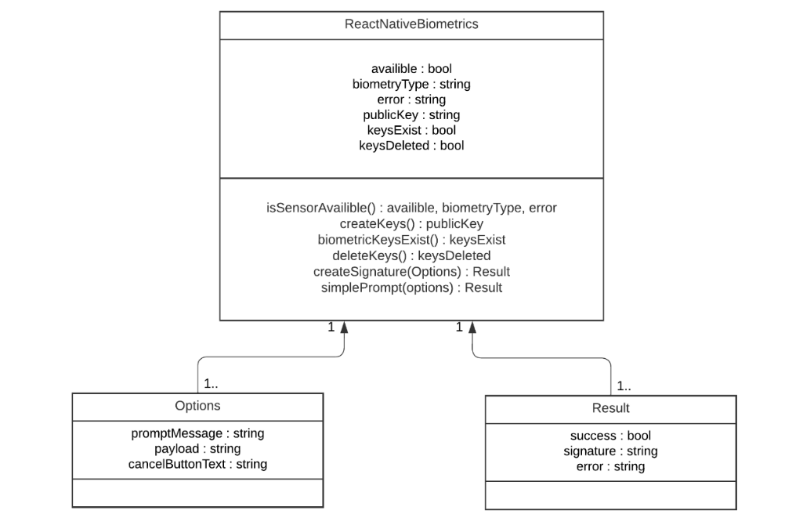
Figure 28: React Native Biometrics Diagram
Though these two APIs have the same functionality, they do differ in their implementation of biometric authentication. LocalAuthentication is an API native to Expo, as opposed to react-native-biometrics being a React Native module. LocalAuthentication also is able to interact with Android’s Biometric Prompt feature, which react-native-biometrics lacks. The Expo API can also allow the user to verify via passcode if the json package returned does not have the sufficient parameters, although our app will not be using this function. It is also important to note that LocalAuthentication is actively maintained and developed by Expo and seeing continuous updates, while the React Native library has not been updated as consistently.

On the other hand, react-native-biometrics has significantly more compatibility with the React Native framework and also works for cross-platform applications. A noticeable advantage of the React Native module is its relative simplicity compared to its Expo counterpart. However, both APIs use the Promise class to verify or deny users who interact with their device’s biometrics. Fortunately, even if one of these biometric-related APIs has a disadvantage that prevents our app from fully relying upon it, the flexibility of React Native allows us to use both to have a more complete package to use for connecting the user’s device to the physical Live Bolt device.

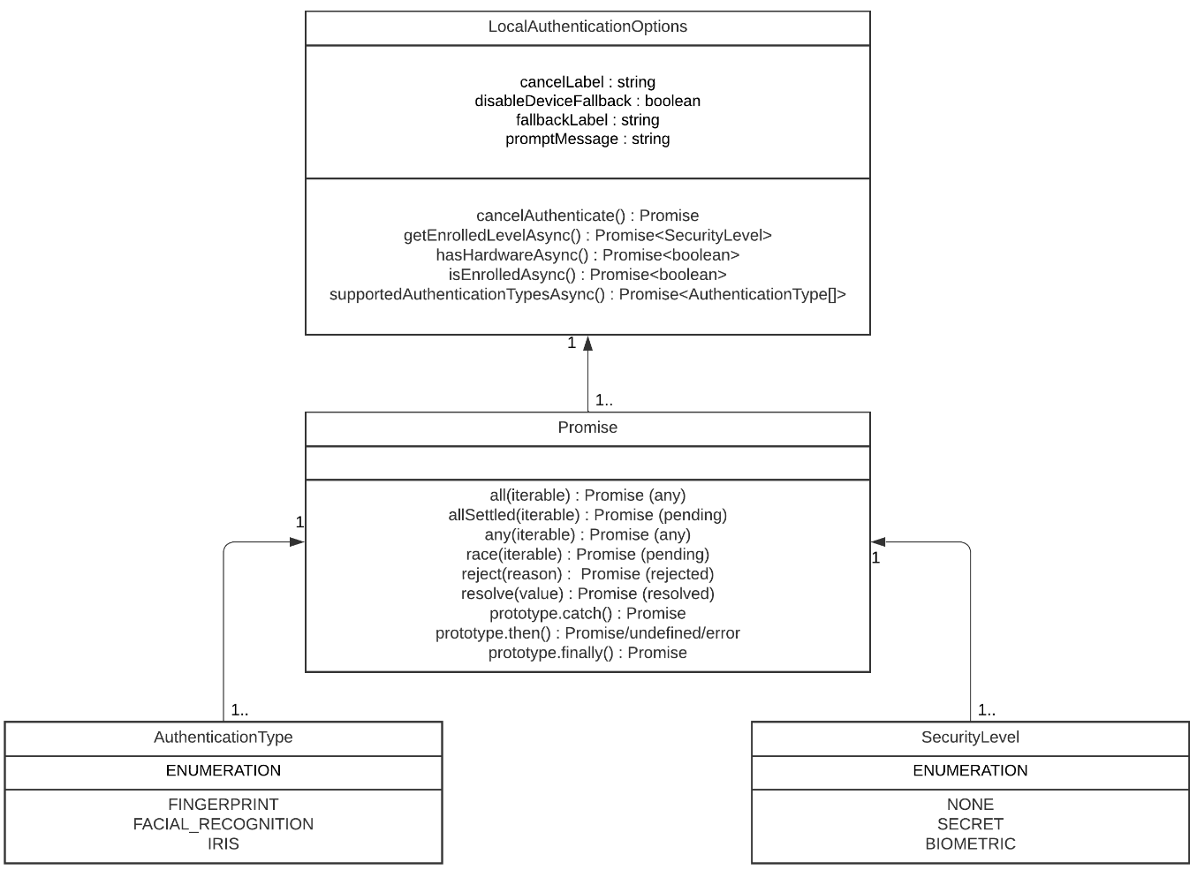
Figure 29: Local Authentication Diagram

5.15 Transmission Control Protocol (TCP)
TCP is a network protocol that creates a connection between two hosts to send data. TCP is a connection-oriented protocol, so it requires a connection to be established before any data transfer takes place. This protocol is widely used for its reliability due to guaranteeing delivery of data and packets in the same order they were initially sent. Some additional benefits of TCP are error free delivery of packets and concurrence control. Within the protocol there is a client host and a server host. The server is always listening for a request to be made from the client host. The client must provide the IP address and port number of the server its trying to contact. It also must provide its own port number and IP address so that the server knows where to send confirmation data that the packet was received. Once the connection is established packets can be transferred between the two hosts. Additionally, a TCP server can support multiple hosts due to a socket being created for each new client connection. Reliability as discussed earlier, in TCP is made possible by the use of acknowledge (ACK) signals. It’s through this that when packets are received by the server an ACK is sent to signify the packet was received. If a packet wasn’t received after a certain amount of time or some noise changed some of the data in the packet the data can be resent to the server. TCP does take longer than UCP to send a packet due to the required connection setup in order to guarantee that the data is correctly transferred over. TCP will be used to create the connection between our mobile application and the Raspberry Pi and MCU. This will create a safer and more reliable communication for our Live Bolt system where we want security to be the focus. [24]

5.16 User Datagram Protocol (UCP)
UDP is a sibling protocol to TCP. This protocol also facilitates the data transfer between different hosts. It is a connectionless protocol meaning that it does not create an explicit connection between the client and the server. TCP can be thought of as a handshaking of data between two host. UDP doesn’t do any of that initial setup and is thought of to be a “best efforts” service. A UDP client only sends the destination IP address and port number of the server it is trying to send data to. As a result of the UDP is much simpler to implement and is faster to send data than TCP. However, it does suffer from this in terms of reliability. Data sent via UDP can be lost or received out of order. UDP is typically used in applications where reliability is not the main concern but speed. These include multimedia services like YouTube, or Netflix where if packets are lost or received incorrectly the data can just be resent. UDP implements a checksum in order to verify if the data received was correct. The checksum is computed on the client end and put into the UDP checksum field when sent. It is then recomputed on the server side and compared with the value computed by the client in the UDP checksum field. If the values are different, then we know that some of the data has been lost or received incorrectly. Unfortunately, this solution does not solve all errors because the checksum field itself could be affected by noise during the data transfer. UDP will be used communication with the ESP-12F Wi-Fi module on which will communicate with the servo controlling the lock, and other hardware mechanisms. UDP in this situation should be reliable enough due to the distance between the components not being very far.

6. Hardware Design Details
This section outlines the specific hardware we identified for the Live Bolt system and each part’s technical specifications. The lock and security box and the process to 3D model and 3D print it will also be discussed, along with how it will house all components. Additionally, we will elaborate on the components for what they’re used for and how they’re electronics work.

6.1 Preliminary Hardware Design
Before going into how we want our Live Bolt design to look like, inspiration of creating the design for the lock is by having a 3D printed doorknob cover the shape of the lock. The covering will fit over the deadbolt turn knob and house the servo motor that’ll create the turning gesture. This eliminates the need to unscrew the doorknob and make modifications to it. Installation at this of the lock will be as simple as adding two-sided tape to the door. Figure 30 below shown below is a preliminary concept of the lock design on a door.

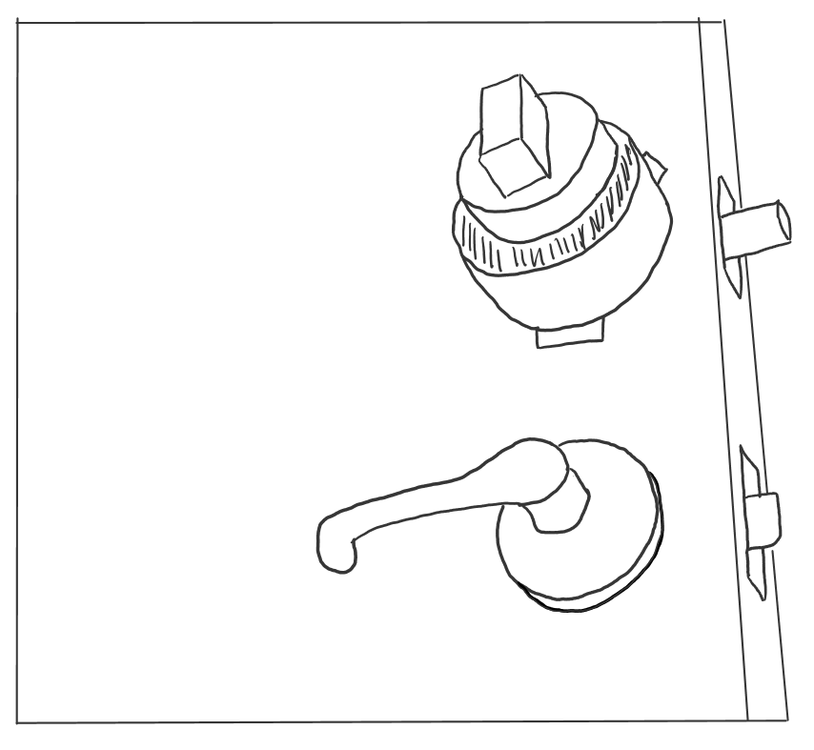
Figure 30: Deadbolt doorknob cover, fitted onto a door lock

Figure 31 shows a close-up view of the cover from the top view. To understand the sketch better it is a 3D printed casing with a servo motor protruding out making the wires exposed but is attached to the dead bolt cover. The side pieces sticking out of the circular encompass are double sided tape that will attach the door to ensure stick. It is something that would be easy to install for the consumer and hold the lock in place.


Figure 31. Frontal view of the Doorknob Cover

Although this is a great start to how we want the lock to look, it would not be ideal to go with design because we want the electronics places away and not exposed to a consumer. Therefore, we intend on harnessing all the electronics onto a box compartment. We also want to make sure that we complete the objective of our design and make sure that there’s enough control access to the user. Hence the introduction of including a security box.

We want to include a security box to have an addition to access control and home monitoring. As a group we just decided to include the option just for the sake of having not only providing the option of home monitoring, but the security box will also have forms of harnessing access control. This portion can be further discussed in the following sections. A preliminary design for the security box is just our design shown in the CAD model.

6.2 Hardware Selections
Previously selected in section 3, we chose all the hardware components that’ll be placed into our design. Our following selection would be to understand how pins will need to be configured in the MCUs.

6.2.1 Arduino Keypad
Since we’re using a 4x4 Arduino keypad, collecting the reading of the number and/or letter is a simple connection based on the division of rows to columns. Better analogy of the keypad configuration is shown in Figure 32. When no buttons are pressed, the columns are read as HIGH, and rows are read in LOW. When a button is pressed then the column is pulled to LOW from the current. From this observation of the MCU, it’d know the column in place so the roles would switch then the rows on HIGH. From the rows on HIGH and columns on LOW, the MCU can find the location of the button when the column pins retrieve back to HIGH. In our design, we will use this to configure onto the MCU and have the reading acknowledge the numbers and letters. Source for understanding the pin configuration is represented from the is from the resource of circuit basics [25].

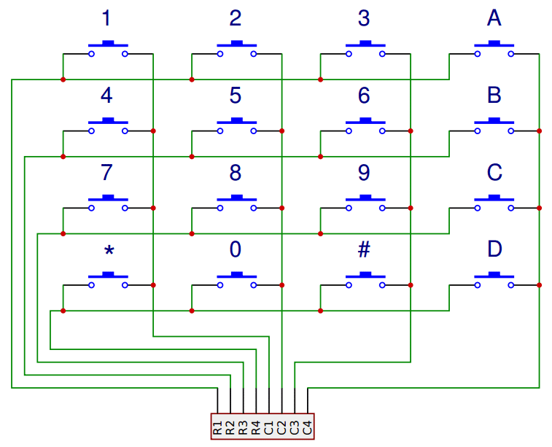
Figure 32. Arduino Keypad Configuration

6.2.2 Raspberry Pi
A Raspberry Pi incorporates numerous features including but not limited to multimedia performance, memory, and connectivity. Including this microcontroller to our project would create value in running the microphone and camera access while wirelessly transmitting data to the Live Bolt application. The two selections to be compatible with the pi is connected shown in section 8. We will test how these two work together and work wirelessly to the ESP. For now, we’ll discuss about their features and how we plan on taking advantage of these specs.

6.2.2.1 Raspberry Pi Microphone
A form of variety we want to incorporate into our product is to speak into the security box and have compatibly to home access. In doing so, our team will purchase a ReSpeaker 4-mic array to connect onto the raspberry pi. The main objective of using this is to have access to the microphone and add value to the use of the Raspberry Pi. The ReSpeaker includes a AC108 quad-channel ADC design for microphone arrays. One thing to note about this purchase is that it’ll be objectively used for the microphone. A schematic of the ReSpeaker in Figure 33 shows the required 40-pin header Raspberry Pi connections along with the locations of the microphones.

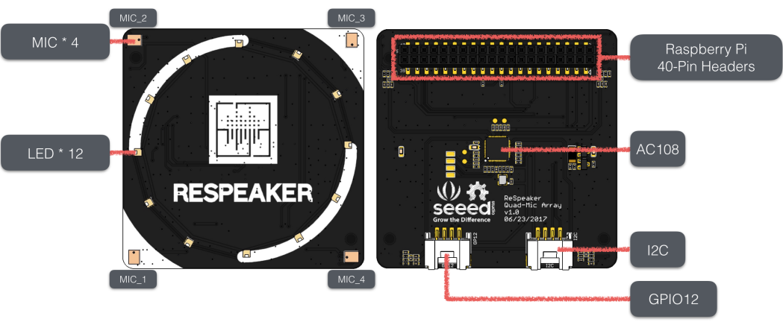
Figure 33. ReSpeaker 4-mic array

There is an addition to including LEDs, but we’ve decided to not use that portion of the component since it’ll be enclosed on the security box. How we will take advantage of this devices is by using speech detection from the user and having that correlate to the pi and continue that communication to unlock the door. Further elaboration about the communication will be talked about during testing in section 8.

6.2.2.2 Arducam Camera Module
Another way we want to maximize the use of the Raspberry Pi is by including a Mini Camera Module. It’s a low-cost add-on that is compatible with the models 4B, Pi 3B+, Pi 3B, Pi 2, and Model A/B/B+. It includes an angle view of 54 x 41 degrees with the capability of processing videos of 1080p30, 720p60, and 640x48-p60/90. The camera connects to the BCM2835/BCM2836 processor on the Pi via the CSI bus which carries a high bandwidth link of pixel data to the processor. An image of the connection is shown in Figure 34. We will enable the camera using once booting our raspberry pi and enabling the capability of the camera to the pi.

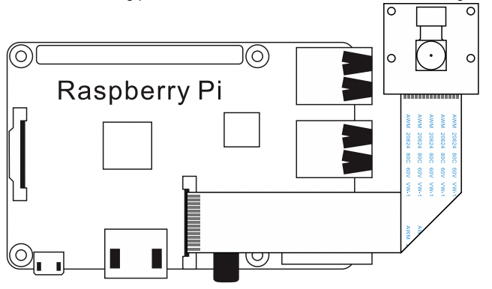
Figure 34. Arducam Connection to Pi

6.2.3 PIR Motion Sensor
The PIR motion sensor will be part of the Security portion of the design to detect font door activity. The sensor we chose is from Stemedu HC-SR501 since it is known for being energy efficient, high quality, and long service life. This choice even provides sensitivity adjustments of 3 – 7 meters and time delay ranging from 3 seconds to 5 minutes. The sensor cone even includes a 100 degree of coverage. This will be useful in our design for we plan on adjusting those parameters based our idea of designing the security box. The PIR motion sensor will be integrated to the MCU of the security box and relay activity to then turn on the camera. An image of the pin configuration for the sensor is shown in Figure 35.

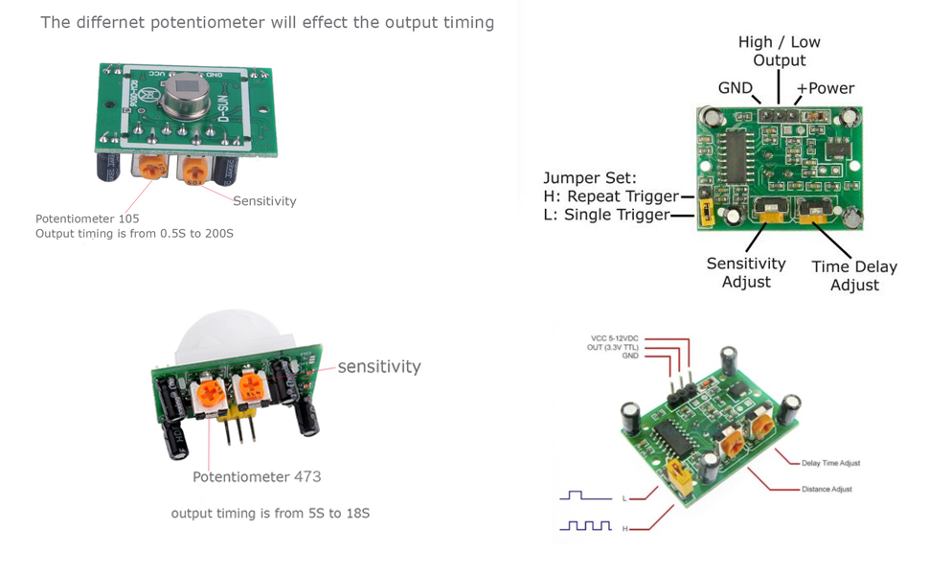
Figure 35. PIR Motion Sensor Layout

6.2.4 High Torque – Metal Gear Servo
Based on a similar experiment of a smart lock we chose this High Torque Servo motor. Its features provide a rotation of 120 degrees (60 in both directions) with the flexibility of up to 170 degrees. It is light weight of 62.14 g with the size dimensions of 40.7x19.7x42.9 mm. We will use the servo to turn the knob in the dead bolt with the plastic horns provided from the kit chosen. How we plan to achieve this is through 3D printing different models that would turn the knob and attach to the plastic horns.

The design of the 3D printed knob will vary through testing to see which would achieve a better effective outcome. Further elaboration of the knob design will be talked about hardware testing. Image of the servo and plastic horns that is determined to be purchased is shown in Figure 36. This will be compatible lock box PCB design to turn the knob and supplied with a 5V battery pack. Horns used for the servo will be varied per testing design in turning the knob meaning it will be a straight plastic horn shown in the figure or an x-horn. If needed, there are other horns available from sellers online that we can also experiment with if the current owns do not achieve what we need them to. There are ones in the shapes we already have, but larger or smaller. There are also completely different shapes we could experiment with, such as the 6-legged star horns.

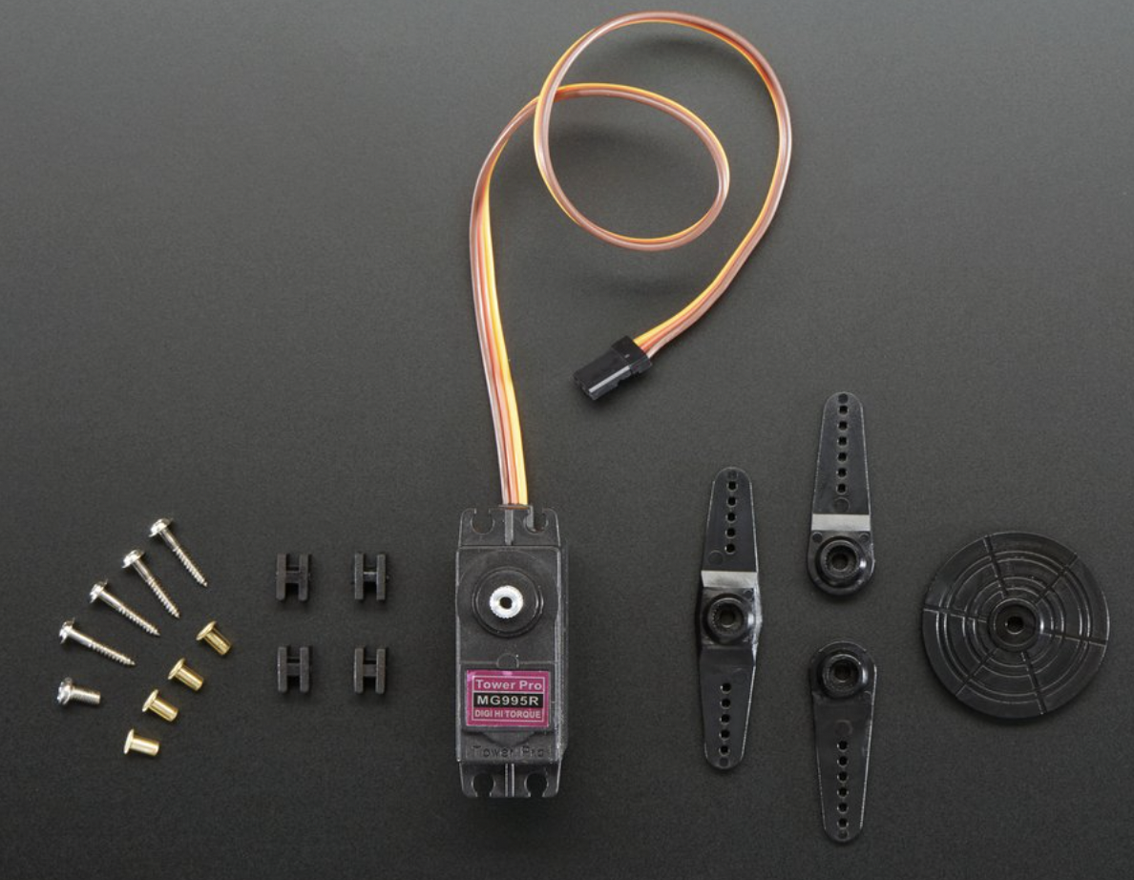
Figure 36. Servo Motor and Plastic Horns

6.3 Power Distribution
Our system is complex in the sense that each component will require a voltage input to keep the system running. Since our design requires microcontrollers, sensors, Wi-Fi module and a servo, it’s essential to make sure that each respective component will function properly and run given the power source provided. Before determining a power distribution system, collecting data of the operating voltage for each component would create value.

Table 14 below is a list of the components used and their voltage requirement. With this list we have a better outline for the power requirement in our system. Based on the data collected, we will create a 5 V battery pack to place onto the lock box and including a 10 V battery pack onto the security box to compensate the total required power distribution. These will be purchased individually and be placed within their own compartment with each respective box. Both boxes will have the option for removing a cover case and recharging the battery packs. Battery packs used for the boxes can be shown in bill of material in section 10.

Table 14: Component Power Requirements
Component Section | Power Requirement | Location of Hardware
Sensors
Raspberry Pi Microphone | Source from Raspberry Pi | Security
Arducam | Source from Raspberry Pi | Security
Motion Sensor PIR Detector | 4.5 – 20 V | Security
NFC Reader | 2.7 – 5.5 V | Security
Microcontrollers
MCU | 10 V | Security
Raspberry Pi | 5 V | Security
Microchip
ESP8266 | 3.3 V | Lock
Servo Motor
High Torque – Metal Gear | 5 V | Lock

6.4 3D Printing
The deadbolt and security box can be created and built through different sets of materials. However, from our objective we want to ensure that Live Bolt is a lightweight portable product. Hence the choice of creating our prototype box will be from 3D printed filament.

Choosing the right filament to create a durable design and withstand temperature is our highest priority. We want to make sure that the customer is obtaining a long-lasting and eco-friendly product. Hence, we will narrow down the choice of using PLA filament for ease of printing quality, temperature withstands, and pricing.

Some qualities PLA filament includes are strength quality of 119 – 184 pounds; it’s ability to stand with cold and hot temperatures without cracking; and its ability to be recyclable after usage. PLA filament is recommended to not be used outside where it is faced through UV rays or moisture; however, since this is a prototype and we’re limited to manufacturing materials, it’s best to showcase our design first from an enclosed box and later incorporate durable outdoor material. Choosing a PLA filament for the deadbolt design doesn’t seem to be a problem since it won’t be over-exposed to UV radiation or drastic temperature change.

Aside from the filament choice for a 3D printer, we want to keep our design within the constraint of being 3D printed. From just general research of printing dimensions for 3D printers, we see that they’re 150x150x150 mm. In form of consideration, we will make sure our design for the lock and security box will be less than or equal to 150 mm in length, width, and height.

6.5 Electronics Placement/ CAD Models
After researching and having the desired parts selected, it is essential to organize the electronic placements for our design. From our objective, we plan on having wireless intercommunication between the lock and security system to the app. Since we’ve decided to work with two aspects for our project, this design will have to be split into an indoor and outdoor design where they will respectively unlock the door and provide home monitoring. A free-handed sketch and basic CAD sketch, using solid works, of the electronics harnessed into a box will be shown.

6.5.1 Lock Box Prototype
Since this project is designed specifically to use a dead bolt lock, we need to integrate hardware to perform the locking/unlocking sequence at the command of the consumer. To meet our objective for the project, we will also keep the design of the lock as minimal and compact as possible.

There’ll be three main components that’ll be harnessed onto the deadbolt design: high-torque standard servo motor, 5V battery pack, and an ESP8266. The servo will oversee turning the knob in the dead bolt; the 5V battery pack will supply power to the servo motor and ESP8266; and the ESP8266 will be the wireless connection to command the servo to unlock/lock the door.

All dimensions of the electronics are taken into consideration when designing the length, width, and dead bolt diameter in the box. The customer will see a 120x80 mm box with curved corners to create an aesthetic design. More elaboration about the design of the box will be further discussed in the next section in CAD modeling. How we plan to organize the component in the box will be shown in the free sketch in Figure 37. This sketch is not to scale (NTS) and will be modified to a more compact lock design. A better representation of the dimensions for the lock box is shown in the next section of the report.

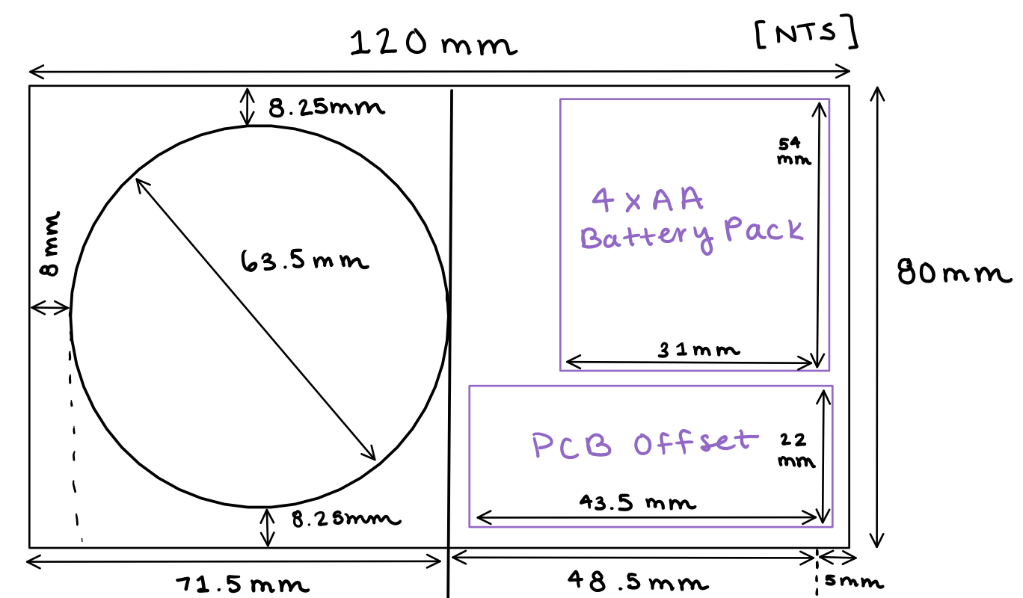
Figure 37. Lock Box with components

6.5.1.1 Lock Box CAD Model
Since we have the general layout of where the electronics will be place in our casing, the following step is to create a model of the box. We said previously that the dimensions will be 120x80 mm for the length and height. We did not mention that width of the box since it is being determined from the dead bolt extruded size along with the servo motor. Other than that, our overall dimension should be able to harness our components.

A unique portion for designing the casing is by having the consumer have easy access to the batteries. We mentioned in the design requirements that Live Bolt would have rechargeable batteries. To complete this requirement, the casing will have an ease of opening/closing the case with a railing system. It’ll open the back portion of the case so the consumer can access the 4x AA battery pack and change when necessary. The CAD model of the idea is shown in Figure 38. Note that the casing will be 3D printed to also fit the objective of creating a lightweight box.

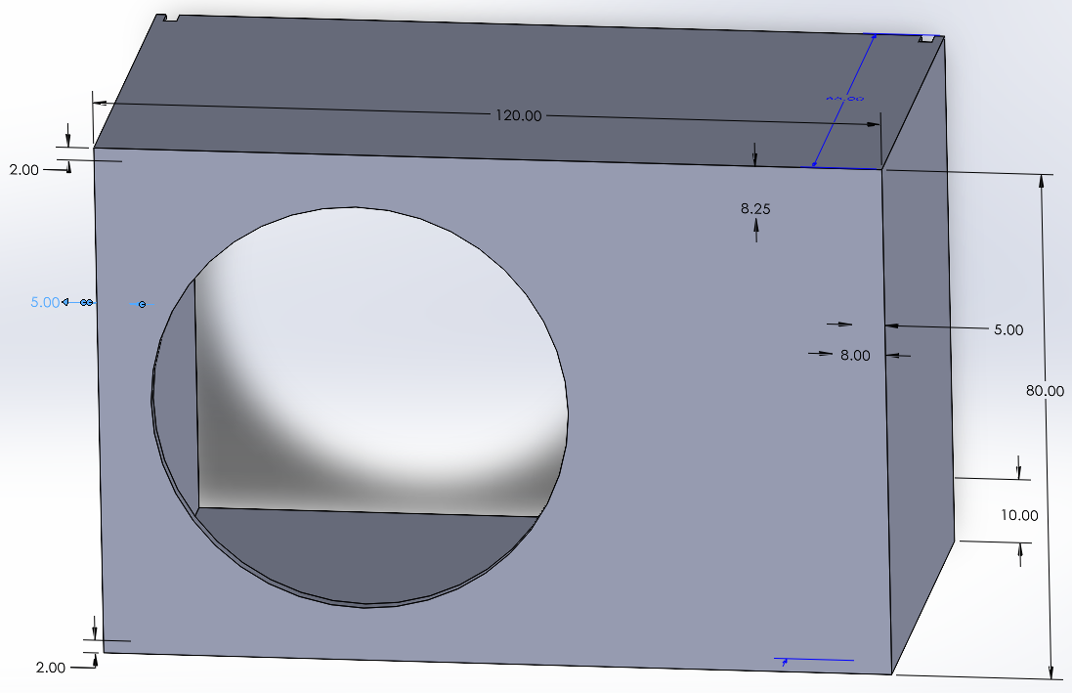
Figure 38. Lock Box CAD dimension model

Figure 39 is an extension of the lock box case including the railing system to open and close the lock box. The image is a representation of the assembly minus the dimensions included. This should fit to scale of a deadbolt. This figure would be a representation of how the back casing will be accessible to the consumer and how they’ll be able to achieve the battery change when necessary.

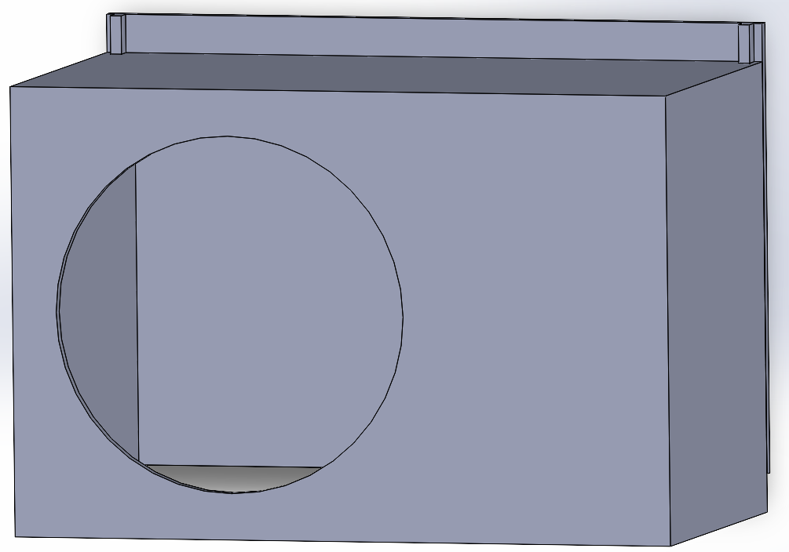
Figure 39. Lock Box assembled with removeable back

6.5.2 Security Box Prototype
The security box prototype design for Live Bolt will be built to accommodate the electronics to compensate with the requirements we laid out for home monitoring, home entrance, and wireless updates to the application. To complete the requirements, we narrowed down all the electronic parts to perform those actions, along with collecting their dimensions to comprise all the settings into a compact security system.

The outside perspective that’ll be viewed by the customer will be a 150x82 mm box with cuts to represent the positions for the Raspberry Pi Arducam, PIR motion sensor, LED light, and Arduino keypad. The most interactive aspect outside of the box will be the keypad. A user can see and physically interact with the keypad for the home entrance Arducam and PIR motion sensor will be the security portion of the project. Their objective is to monitor and relay information about front door activity to the application. Including these components in our design will cover security object in our project.

The interactive portion of the box that is not viewed by the customer is the access to speech detection. Using a Raspberry Pi Microphone and relaying speech detection to the raspberry pi is way we wanted to incorporate access control to the customer. Since this microphone is flushed into the box, security breach from speech detection will be lowered since there is no outside acknowledgement of an entrance code.

Within the Live Bolt box, we will include a Raspberry Pi, MCU (PCB offset), NFC Reader, Raspberry Pi Microphone, and a rechargeable battery component. In the sketch for Figure 40, the box was designed to equate the size of the microcontrollers in parallel to compensate for the needs of the electronics, e.g., Arducam and PIR motion sensor. One thing to note that is missing from the sketch is including the design for the rechargeable battery. Although this is not in the sketch it something that will be included in the box behind the microcontrollers. The sketch also shown is not to scale (NTS) with representing dimensions, but the next section of the report will show an accurate scaling.

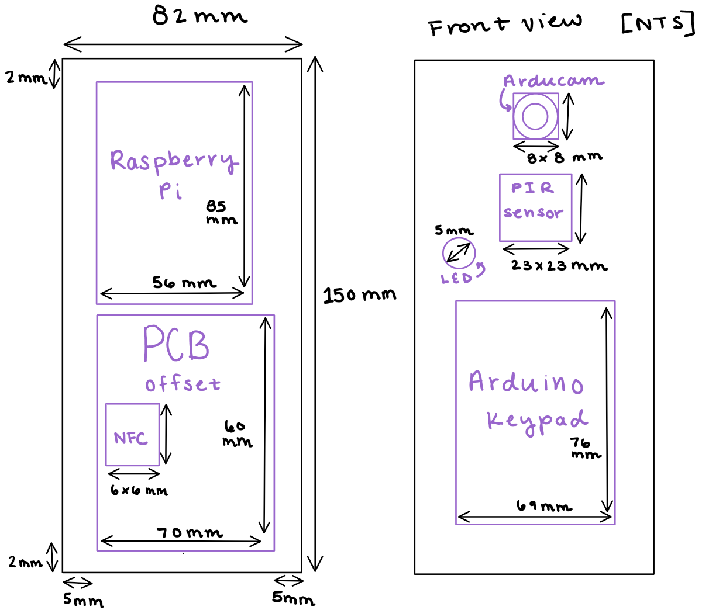
Figure 40. Security Box with components

6.5.2.1 Security Box CAD Model
After collecting the total dimensions of the components within the security box, the CAD model will have to cover mounting and connection. To achieve this there need to be 2 designs, the back portion of the box and the front view of the box. They will both vary in design based on what’ll be required from each and come together in a railing system.

The back portion of the box will include 4 screwdriver holes and a railing system to mount onto the wall and then connect to the box. The box that harnesses the electronic components will have cuts for the Arducam, PIR motion sensor, and slit cut for the Arduino Keypad. It is scaled to provide the detection reading of the PIR 100-degree cone area and open space to include the keypad. This would amount to 150x82 mm in length and height. The width shown in Figure 41 is the offset amount we predict we’ll need for the electronics. With this design, we hope to make the security box have ease in mounting and access to the battery.

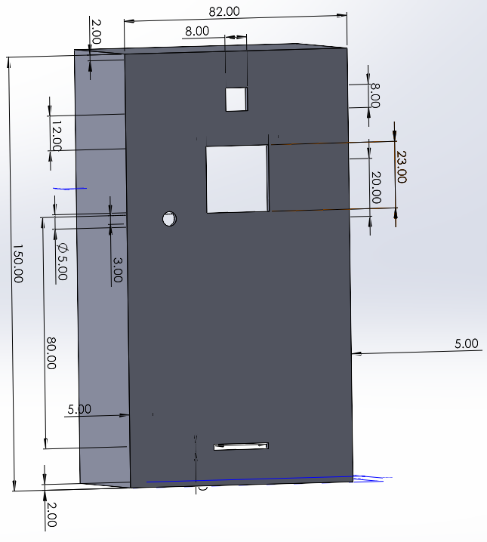
Figure 41. Security Box CAD dimension model

In Figure 42, we have the outline for the box being assembled including the railing system for accessing the battery. There’ll be a clipping method in this railing system that would lock the box in place and secure the mounting to the wall. Future edits that we predict will need to be added to the box design would be adding holes for the microphone and making the wall thinner where the NFC module will be placed. This is currently under review, as we will need to test how accurately the microphone array can detect speech within the box and test the maximum wall thickness that the NFC module can still be triggered.

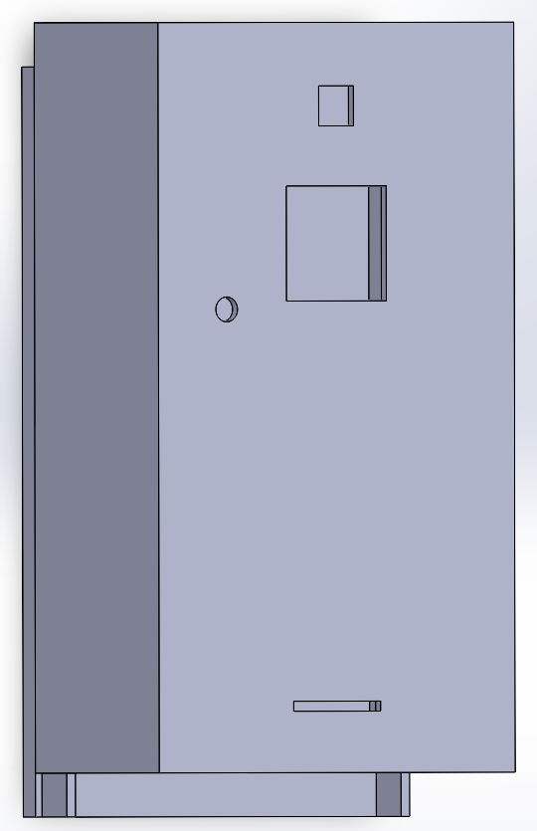
Figure 42. Security Box assembled with removable back

6.6 Summary of Design
In hardware, we discuss about what components will be included but not the overall interaction of the system. Although Live Bolt is split into two aspects (lock and security), they’re integrated together to perform the objective of home access and monitoring. In Figure 43 we see how the microcontrollers, Wi-Fi module, and electrical hardware come together to provide the overall concept of what make Live Bolt a functioning home access and security system. The arrows pointing through the diagram represents their relationship within the system and whether their representation in the graph is an input or output.

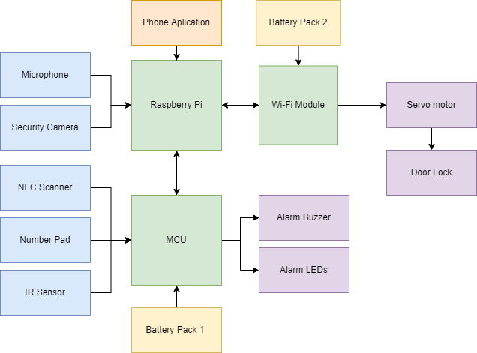
Figure 43. Hardware Design Block Diagram

7. Printed Circuit Board Integrated Schematics
To achieve a concise and compact final product, a printed circuit board will need to be designed after the breadboarding phase of the project is complete. This section will outline all aspects of the PCB design process as well as the ordering and assembly. The PCB CAD software will also be determined in this section for there are multiple user application that can execute our desired design.

7.1 PCB Terminology
Before we go into the designs created for our two PCBs, we will go over some common terms used in printed circuit board design. This is important to understand what choices we are making and to give necessary background to understand why these choices were made.

Table 15 provides some common terms and abbreviations regarding PCB terminology and their respective explanations.

Table 15: Common PCB Terms
Term | Explanation
CAD | Computer-aided Design. This refers to the software used to design a PCB.
Component | Components are what make up the circuit of the PCB. They get attached to the board after it is designed and printed.
Copper | Copper is a conductive metal that laminates most PCBs
DRC | Design Rule Checks are an automated process ran by the CAD software to ensure the PCB is ready to be printed. They find potential errors such as holes or traces being too close together, or errors in the circuitry.
Footprint | A footprint is a digital representation of a component that acts as a placeholder while designing the PCB. Usually, footprints have the component specifications like size to ensure everything fits properly on the board.
FR-4 | The most common material PCBs are made of. It is a glass reinforced epoxy resin.
Gerber FIle | Gerber Files are files of the PCB that outline each layer of the design. They are sent to vendors who will print the board.
IC | Integrated Circuits are chips that house very small circuits that help to keep the overall PCB organized and neater. ICs have many uses and applications, from voltage regulators to timers and more.
Pad | A conductive spot for components to be soldered to the board.
Silk Screen | The silk screen is a nonconductive layer on the board, usually reserved for logos or words. It is useful to label specific spots in the silk screen to refer to them during assembly.
Solder Mask | Solder Mask is a nonconductive layer that covers most of the board. It insulates copper traces to negate shorting of the circuit.
SMT | Surface Mount Technology is a way to connect components to the board. Surface mount components are rested on pads and soldered directly to the board. Most consumer electronics rely on SMT.
Through Hole | This is the alternative to SMT and refers to the leads of electrical components being passed through holes in the PCB and soldered into it. This method uses up more space but is usually easier to do.
Trace | Copper traces are what conducts the electricity between each component. They are etched into the solder mask so that only the underlying copper remains.
Via | A via is a conductive hole in a PCB that can connect different layers of the board, such as components on the top of the board connecting to components on the bottom of the board.

7.2 PCB CAD Software
There are many computer-aided design (CAD) tools that allow for the design and testing of printed circuit boards. The two that we are considering for this project are KiCad and Autodesk EAGLE.

7.2.1 KiCad
KiCad is a free design suite for designing and simulating printed circuit boards that was developed in 1992. Since it is free of cost, there is a variety of tutorials and resources online. This makes the learning curve for KiCad much better for new designers. It offers Simulation Program with Integrated Circuit Emphasis (SPICE) simulation, open-source footprint libraries, and a 3D-view of the PCB once it is designed. Figure 44 shows a screenshot from the PCB designer/editor in KiCad.

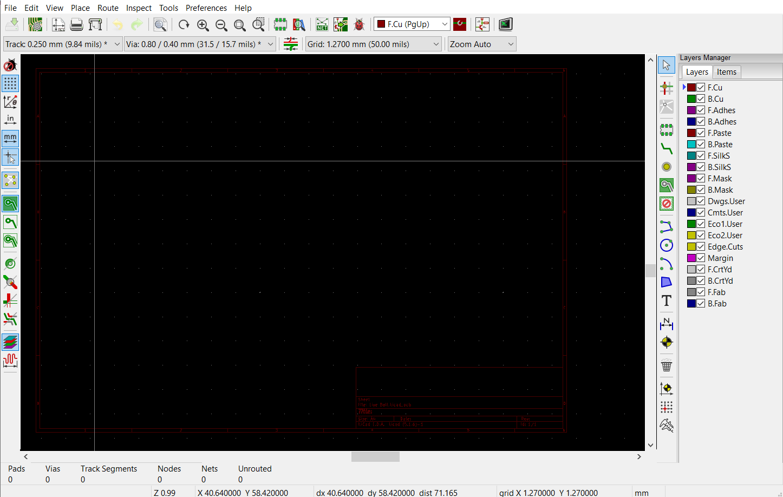
Figure 44: A screenshot of the PCB design window from KiCad

7.2.2 EAGLE
EAGLE, designed by Autodesk in 1988, is another CAD software for PCB design. EAGLE stands for Easily Applicable Graphical Layout Editor. Unlike KiCad, it is not free and instead offers a subscription-based model. However, University of Central Florida students get Eagle for free with their student emails. Since EAGLE is closed source, there aren’t as many online resources as possible and customization options, and it is a bit harder to start using when compared to KiCad. EAGLE was used as the CAD software of choice in the EEL 3926L Junior Design course at UCF, so students do have some experience with it.
EAGLE also offers the option to collaborate with others on a single design and dynamically update the design. Figure 45 shows a screenshot from the PCB editor in Eagle.

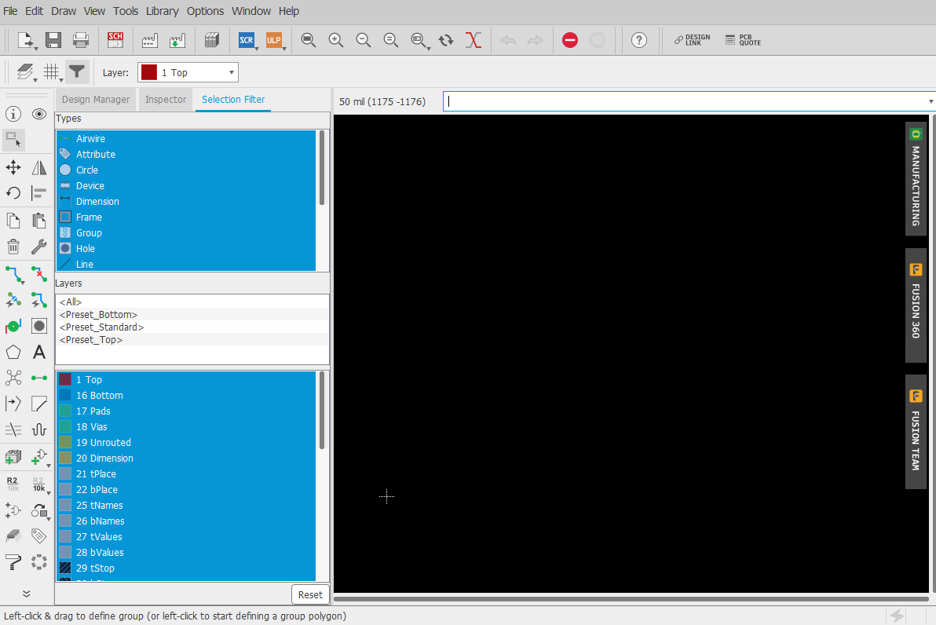
Figure 45: A screenshot of the PCB design window from Eagle

7.2.3 CAD Software Decision
Due to the advantages like, being free of charge, having a low skill level, and having open-source libraries and tutorials online, the team has decided to create our circuit and PCB design in KiCad.

7.3 Printed Circuit Board Designs
This section will outline the printed circuit board designs and the process to create them. Since this project is broken up into the indoor (lock) module and outdoor (security) module, there will be separate sections for each. Since these are prototypes, the component placement and overall shape of the boards and traces may change in the future.

7.3.1 Security PCB Design
The components chosen for our security circuit, shown in Figure 46, all have different power requirements, as shown in section 7.2. Due to this, we will need to have varying voltage levels throughout the printed circuit board. Our current design currently has only a single 12-volt battery pack as the power source, so we will need to incorporate voltage dividers. Voltage dividers work by taking the voltage at the node between two resistors in series. The input voltage is connected at the first resistor, and the output voltage is taken at the node between the two resistors.

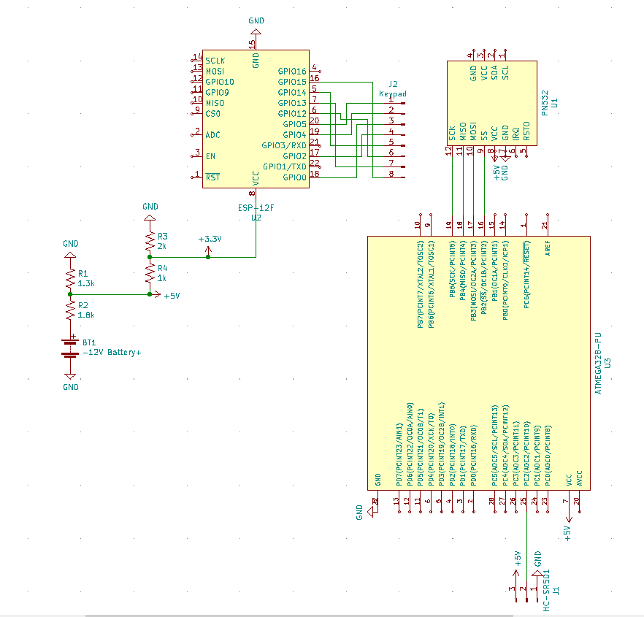
Figure 46: Security Module Circuit Schematic

The output voltage can be calculated by dividing the second resistance by the total and multiplying that ratio by the input voltage. Our battery pack is 12 volts, and we have components that operate at 5 volts and 3.3 volts. Table 16 provides the input voltages and new output voltages for the circuit.

Table 16: Voltage divider resistor values and new voltages
Input Voltage | Resistor 1 | Resistor 2 | Output Voltage
12V | 1.8kΩ | 1.3kΩ | (1.3k/3.1k)*12V = 5.03V
5V | 1kΩ | 2kΩ | (2k/3k)*5V=3.33V

These voltage dividers, and all the other components for the security circuit can be seen connected below in Each new reference voltage from the voltage divider connects to a different. power plane on the board. Power planes allow for all the power pins to be directly connected to the same node. The back of the board is also a ground plane, that allows for every ground pin to be grounded on the same node. The power planes are the red squares, and the ground plane is the green square in Figure 47.

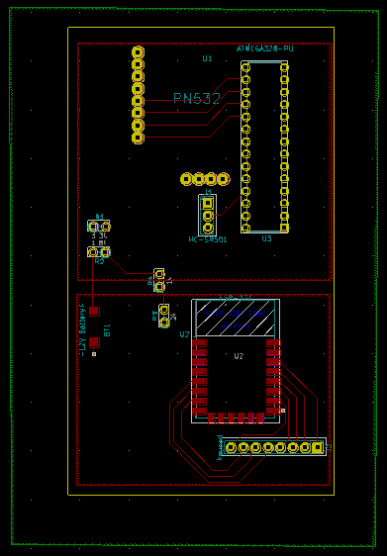
Figure 47: Prototype Security PCB Design

Another consideration that was made was how readily available schematics and PCB footprints are for each of the parts we chose. We were able to find these online for every part including the ATMega328PU Arduino chip, the PN532 NFC module, and the ESP-12F module. The keypad and infrared sensor only required 8x1 and 3x1 pin headers be fixed to the board.

The battery pack will be soldered directly to pads on the board. Components are a mix of through hole and surface mount technologies. The battery pack wires and ESP-12F will be mounted to the board, while the PN532, ATMega328PU, voltage dividers, and pin headers are all through hole. Figure 48 shows the front and back of the security PCB 3D model generated by KiCad.

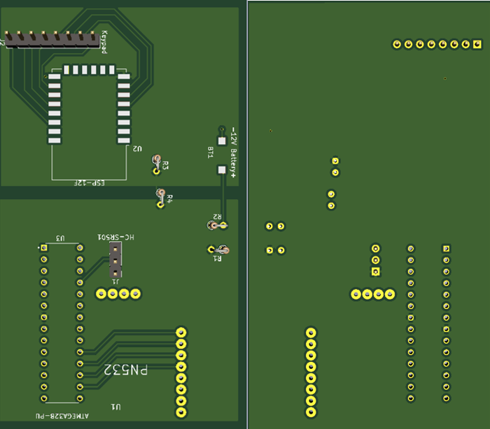
Figure 48: 3D Prototype PCB Model

7.3.2 Lock PCB Design
The design for the locking module is much simpler than the security module. This PCB only has pads for a battery pack, pin headers for the servo motor, through holes for a voltage divider, and a pad for the second ESP-12F chip to be surface mounted. Figure 49 shows the KiCad schematic for the lock circuit.
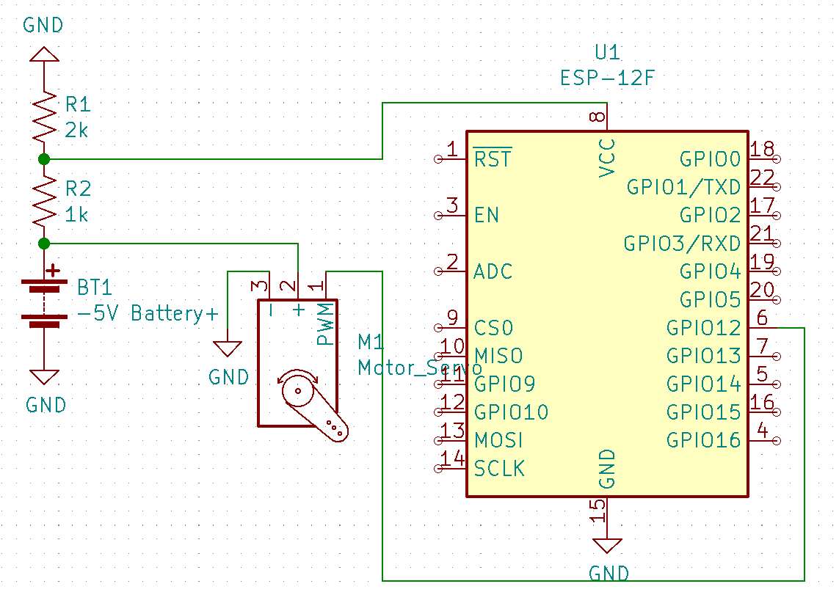
Figure 49: Lock Circuit Schematic
The components for this PCB are used to communicate with the security module, and then turn the dead-bolt knob when the unlock criteria are met. The ESP-12F runs at 3.3 volts, while the servo motor runs at a minimum of 4.8 volts. Because of this, we will need to have a 5-volt battery pack for the servo motor, and then divide the voltage again to 3.3 volts like in the security module to power the ESP chip. Figure 50 shows the circuit in the PCB editor.

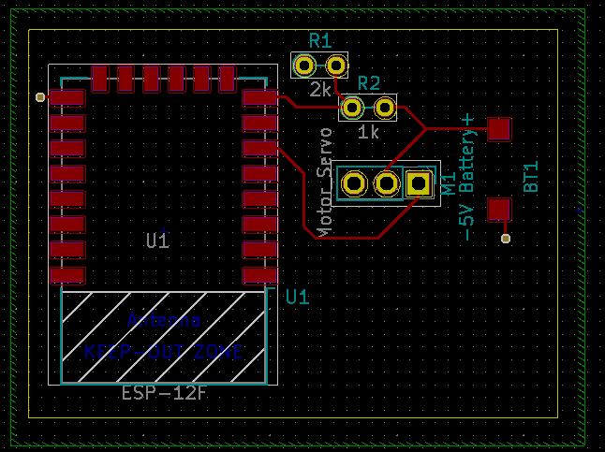
Figure 50: Prototype Lock PCB Design

For this board, there are no power planes, but the bottom of the board is also a ground plane like the security board. Due to the minimal components on this board and the inclusion of a ground plane, there are very minimal traces included in this circuit. The 3D models of the front and back view of the PCB are shown in Figure 51 and Figure 52.
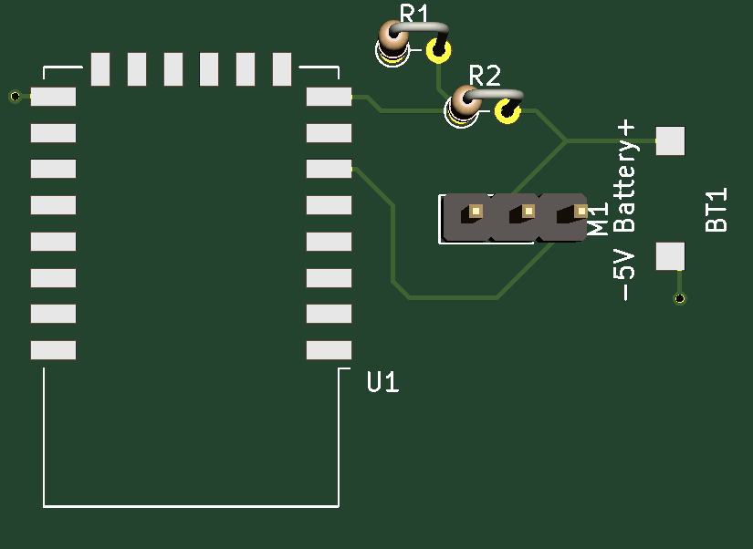
Figure 51: Front Lock PCB 3D Model

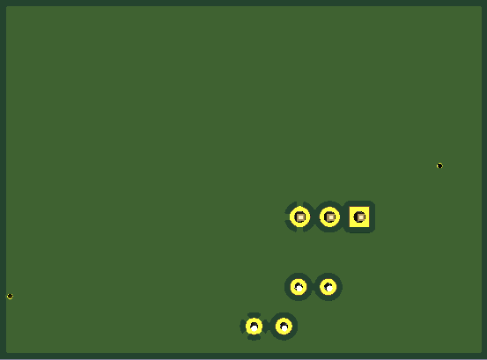
Figure 52: Back Lock PCB 3D Model

7.4 PCB Vendor and Assembly
The process of getting a PCB printed is simple. Once the design is completed, the gerber files should be exported and sent to a vendor. Once they have the gerber files, the number of layers, size of the board, thickness, color, and quantity are all defined. There are numerous vendor options online to get a PCB printed and mailed.

The option we are going to pursue will be JLCPCB due to having positive experiences with them in the past for printing PCBs. JLCPCB services over 20,000 orders daily and produce 6 million PCBs each year. They ship to over 170 countries and have an on-time delivery rate of 99.97%. Depending on the size and complexity of the board, they offer prices as low as $2 for 5 boards, excluding shipping. They also offer PCB surface mount assembly, since the process for surface mount soldering is more complex than through hole. There is also a feature for surface mount technology boards called SMT Stencils. This option allows the surface mount pads to arrive with solder already applied, which makes it very easy to place the component on the pads and simply melt the solder until the component falls right into place. The University of Central Florida Senior Design Lab also includes a reflow oven to solder surface mount technology products. This is a great option for us to use when we begin soldering our surface mount components. Figure 53 shows the JLCPCB order page and the various options given when ordering a PCB.

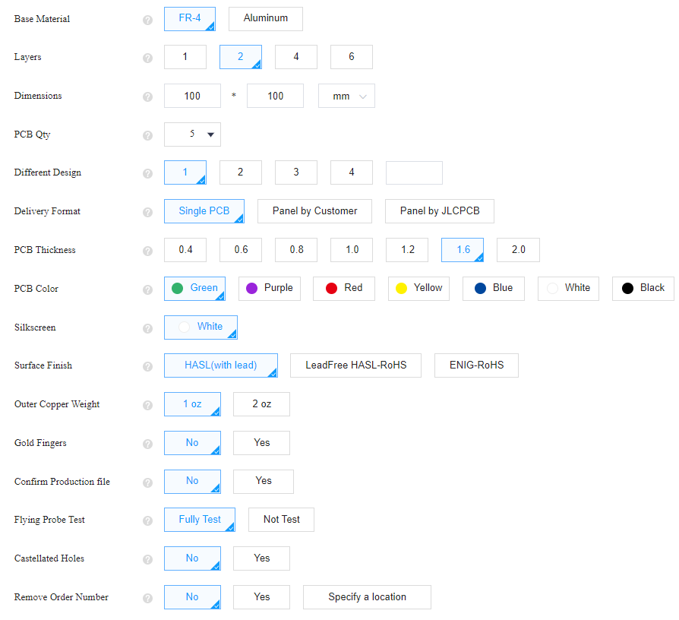
Figure 53: JLCPCB PCB Order Options

For a JLCPCB standard PCB, meaning two layers and less than 400 millimeters by 500 millimeters, JLCPCB is able to start and finish production in one to two days. Once production is finished, the board is ready to be shipped. We do not expect our board to be larger than 150 millimeters by 150 millimeters, so we will use this size as a benchmark when calculating board cost and shipping. For a two-layer board of this size, the price of production equates to $13.40. This is made up of a $4.00 engineering fee and $9.40 for the actual board. Table 17 gives the prices and shipping times for delivering to the United States of America for a two-layer 150 millimeter by 150 millimeters board.
Table 17: JLCPCB Shipping Costs and Delivery Times
Shipping Method | Cost | Delivery Time | Restrictions
DHL Express Worldwide | $22.97 | 3-7 business days | ≤10000kg
DHL Express Economy | $21.66 | 5-8 business days | ≤11.5kg
UPS Express Saver | $22.97 | 6-9 business days | ≤10000kg  ≤120x70cm
FedEx International Priority | $20.70 | 5-8 business days | ≤10000kg  ≤121x121cm
Global Direct Line Saver | $11.69 | 6-16 Business days | ≤1.8kg  ≤$150
Economical Global Direct Line | $9.73 | 10-18 business days | ≤1.8kg  ≤$150

Since we are trying to minimize prices, we will most likely go with Economical Global Direct Line. We will have the summer semester to collect remaining parts before Senior Design 2 in the Fall, so a 10 to 18 business day delay is not an issue for us. We may need to expedite the shipping and pay a bit more if we need to order newer versions of our PCBs, since we will most likely need to make adjustments after ordering and testing the first copy. Once the PCB arrives, we can begin assembly and testing.

8. Project Prototype Testing Plan
How we plan on testing Live Bolt will be split into hardware and software components. The testing plan are ideas/ goals we want to do to achieve a presentable project.

8.1 Hardware Test Environment
Designing Live Bolt comes with two components that is iterated throughout the document: a lock and security box. The lock box will only function with the use of a deadbolt lock while the security box just needs a brick, concrete, or stucco wall to mount onto. How we plan to initially test Live Bolt in an environment will be through our apartment homes. We plan on mounting the lock box to our doors and testing iteration between the wireless communication of locking/unlocking sequence.

As soon as we see a high success rate to the lock box, we will then transition to creating our own prototype door with a doorknob and deadbolt lock. The security box on the other hand would only be tested in an environment for when we’re mounting the box. Mounting would require a sturdy wall and since we’re in apartment complex, we’d like to avoid any consequence for drilling into a wall. Solution to presenting the mount and show in the senior design show case would be to create our own concrete wall. Meaning that we’d use a cement block to prove mounting. The reason to creating this prototype environment is to present the scenario for when it comes to demonstrating Live Bolt.

8.2 Hardware Specific Testing
The hardware testing encompasses ensuring the electronic components, PCB design, and housing choices all work as intended and can be all interfaced together to create the final product. This further elaboration would outline our team strategy when understanding what will be tested when building Live Bolt and creating our final product. Also outlining steps/ procedures that would provide guidance in finishing our product from conducted research.

8.2.1 MCU Testing
To test the Raspberry Pi’s and MCU’s functionality with the application a connection between the two must first be established. We plan to use one of two methods to do so. The first method would require establishing a Bluetooth connection between the mobile device and Raspberry Pi. The second method would involve setting up a Wi-Fi access point on the Raspberry Pi so a mobile device can connect to it.

A Bluetooth connection between the devices would allow for testing and connecting to the application when there is no Wireless network available. Some user made APIs exist to make this connection easier to establish between the devices. One such library is bluedot which a provides both a communication API for setting up connections, a Mock API for testing connections, and a mobile Application for controlling the PI over the connection. [26] This functionality would allow us to test the connection between the various parts of our system without having to spend a lot of time getting things set up. Additionally, we can use bluedot’s mobile application to troubleshoot certain functions of Raspberry Pi and MCU, such as locking and unlocking the lock. To pair the devices using Bluetooth we will need to follow the following steps:

On phone:

- Open Settings
- Select Bluetooth and make your phone “discoverable”

On Raspberry Pi:

- Click Bluetooth ‣ Turn On Bluetooth (if it’s off)
- Click Bluetooth ‣ Make Discoverable
- Click Bluetooth ‣ Add Device
- Your phone will appear in the list, select it and click Pair

On the phone and Raspberry Pi.

- Confirm the pairing code matches
- Click OK [27]

Alternatively, the command line can also be used to facilitate the connection. This can be done by entering a series of commands into the prompt to create the connection.

Setting up a Connection using Wi-Fi has the benefit of ranging long distances and tends to have a stronger connection when compared to Bluetooth. The access point that we set up will facilitate a Transmission Control Protocol (TCP) connection for communication between the devices. TCP Connections create a more secure, reliable connection between devices. Although it is slower than its sibling protocol UDP it is more dependable making it a good option for setting up the connection. The following are the steps needed to establish a TCP connection between the Raspberry Pi Server which will listen for request from the phone Client:

- Set up Raspberry Pi as Access Point.
- Set up Raspberry Pi as TCP Server to listen for connections.
- Connect phone (TCP Client) to Raspberry Pi via Wi-Fi to the access point and send socket connection over.
- Send data from phone to Raspberry Pi. [28]

This functionality will be accomplished following the official guide for setting up a Wireless Access Point on the Raspberry Pi:

- Verifying the Raspberry Pi is set up correctly before beginning
- Install Access Point and Management Software
- Set up the Network Router
- Ensure Wireless Operation
- Configure the Access Point Software
- Running the new Wireless Access Point

As long as a Bluetooth or Wi-Fi connection is in place, we will be able to test the functionality of the system as a whole. We will conduct these tests primarily through a software testing framework as discussed earlier.

8.2.2 Deadbolt Knob Design Testing
In the earlier portion of the report, we mentioned that knob design would vary since all deadbolt knobs vary in sizing. From this understanding, our objective is to have the lock box be versatile with all deadbolt doors. We came up with two design solutions to complete that objective. One thing to note before creating the design is that knob will be 3D printed & fit onto the servo motor’s plastic horns. We’ll be using two different types of plastic horns for these motors based on the change of design. In Figure 54, it is using one long horn already provided by the servo motor package and will be super glued together. After being placed together it will be connected to the servo motor and do a turning configuration as if one would turn to unlock the knob.

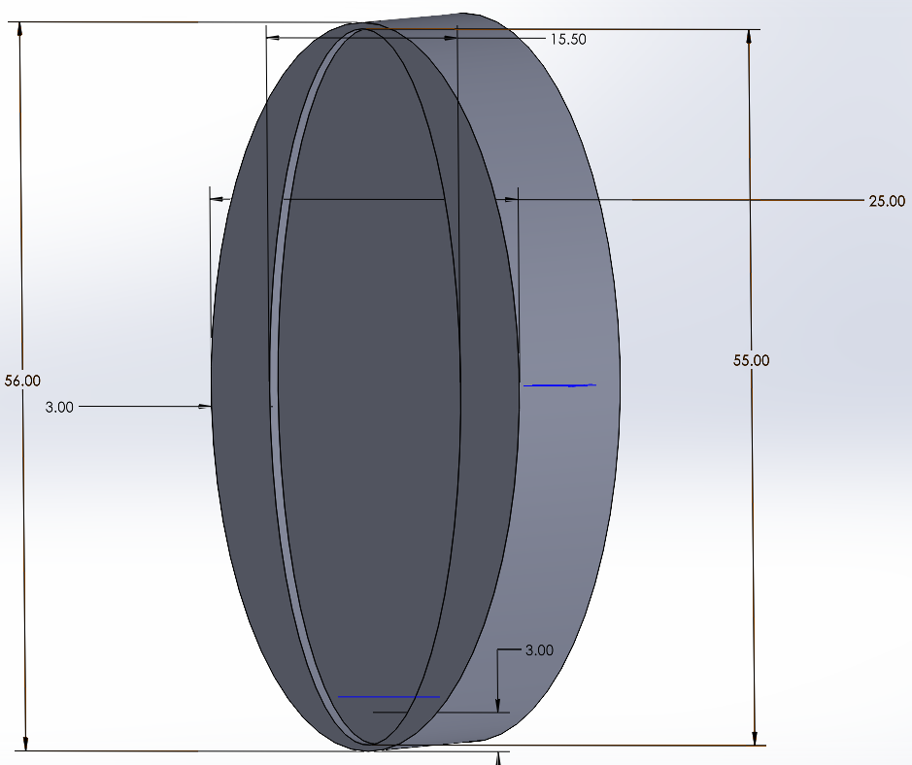
Figure 54. Solidworks Straight horn Design 2
This design has its flaws since it’ll be a fixed shape to place onto a dead bolt knob. All knobs come in different shapes and could on how this design would perform. Ideally a perfect shape knob would turn with ease however there is no standard knob placed on every dead bolt. Dimension of the design would be 55 x 25 x 20 millimeters with respect to length x width x height. The reason for choosing these dimensions was so it can fit onto the knob and turn effectively while having an opening to cover the whole dead bolt (as discussed in section 6). Width size is chosen to be slightly big to fit encompass any knob but to also ensure there’ll be a turn from the servo motor.

In Figure 55, we have an image of a cylinder with two holes. To explain this better, we will be using that image with a x-horn for the servo motor meaning there’ll be 4 legs protruding from the horn. The cylinders will be there to cause the movement of the knob and be secured to the horn with the small holes. The dimensions were chosen based on dimensions provided from the plastic x-horn. Each hole provided from the x-horn is to be around 4.95 mm apart in distance. This will be inserted by a pin to hold in place to the x-horn. The 20 mm in height will be the standard size to when the looking at the distance between x-horn and knob. That standard will also be implemented when discussing on design 2.

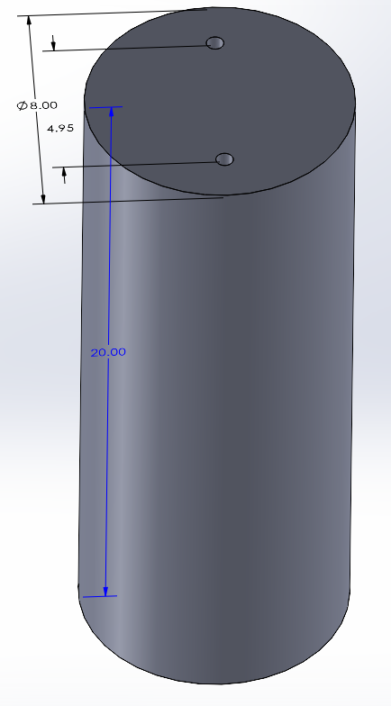
Figure 55. Solidworks X-horn Design 1

These two designs have their own respective choice for making a great outcome when performing the unlocking mechanism; however, they’re not perfect and would need to be tested to ensure that there’ll be a great outcome. Table 18 will the layout for outline for the pros and cons for each design. Although we will talk about what type of factors they bring, these are all assumptions we understand that could bring risk into the lock box. Testing these designs would provide better clarification on performance and construction. The team has access to 3D printers so we are able to print both designs and test them to determine which design is best applicable to the Live Bolt system.

Table 18: Pros and Cons for knob design
Knob testing | Pros | Cons
Design 1 | Provides better flexibility to customize to knob sizing | Four pin design risks breakage
Design 1 | Creates ease in movement of the servo | Requires extensive work for 3D printing
Design 1 | Easy to install | Not easy to replace
Design 2 | Durable | Causes a lot of friction making knob turn difficult (overworking the servo)
Design 2 | Easy design | Fixed sizing therefore might not adjust to deadbolt knobs
Design 2 |  | Requires more filament printing

8.2.3 Electrical Components Testing
This section will go into detail how we will go about setting up and testing each component individually before integrating them together for the final design of the Live Bolt system.

8.2.3.1 ESP8266/Arduino Programming
Programming the ESP8266 NodeMCU is very similar to the way any Arduino board is programmed. There are a few things you must set up first, however.

- First you must go to Preferences in your Arduino IDE and enter: http://arduino.esp8266.com/stable/package_esp8266com_index.json into the “Additional Boards Manager URLs” section since the ESP8266 isn’t running native Arduino architecture.
- Then you must install the ESP8266 board package within the Board Manager menu. The option should be there if the URL was placed correctly in the previous step.
- Plug in your ESP8266 into the computer via a micro-USB. If a low-quality cable is used, the computer may not be able to read that the board is plugged in.
- Once plugged in and recognized, the computer should automatically download drivers. If it does not, you can manually install the CH340 drivers from the internet.
- Once everything is correctly installed, you can select “NodeMCU 1.0 (ESP-12E Module)” from the board menu.
- Select the new COM port in the Port menu.

With these steps completed, the ESP8266 should be ready to be programmed. There are some differences with programming an ESP8266 vs an Arduino. One major difference is that when defining pins, the Arduino allows you to use the number of the digital pin. Digital Pin 6 = D6 = 6. On the ESP8266 NodeMCU breakout board, the digital pin number does not correlate with the number you define in the code. This means you need to refer to a pinout sheet when coding. The number you define for each pin correlates to the respective GPIO pin. This means that D6 on the development board would be defined as “12”, since it is the GPIO12 pin.

There is also a way to program the ESP8266 and Arduino without plugging it in to the computer and uploading the code through a serial connection. This method is known as Over the Air programming. You can set this up via the Arduino IDE. An example code in the IDE called “BasicOTA.ino” provides the framework for this process. With the ESP8266 or Arduino plugged in to the computer, you have to configure your Wi-Fi parameters. After running the code and saving it to the board, unplug it. You can now power it with a portable power source such as a battery. When the board has power, you’ll see a new port in the tools that you can select. There are a few Over the Air functions that you must put into your original sketch code, and once that is done, you can upload the sketch and your board should have received it wirelessly.

The Over the Air method of uploading code to the ESP8266 or Arduino will come in handy once we solder the chip to our designed PCB, since we will not have a micro-USB port to upload sketches to it. This means we can make small changes to our code without having to desolder and resolder the microchip every time.

8.2.3.2 ESP Wi-Fi Communication
One of the main features that allows the Live Bolt system to function is the connection between the security module and the lock module. This connection is established due to the ESP-12F’s Wi-Fi capabilities. Establishing this connect is relatively easy to do. One board is considered the Server while the other is considered the Client. The Server is what is the access point for the Client to connect to. The Client connects to the Wi-Fi access point of the Server by uploading credentials that are defined by the user.

A Wi-Fi name and password must be chosen, and they must match up between the Server and Client. Both boards communicate via the User Datagram Protocol (UDP) communication protocol. UDP is useful for this application because it is relatively simple to set up. After UDP is configured for each board, the Server listens to the UDP port for packets to be sent from the Client. In our case, the Client is the security board sending data to the lock board, which is the Server. When the Server receives a packet from the Client, it will know whether to turn or not turn the servo motor [29].

8.2.3.3 HC-SR501 IR Sensor
The IR sensor does not require any microcontroller to function. This mean that it can be hardcoded into a circuit. The main set up required for this component is configuring the sensitivity (range) and time delay of the sensor. There are two potentiometers on the board that can be turned to adjust these parameters. Since we would like to detect motion in front of the lock, the range will be set to 1-3 meters to get a decent coverage. The delay will also be set to 2-5 seconds, so it doesn’t trigger again for the same person passing by. There is also a pin jumper in the corner of the module to change between single trigger mode or repeat trigger mode. Single trigger mode will change the state of the sensor whenever motion is detected. Repeat trigger mode will turn the sensor on when motion is detected, and after a delay it will turn it back off until motion is detected again.

Repeat trigger is more useful for our application because we will want to detect motion, send a notification to the application, and then wait for more motion afterwards. The final consideration for this sensor when setting up is that it needs up to a minute after receiving power to calibrate and get acclimated to the environment it is placed in. To test if the component works, an LED and 330-ohm resistor was connected to the sensors output. After calibration, when motion is detected, the output will go high and light up the LED. The test setup is shown in Figure 56.
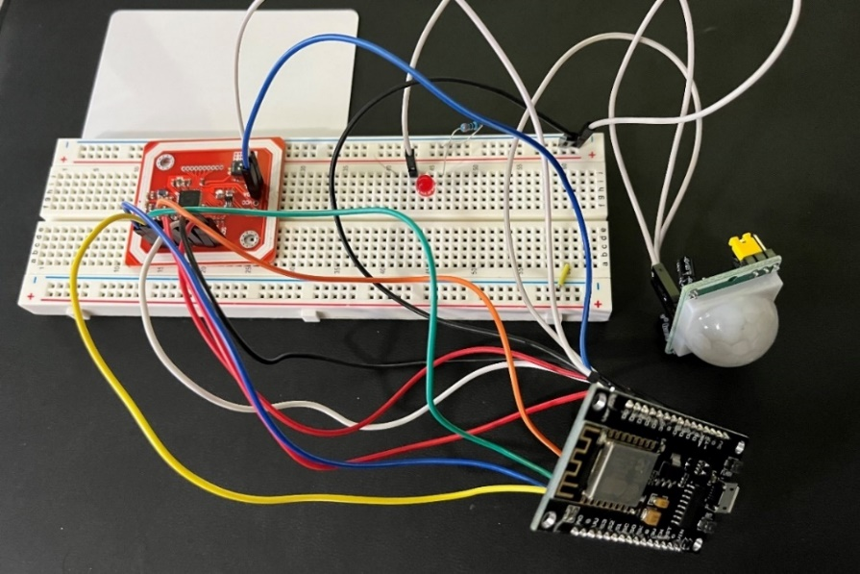
Figure 56: Hardware Development of NFC (Left) and PIR Sensor (Right)

8.2.3.4 Membrane Keypad
The keypad is simple to test with the ESP8266 and requires very little setup. In the Arduino IDE, a character array is created to mimic how the keypad looks. By using the Keypad.h library, the character can be printed when the corresponding button is pressed. For testing, the character is printed to the serial monitor in the Arduino IDE. For the actual product, the code inputted will be compared to a set pin code and will either grant or deny access to the user. The keypad test setup is shown below in Figure 57. Each of the eight pins on the keypad is connected to a digital pin on the ESP8266, D1 through D8.

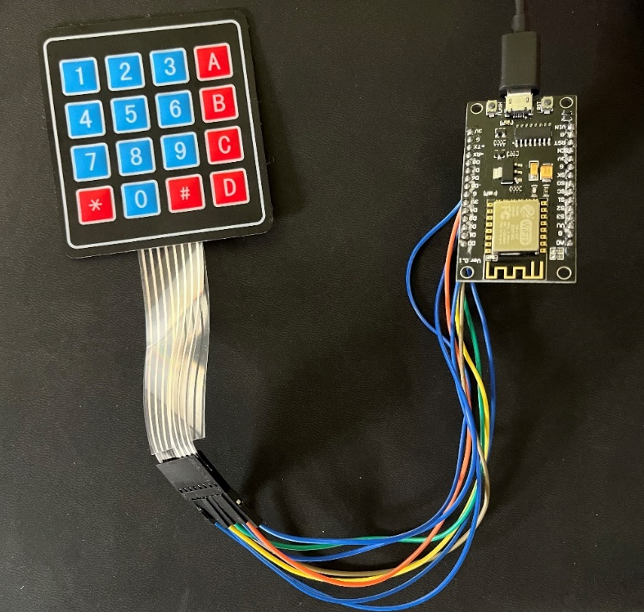
Figure 57: Hardware Development of Membrane Keypad

8.2.3.5 HiLetgo NFC Module
The HiLetgo PN532 module comes unsoldered, so header pins need to be soldered on to connect it to the final PCB design. For development, jumper cables were inserted into the header holes.
There were initially issues testing the PN532 module with the ESP8266, due to lack of digital pins, and errors with communication protocols. This led us to use the Arduino ATMega328pu microprocessor for NFC capabilities on the live bolt system. The chosen protocol was SPI due to only requiring 4 pins to be connected to the chip, rather than 6 that are required with I2C. With I2C, the IRQ and RSTQ pins are also required.

Testing the NFC reader with the ATMega chip was relatively simple once the correct pins were connected. There are libraries for the PN532 module that include test examples. The example ran was able to output the code of whatever NFC tag that was held to the module into the Arduino IDE serial monitor. Three tags were tested, being an NFC keychain, a keycard, and the Apple iPhone Apple Pay feature. All worked as expected, and this code can be modified to be used with the Live Bolt system. Figure 56 shows the development of the NFC module, along with the previously mentioned infrared sensor.

8.2.3.6 High Torque Servo Motor
The Servo chosen for this project is called the Tower Pro MG995. The servo motor functionality can be tested through simply connecting the servo motor to a pin of the ESP8266 along with ground and 5V to supply its mobility. In a sense of programming and testing the servo moving. That is through the pin and having a servo library enabled. From then it can be programmed to sweep positions through the desired position. Since this servo is designed to provide 120 degrees of rotation, creating a loop to go 60 in each direction would perform the testing of the servo. This can then be in variation of steps to create the sweep and have delays as desired.

8.2.3.7 Raspberry Pi Dependencies and Packages
Raspberry Pi (rpi) as described previously is a 1.4 GHz 64-bit quad-core processor. In essence, it’s a small computer that can run through dependencies and packages depending on what desired from the output of the rpi. Before even beginning to power the rpi, some initialization testing that would add value would be from downloading the operating system image onto one’s desktop to initialize a microSD card and boot the rpi capabilities. The next course of action is to insert the microSD card onto the rpi and plug in the micro-USB in the power supply to have it just power on. Two small LEDs on the side of the board will begin to turn on once there is a reading from the power supply and connection of the microSD. Additional requirements to run/ interact with the rpi would be to connect a keyboard and mouse on the USB ports located on the side.

If a user is doing the bare minimum in just turning on and loading up the operating system there should be no form of complication in proceeding with this steo.

8.2.3.8 Arducam
Navigating Arducam, there’s a couple of functionalities that should be mentioned when implementing its full uses. A great example that is worth mentioning is libcamera. Libcamera is an open-source camera stack that is used by raspberry pi in developing the camera software library. Testing the camera operation requires the following steps:

- Opening raspi-config tool in terminal
- Run sudo raspi-config
- Select Enable camera and hit enter
- Hit Finish and the program will reboot

When testing the camera, there could be a possibility of the camera module not working. A way that the manufacture recommends to do is run apt-get update and sudo apt-get upgrade before starting the trouble shoot. Another way we want to ensure proper function is by making sure there’ll be enough power supply to the camera module to the raspberry pi. Running vcgencmd get_camera would provide an ouput of supported=1 and detected=1. In the situation that support =0, it indicates that that the camera is not enabled. When detected=0 the camera is not correctly connected which can come from the ribbons not attached properly [30]. A better configuration of the Arducam camera module can be seen interfaced with the Raspberry Pi in Figure 58.

8.2.3.9 Phrase Recognition
The Respeaker is an array of four microphones that work with the Raspberry Pi. To begin testing, the array needs to be mounted to the Raspberry Pi in the proper orientation, so every pin corresponds to the correct header. The microphone array can be seen mounted in Figure 58. Then the Respeaker Seed voice card must be installed to the OS on the Raspberry PI. In Audacity or another audio editing application, the input channels need to be configured to the AC108 4 channel, corresponding to the 4 AC108 microphones. Now the array should be configured to act as a microphone. There are also LEDs on the board, but since they will be placed inside the housing of the Live Bolt system, we do not need to program them.

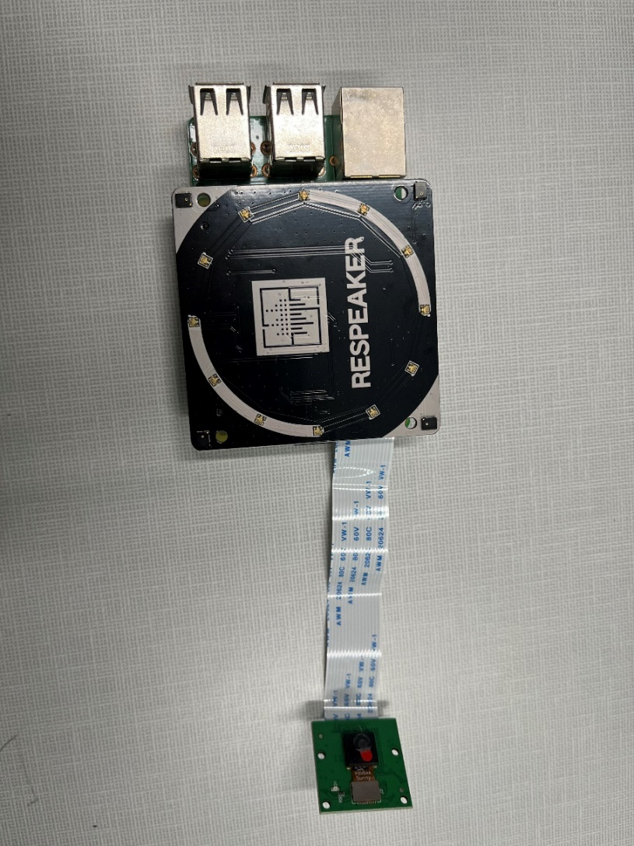
Figure 58: Microphone array and Arducam camera interfaced with Raspberry Pi

Now that the microphone is set up, software needs to be created to enable phrase detection. The programming language of choice for this is Python due to its ease of use and plethora of online materials to work with. There are a variety of packages for speech recognition in Python, such as:
- apiai
- assemblyai
- google-cloud-speech
- pocketsphinx
- SpeechRecognition
- watson-developer-cloud
- wit

Apiai and wit even offer natural language processing capabilities. Natural language processing allows for not only capture of words, but also emotion. Since we only need to recognize a spoken word to act as a passcode for the lock, recognizing emotion is irrelevant and we will not be considering natural language processing in the design. SpeechRecognition actually makes use of many of the APIs listed and allows for each one to be called and compared against each other. This makes SpeechRecognition the most versatile option and the best choice for the phrase detection software. The code works by using th Recognizer class for each specific API. The class won’t work without an audio data type to pass through it, which is the voice captured by the microphone or from an audio file.

To capture voices in real-time, another library is required, PyAudio. PyAudio allows for the .Microphone() class to be used with SpeechRecognition. Now the .listen() method can be called to listen to voices live. From here, the system can detect what the voice said, and simple if logic statements can be called to do different things based on the phrase detected. One final thing to note is that sometimes there will be ambient noise, due to the lock being outside. To circumvent this, the adjust_for_ambient_noise() method of the Recognizer class can be called to equalize the audio. It does this by listening to the first bit of the recording and calibrates to that noise level to try to compensate for it. While not perfect, it can help for minor ambient noise like birds chirping or leaves blowing.

8.2.4 Battery Testing
Testing Live Bolt’s batteries will be split into checking the locking and security system. We talked in power distribution about the require power for each device. The next step after configuring the power requirement would be to test if the rechargeable battery pack would suffice our desired output. Testing the battery pack in the lock box would be as simple as inserting the AA batteries into a 5V battery case and measuring the outcome with a digital multimeter. As for the security box batteries, we would be doing the same procedure except with a 12V battery back. Making sure that the desired output of approximately 5 and 12 V would both be checked using a multimeter. We want to ensure this step is complete and there is no error is the pack that is purchased before plugging this onto the PCB for the lock and security box. We will be able to connect these ends from just soldering the open circuit ends to the PCB. There’ll be a place holder for the battery to connect to as discussed in section 7.

8.3 Software Test Environment
Just as important it is to write clean code is to test that written code. This is more easily accomplished by a software testing environment. The key areas in a Software testing environment include:

- System and applications
- Test data
- Database server
- Front-end running environment
- Client operating system
- Browser
- Hardware includes Server Operating system
- Network
- Documentation

When first setting up the Test environment several factors should be taken into consideration. Some tests may not run locally on a computer so a server test environment may need to be created. Some tests may require a network connection to be established before tests can be run. Some testing frameworks can be run on different browsers or software’s to be used in conjunction when testing. Additionally test data may need to be provided to ensure the functionality of the program. Many companies use a portion of their production data as test data which is something we will consider when we begin testing.

Some of the common challenges to a Test Environment include:

- Planning how resources will be used.
- Shared usage of the testing Environment by the team.
- The time required to set up the test environment.
- Variations in the way the test environment must be configured when dealing with different types of tests.

Some of the best practices to a Test Environment include:

- Clarifying the Testing Requirements.
- Checking connectivity of hardware and software components before testing.
- Making sure that all the required hardware and software had been correctly installed.
- Planning a routine usage of the testing environment.
- Automating any tools and their dependencies. [31]

8.4 Software Specific Testing

8.4.1 Types of Testing
Within Software Testing there are different types of testing. Each one has a specific focus in mind as the reason for its use. Choosing the right testing type will also determines the type of testing frameworks we will use during our design. All have importance however for our project we will discuss the most common below.

Before we can discuss specific tests, we first must look at Automatic versus Manual testing. As both names suggest manual testing is done by a person running each test themselves using various tools. This can be quite expensive in both time and money. Additionally, humans are subject to error resulting in inaccurate results. Automatic testing on the other hand involves a machine running tests independently of a person. These scripts can be run by the computer a set interval of time and is typically much faster than manual testing.

- Unit Tests involve testing individual methods and functions used by components of software. These test typically are cost effective and can be run quickly.
- Integration Tests test how well different parts of an application work together. These are useful for testing two parts of an application that rely on each other such as the database and frontend.
- Functional Tests focus on the business requirements of a piece of software. This deals primarily with the outputs of different functions without focusing on what preforms the action. These tests only verify what is produced by whatever is being tested.
- End-to-end Tests verify a user’s behavior through software within an application environment. By using End-to-end tests human behavior can be tested more rapidly and the application flow can be tested for accuracy.
- Acceptance Tests, like functional tests, are tests that check business requirements. These tests require the entire application to be functioning before and test for user actions within the application.
- Performance Tests put the system under stress to test the software when it is under a substantial load.
- Smoke Tests are quick test designed to check basic functionality of a program. They are useful primarily after a new build has been released and is being tested to see if it requires further, more expensive testing. [32]

8.4.2 Testing Frameworks
The 5 different testing frameworks we will be considering for our project include Jest, Mocha, Cypress, Jasmine, and Selenium. We will be discussing more about each one in each of the following sections. Each one has its own uses and implements at least 1 of the major models in automated testing.

- The Linear Scripting Framework involves the creation and execution of tests in an incremental order. The tests are produced and run individually under this model. This model is based on the concept of record and playback.
- The Modular Testing Framework is based on the concept of abstraction. Independent tests are developed, and an abstraction layer is used to hide the tests from the application.
- The Data Driven Testing Framework uses tabular storage of the input and expected output results when testing.
- The Keyword Driven Testing Framework involves using data tables and keywords to analyze actions that occur during tests. It is an extension of Data Driven Testing.
- The Hybrid Testing Framework is a combination of a couple other frameworks including modular, data-driven and keyword testing. This framework is used frequently in end-to-end testing.
- The Test-Driven Development Framework (TDD) includes automated unit testing that pushes forward software development. This framework type allows for rapid development of ode as well as confidence in the systems reliability.
- Behavior Driven Development Framework (BDD) stems from Test-Driven development but differs in how tests focus more on system behavior. [33]

8.4.3 Jest
Jest is a popular JavaScript testing framework created by Meta. It is known most distinctly for its simplicity. Some of the key features it provides includes requiring limited configuration, snapshots, isolated tests, and well documented API. Just after installation is set to run without requiring much groundwork out of the box. Snapshots allow for easer tracking of object in real time as testing is being done. Tests are also isolated by separating the processes that run them. Additionally, Jest is well documented both by the creators as well as the large community that uses the Framework. Jest works with a variety of languages and tools including those being used in our MERN stack. Jest is simple to install and can be easily through entering one of the two following commands into the command line: “npm install --save-dev jest” or “yarn add --dev jest”. [34]

8.4.4 Mocha
Mocha is a JavaScript testing framework that runs on Node.js through the browser. Mocha can be used for both synchronous and asynchronous testing. Mocha also used frequently with Chai, a well know assertion library for Node.js. Mocha’s default interface is Behavior-driven development (BDD) which helps developers create more predicable behavior within developed code. Behavior-driven development rose out of an offshoot from Test-Driven development (TDD). Mocha can be installed easily by using the command “npm install mocha” in the command line. [35] [36]

8.4.5 Cypress
Cypress is a frontend testing framework that allows for developers to create faster and more reliable tests. Cypress addresses the major areas of software testing including:

- Setting Up Tests
- Writing Tests
- Running Tests
- Debugging Tests

Cypress is similar to Selenium, discussed in section 9.4.7, however differs in its architecture and lacks some of the same restrictions that hold Selenium back from further use. With Cypress’s end-to-end, integration, and unit tests can all be implemented. Cypress also includes the freely available cypress ecosystem which includes Test Runner for running test and a dashboard interface for keeping track of recorded tests. Cypress also includes the following features:

- Time Travel which includes screenshots capture as tests run. These screenshots can be viewed to see further information regarding any issues that happen.
- Debuggability is present in how errors are easy to read, availability of debug tools, and stack traces.
- Automatic Waiting allows for automatic waiting for commands before the rest of your code runs. As such commands to manually make a program wait are not needed when testing.
- Spies, Stubs, and Clocks involves managing how timers, server responses, and functions run.
- Network Traffic Control as it sounds allows for management of network traffic.
- Consistent Results are made possible by not relying on or integrating existing programs.
- Screenshots and Videos are made available as the test runs. They can be viewed through the Command Line Interface as the program runs.
- Cross Browser Testing allows for Cypress to run on multiple different browsers to ensure functionality.

All of this makes Cypress a compelling option for testing our development. [37]

8.4.6 Jasmine
Jasmine is a testing framework for JavaScript. Because it was developed for JavaScript it runs on any languages or tools that implement JavaScript, like React. Jasmine has easy to understand syntax and supports asynchronous testing. It also allows for using test doubles through the use of spies. Additionally, it can facilitate Frontend testing through the Jasmine-jQuery extension. Jasmine can either be added to Node.js or to a browser itself. Only 3 simple commands need to be run before Jasmine can be used for testing. As a result of this the set-up process for Jasmine is relatively easy. Additionally, Jasmine has a significant documentation base making it quick to find references for any issues are run into. There is also an active community for the framework making in a solid choice for testing our application. [38]

8.4.7 Selenium
Selenium is at its core a few tools for automating web browser testing. Selenium has an IDE can easily be downloaded as an extension for Google Chrome and Firefox. The extension is easy to use and has good documentation on their website. It also has a domain-specific language, Selenese, that allows for tests to be written and translated into many popular languages. Selenium has a couple tools available as part of its suite. These tools include the Selenium IDE, client API, Remote Control, WebDriver, and Grid. The IDE as discussed before manages test scripts, automated testing, and code completion. The client API allows for tests to be written in different programming languages which are translated to Selenese through calls to the Selenium API. Selenium Remote Control is a server that allows for automated tests to be run in a browser. The Selenium WebDriver includes an interface that communicates instructions to make content work the same across browsers. The Grid allows for tests that would typically run-in browsers to run on remote machines. Selenium’s wide array of tools make it a compelling option for us as a Testing Framework. [39]

9. Administrative Content
Designing a smart door lock and security system has been a challenging yet fun and rewarding experience for the Live Bolt team. All the administrative tasks like sharing documents and creating meetings were done through a group chat platform known as Discord. Discord played a large role in allowing the group to always keep an open line of communication during the design process. It has the capability for text communication as well as voice calling and screen sharing features.

In addition to constantly communicating online, the team also met up in person once a week. Since the members all had lots of outside obligations, such as work and class, Friday mornings at 9:30 am were decided to be the recurring meeting time. The team usually opted to meet in the engineering atrium or library study rooms. The purpose of these weekly meetings was to provide updates on each member’s specified area. We broke down the project into two main areas: hardware design and software design. Software design mainly includes the phone application and the User Experience design. Hardware design includes the prototyping of the circuit and PCB design, and the design of the housing that will hold the components.

Our team was made up of two computer engineering students who focused on the app and database, and two electrical engineering students who focused on the circuit, PCB, and 3D design of the housing. Separate meetings were held on occasion for each sub team to get more work done. By splitting the team this way, we were able to divide the work up and complete the design process much quicker. The division of labor can be seen in Figure 59.

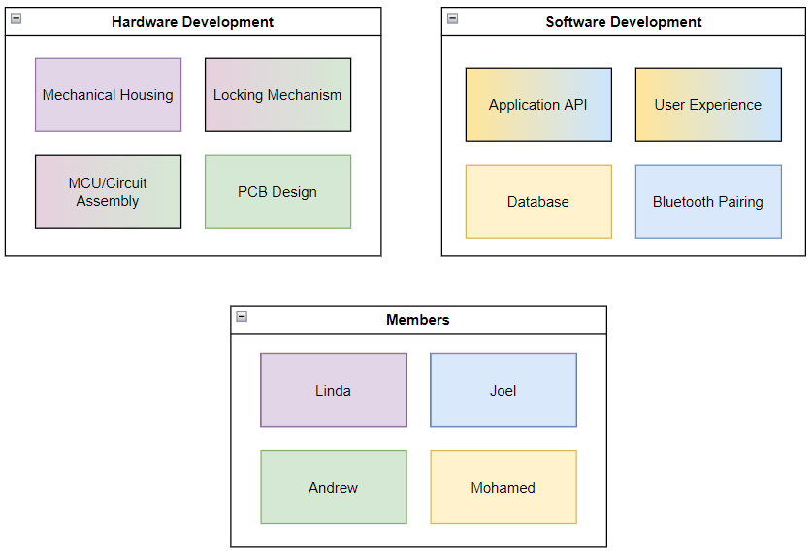
Figure 59: Division of Labor for Live Bolt

Going into Senior Design 2, the team will continue to carry out this division of duties when creating the application and physical product. Physical testing has already begun for most of the hardware of the project, so we will need to continue this in Senior Design 2 and order the printed circuit board to begin testing that and incorporating each subsystem into the final product.

9.1 Milestone Discussion
In Table 19 and Table 20, shown below detail our plans of researching and completing our senior design project. Table 19 focuses on our milestones we will be working on in Senior Design I while Table 20 lists our milestones for Senior Design 2.

The milestones column lists the tasks we are trying to accomplish during each semester. The duration column lists the number of weeks we will devote to each milestone. The dates column lists the deadlines we must complete the milestone by to keep on track. Some of the dates in Table 20 are tentative as we do not know the exact dates, we will need to complete milestones that far into the future. As we continue working on and researching our project, we plan to revisit these milestones frequently.

Table 19: Senior Design 1 Milestones
Milestone | Duration | Dates
Brainstorm | 1 Week | January 14
Select Project | 1 Week | January 21
Divide and Conquer | 2 Weeks | February 4
Research | 4 Weeks | March 4
Table of Contents | 1 Week | March 11
60 Pages Due | 2 Weeks | March 25
Edit Draft | 3 Weeks | April 15
Finalize Report | 1 Week | April 22
Submit Final Report | 1 Week | April 29

Table 20: Senior Design 2 Milestones
Milestone | Duration | Dates
Source Remaining Parts | 2 Weeks | September 2
Build Prototype | 4 Weeks | September 30
Test and troubleshoot | 3 Weeks | October 21
Finalize Prototype | 3 Weeks | November 11 (Tentative)
Final Report | 2 Weeks | November 25 (Tentative)
Final Presentation | 1 Weeks | December 2 (Tentative)

9.2 Software Development Gantt Chart
The Gantt chart shown in Figure 60 was created using the TeamGantt website and covers all the major software planning and development tasks for the Spring 2022 semester. The timeline of this chart is from January 9th to April 29th, four months into the semester. The two categories, Research and Design, contain several smaller tasks with their completion percentages displayed as well. At the time of writing this section, all research tasks have been completed and almost half of the application’s design has been done. The main tasks being worked on now are the design of the application’s UI and population of test data to the application database. Most of the software planning and design were done by two members of the team, with much of the work divided evenly between them.
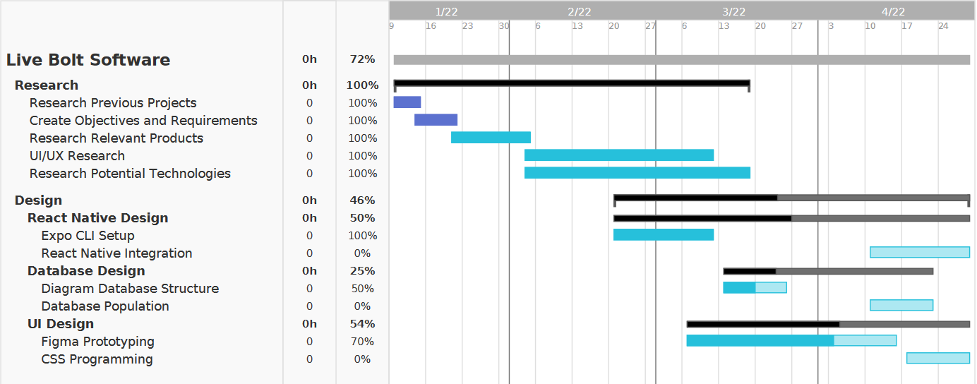
Figure 60: Software Development Gantt Chart

9.3 Hardware Development Gantt Chart
In Figure 61, the senior design 1 hardware development process is highlighted. The outline consists of crossing from February to May showing our preliminary research to finalizing the design for our senior design report. A couple of important mentions to the gantt chart is that the dark blue represents finished, purple means in progress but behind, pink is present actions and light blue it future actions.

This Gantt chart extends to senior design 2 to outline our goals and keep track of future progress. This gantt chart isn’t a final product to represent all of hardware’s necessary action. Instead, this is represented as a draft that can edited later.

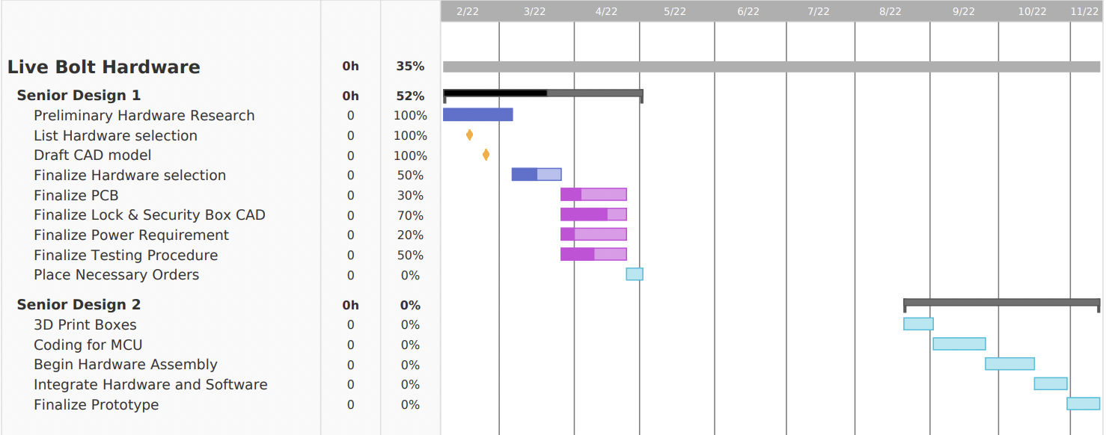
Figure 61: Hardware Development Gantt Chart

9.4 Budget and Finance Discussion
A goal is to make Live Bolt as cost-effective as possible while maintaining quality in the build and design. This is due to two main reasons: wanting to keep costs down for any hypothetical consumer who purchases the system, and lack of outside sponsorship for this project. All costs associated with Live Bolt’s development are being directly funded by the four team members. Development for the Live Bolt system will cost approximately $242.72 for a fully working product. This is within the team’s original budget and is relatively cheap and cost effective. The cost would be higher to produce more however, since the team would need to purchase more components that they already had before. We would have to purchase more ESP8266s, keypads, LEDs, and buzzers, which would drive up the production cost.
Table 21 outlines the parts we have identified for the product and their costs. Most items are marked as 2 needed, so there will be backup components in case any malfunction. The price per single unit and total price are both listed. Items marked as $0 indicate that the team already has them, so there is no need to include those costs in the final price. The final row also provides the total cost of all components and the amount of money each member of the group will contribute. Development for the Live Bolt system will cost approximately $242.72 for a fully working product. This is within the team’s original budget and is relatively cheap and cost effective. The cost would be higher to produce more however, since the team would need to purchase more components that they already had before. We would have to purchase more ESP8266s, keypads, LEDs, and buzzers, which would drive up the production cost.

Table 21: Bill of Materials
Part Description | Qty Needed | Price/Unit | Estimated Total Price
Raspberry Pi 3 | 1 | $0 | $0
LED’s | 1 | $0 | $0
Assorted Wires, LEDs, Buzzer, and other electrical components | - | $0 | $0
Camera | 2 | $15 | $30
Keypad | 2 | $0 | $0
NFC Reader | 2 | $9 | $18
IR Motion Sensor | 2 | $8 | $16
Raspberry Pi Microphone Array | 2 | $29 | $58
High Torque Servo | 2 | $20 | $40
Lock Battery Holder | 1 | $2 | $2
Security Battery holder | 1 | $7 | $7
PLA 3D Printing Filament | 1 | $22 | $22
ESP8266 | 2 | $0 | $0
PCB Printing | 2 | $24.86 | $49.72
Doorknob and lock for Testing | 1 | $0 | $0
Total Members | 4 | $60.68 | $242.72

Appendices

Appendix A: References

References

[1] |  | [Online]. Available: https://magpi.raspberrypi.com/articles/raspberry-pi-4-vs-raspberry-pi-3b-plus.
[2] |  | [Online]. Available: https://www.biometricupdate.com/202001/biometric-facial-recognition-hardware-present-in-90-of-smartphones-by-2024.
[3] |  | "Fingerprint Scanners: What are the Different Types?," Almas Industries, [Online]. Available: https://almas-industries.com/blog/fingerprint-scanners-types/.
[4] |  | "Controlling AC Devices with Arduino," DroneBot Workshop, [Online]. Available: https://dronebotworkshop.com/ac-arduino/.
[5] |  | [Online]. Available: https://www.wynnslocksmiths.com.au/electric-strike-magnetic-lock-difference/.
[6] |  | [Online]. Available: https://www.hvrmagnet.com/blog/what-is-electromagnetic-lock-and-how-it-works/.
[7] |  | [Online]. Available: https://www.frontrangelocksmith.com/blog/the-best-lock-for-your-home-is-your-lock-really-safe/.
[8] |  | "Liquid Crystal Displays (LCD) with Arduino," Arduino, [Online]. Available: https://docs.arduino.cc/learn/electronics/lcd-displays.
[9] |  | "AA battery," [Online]. Available: https://en.wikipedia.org/wiki/AA_battery.
[10] |  | "Coding Standards and Guidelines," [Online]. Available: https://www.geeksforgeeks.org/coding-standards-and-guidelines/ .
[11] |  | "Developer Content Policy," [Online]. Available: https://play.google.com/about/developer-content-policy/.
[12] |  | "App Store Review Guidelines," [Online]. Available: https://developer.apple.com/app-store/review/guidelines/#performance.
[13] |  | [Online]. Available: https://www.ieee.org/about/corporate/governance/p7-8.html.
[14] |  | [Online]. Available: https://developer.android.com/guide/topics/connectivity/bluetooth.
[15] |  | [Online]. Available: https://github.com/rusel1989/react-native-bluetooth-serial#events.
[16] |  | [Online]. Available: https://code.visualstudio.com/docs.
[17] |  | [Online]. Available: https://reactnative.dev/docs/components-and-apis#basic-components.
[18] |  | [Online]. Available: https://reactnative.dev/docs/virtualizedlist.
[19] |  | [Online]. Available: https://reactnative.dev/docs/pressable.
[20] |  | [Online]. Available: https://reactnative.dev/docs/keyboardavoidingview.
[21] |  | "Near field communication overview," [Online]. Available: https://developer.android.com/guide/topics/connectivity/nfc.
[22] |  | "Core NFC," [Online]. Available: https://developer.apple.com/documentation/CoreNFC.
[23] |  | [Online]. Available: https://support.apple.com/en-us/HT208108.
[24] |  | "TCP," [Online]. Available: https://developer.mozilla.org/en-US/docs/Glossary/TCP.
[25] |  | K. Pattabiraman, "Circuit Basics," [Online]. Available: https://www.circuitbasics.com/how-to-set-up-a-keypad-on-an-arduino/. [Accessed 2022].
[26] |  | "Blue Dot," [Online]. Available: https://bluedot.readthedocs.io/en/latest/index.html.
[27] |  | "Pair a Raspberry Pi and Android phone," [Online]. Available: https://bluedot.readthedocs.io/en/latest/pairpiandroid.html.
[28] |  | "TCP Communication with Android via wifi," [Online]. Available: https://raspberrypi.stackexchange.com/questions/66700/tcp-communication-with-android-via-wifi.
[29] |  | "How To Setup Communication Between Two ESP8266 Using Arduino," siytek, 30 March 2020. [Online]. Available: https://siytek.com/communication-between-two-esp8266/. [Accessed 20 April 2022].
[30] |  | "Cameras for Raspberry Pi," December 2021. [Online]. Available: https://www.arducam.com/docs/cameras-for-raspberry-pi/introduction/.
[31] |  | "Test Environment for Software Testing," [Online]. Available: https://www.guru99.com/test-environment-software-testing.html#3.
[32] |  | "The different types of software testing," [Online]. Available: https://www.atlassian.com/continuous-delivery/software-testing/types-of-software-testing.
[33] |  | T. B. A. Test Automation Frameworks – Why. [Online]. Available: https://www.testingxperts.com/blog/test-automation-frameworks.
[34] |  | "Jest," [Online]. Available: https://jestjs.io/.
[35] |  | "Mocha," [Online]. Available: https://mochajs.org/.
[36] |  | "Mocha.js, the JavaScript test framework: A tutorial," [Online]. Available: https://blog.logrocket.com/a-quick-and-complete-guide-to-mocha-testing-d0e0ea09f09d/#whatismochajs.
[37] |  | "Cypress," [Online]. Available: https://www.cypress.io/.
[38] |  | "Jasmine," [Online]. Available: https://jasmine.github.io/.
[39] |  | "Selenium," [Online]. Available: https://www.selenium.dev/.
[40] |  | "Introduction to Expo," [Online]. Available: https://docs.expo.dev/.
[41] |  | "Publish your app," [Online]. Available: https://support.google.com/googleplay/android-developer/answer/9859751?hl=en#zippy=%2Capp-status.
[42] |  | "Usage statistics of JavaScript as client-side programming language on websites," [Online]. Available: https://w3techs.com/technologies/details/cp-javascript/.
[43] |  | "Getting Started," [Online]. Available: https://developer.mozilla.org/en-US/docs/Web/Guide/AJAX/Getting_Started.
[44] |  | "Guidelines," [Online]. Available: https://developer.apple.com/app-store/guidelines/.
[45] |  | "802.11 Standards Explained: 802.11ax, 802.11ac, 802.11b/g/n, 802.11a," [Online]. Available: https://www.lifewire.com/wireless-standards-802-11a-802-11b-g-n-and-802-11ac-816553.
[46] |  | "How to Choose a Deadbolt - The Deadbolt Guide," [Online]. Available: https://www.doorware.com/specials/help-center/deadbolt-guide.cfm.
[47] |  | "Near Field Communication Technology Standards," [Online]. Available: http://nearfieldcommunication.org/technology.html.
[48] |  | "Bluetooth Standards and Technology," [Online]. Available: https://www.digi.com/solutions/by-technology/bluetooth-standards.
[49] |  | "Referential Integrity and Relational Database Design," [Online]. Available: http://web.mit.edu/11.521/www/lectures/lecture10/lec_data_design.html.
[50] |  | "Test Environment for Software Testing – A Detailed Guide," [Online]. Available: https://www.softwaretestingmaterial.com/test-environment/?utm_source=rss&utm_medium=rss&utm_campaign=test-environment.
[51] |  | "Top 3 JavaScript Testing Frameworks with their Pros and Cons," [Online]. Available: https://www.rlogical.com/blog/top-3-javascript-testing-frameworks-with-their-pros-and-cons/.
[52] |  | [Online]. Available: https://www.hackster.io/petewarden/recognizing-speech-with-a-raspberry-pi-50b0e6.
[53] |  | [Online]. Available: https://stt.readthedocs.io/en/latest/index.html.
[54] |  | [Online]. Available: reactnative.dev/docs/components-and-apis.
[55] |  | "Setting up a Routed Wireless Access Point," [Online]. Available: https://www.raspberrypi.com/documentation/computers/configuration.html#setting-up-a-routed-wireless-access-point.
[56] |  | [Online]. Available: https://support.apple.com/en-us/HT208108.

Appendix B: Figures
Figure 1: Reproduction Arduino Uno (Top) and Arduino Mega (Bottom) running ATmega architecture 11
Figure 2: Raspberry Pi 4 (Left) and Raspberry Pi 3B+ (Right) [1] 13
Figure 3: MSP430FR6989 Launchpad (Left) vs MSP430G2553 Launchpad (Right) 14
Figure 4: ESP32 (Left) vs ESP8266 NodeMCU (Right) 15
Figure 5: Example of an Electric Strike Lock on a Door [5] 24
Figure 6: Magnetic Lock on Door [6] 25
Figure 7: Traditional Dead Bolt Lock on Door [7] 25
Figure 8. Deadbolt lock size standards 35
Figure 9: Lock/Unlock Flowchart 47
Figure 10. Initial Sketch of Application Main Interface 50
Figure 11: Color Palette 1 51
Figure 12: Sample Login/Register Page 1 51
Figure 13: Sample Home/Profile Page 1 52
Figure 14: Setting/GPS Proximity Pages 1 53
Figure 15: Color Palette 2 54
Figure 16: Sample Login/Register Page 2 54
Figure 17: Sample Home/Profile Page 2 55
Figure 18: Settings Page 2 56
Figure 19: Login and Signup Navigation Flowchart 57
Figure 20: Use Case Diagram of Application including both Hardware/Software Unlocking Mechanisms 58
Figure 21: Sample Application Initial Logo Sketch 59
Figure 22: Sample Application Logo Mockup in Inkscape 59
Figure 23: API for react-native-ble-plx 61
Figure 24: Virtualized List on iPhone Example 67
Figure 25: Pressable State Diagram, courtesy of React Native 68
Figure 26: Entity Relationship Diagram 69
Figure 27: User and ActivityLog Objects 70
Figure 28: React Native Biometrics Diagram 72
Figure 29: Local Authentication Diagram 73
Figure 30: Deadbolt doorknob cover, fitted onto a door lock 75
Figure 31. Frontal view of the Doorknob Cover 76
Figure 32. Arduino Keypad Configuration 77
Figure 33. ReSpeaker 4-mic array 78
Figure 34. Arducam Connection to Pi 79
Figure 35. PIR Motion Sensor Layout 79
Figure 36. Servo Motor and Plastic Horns 80
Figure 37. Lock Box with components 83
Figure 38. Lock Box CAD dimension model 84
Figure 39. Lock Box assembled with removeable back 85
Figure 40. Security Box with components 86
Figure 41. Security Box CAD dimension model 87
Figure 42. Security Box assembled with removable back 88
Figure 43. Hardware Design Block Diagram 89
Figure 44: A screenshot of the PCB design window from KiCad 91
Figure 45: A screenshot of the PCB design window from Eagle 92
Figure 46: Security Module Circuit Schematic 93
Figure 47: Prototype Security PCB Design 94
Figure 48: 3D Prototype PCB Model 95
Figure 49: Lock Circuit Schematic 95
Figure 50: Prototype Lock PCB Design 96
Figure 51: Front Lock PCB 3D Model 96
Figure 52: Back Lock PCB 3D Model 97
Figure 53: JLCPCB PCB Order Options 98
Figure 54. Solidworks Straight horn Design 2 102
Figure 55. Solidworks X-horn Design 1 103
Figure 56: Hardware Development of NFC (Left) and PIR Sensor (Right) 107
Figure 57: Hardware Development of Membrane Keypad 107
Figure 58: Microphone array and Arducam camera interfaced with Raspberry Pi 110
Figure 59: Division of Labor for Live Bolt 117
Figure 60: Software Development Gantt Chart 119
Figure 61: Hardware Development Gantt Chart 120

Appendix C: Tables
Table 1: Requirement specifications for Security System Features 3
Table 2: Requirement specifications for Access Control Features 4
Table 3: Requirement specifications for Application Features 4
Table 4: Requirement specifications for Design Features 4
Table 5: House of Quality for Live Bolt 6
Table 6: Arduino Uno vs Arduino Mega Comparisons 10
Table 7: Raspberry Pi 3B+ vs Raspberry Pi 4 comparisons 12
Table 8: MSP430FR6989 Launchpad vs MSP430G2553 Launchpad comparisons 13
Table 9: ESP32 vs ESP8266 comparisons 16
Table 10: Comparisons Between Facial Recognition Methods 19
Table 11: Pin functions on LCD Display 27
Table 12: Communication protocols for NFC Reader 29
Table 13: Summary of Live Bolt Hardware 31
Table 14: Component Power Requirements 81
Table 15: Common PCB Terms 90
Table 16: Voltage divider resistor values and new voltages 94
Table 17: JLCPCB Shipping Costs and Delivery Times 98
Table 18: Pros and Cons for knob design 104
Table 19: Senior Design 1 Milestones 118
Table 20: Senior Design 2 Milestones 118
Table 21: Bill of Materials 121

