Fluoride Level Observation and Water Quality
F L O W

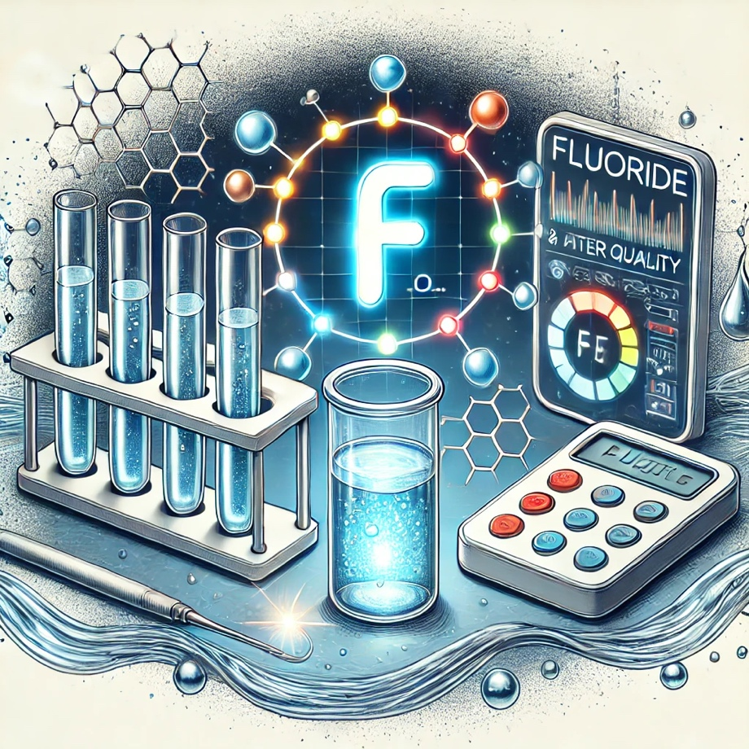

Senior Design 1 - Group 7

Elisa Johnston - Photonic Science and Engineering
Nyla Seymour - Computer Engineering
Nehito Dorval - Computer Engineering
Odane Lennox - Electrical Engineering

Project Committee: Dr. Mark Maddox, ECE
Dr. Jeremy Mares, CREOL

Advisers: Dr. Lei Wei, ECE
Dr. Aravinda Kar, CREOL
Table of Contents
Chapter 2 Project Description 1
2.1 Motivation 1
2.2 Background 2
2.3 Project Goals 2
2.3.1 Basic goal 2
2.3.2 Advanced goal 2
2.3.3 Stretched goal 2
2.3.4 Objectives……………………………………………………………………………....3
2.4 Description and Features/Functionalities 3
2.4.1 Optical System 3
2.4.2 Customer Input and Market Analysis 3
2.4.3 User-Friendly Interface………………………………………………………….4
2.4.4 Cost-Friendly Interface………………………………………………………....5
2.4.5 Data Acquisition and Processing…………………………………………….….5
2.4.6 Calibration and Validation…………………………………………………...….5
2.4.7 Sample Preparation…………………………………………………………….5
2.4.8 Customer Input and Market Analysis………………………………………….5
2.4.8.1 Existing Products…………………………………………………………...5
2.5 Engineering Specifications………………………………………………... 10
2.6 Block Diagrams 11
2.6.1 System Overview Block Diagram 11
2.6.2 Hardware Block Diagram 11
2.6.3 Software Block Diagram 13
2.6.3.1 Software Description……………………………………………………13
2.6.3.2 Software Implementation……………………………………………….13
2.6.3.3 Testing Environment…………………………………………………….14
Chapter 10 Administrative 15
10.1 Budget 15
10.2 Milestones 15
10.3 Work Distribution 15
Appendix A 15

Chapter 2 Project Description

2.1 Motivation and Background

Fluoride is a mineral that is naturally present in our environment. You can find it in the air we breathe, the soil, the water we drink, and even in the food we eat. Getting the right amount of fluoride is crucial for our overall health, especially for our bones and teeth. According to the World Health Organization (WHO), consuming fluoride can significantly reduce the risk of tooth decay and cavities. However, it's important to note that too much fluoride can have negative effects on health.[1]

When we are exposed to high levels of fluoride over a long period, it can lead to serious health issues such as skeletal fluorosis. This condition is characterized by pain and stiffness in the joints, and in severe cases, it can cause bone deformities. Excessive fluoride accumulates in the bones, making them hard and less elastic, which can result in joint pain and damage.[1]

WHO estimates that at least 2.4 billion people worldwide suffer from cavities in their permanent teeth, including about 486 million children.[2] Tooth decay is a major public health issue, and this is why WHO and other health organizations promote public health initiatives to ensure people get enough fluoride, particularly in areas where it is deficient. One effective method to increase fluoride intake is by adding fluoride to community drinking water supplies. This process, known as water fluoridation, has been shown to significantly reduce the incidence of cavities.[3]

However, since fluoride is naturally present in the environment, especially in groundwater, there is a risk of consuming too much fluoride. This is particularly true for communities that rely on groundwater for drinking and agriculture. High levels of fluoride can lead to conditions like skeletal fluorosis and dental fluorosis. Skeletal fluorosis affects the bones and joints, causing pain and stiffness as mentioned above. Dental fluorosis affects the teeth, leading to discoloration and damage to tooth enamel. In severe cases, the enamel can become pitted and discolored.[1]

WHO predicts that high levels of fluoride in drinking water will continue to affect millions of people worldwide with dental and skeletal fluorosis for years to come. Many affected communities may unknowingly consume excessive fluoride due to a lack of technology to detect fluoride levels in drinking water. Addressing this issue requires both monitoring fluoride levels and implementing measures to mitigate excessive fluoride exposure, such as using alternative water sources or employing de-fluoridation techniques where necessary.[2]

Our motivation for this project stems from the clear need for a reliable, affordable, and portable method to measure fluoride levels in drinking water. Current technologies are either too expensive or not easily accessible, particularly for communities in developing regions. We aim to bridge this gap by developing a device that uses fluorescence spectroscopy to provide accurate, real-time data on fluoride concentrations. This device will empower communities to take control of their water quality, ensuring they can maintain safe fluoride levels to protect their health.

By providing an affordable solution, we hope to support global health initiatives that aim to manage fluoride levels more effectively. Our device will not only help prevent the negative health impacts of both fluoride deficiency and excess but also contribute to raising awareness about the importance of monitoring drinking water quality. Our goal is to develop a tool that is easy to use, portable, and cost-effective, making it accessible to everyone who needs it. By addressing the need for affordable and accurate fluoride detection, we aim to contribute to the global effort to safeguard public health.

2.3 Project Goals

2.3.1 Basic goal
- Build a prototype that can accurately measure fluoride levels in water, with an accuracy of ±0.1 mg/L. This prototype will help us test and improve our design in real-world conditions.
- Set a minimum detection level. Make sure the device can detect at least 0.5 mg/L of fluoride, just below the safe level for intake for human body. This will cover the typical fluoride levels found in drinking water and ensure the device can monitor even small amounts of fluoride effectively.
- Calibrate the device. Prepare fluoride solutions with known concentrations (0.1, 0.5, 1, 2, 5 mg/L) and measure their fluorescence intensity. Plot these measurements to create a calibration curve, which will help interpret the device’s readings accurately.

2.3.2 Advanced goal
- Improve the device so it can detect very low levels of fluoride, down to 0.05 mg/L. This will help it work better in areas where fluoride levels are very low, giving more accurate and reliable water quality data.
- Test the device with different kinds of water, including those with other substances that might interfere. This will show that the device works well in real-world conditions and can give accurate readings no matter what is in the water.

2.3.3 Stretched goal
- Design and build a housing for the device that is lightly sealed to prevent stray light from interfering with the measurements. This will help ensure accurate and reliable readings by protecting the device from external light sources.
- Design the housing so that the device is easy to carry and use in different locations. This will allow users to monitor water quality conveniently, whether they are in the field, in rural areas, or moving between different testing sites.

2.3.4 Objective
- Research and choose a high-sensitivity, high-selectivity probe for fluoride ions: We'll focus on identifying a suitable fluorescent probe, such as a BODIPY-based probe, known for its high sensitivity and selectivity for fluoride ions.
- Validate probe sensitivity and selectivity through preliminary tests: Conduct initial tests to confirm that the selected probe responds accurately and reliably to fluoride ions, ensuring it meets the required standards for our device.
- Construct an optical system: We will build an optical system using a laser light source, a dichroic beam splitter, an excitation filter, an emission filter, and a photodetector. We will also use lenses to collimate and focus light onto the beam splitter, cuvette and photodetector. This setup is crucial for accurately measuring the fluorescence emitted by the probe in response to fluoride ions.
- Prepare standard fluoride solutions: We'll prepare a series of fluoride solutions with known concentrations (0.1, 0.5, 1, 2, 5 mg/L).
- Measure fluorescence intensity for each standard solution: Using our optical system, we will measure the fluorescence intensity of each standard solution.
- Plot fluorescence intensity vs. fluoride concentration: Establish a calibration curve by plotting the measured fluorescence intensity against the fluoride concentration. This curve will be essential for interpreting the device's readings accurately.

2.4 Description and Features/Functionalities

2.4.1 Fluorescence Detection: Our device will be able to measure fluoride levels in water using fluorescence spectroscopy. This technique relies on a fluorescence probe, which changes its fluorescence, or light emission, when it reacts with fluoride ions in the water.[4] We will shine a specific wavelength of light of higher energy, onto the sample, causing the probe to emit light at a different wavelength, a lower energy wavelength. A photodiode will measure this emitted light to accurately determine the fluoride concentration.

2.4.2 Portable and Compact Design: One of the primary goals for our device is to ensure it is portable and compact. We aim for it to weigh less than 1 kg, making it easy to carry and use in various locations, including remote areas. This portability will allow for on-site water testing without needing a fully equipped laboratory.
2.4.3 User-Friendly Interface: The user interface of our device will feature a simple LCD or OLED screen to display real-time fluoride level readings. We intend to design this interface to be intuitive, guiding users through each step of the measurement process. This will ensure that the device is accessible even to individuals with minimal technical background, facilitating widespread use.

2.4.4 Cost-Effective Components: To keep the device affordable while maintaining high quality, we plan to use cost-effective components. These will include a laser diode for the excitation process, a silicon photodiode for detecting the emitted light, and commercial optical filters to ensure only the specific wavelengths of light are measured. This approach aims to reduce costs without compromising performance.

2.4.5 Data Acquisition and Processing: Our design includes integrating a microcontroller, such as an Arduino, to automate data collection and processing. The microcontroller will gather data from the photodiode, process the fluorescence intensity, and calculate the fluoride concentration. The results will then be displayed on the screen, providing immediate and reliable readings.

2.4.6 Calibration and Validation: To ensure the device's accuracy over time, we plan to include a calibration module. Users will be able to calibrate the device using standard fluoride solutions, measuring known concentrations to create a calibration curve. This curve is essential for accurately calculating fluoride levels in unknown samples, ensuring the device remains reliable.

2.4.7 Sample Preparation: The sample preparation process we are planning is straightforward. Users will collect water samples and filter them if necessary to remove particles. The sample will then be mixed with the Zirconium-Alizarin complex solution, which reacts with any fluoride ions present. The device will then shine a 450 nm laser light onto the prepared sample. If fluoride is present, the sample will emit light at a different wavelength, which will be detected by the photodiode. The microcontroller will process this data and calculate the fluoride concentration.

2.4.8 Customer Input and Market Analysis
I reviewed multiple articles from companies that manufacture spectrometers for water quality monitoring. While our project focuses specifically on detecting fluoride levels in drinking water, these industry products offer broader applications in environmental and industrial settings. Comparing our concept with existing products revealed a market gap for devices that can continuously monitor water quality and provide real-time data. This feedback informed our decision to incorporate features such as portability, high sensitivity, and user-friendly interfaces, along with the option for remote monitoring and automated calibration.

2.4.8.1 Existing Products

Agilent Cary Eclipse Fluorescence Spectrometer[5]

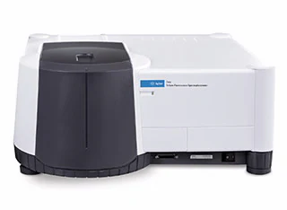
Pros:
- Wavelength Range: Operational excitation and emission wavelengths range from 200 nm to 900 nm.
- Versatile Measurements: Offers high sensitivity and can switch between fluorescence, phosphorescence, chemiluminescence, and bioluminescence measurements.
- Fast Data Collection: Exceptional data collection speed, scanning the entire wavelength range in under three seconds.
- Room Light Immunity: Can operate with the sample compartment open, providing ease of access to samples.
- Longevity and Low Cost of Ownership: Equipped with a xenon flash lamp with a guaranteed lifetime of up to 10 years, reducing the need for frequent replacements.
Cons:
- Price: Ranges from $15,000 to $25,000, depending on configuration and accessories.
- Weight: Weighs around 30 kg, making it less portable.

HORIBA Aqualog® [6]

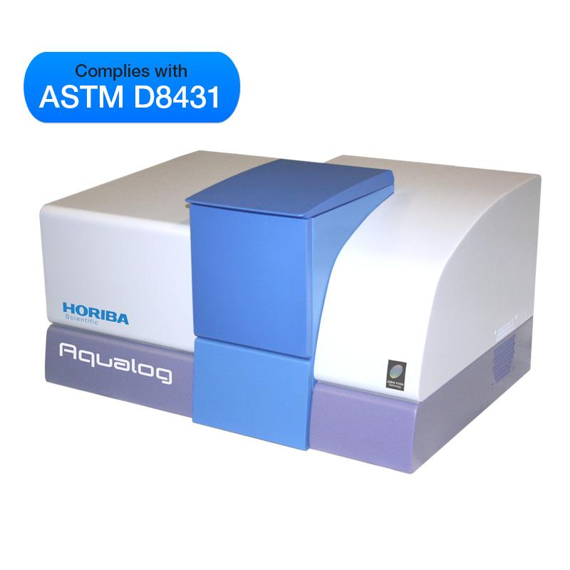
Pros:
- Wavelength Range: Operational excitation and emission wavelengths range from 250 nm to 800 nm.
- Simultaneous Measurements: Capable of simultaneous absorbance, transmission, and fluorescence Excitation-Emission-Matrix (EEMs) acquisition.
- Comprehensive Data Analysis: Ideal for detailed water quality analysis and environmental monitoring due to its ability to capture comprehensive spectral data.
Cons:
- Price: Ranges from $30,000 to $50,000 based on the configuration and additional features.
- Weight: Weighs around 32 kg, which is quite heavy and limits portability.

RF-6000 Spectrofluorophotometer[7]

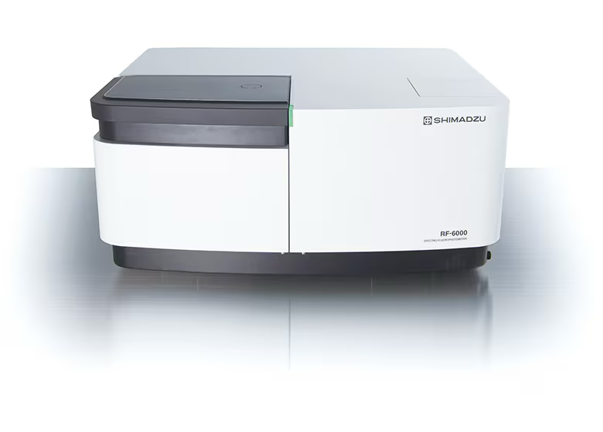
Pros:
- Wavelength Range: Operational excitation and emission wavelengths range from 200 nm to 900 nm.
- Versatile Applications: Suitable for a variety of applications including environmental, biochemical, and material science research.
- High Sensitivity and Stability: Provides high sensitivity and excellent stability, making it suitable for various analytical tasks.
Cons:
- Price: Ranges from $20,000 to $30,000 based on configuration and additional features.
- Weight: Slightly less portable due to its weight and size.

2.5 Engineering Specifications

Component | Parameter | Specification
Laser Diode | Wavelength | 450 nm
 | Output Power | 5 mW
 | Beam Divergence | <1 mrad
Zirconium-Alizarin Complex | Detection Range | 0.05 mg/L to 5 mg/L
 | Fluorescence Emission | 500-600 nm
Optical Filters | Excitation Filter Bandwidth | 40 nm (centered at 450 nm)
 | Emission Filter Bandwidth | 50 nm (centered at 550 nm)
Photodiode | Sensitivity | 0.1 µA/W
 | Response Time | <1 ms
Microcontroller | Processing Speed | 16 MHz
 | Memory | 32 KB Flash, 2 KB SRAM
Display | Type | LCD/OLED
 | Resolution | 128 x 64 pixels
Power Supply | Voltage | 5V DC
 | Battery Life | Up to 8 hours continuous use
Calibration Module | Calibration Stability | Monthly calibration required
 | Accuracy | ±0.1 mg/L

2.6 Block Diagrams

2.6.1 System Overview Block Diagram

2.6.2 Hardware Block Diagram
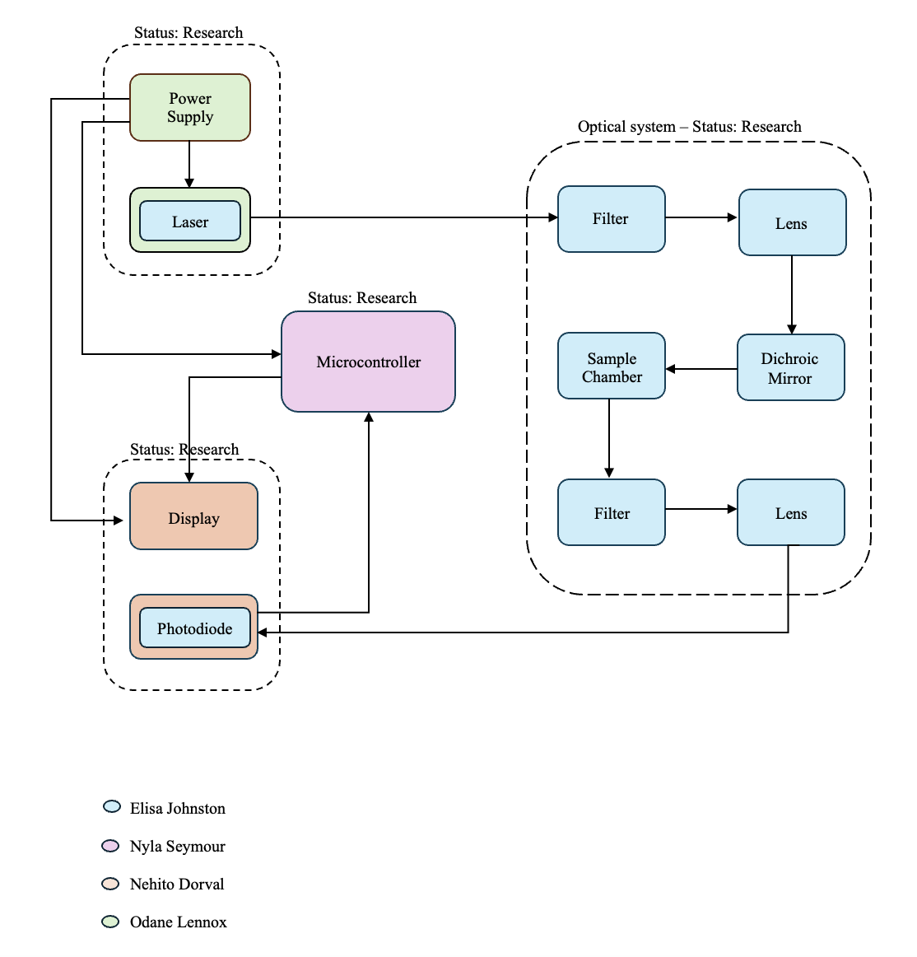

2.6.3 Software Block Diagram

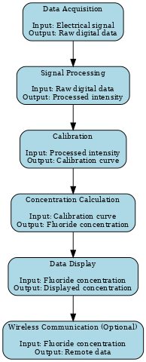
Figure 3: The software diagram illustrates the architecture and flow of a software system, mapping out its components, interactions, and data flow to provide a visual understanding of the software's structure and behavior.

2.6.3.1 Software Description
The portable fluoride detection device's software is made to analyze signals from a Si photodiode, determine the amount of fluoride in drinking water, and show the user the results. The software is divided into multiple modules, each of which performs a certain task in the overall procedure. The initial step in the process is the Data Acquisition Module. It records the first electrical signal from the Si photodiode, which indicates how bright the sample's fluorescence is. This module forms the raw data required for additional analysis by converting the analog signal from the photodiode into a digital format that the microcontroller can process.
After data is acquired, control is transferred to the Signal Processing Module. After receiving the raw data from the data acquisition module, this module processes it in order to obtain values for the fluorescence intensity that are useful. In order to eliminate noise and guarantee that the recovered data appropriately depicts the fluorescence intensity, it filters, amplifies, and improves the signal quality. Subsequently, a calibration curve is generated by the Calibration Module using the processed fluorescence intensity data and standard fluoride solution data. The fluorescence intensity and known fluoride concentrations are correlated by this curve. Because it offers the reference required to ascertain the fluoride concentration in unidentified samples, the calibration module is essential.
Calibration is followed by the Concentration Calculation Module. The actual fluoride concentration in the sample is determined using the calibration curve and the processed fluorescence intensity. This module produces an accurate measurement of the fluoride concentration by applying the calibration data to the fluorescence intensity. The user is subsequently shown the computed fluoride concentration by the Data Display Module. It presents the numerical data on an interface, like an LCD or OLED screen, after converting it into a format that can be read by humans. This module makes sure the user can readily obtain and understand the results. Optionally, a Wireless Communication Module can be included. If present, this module takes the calculated fluoride concentration and transmits it to a mobile app or computer for remote monitoring and data logging. This feature adds convenience by allowing users to track and record fluoride levels over time.

2.6.3.2 Software Implementation

The software implementation entails writing code for the modules mentioned above in C that is compatible with microcontrollers. This ensures precise computation of fluoride concentration and effective data processing. In order to capture and digitize the photodiode signal, the Data Acquisition Module implementation necessitates creating an Analog-to-Digital Converter (ADC) interface and setting the ADC for the proper sample rates and resolution. Creating filtering algorithms to eliminate noise from the raw data, putting amplification functions into place to boost the signal, and writing code for signal extraction with an emphasis on the pertinent fluorescence intensity are all part of the Signal Processing Module.
A data structure must be made for the Calibration Module in order to hold the standard fluoride solutions and matching fluorescence intensities. Using this data, algorithms must be created to produce a calibration curve; also, the calibration procedure needs to be reproducible and user-friendly. In order to calculate and output the fluoride concentration, the Concentration Calculation Module needs to implement functions that apply the calibration curve to the processed fluorescence intensity. The Data Display Module entails connecting to a display screen (such as an LCD or OLED), creating an easy-to-read format for the fluoride concentration, and making sure the display refreshes automatically with fresh data. Implementing wireless communication protocols, such as Bluetooth or Wi-Fi, creating an interface for data transfer to external devices, and guaranteeing safe and dependable data transmission are all necessary for the Wireless Communication Module.
2.6.3.3 Testing Environment

To guarantee thorough validation of every module, the software testing environment will comprise both hardware and software components. A Si photodiode linked to the microcontroller, common fluoride solutions for calibration, an LCD/OLED display screen for data viewing, and optional wireless connection devices make up the hardware configuration. An Integrated Development Environment compatible with the microcontroller, such as an Arduino IDE, to simulate the signal acquisition and processing, and test scripts to automate the concentration calculation and calibration processes will be the tools used for software testing. There will be multiple steps in the testing process. Every module will be tested separately during unit testing to guarantee proper functionality. Modules will be gradually combined throughout integration testing, and their relationships will be examined. System testing will use genuine samples and a realistic situation to test the entire system. Performance testing will assess the speed, accuracy, and dependability of the system. Ultimately, user testing will be done to make sure the interface fits user needs and is easy to use. The software for the portable fluoride detection gadget will produce accurate and trustworthy results by putting strict testing procedures in place and making sure every module works correctly and efficiently.

Chapter 10 Administrative

10.1 Budget

10.2 Milestones

10.3 Work Distribution

Declaration:
We hereby declare that we have not copied more than 7 pages from the Large
Language Model (LLM). We have utilized LLM for drafting, outlining, comparing, and summarizing.

References

[1] W. H. O. 2004. "Fluoride in Drinking-water." https://www.who.int/docs/default-source/wash-documents/wash-chemicals/fluoride-background-document.pdf (accessed.
[2] W. H. Organization. "Inadequate or excess fluoride." https://www.who.int/teams/environment-climate-change-and-health/chemical-safety-and-health/health-impacts/chemicals/inadequate-or-excess-fluoride (accessed.
[3] S. Peckham and N. Awofeso, "Water Fluoridation: A Critical Review of the Physiological Effects of Ingested Fluoride as a Public Health Intervention," The Scientific World Journal, vol. 2014, pp. 1-10, 2014, doi: 10.1155/2014/293019.
[4] I. Stone, "Detection of fluorides using the zirconium lake of alizarin," Journal of Chemical Education, vol. 8 (2), p. 347, doi: https://doi.org/10.1021/ed008p347.
[5] "Cary Eclipse Fluorescence Spectrometer." https://www.agilent.com/en/product/molecular-spectroscopy/fluorescence-spectroscopy/fluorescence-systems/cary-eclipse-fluorescence-spectrophotometer (accessed.
[6] "Aqualog - Environmental Water Research Analyzer." https://www.horiba.com/int/scientific/products/detail/action/show/Product/aqualog-environmental-water-research-analyzer-3497/ (accessed.
[7] "RF-6000 Spectrofluorophotometer." https://www.ssi.shimadzu.com/products/fluorescence/fluorescence-spectroscopy/rf-6000/index.html (accessed.

