Senior Design 1
Fluoride Level Observation in drinking Water
F L O W
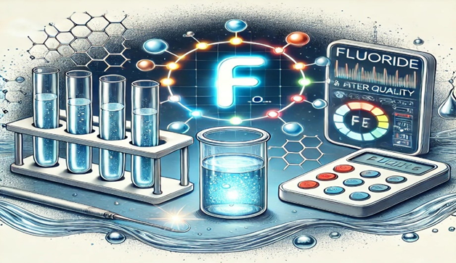
College of Electrical Engineering and Computer Science
College of Optics and Photonics
University of Central Florida
Dr. Lei Wei, ECE
Dr. Aravinda Kar, CREOL
Group 7 CREOL
Nehito Dorval- Computer Engineering
Elisa Johnston- Photonic Science and Engineering
Odane Lennox- Electrical Engineering
Nyla Seymour- Computer Engineering
Project Committee: Dr. Mark Maddox, ECE Dr. Jeremy Mares,CREOL

Table of Contents
Chapter 1 Executive Summary 1
Chapter 2 Project Description 3
2.1 Motivation and Background 3
2.2 Project Goals 5
2.2.1 Basic goal 5
2.2.2 Advanced goal 5
2.2.3 Stretched goal 5
2.2.4 Basic Objective 5
2.2.5 Advanced Objective 6
2.2.6 Stretched Objective 7
2.3 Description and Features/Functionalities 7
2.3.1 Fluorescence Detection 7
2.3.2 Portable and Compact Design 7
2.3.3 User-Friendly Interface 8
2.3.4 Cost-Effective Components 8
2.3.5 Data Acquisition and Processing 9
2.3.6 Calibration and Validation 9
2.3.7 Sample Preparation 9
2.3.8 Customer Input and Market Analysis 9
2.3.9 House of Quality 11
2.3.10 Existing Products 13
2.3.11 Cary Eclipse 13
2.4 Engineering Specifications 18
2.4.1 Detection Range (0.1 ppm to 10 ppm) 18
2.4.2 Measurement Accuracy (±0.05 ppm) 18
2.4.3 Fluorescence Excitation Wavelength (554 nm) 18
2.4.4 19
2.4.5 Sampling Volume (3.5 mL) 20
2.4.6 Response Time (< 10 seconds) 20
2.4.7 Power Supply Voltage (5V USB powered) 20
2.4.8 Operating Temperature Range (10°C to 40°C) 20
2.4.9 Data Output Interface (I2C and SPI) 20
2.6 Block Diagrams 22
2.6.1 Optical System Overview Block Diagram 22
2.6.2 Hardware Block Diagram 23
Block Diagram Overview 23
2.6.3 Software Block Diagram 24
Chapter 3: Research and Part Selection 25
3.1 Research 26
3.1.1 Existing Methods for Fluoride Detection 27
3.1.2 Fluorescence Spectroscopy 28
3.1.2 Types of Fluorescence Spectroscopy 30
3.2 Technology Comparison 31
3.2.2 Detection Method: Photodiode vs. Photomultiplier Tube (PMT) vs. CCD Camera 32
3.2.3 Filter Type: Bandpass vs. Notch Filter 33
3.2.4 Case Study Real-World Case Studies, Scenarios, and Applications of the FLOW Device 33
3.3 Part Selections 40
3.3.1 Optical Components 40
3.3.2 Light Source 40
Table 4: Light source comparison 40
3.3.3 Lenses 41
Table 5: Lens Comparison 43
3.3.4 Optical Filter Comparison 43
Table 6: Emission Filter 44
3.3.5Photo Detector Comparison 45
Table 7: Detector Comparison 45
Table 8 Fluorescent Probes 46
3.4. PCB Integration 47
3.4.1 Design Techniques 47
3.4.2 Part selections 53
3.4.2.1 Microcontroller Selection 53
Table 9: Microcontrollers 53
3.4.2.2 USB-To-UART Bridge 55
Table 10: Universal Asynchronous Receiver/Transmitter Bridge 55
3.4.2.3 Voltage Regulator Selection 55
Table 11: Linear, Low Drop Out (LDO) Voltage regulator 55
Table 12: Switching Voltage regulator 56
3.4.2.4 Electrostatic Discharge Circuit Protection 57
Table 13: Transient Voltage Suppressors ESD Protection 57
3.4.2.5 Connection Interface 58
Table 14: Universal Serial Bus Port 58
3.4.2.6 Peripherals 59
Table 15: LEDs 59
Table 16: Switches 59
3.5 Software Research 61
3.5.1 Integrated Development Environment Analysis 61
3.5.1.3 STM32CubeIDE 63
3.5.2 Selected IDE 67
3.5.3 LED/OLED Display 68
Chapter 4 Standards and Design Constraints 72
4.1 Standards 72
4.1.1 ISO 5725-1: Accuracy (Trueness and Precision) of Measurement Methods and Results 72
4.1.2 ISO 7027: Water Quality - Determination of Turbidity 72
4.1.3 IEC 60825-1: Safety of Laser Products 73
4.1.4 ISO 14001: Environmental Management Systems 73
4.1.5 ANSI Z136.1-2014 73
4.1.6 IEEE-370-2020 74
4.1.7 IPC-2221 74
4.1.8 IPC-4101 75
4.1.9 IEC 60529 (1989 +A1: 1999 + A2: 2013) 75
4.1.10 ISO/IEC 25010:2011 - Systems and Software Quality Requirements and Evaluation (SQuaRE) 75
4.1.11 ISO/IEC 12207:2017 - Systems and Software Engineering - Software Life Cycle Processes 75
4.1.12 ISO/IEC 29119 - Software and Systems Engineering - Software Testing 76
4.1.13 IEC 62304:2006 - Medical Device Software - Software Life Cycle Processes 76
4.1.14 ISO/IEC 27001 - Information Security Management 76
4.1.15 ISO/IEC 12207:2008 - Software Life Cycle Processes 76
4.1.16 Optics Standards 77
Table 19: Software Standards Summary 78
4.2 Optical Design Constraints 78
4.2.1 Budget Constraints 78
4.2.2 Component Availability 79
4.2.3 Accuracy and Sensitivity Requirements 79
4.2.4 Size and Portability Constraints 80
4.2.5 Ease of Use 80
4.3 Hardware Constraints 80
4.3.1 Wireless Bluetooth Connectivity 80
4.3.2 Multilayer PCB 81
4.4 Software Constraints 81
4.4.1 Microcontroller Limitations 81
Processing Power: 81
4.4.2 Memory Usage 81
4.4.3 Power Consumption 81
4.4.4 Real-Time Processing 81
4.4.5 Accuracy and Precision 82
4.4.6 User-Friendliness 82
4.4.7 Data Storage 82
Table 20: Software Constraints Summary 82
4.5 Safety Constraints 83
4.5.1 Chemical Safety 83
4.5.2 Electrical Safety 83
4.5 Time Constraints 83
4.5 Economic Constraints 84
Chapter 5 Comparison of ChatGPT and Similar Platforms 85
5.1 ChatGPT Analysis 85
5.2 Understanding Large Language Models (LLMs) 85
5.3 Google Bard 86
5.4 HuggingChat 86
5.5 WriteSonic 87
5.6 Bing AI 87
5.7 Claude 87
5.8 Perplexity 88
5.9. ChatSonic 88
5.10 Poe 88
5.11 Pi 89
5.12 Amazon CodeWhisperer 89
5.13 Jasper AI 89
5.14 Conclusion 89
Chapter 6 Hardware Design 91
6.1 PCB Design Integration 91
6.2 Power Supply 92
6.2.1 PC Power Supply 92
6.3 Voltage Regulator design 93
6.4 PCB Manufacturing Capabilities 96
6.5 Housing 97
Chapter 7 Software Design 98
7.1 Overall Software Design 98
7.2 User Interface 102
7.3 Data Transfer 104
7.3.1 Bluetooth Low Energy (BLE) Data Transmission 105
7.3.2 Wi Fi Data Transmission 106
7.3.3 Connecting with the Mobile App 107
7.4 Using Data Structures 108
7.4.1 Arrays 108
7.4.2 Linked Lists 108
7.4.3 Structs 108
7.4.4 Queues 108
7.4.5 Circular Buffers 108
7.4.6 Trees and Hash Tables 109
7.5 Programming ESP32 Microcontroller 109
7.6 Software Architecture Testing 110
Chapter 8 System Fabrication/Prototype Design 112
8.1 PCB Schematic 113
8.2 PCB Board Layout 115
Chapter 9 System Testing and Evaluation 117
9.1 Hardware and Software Testing 117
9.1.1 Optical Hardware Testing 117
9.1.2 PCB Hardware Testing 118
9.1.3 Software Testing 118
9.2 Performance Evaluation 118
9.4 Software Plan for Senior Design 2 121
Chapter 10 Administrative 123
10.1 Budget 123
Table 22: Estimated Expenses 123
Table 23: Bill of Materials 124
10.2 Milestones 125
10.3 Work Distribution 127
10.4 Declaration 127
Chapter 11 Conclusion 128

Chapter 1 Executive Summary
The F.L.O.W (Fluoride Level Observation in Water) project is motivated by the critical need to monitor fluoride concentrations in drinking water. Fluoride, a naturally occurring mineral, plays a vital role in dental health by preventing tooth decay and cavities. According to the World Health Organization (WHO), the optimal fluoride concentration in drinking water should be between 0.5 and 1.5 mg/L to prevent dental caries. However, excessive fluoride levels can lead to adverse health effects, including dental and skeletal fluorosis. This project aims to address the dual challenge of ensuring adequate fluoride intake while preventing overexposure, particularly in communities relying on groundwater, where fluoride levels can vary significantly. Our project focuses on developing a reliable, affordable, and portable device to measure fluoride concentrations in drinking water using fluorescence spectroscopy. Current methods for fluoride detection are often expensive, complex, and not readily accessible in developing regions. The F.L.O.W device aims to provide an alternative solution by offering accurate, real-time data on fluoride levels, thereby helping communities manage their drinking water quality effectively.
The core of the F.L.O.W device is its optical system, which includes a 532 nm green laser as the excitation source, a collimating lens (Edmund Optics 66-625) to maintain parallel light rays, and emission filters (Thorlabs FB580-10, Edmund Optics 43-198, and Midwest Optical BP590) to isolate the fluorescence emission from the excitation light. These filters ensure that only the relevant wavelengths reach the detector, providing flexibility for various experimental conditions and probe emission spectra. The focusing lens (Thorlabs AL2520-A) enhances signal intensity by concentrating the emitted fluorescence onto the photodetector, while minimizing spherical aberrations for precise focusing. The detectors chosen for this project, including Thorlabs PDA100A2, Adafruit TSL2591, and Hamamatsu S1226-18BQ, convert the fluorescence signal into an electrical signal for analysis. Each detector was selected based on its noise equivalent power (NEP), active area, and sensitivity to ensure optimal performance. Managing chromatic dispersion, a significant challenge in fluorescence spectroscopy, involves using achromatic lenses to refocus divergent wavelengths and ensure accurate spectral data capture. Our project goals include developing a detector that can measure fluoride concentrations with an accuracy of ±0.1 mg/L, designing a housing that prevents stray light interference, and creating a PCB prototype that meets power requirements. Additionally, we aim to develop software for real-time data display and basic data logging, with advanced goals of adding Bluetooth features for wireless data transmission and creating a calibration system for accuracy.
The power management and distribution for the system will be integrated using a PCB that will supply the necessary power requirements to the external optical components and establish a communication link to the PC and a display screen via Bluetooth connection. The board design foundation will consist of a two-layer prototype with the top layer containing all the electrical components and the bottom layer being solely reserved for the reference plane. The PC will serve as the primary power source via USB connection supplying a constant power delivery to the board. Additionally, peripherals integration will be designed and modified for user interactions to display functionality of the PCB using signal interruptions and flashing LEDs. The overall main goal of prototyping a PCB for the system is to establish and manage all required power and data transfer between all devices interconnected to the board.
The software powering the FLOW device, designed for monitoring fluoride levels in water, is meticulously crafted to guarantee dependable fluoride results. Its modular structure consists of components for acquiring data, processing signals, calibrating, calculating concentrations, displaying data, and enabling communication. The data acquisition module connects with the photodiode sensor and utilizes an Analog to Digital Converter (ADC) to capture and convert the fluorescence intensity signal into format. Signal processing algorithms like moving filters are employed to refine and stabilize this collected data. The calibration section produces a calibration curve that links fluorescence intensity with known concentrations; this information is utilized by the concentration calculation module to determine fluoride levels. Real time results are showcased on a screen while the wireless communication feature allows for Bluetooth and Wi Fi connectivity for portable data recording. This robust software framework ensures flawless operation of the FLOW device by delivering the user with real time updates on the fluoride levels in drinking water.
By integrating high-sensitivity components and advanced spectroscopic techniques, the F.L.O.W device offers a practical solution for communities to monitor and manage fluoride levels in drinking water. This device not only supports global health efforts by preventing the health problems associated with both insufficient and excessive fluoride intake but also raises awareness about the importance of monitoring drinking water quality. Through innovative design and rigorous testing, the F.L.O.W project strives to make fluoride detection accessible and reliable for all communities.

Chapter 2 Project Description
We give a thorough outline of our project in Chapter 2, with a particular emphasis on the creation of a novel tool that uses fluorescence spectroscopy to precisely measure the fluoride content of drinking water. This chapter explores the fundamental reasons behind our research, highlighting the serious health and environmental risks related to groundwater sources' erratic fluoride levels. We outline our goals, highlighting our dedication to developing a fluoride monitoring system that is dependable, reasonably priced, and easy to use.
Our project aims to meet the pressing demand for easily accessible fluoride detection, especially in areas where naturally occurring groundwater fluoride amounts might fluctuate greatly and pose health hazards. Our goal is to create a device that provides accurate, real-time data on fluoride concentrations by utilizing cutting-edge fluorescence spectroscopy methods and incorporating affordable components. To make educated judgments about water treatment and safety, both individual consumers and public health professionals need this expertise.
The chapter also emphasizes our device's special qualities, such as its mobility, user-friendliness, and compliance with current water testing procedures. We investigate how our tool might raise public awareness by giving clear and fast feedback on water quality, enabling communities to take charge of their drinking water management. We also talk about our device's prospective uses outside of the home, such as environmental authorities' use of it for field testing and our support of fluoride contamination studies.
Our goal is to close the gap between expensive, laboratory-grade equipment and general accessibility via careful engineering and research. To assure widespread acceptance, our product not only aims to achieve strict requirements for accuracy and dependability, but also prioritizes price. By tackling these complex issues, Chapter 2 creates a clear picture of the relevance and impact of our project in enhancing environmental and public health monitoring, laying the groundwork for the technical and design talks that will come.

2.1 Motivation and Background
Fluoride is a mineral that is naturally present in our environment. You can find it in the air we breathe, the soil, the water we drink, and even in the food we eat. Getting the right amount of fluoride is crucial for our overall health, especially for our bones and teeth. According to the World Health Organization (WHO), consuming fluoride can significantly reduce the risk of tooth decay and cavities. However, it is important to note that too much fluoride can have negative effects on health. Listed on a table below are the fluoride concentration levels and its effect on our body.[1]

Table 1: Fluoride Concentration Levels and Their Effects
Concentration (mg/L) | Effects on Human Body
< 0.5 | Increased risk of dental caries, insufficient fluoride for dental health
0.5 - 1.5 | Optimal range for preventing dental caries, beneficial for dental health
1.5 - 2.0 | Mild dental fluorosis (white spots on teeth)
2.0 - 4.0 | Moderate dental fluorosis (brown stains on teeth), possible bone issues
4.0 - 10.0 | Severe dental fluorosis (pitting and discoloration of teeth), increased risk of skeletal fluorosis (joint pain and stiffness)
> 10.0 | Severe skeletal fluorosis (crippling bone deformities, severe joint pain and stiffness), potential effects on kidney function and other organs
To give you an idea of how common tooth decay is, WHO says that around 2.4 billion people worldwide have cavities, including about 486 million kids.[1] WHO estimates that at least 2.4 billion people worldwide suffer from cavities in their permanent teeth, including about 486 million children.[2] Tooth decay is a huge issue, which is why WHO and other health organizations push for enough fluoride, especially in places where it’s lacking. Adding fluoride to drinking water has been shown to really cut down on cavities.[3] But there’s a downside. Since fluoride is naturally in the environment, especially in groundwater, there’s a risk of getting too much. This is a big problem for communities that rely on groundwater. Too much fluoride can lead to skeletal and dental fluorosis. Skeletal fluorosis causes joint pain and stiffness, while dental fluorosis affects your teeth, causing white spots or streaks, and in severe cases, pitting and discoloration.[1] WHO also warns that high fluoride levels in drinking water will continue to affect millions of people, causing dental and skeletal fluorosis. Many communities might not even know they’re consuming too much fluoride because they lack the technology to check their water. To fix this, we need to monitor fluoride levels and reduce exposure where necessary.[2] Our project aims to create a reliable, affordable, and portable way to measure fluoride in drinking water. Current methods are often too expensive or not accessible, especially in developing regions. We want to change that by making a device that uses fluorescence spectroscopy to give accurate, real-time data on fluoride levels. This device will help communities manage their water quality and keep fluoride levels safe. Getting too much fluoride can cause long-term health problems, while not enough can lead to dental issues. By offering an affordable solution, we hope to support global health efforts to manage fluoride levels better. Our device will help prevent the health problems caused by both too little and too much fluoride and raise awareness about the importance of monitoring drinking water quality.

2.2 Project Goals

2.2.1 Basic goal
- Build a detector that could accurately detect and measure the fluoride concentration in drinking water with an accuracy of ±0.1 mg/L. Ensure the fluoride detector’s detection limit is at least 0.1 mg/L to cover the typical drinking water standards.
- Design and build a housing for the device that is tightly sealed to prevent stray light from interfering with the measurements.
- Design a PCB prototype that satisfies power delivery requirements for the fluoride analyzer system.
- Design an internal/external power supply system for the PCB.
- Develop software to collect and display fluoride concentration readings in real-time.
- Implement basic data logging capabilities to store the measurements for future analysis.

2.2.2 Advanced goal
- Develop a calibration system for the detector to ensure accurate fluoride measurements in drinking water. Test the device using different sources of drinking water, from well water, city water, including commercial bottled water.
- Add Bluetooth features to the PCB to enable a wireless interface for display screen.
- Enhance the software to support wireless data transmission via Bluetooth.
- Implement error handling and diagnostics software features to ensure the device operates reliably under various conditions.

2.2.3 Stretched goal
- Design the housing so that the device is easy to carry and use in different locations. This will allow users to monitor water quality conveniently, whether they are in the field, in rural areas, or moving between different testing sites.
- Design a photo resistor diode capable of analyzing the levels of contaminants in a body of water.
- Enable the software to interface with additional sensors for detecting other contaminants, providing a more comprehensive water quality analysis.

2.2.4 Basic Objective
- We will integrate the Adafruit TSL2591 High Dynamic Range Digital Light Sensor into our system. This sensor's high sensitivity and precision will allow us to measure the fluoride concentration accurately. We'll calibrate the sensor using standard fluoride solutions to ensure it meets the desired accuracy.
- We will test the detector with various fluoride concentrations, including very low levels, to ensure it can reliably detect concentrations as low as 0.1 mg/L. This involves setting up a series of controlled experiments where we gradually decrease the fluoride concentration in the samples to determine the lowest detectable limit.
- The housing design will be critical to the device's accuracy. We'll use materials that block out ambient light and create a seal that prevents any light leakage. The design process will involve 3D modeling and prototyping to test and refine the housing to ensure it provides a dark environment for the sensor.
- The PCB design will need to efficiently manage power distribution to all components, including the sensor, microcontroller, and display. We'll use PCB design software to layout the circuit, ensuring all power requirements are met without overloading any components.
- We will design a dual power supply system that allows the device to be powered both by an internal battery and an external power source. This ensures flexibility and reliability, particularly for field use where external power might not be available.
- The software will be developed to interface with the sensor and microcontroller, displaying the real-time fluoride concentration on a screen. This involves writing code to read sensor data, process it, and present it in a user-friendly format.
- The software will also include a data logging feature that records each measurement along with a timestamp. This will allow users to review past readings and analyze trends in fluoride concentration over time.

2.2.5 Advanced Objective
- We'll create a calibration protocol using known fluoride concentration standards. The device will be calibrated regularly to maintain accuracy. This process will involve software that prompts the user through each step of calibration and automatically adjusts the sensor's baseline readings.
- We will collect samples from various water sources and use our device to measure their fluoride concentrations. These tests will help validate the device's performance across different water types and ensure it provides accurate readings regardless of the water source.
- By incorporating a Bluetooth module into the PCB, we can transmit data wirelessly to a display screen. This requires updating the PCB design to include the Bluetooth hardware and writing software to manage the wireless data transfer.
- The software will be updated to send data to a connected Bluetooth device, such as a smartphone or tablet. This involves developing a mobile application that can receive and display the data in real-time, providing a convenient way for users to monitor fluoride levels.
- We will develop comprehensive error handling routines that detect and respond to common issues, such as sensor malfunctions or power supply problems. The diagnostics features will help users troubleshoot and maintain the device, ensuring consistent and reliable operation.

2.2.6 Stretched Objective
- The housing will be lightweight and portable, with a handle or strap for easy carrying. We'll focus on a compact design that protects the device during transport while allowing quick setup and operation in various environments.
- In addition to fluoride detection, we'll explore incorporating a photodiode sensor that can detect other contaminants. This involves researching suitable photodiodes and integrating them into our system, along with developing the necessary software to interpret their readings.
- The software will be designed to support multiple sensors, allowing users to monitor various water quality parameters simultaneously. This will involve modular software development, where each sensor's data can be independently processed and displayed.

2.3 Description and Features/Functionalities

2.3.1 Fluorescence Detection
Our device will measure fluoride concentration levels in drinking water using fluorescence spectroscopy method. This technique relies on a fluorescence probe, which changes its fluorescence, or light emission, when it reacts with fluoride ions in the water sample.[4] We will shine a specific wavelength of light of higher energy onto the sample, causing the probe to emit light at a different wavelength, a lower energy wavelength. A photodiode will measure this emitted light to accurately determine the fluoride concentration.

2.3.2 Portable and Compact Design
Achieving a portable and compact design for our device is critical for its intended application. By targeting a weight of less than 1 kg, we ensure that the device is not only easy to transport but also user-friendly for individuals who may need to carry it over long distances or use it in various environments. This portability means that the device can be used in a wide range of locations, from urban centers to rural and remote areas where access to advanced laboratory facilities is limited or non-existent. The compact design does not compromise the device’s functionality. Instead, it enhances its usability by enabling on-site testing of drinking water. This capability is especially important for field applications where immediate results are necessary to assess water quality and make timely decisions. For example, in emergency situations such as natural disasters or contamination events, having a portable testing device allows for quick identification of unsafe water sources, ensuring that communities can take appropriate actions to secure safe drinking water.

2.3.3 User-Friendly Interface
The user interface of our device will feature a simple LCD or OLED screen to display real-time fluoride level readings. This interface is designed to be intuitive and easy to use, ensuring that individuals with minimal technical background can operate the device without difficulty. To achieve this, the interface will provide step-by-step guidance throughout the measurement process. Clear instructions will be displayed at each stage, helping users understand what actions to take next. Visual aids, such as icons and progress bars, will assist in conveying information effectively and minimizing any potential confusion. Additionally, prompts will be included to alert users if any errors occur or if further action is required. These prompts will be straightforward and concise, making it easy for users to follow. By focusing on user-centric design principles, our goal is to create a device that facilitates widespread use and empowers communities to independently monitor their drinking water quality, ensuring it remains safe and within recommended fluoride levels.

2.3.4 Cost-Effective Components
This project is personally funded by our group, so to keep the device affordable while maintaining high quality, we plan to use cost-effective components. Our approach includes utilizing a green laser diode for the excitation process, which is both efficient and affordable. The green laser diode will be essential in providing the necessary excitation energy for the fluoride detection process. For detecting the emitted light, we will use the Adafruit TSL2591 High Dynamic Range Digital Light Sensor. This sensor is well-suited for our application due to its high sensitivity and wide dynamic range, allowing it to accurately detect changes in light intensity. The TSL2591 is an integrated sensor that includes photodiodes and additional circuitry for digital output, making it a cost-effective yet powerful component for our device. To ensure that only specific wavelengths of light are measured, we will use commercially available optical filters. These filters are crucial for isolating the wavelengths of interest, thereby improving the accuracy of our measurements. By selecting optical filters that are readily available and reasonably priced, we can maintain the overall cost-effectiveness of our device. In addition to these primary components, we will carefully source other necessary parts such as the microcontroller, power supply, and housing materials. Our goal is to find suppliers that provide high-quality components at reasonable prices. By thoroughly researching and comparing different options, we aim to achieve a cost-effective yet reliable and functional design. Overall, our strategy is to balance performance and cost through careful selection and sourcing of components. This will help us keep the overall expense of the device manageable while ensuring it meets the required standards of functionality and reliability.

2.3.5 Data Acquisition and Processing
Our design includes integrating a microcontroller, such as the ESP32, to automate data collection and processing. The ESP32 is chosen for its versatility and capability to handle various tasks efficiently. The microcontroller will gather data from the photodiode, which detects the fluorescence intensity emitted by the water sample. This fluorescence intensity is directly related to the fluoride concentration in the water. The ESP32 will process this data using an onboard algorithm to calculate the exact fluoride concentration. The calculated results will be displayed on an attached screen, providing users with immediate and reliable readings. This real-time display ensures that users can quickly assess the fluoride levels in their water samples. Additionally, the ESP32's Wi-Fi and Bluetooth capabilities will enable advanced features such as data logging and remote monitoring. Data logging will allow for the storage of fluoride concentration readings over time, which can be useful for tracking changes and trends. Remote monitoring will enable users to access the data from their devices, providing convenience and flexibility. The potential integration with mobile applications will further enhance user experience and data management, allowing for easy access, analysis, and sharing of data. By incorporating these features, our design aims to provide a comprehensive solution for monitoring fluoride levels in drinking water, ensuring both accuracy and user convenience.

2.3.6 Calibration and Validation
To ensure the device's accuracy over time, we plan to include a calibration module. Users will be able to calibrate the device using standard fluoride solutions, measuring known concentrations to create a calibration curve. This curve is essential for accurately calculating fluoride levels in unknown samples, ensuring the device remains reliable.

2.3.7 Sample Preparation
The sample preparation process we are planning is straightforward. Users will collect water samples and filter them if necessary to remove particles. The sample will then be mixed with the Rhodamine B solution, which reacts with any fluoride ions present. The device will then shine a laser light onto the prepared sample. If fluoride is present, the sample will emit light at a different wavelength, which will be detected by the photodiode. The microcontroller will process this data and calculate the fluoride concentration.

2.3.8 Customer Input and Market Analysis
I reviewed multiple articles from companies that manufacture spectrometers for water quality monitoring. While our project focuses specifically on detecting fluoride levels in drinking water, these industry products offer broader applications in environmental and industrial settings. Comparing our concept with existing products revealed a market gap for devices that can continuously monitor water quality and provide real-time data. This feedback informed us of our decision to incorporate features such as portability, high sensitivity, and user-friendly interfaces, along with the option for remote monitoring and automated calibration.

2.3.8.1 Overall Marketability
The FLOW device, designed to monitor levels in water, shows promise in the market thanks to its technology integration, real-time data analysis, and strong data management features. These aspects make it appealing to a range of sectors, including health organizations, environmental agencies, and educational institutions. A key advantage of the FLOW device is its incorporation of communication technologies like Bluetooth and Wi Fi. This enables data transfer to smartphones, tablets or central monitoring systems for access to water quality information from any location. Such functionality proves beneficial for monitoring initiatives that require continuous and widespread data collection.
Furthermore, the robust data storage and analytics capabilities of the FLOW device distinguish it from water quality assessment tools. Equipped with software for handling large amounts of data, the device allows for thorough historical analysis. Users can monitor changes in levels over time, spot trends, and make informed decisions based on detailed reports generated by the system. This level of data management is vital for researchers and public health authorities involved in tracking water quality patterns and evaluating the impact of water treatment measures.
One of the benefits of the FLOW device is its planned adaptability and scalability. It can easily be integrated into existing water quality monitoring systems offering a solution that can grow as needed. This feature appeals to water authorities and environmental monitoring agencies looking for solutions that can expand with their monitoring requirements. Moreover, the devices' software will be designed for updates ensuring users always have access to the features without requiring physical upgrades.
The FLOW device is also anticipated to excel in providing real time alerts and notifications which are crucial for detection and swift responses to potential drinking water quality issues. By monitoring levels and promptly alerting users of any deviations from safe limits the device helps prevent prolonged exposure to harmful concentrations. This proactive approach to managing water quality can greatly improve health protection and decrease the risk of fluoride related health issues.
Regarding market reach, the device has a range of uses from household applications to large scale industrial and environmental monitoring. In homes it is designed to reassure homeowners by ensuring their drinking water is safe, from levels of fluoride. In settings in fields, like agriculture and manufacturing where water quality holds great importance the FLOW device stands out as a dependable solution for upholding optimal water conditions. Environmental monitoring agencies can make use of this device for field research and term ecological evaluations, benefiting from its precise and reliable data collection abilities.
Implementing real time data sharing features and collaborative functions enhance its appeal in the market. By allowing stakeholders to access and exchange water quality information the device promotes cooperation among groups such as government bodies, non-governmental organizations (NGOs) and research institutions. This collaborative approach not only enhances data accuracy and dependability, but it also strengthens joint efforts in managing and safeguarding water resources.
The potential of this device in environments should not be underestimated. Universities and research institutions can employ the FLOW device for pursuits providing students and researchers with a tool for exploring drinking water quality issues and studying the effects of fluoride on health and the environment. This educational use can contribute to raising awareness and advocating for practices in water management among scientists and policymakers.
Aside from its benefits, the FLOW device aligns well with the increasing trend towards devices that are interconnected. In the realm of the Internet of Things (IoT) landscape the device can be linked with home and industrial systems providing users with an approach to managing their drinking water quality and other environmental factors. This connectivity will enhance the devices value as well as position it as a forward-thinking solution in an increasingly interconnected world.
To sum up, the planned features of the FLOW gadget greatly boost its market appeal. These features encompass integration like wireless communication, data recording and analysis capabilities, real time notifications, as well as flexibility and scalability. These attributes make it a valuable tool for purposes spanning from residential to industrial and environmental monitoring applications. Its capacity to merge into existing networks and its alignment with trends further solidify its market standing, presenting it as an option for diverse user segments. Consequently, the FLOW device emerges as an innovative solution for addressing the concern of fluoride concentration monitoring in drinking water even before its actual development.

2.3.9 House of Quality
The House of Quality (HoQ) is a fundamental component of the Quality Function Deployment (QFD) process, used to transform customer requirements into engineering specifications. For the F.L.O.W. (Fluoride Level Observation in Water) project, the HoQ serves as a crucial tool to ensure that the system design aligns with the needs and expectations of the end-users. By systematically identifying and prioritizing customer requirements, such as accurate fluoride detection, cost-effectiveness, ease of use, portability, and reliability, the HoQ helps translate these needs into specific, measurable engineering parameters. In the context of the F.L.O.W. project, the HoQ matrix provides a structured approach to mapping customer requirements to key engineering specifications like detection limit, measurement range, power consumption, weight and dimensions, durability, and material cost. By evaluating the correlations between these requirements and specifications, the HoQ ensures that the design decisions are driven by user needs. For example, the high importance of accurate fluoride detection is directly linked to specifications such as detection limit and measurement range, ensuring that the chosen sensors and optical components meet the necessary precision and sensitivity. Similarly, the need for a cost-effective solution emphasizes the importance of selecting affordable materials and components without compromising performance. Overall, the House of Quality helps the F.L.O.W. project team prioritize design features, make informed trade-offs, and ultimately develop a system that effectively meets the user’s expectations and regulatory standards.
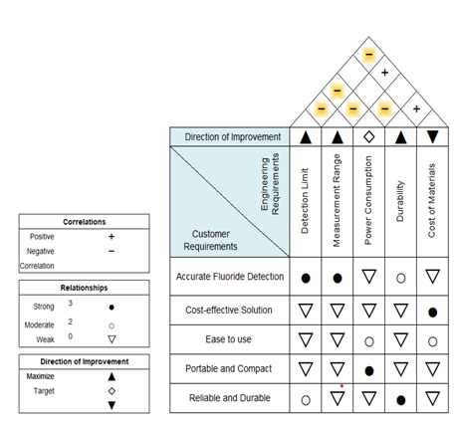
Fig 1: House of Quality

2.3.10 Existing Products
The market for fluorescence spectroscopy devices is rich with advanced instruments tailored to a variety of analytical needs, particularly in water quality monitoring. These sophisticated tools are essential for detecting and quantifying fluoride concentrations in drinking water, crucial for public health. Fluoride, found in various environmental sources, is vital for dental health but can cause severe issues like dental and skeletal fluorosis when present in excess, especially in groundwater-dependent communities. Fluorescence spectroscopy offers a powerful solution for monitoring fluoride levels accurately and efficiently. The versatility of these instruments allows for detailed and precise measurements, making them invaluable in both laboratory and field settings. They enable quick testing of water from different sources, providing real-time data on fluoride levels, which is particularly important in areas with variable fluoride concentrations to ensure safe drinking water.
When developing the F.L.O.W (Fluoride Level Observation in Water) device, it is essential to consider existing products that share similar functionalities and technological foundations. Understanding these products provides insight into current market standards, helps identify potential improvements, and ensures that our device meets or exceeds existing capabilities. Here are three notable fluorescence spectroscopy devices that are closely related to our F.L.O.W

2.3.11 Cary Eclipse
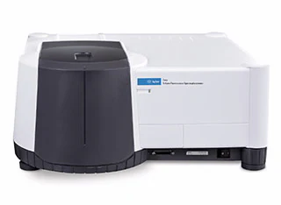
Fig 2: Agilent Cary Eclipse Fluorescence Spectrometer[5]
Cary Eclipse fluorescence spectrometer by Agilent can collect data in multiple modes, including fluorescence, phosphorescence, chemiluminescence, bioluminescence, and time-resolved phosphorescence based on the specifications listed on the Agilent’s website. This multiwavelength capability allows it to operate with excitation and emission wavelengths ranging from 200 nm to 900 nm, which makes it suitable for a wide range of applications. The device’s light source, the high-intensity xenon flash lamp ensures that stable light output and a longer lifetime, helps reduce the need for frequent replacements. The spectrometer's broad spectral range analysis makes it ideal to analyze several types of luminescence in studying complex samples and processes across several fields of sciences as well as environmental monitoring.

2.3.12 HORIBA Aqualog®
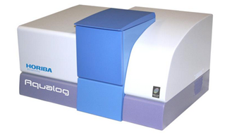
Fig 3: HORIBA Aqualog® [6]
HORIBA Aqualog® is designed specifically for water quality analysis, combining fluorescence and absorbance measurements in one system. Its excitation wavelength ranges from 240 nm to 800 nm and emission range from 250 nm to 800 nm provide extensive spectral coverage, allowing for the detailed characterization of water samples. The device advanced CCD detection technology enables simultaneous multi-wavelength detection, significantly reducing analysis time compared to traditional scanning spectrofluorometers. The Aqualog®'s advanced data analysis tools, including peak fitting, deconvolution, and multi-component analysis, make it highly effective for applications such as characterizing dissolved organic matter, tracking pollutants, and assessing water treatment processes. Its ability to perform both fluorescence and absorbance measurements simultaneously enhances its analytical capabilities, providing comprehensive insights into water quality.

2.3.13 RF-6000 Spectrofluorophotometer
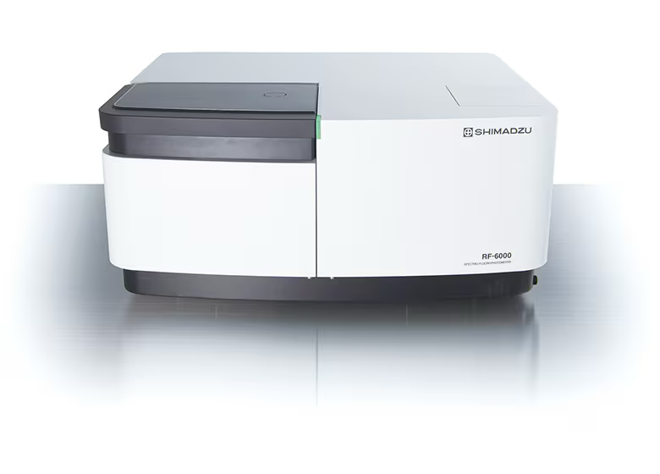
Fig 4: RF-6000 Spectrofluorophotometer[7]
RF-6000 Spectrofluorophotometer offers excitation and emission wavelengths ranging from 200 nm to 900 nm, ensuring broad spectral coverage for various applications. Its high sensitivity and accuracy enable the detection of low concentrations of analytes with excellent repeatability. The high-intensity xenon lamp provides stable light output and long-lasting performance. The RF-6000's user-friendly interface and sophisticated software offer advanced data analysis capabilities, such as spectral correction, peak identification, and quantification. This makes it ideal for applications in life sciences, environmental monitoring, pharmaceuticals, and material sciences, including studying protein folding, enzyme kinetics, DNA/RNA analysis, and detecting pollutants and contaminants. The spectrofluorophotometer's multiwavelength capabilities allow for detailed and comprehensive analysis of complex samples.

Table 2: Specification of existing product for fluorescence spectroscopy
Specification | Agilent Cary Eclipse | HORIBA Aqualog | RF-6000 Spectrofluorophotometer
Excitation Wavelength Range | 200 nm to 900 nm | 240 nm to 800 nm | 200 nm to 900 nm
Emission Wavelength Range | 200 nm to 900 nm | 247 nm to 828 nm | 200 nm to 900 nm
Wavelength Accuracy | ±1.5 nm | ±1 nm | ±1.5 nm
Wavelength Repeatability | ±0.2 nm | ±0.5 nm | ±0.2 nm
Sensitivity (S/N Ratio) | > 1200:1 (RMS, water Raman) | > 6000:1 (RMS, water Raman) | > 1500:1 (RMS, water Raman)
Light Source | Pulsed xenon flash lamp | Xenon flash lamp | Xenon arc lamp
Lamp Life | Up to 10 years | 1 billion flashes | 2000 hours
Scan Speed | 0.1 nm/min to 2400 nm/min | Up to 200,000 nm/min | 1 nm/min to 3000 nm/min
Resolution | 1.5 nm | 1 nm | 1 nm
Detector | R928 photomultiplier tube | CCD array detector | Photomultiplier tube (PMT)
Data Collection Modes | Fluorescence, phosphorescence, chemiluminescence, bioluminescence, time-resolved phosphorescence | Absorbance, fluorescence, synchronous scanning, EEM fluorescence | Fluorescence, phosphorescence, chemiluminescence, bioluminescence, time-resolved fluorescence
Temperature Control | Peltier or water-cooled accessories available | Thermostatted sample holder available | Optional thermostatted cell holder
Software | Cary Eclipse software | Aqualog software | LabSolutions RF software
Dimensions | 69 cm x 49 cm x 34 cm | 60 cm x 40 cm x 28 cm | 65 cm x 55 cm x 30 cm
Weight | 32 kg | 25 kg | 32 kg

2.4 Engineering Specifications

2.4.1 Detection Range (0.1 ppm to 10 ppm)
This specification defines the device's capability to detect and measure fluoride concentrations from very low (0.1 parts per million) to relatively high (10 parts per million) levels. This range is chosen to encompass typical fluoride concentrations found in drinking water, which are often regulated to fall within 0.7 to 1.2 ppm. The lower end (0.1 ppm) ensures sensitivity to trace amounts of fluoride, allowing the system to detect and respond to minimal fluoride presence, which is critical for ensuring safety and compliance with health standards. The upper end (10 ppm) allows for the detection of unusually high levels, which could be relevant in specific industrial or environmental contexts where fluoride contamination might occur. This broad detection range ensures that the device can handle a variety of real-world scenarios effectively.

2.4.2 Measurement Accuracy (±0.05 ppm)
Accuracy is really important for ensuring that our device's readings closely match the actual fluoride concentrations in drinking water samples and our aim would be to get as close to the actual concentration level if not exactly at the correct level. Our research, we learned that an accuracy of ±0.05 ppm means that if the true fluoride concentration is 1 ppm, the device should give a reading between 0.95 ppm and 1.05 ppm, we will know once we start building and testing our device[1, 8]. Precision is also crucial for meeting regulatory standards and ensuring that drinking water quality meets health and safety guidelines. Plus, high accuracy helps us make more confident decisions about the quality of water we are drinking.
High accuracy is very important because it will help reduce mistakes, which would make the results more reliable and consistent. Reliable and consistent results mean we can do the tests multiple times under the same conditions and get the same results each time. This is essential for making sure everything is working correctly. Precise measurements also support the F.L.O.W. project by providing accurate data, which is necessary to prove that our fluoride detection system works well. This high level of accuracy would help people trust the device's readings, making it a valuable tool for regularly checking fluoride levels in drinking water.

2.4.3 Fluorescence Excitation Wavelength (554 nm)
The excitation wavelength refers to the specific wavelength of light that is used to excite the fluorophore, which in this particular case is Rhodamine B. At 554 nm, the green laser effectively and efficiently excites Rhodamine B, causing it to emit fluorescence. The choice of this specific wavelength is based on the absorption spectrum of Rhodamine B, which has a peak absorption around this particular value[9]. By using the optimal excitation wavelength, we ensure maximum fluorescence efficiency, which leads to stronger and more detectable emission signals. This careful selection of the wavelength is crucial because it directly impacts the effectiveness of the excitation process. The green laser at 554 nm interacts perfectly with Rhodamine B, maximizing the fluorescence output. This means that the emitted fluorescence is much stronger and more easily detectable, which is essential for obtaining accurate and reliable results in our experiments. By ensuring that we use the best possible wavelength for excitation, we enhance the overall performance and sensitivity of our fluorescence detection system. This careful consideration of the excitation wavelength is a key factor in the success of our project, as it directly influences the quality and reliability of our fluorescence measurements.
2.4.4 Fluorescence Emission Detection Wavelength (575 nm with 40 nm FWHM)
The emission wavelength specification is crucial as it determines the range of wavelengths that the detector will observe and measure. Our fluorescence probe is designed to emit fluorescence light around 576 nm, which is within the visible spectrum[9]. To accurately capture this emission, we will use a bandpass filter that is precisely centered at 576 nm and has a 40 nm Full Width at Half Maximum (FWHM). This means the filter allows light within the range of approximately 556 nm to 596 nm to pass through. This range is carefully selected to capture the majority of the emission spectrum produced by our probe. By doing so, we ensure that the detected signal corresponds specifically to the fluorescence of the dye used in the probe, which is influenced by the presence of fluoride in the water sample. This careful selection of the bandpass filter is important because it helps in accurately detecting and measuring the fluorescence signal. It avoids interference from other wavelengths and ensures that the readings we obtain are reliable and correspond directly to the fluoride concentration. This setup is a key component of our F.L.O.W. project, as it enhances the accuracy and reliability of our measurements, ultimately contributing to the overall success of the project.
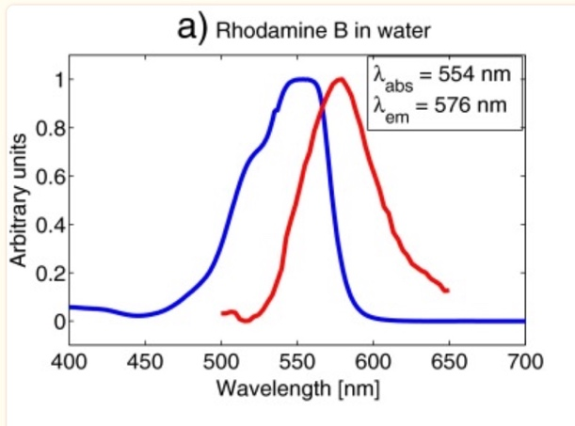
Figure 5: Absorption and emission spectra of the fluorescence probe,
Rhodamine B [9]

2.4.5 Sampling Volume (3.5 mL)
The sampling volume specifies the amount of water sample that the cuvette can hold. A 3.5 mL volume is a standard size sufficient for obtaining a representative sample for testing. This volume allows for adequate interaction between the fluorescence probe (e.g., Rhodamine B) and the fluoride in the sample, ensuring accurate measurements. It also ensures that the sample covers the path of the excitation beam and the emission path, leading to reliable fluorescence detection. This setup ensures that the excitation light from the laser diode interacts uniformly with the sample, and the emitted fluorescence is efficiently collected by the photodiode after passing through the emission filter.

2.4.6 Response Time (< 10 seconds)
Response time refers to how quickly the device can provide a stable reading after the sample is introduced. A response time of less than 10 seconds is essential for practical usability, allowing for rapid testing and real-time monitoring. Quick response times are particularly important in scenarios where multiple samples need to be tested in succession or when continuous monitoring is required. The system's rapid response is facilitated by the efficient processing capabilities of the ESP32 microcontroller and the immediate signal amplification provided by the operational amplifier, ensuring that fluorescence changes are quickly and accurately detected and processed.

2.4.7 Power Supply Voltage (5V USB powered)
The device operates on a 5V power supply, typically provided via a USB connection. This specification ensures compatibility with common power sources, including USB ports on computers, portable power banks, and USB wall adapters. The 5V standard is widely used, making the device easy to power in various settings, enhancing its portability and convenience.

2.4.8 Operating Temperature Range (10°C to 40°C)
The operating temperature range indicates the temperatures within which the device can function accurately. Ensuring the device operates between 10°C and 40°C covers typical ambient conditions in which the device might be used, from cool indoor environments to warmer field settings. Maintaining accuracy across this range ensures reliable performance in different climates and conditions.

2.4.9 Data Output Interface (I2C and SPI)
The device utilizes both Inter-Integrated Circuit (I2C) and Serial Peripheral Interface (SPI) for communication. The I2C interface allows for easy communication between the sensor and microcontrollers or other digital devices. It supports multiple devices on the same bus, simplifying wiring and integration. The SPI interface is used for high-speed communication with the MicroSD card module, enabling efficient data logging. These interfaces are particularly useful for data logging, remote monitoring, and integration with control systems, making the device versatile for various applications.
Table 3: Key Engineering Specifications
Specification | Value/Description | Demonstrable Specification
Detection Range | 0.1 ppm to 10 ppm | Detectable fluoride concentration from 0.1 ppm to 10 ppm
Measurement Accuracy | ±0.05 ppm | Ability to measure fluoride concentration within ±0.05 ppm
Fluorescence Excitation Wavelength | 532 nm | Use of 532 nm laser diode for excitation
Fluorescence Emission Detection Wavelength | 575 nm (with 40 nm FWHM) | Emission filter centered at 575 nm with 40 nm bandwidth
Sampling Volume | 3.5 mL (cuvette size) | Cuvette holds 3.5 mL of sample
Response Time | < 10 seconds | Time taken to get a stable reading
Power Supply Voltage | 5V (USB powered) | Device operates on a 5V power supply
Operating Temperature Range | 10°C to 40°C | Device will function accurately within this temperature range
Data Output Interface | I2C | Communication via I2C for data acquisition

2.6 Block Diagrams

2.6.1 Optical System Overview Block Diagram
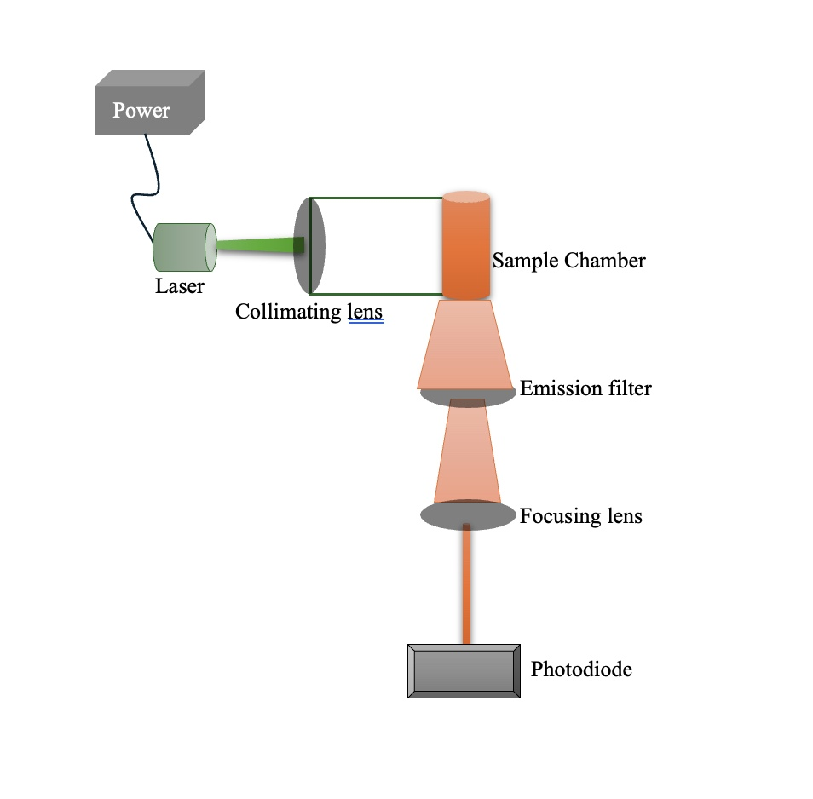
Figure 6: Optical system overview

2.6.2 Hardware Block Diagram
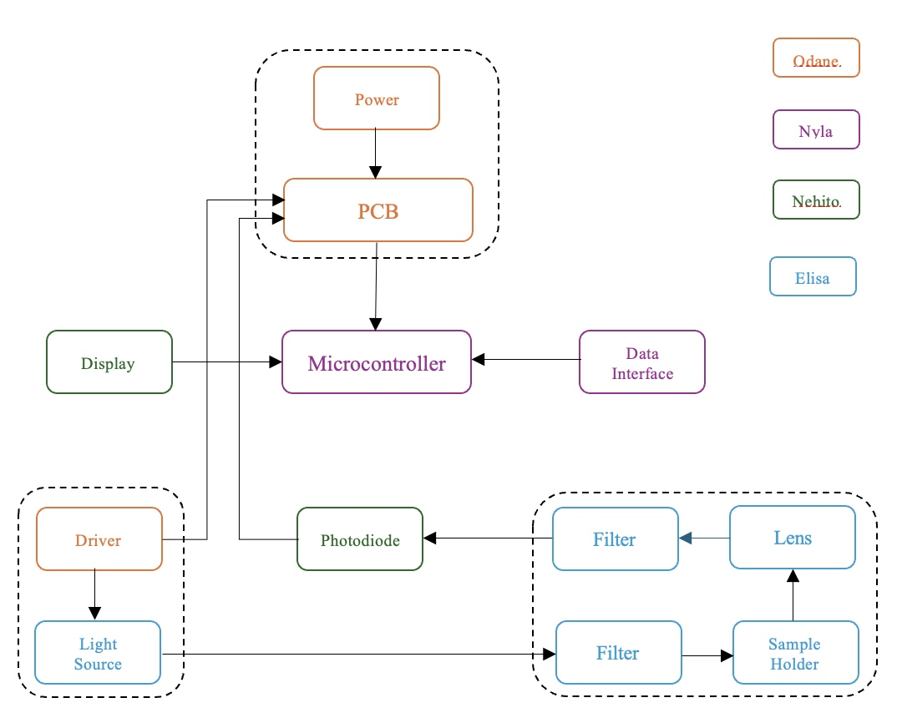
Figure 7: Hardware Block Diagram

Block Diagram Overview
- Light Source: Provides excitation light
- Optical Filters: Filter out unwanted wavelengths
- Sample Holder (Cuvette): Contains the water sample
- Detector: Captures emitted fluorescence and converts it to an electrical signal
- Microcontroller: Processes the signal and controls system operations
- Display and Data Interface: Shows data and facilitates communication
- Power Supply: Powers the entire system.

2.6.3 Software Block Diagram
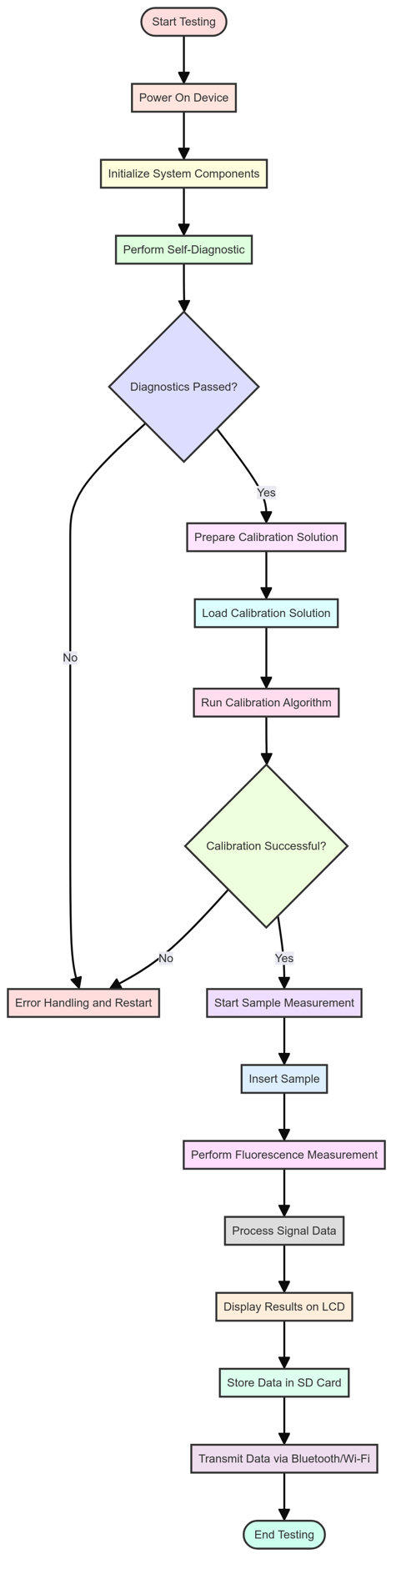
Figure 8: The software diagram illustrates the architecture and flow of a software system, mapping out its components, interactions, and data flow to provide a visual understanding of the software's structure and behavior.

Chapter 3: Research and Part Selection
A thorough investigation into finding and choosing the best technologies and project components is covered in detail in Chapter 3. This chapter offers a thorough overview of the standards and procedures applied throughout the part selection process, along with a thorough comparison of the many technologies that are now in use. The goal is to locate parts that satisfy our exacting standards for dependability, affordability, and performance to successfully manufacture and assemble our fluoride detection system.
We start off by going over the basic outline that was done to comprehend the state of technology and find possible parts that may be included in our FLOW device. Investigating the most recent developments in sensor technologies, microcontroller alternatives, fluorescence spectroscopy, and other crucial electronic components are all part of this chapter. This is to best understand how to maximize our device’s capabilities. A predetermined set of criteria, including precision, power consumption, cost, simplicity of integration, and long-term dependability, were used to assess each candidate component.
After that, a comparison of the technologies and components considered is presented in this chapter. We list the advantages and disadvantages of each choice and explain why some elements were selected over others. For example, we contrast several microcontrollers, power management systems, and fluorescence sensors, pointing out the advantages and disadvantages of each in relation to the requirements of our project. Through a careful consideration of cost, dependability, and performance, this study guarantees that our final decisions are well-reasoned and well-informed.
Our project's part selection is crucial, and this chapter goes into detail about the difficult task of finding and testing components. We talk about the pragmatic aspects of procurement, such possible lead times, component availability, and supplier dependability. We also detail the steps of iterative testing and prototyping, wherein a subset of components was tested under real-world settings to confirm their functionality and suitability for our overall system design.
The chapter's treatment of PCB (Printed Circuit Board) design and integration is essential reading. We examine the thoughtful arrangement and interconnection of the selected components to maximize performance, reduce interference, and guarantee resilience. Power distribution, temperature control, and signal integrity. Our creative design is turned into a physical, functional prototype through the crucial stage of PCB design, which prepares it for additional testing and ultimately manufacturing.
Our goal is to build a device that not only meets but beyond the performance, cost-effectiveness, and reliability requirements by considering all the options and making well-informed selections. This chapter provides a clear and comprehensive path from research and selection to integration and testing, serving as a fundamental manual for the technological growth and implementation of our fluoride detecting equipment. It highlights our dedication to accuracy and completeness in every facet of our project, guaranteeing that the finished result will be both creative and useful.

3.1 Research
For our project, we will build a cost effective, portable device to measure fluoride concentration levels in drinking water using fluorescence spectroscopy method. To start, we will research existing methods and technologies for detecting fluoride in water. This involves reviewing scientific literature and analyzing current products on the market to understand their strengths and weaknesses. From this research, we will define what our device needs to achieve in terms of accuracy, sensitivity, portability, and cost. For instance, we will examine high-end laboratory equipment, which, while accurate, is often expensive and not portable, and compare these to more affordable but less sensitive handheld meters. This comprehensive analysis will inform our design choices and help us strike a balance between cost and performance.
In the design phase, we will focus on creating an optical system that uses cost-effective components. This includes selecting light sources, filters, lenses and dichroic mirror. These components will work together to detect fluoride accurately. For example, we will use a high energy or shorter wavelength to excite the fluorescent probes that we will be mixing with our water sample in the cuvette, which will then emit fluorescence light that we will capture using a photodetector. We will build a prototype of the device using 3D printing and other readily available materials to ensure it is compact and portable. Additionally, we will select or develop fluorescent probes that are highly sensitive to fluoride ions. These probes will bind specifically to fluoride, emitting light that can be measured to determine the fluoride concentration in the water sample.
Next, we will calibrate and test the device. Calibration involves preparing standard solutions with known fluoride concentrations and measuring their fluorescence to create a calibration curve. This curve will help us determine the fluoride concentration in unknown water samples. We will validate the device by testing it with various water samples, ensuring it provides accurate and reliable results. This step is crucial for ensuring that the device can perform well in different environmental conditions and with different water chemistries.
For data acquisition and processing, we will integrate a microcontroller like Arduino. This will control the light source, collect data from the detector, and process the signals to determine fluoride levels. We will also develop for our stretched goal a user-friendly interface, possibly including a mobile app, to display real-time data and alerts. Wireless communication features like Bluetooth or Wi-Fi will allow remote monitoring. This integration will enable users to monitor water quality conveniently and receive timely notifications if fluoride levels deviate from safe ranges. Overall, keeping costs low is our top priority since this project is personally funded by us. We will select affordable yet reliable components and explore cheaper alternatives.

3.1.1 Existing Methods for Fluoride Detection
There are several methods for detecting the concentration of fluoride in drinking water which is crucial for our body. It is important to ensure that our fluoride intake follows WHO guidelines. Researchers and laboratories use several methods to detect fluoride and its concentration in drinking water, each with its own advantages, limitations, and applications. The most common methods include ion-selective electrodes, colorimetry, ion chromatography, and fluorescence spectroscopy. Understanding these methods is important for selecting the appropriate technology for each application, ensuring accurate measurement of fluoride concentration.
Colorimetry
Colorimetry is a commonly used method for detecting fluoride in water because it is straightforward and relatively low-cost. The process involves using a reagent that reacts with fluoride ions to produce a color change, which can then be measured with a spectrophotometer or colorimeter. One widely used technique is the SPADNS method, where a chemical reaction with fluoride bleaches a red dye, making the solution lighter. The lighter the color, the higher the fluoride concentration. However, colorimetry is not without its challenges. Other substances in the water can affect the readings. A study conducted by Brossok, McTigue, and Kuthy looked at water samples from 110 public wells in Ohio using both colorimetry and ion-specific electrodes. They discovered that in 60% of the samples, the fluoride readings differed by more than 0.1 ppm between the two methods, with an average difference of ±0.14 ppm. They found that high sulfate levels in the water interfered with the colorimetric readings. The study concluded that without distillation to remove these interfering substances, the colorimetric method might not be reliable, potentially leading to incorrect fluoride supplement recommendations nearly half the time.
Ion Chromatography (IC)
Ion Chromatography (IC) is a modern and highly effective method for measuring fluoride levels in water. It works by separating ions based on their charge through an ion exchange process. The water sample is injected into a stream of carbonate-bicarbonate eluent, passes through ion exchangers, and separates the fluoride ions based on their affinity for the anion exchanger columns. These fluoride ions are then converted into a highly conductive form and detected using a conductivity detector. The method is precise and accurate, allowing for the identification and quantification of fluoride by comparing the retention times and peak areas to standards. A study by Bondu et al. validated the IC method for fluoride detection in drinking water, comparing it to the Ion Selective Electrode (ISE) method. They analyzed water samples from 165 villages in the Vellore district and found that IC showed excellent precision and linearity, with a detection limit of 0.027 ppm and a quantification limit of 0.083 ppm. The study revealed that 46.1% of the villages had fluoride levels above 1.00 ppm. The results confirmed that IC is a reliable and accurate method for assessing fluoride levels, especially in areas with high fluoride concentrations where other methods might not be as effective.

3.1.2 Fluorescence Spectroscopy
For our fluoride detector project, we will be utilizing fluorescence spectroscopy to detect and measure fluoride concentration levels in drinking water. Fluorescence spectroscopy is an analytical technique used to study the properties of organic and inorganic substances by examining their fluorescence. Fluorescence is the emission of light by a substance that has absorbed light or other electromagnetic radiation. This process involves two key stages: excitation and emission.
Excitation
When a molecule absorbs photons from an external light source, such as ultraviolet (UV) or visible light, it transitions from its ground state to an excited electronic state. This absorption process involves promoting an electron to a higher energy orbital. The energy required for this transition corresponds to the difference between the ground state and the excited state, and this energy is characteristic of the molecule.
During excitation, the absorbed energy causes the electrons to vibrate and rotate within the molecule, temporarily increasing the molecule’s energy level. The specific wavelength of light absorbed depends on the molecular structure and the surrounding environment, which can be studied to gain insights into the molecular dynamics and interactions.
Emission
After excitation, the molecule quickly loses some of its energy through non-radiative processes such as vibrational relaxation and internal conversion. These processes occur on a very short timescale, typically within picoseconds (10^-12 seconds). Once the molecule has relaxed to the lowest vibrational level of the excited state, it can return to the ground state by emitting a photon, a process known as fluorescence.
The emitted photon has a longer wavelength (lower energy) than the absorbed photon because of the energy lost during the non-radiative processes. This phenomenon is known as the Stokes shift. The emission spectrum provides valuable information about the electronic structure and environment of the fluorophore.
Instrumentation
A typical fluorescence spectrometer consists of several key components that work together to measure the fluorescence properties of a sample:
Light Source
The light source provides the excitation energy necessary to induce fluorescence in the sample. Common light sources include xenon lamps, mercury vapor lamps, and lasers. Lasers are preferred for their high intensity and narrow wavelength range, which allow for precise excitation of specific fluorophores.
Monochromator
The monochromator selects specific wavelengths of light for excitation and emission. It typically consists of diffraction gratings or prisms that disperse light into its component wavelengths. By adjusting the monochromator, researchers can isolate the desired wavelengths for both excitation and emission, enhancing the specificity and sensitivity of the measurements.

Sample Holder
The sample holder, often a cuvette, contains the sample being analyzed. Cuvettes are usually made of quartz or glass, which are transparent to the excitation and emission wavelengths. The sample holder must be designed to minimize background fluorescence and ensure accurate measurements.
Detector
The detector captures the emitted fluorescence and converts it into an electrical signal. Common detectors include photomultiplier tubes (PMTs) and charge-coupled devices (CCDs). PMTs are highly sensitive and capable of detecting low levels of light, while CCDs provide high-resolution imaging and are useful for applications requiring spatial information.
Data Processing Unit
The data processing unit analyzes the electrical signals from the detector and displays the fluorescence data. It includes software for controlling the spectrometer, processing the data, and generating spectra and other analytical outputs.

3.1.2 Types of Fluorescence Spectroscopy
Steady-State Fluorescence Spectroscopy
Steady-state fluorescence spectroscopy is particularly well-suited for the detection of fluoride ions in water due to its high sensitivity and quantitative capabilities. This method involves exposing the sample to a continuous light source, typically a laser or LED, and measuring the resulting fluorescence intensity emitted by the fluorophores in the sample. The intensity of this fluorescence is directly proportional to the concentration of fluoride ions, allowing for precise quantification. The technique is advantageous because it can detect very low concentrations of fluoride, making it ideal for applications in drinking water analysis where fluoride levels must be monitored accurately to ensure safety and compliance with health standards. Furthermore, steady-state fluorescence spectroscopy is relatively straightforward to implement compared to more complex methods like time-resolved fluorescence. It requires less expensive equipment and simpler data analysis, making it a cost-effective option for routine monitoring and field applications.
Time-Resolved Fluorescence Spectroscopy
Time-resolved fluorescence spectroscopy measures the decay of fluorescence intensity over time after excitation by a short light pulse. This method provides detailed information about the fluorescence lifetime, which can offer insights into the molecular environment and dynamics that are not accessible through steady-state measurements. In the context of fluoride detection, time-resolved fluorescence can help distinguish between different fluorophores or quenching processes that might affect the fluorescence signal, leading to more accurate and specific measurements. The technique is highly sensitive and can detect very low levels of fluorescence, making it suitable for applications where high precision is necessary. However, the complexity and cost of the required instrumentation, which includes pulsed light sources and fast detectors, make it less practical for routine fluoride monitoring compared to steady-state fluorescence spectroscopy. This method is more appropriate for advanced research settings where detailed molecular information is needed.
Fluorescence Resonance Energy Transfer (FRET)
Fluorescence Resonance Energy Transfer (FRET) is a powerful technique used to study interactions between molecules at very close distances, typically within 1-10 nanometers. FRET measures the energy transfer efficiency between two fluorophores: a donor and an acceptor. When the donor fluorophore is excited, energy is transferred to the acceptor if they are sufficiently close, resulting in fluorescence from the acceptor. This method is highly sensitive to changes in distance between the fluorophores, making it ideal for studying molecular interactions and conformational changes. In the context of fluoride detection, FRET could be used to design sensors where the presence of fluoride ions brings the donor and acceptor into proximity, triggering a measurable FRET signal. However, FRET requires careful design and calibration of the donor-acceptor pairs and is more complex and costly than steady-state fluorescence spectroscopy. Its use is thus more suited for detailed biochemical studies rather than routine fluoride monitoring.
Fluorescence Correlation Spectroscopy (FCS)
Fluorescence Correlation Spectroscopy (FCS) analyzes fluctuations in fluorescence intensity within a small, defined volume over time, providing information about the number and diffusion properties of fluorescent molecules in solution. FCS is incredibly sensitive and can detect single molecules, making it suitable for studying very low concentrations of analytes, including fluoride ions. This technique can provide detailed information about the dynamics and interactions of molecules, such as binding events and diffusion coefficients. For fluoride detection, FCS could be used to monitor changes in the fluorescence properties of a sensor molecule in the presence of fluoride ions. However, FCS requires specialized equipment and complex data analysis, making it more appropriate for advanced research laboratories than for routine monitoring. Its high sensitivity and ability to provide dynamic information are its primary advantages, but these come at the cost of increased complexity and expense.

3.2 Technology Comparison
3.2.1 Excitation Source: Laser Diode vs. LED
When selecting an excitation source for a fluorescence spectrometer designed to detect fluoride concentration, one must consider both laser diodes and LEDs. Laser diodes offer high intensity and a narrow wavelength range, making them ideal for precise targeting of specific fluorophores like Rhodamine B. The coherent and collimated light produced by laser diodes ensures efficient excitation, which is crucial for generating a strong fluorescence signal. This high level of precision and intensity is particularly beneficial in applications requiring accurate quantification of low-concentration analytes. However, laser diodes are generally more expensive than LEDs and pose potential safety hazards, such as the risk of eye damage from direct exposure to the beam. These safety concerns necessitate careful handling and the implementation of protective measures in the device design.
On the other hand, LEDs are a more cost-effective and safer alternative for light sources. They emit a broader spectrum of light and have a lower intensity compared to laser diodes. While this broader emission can be beneficial in some applications, it may also result in less efficient excitation of the fluorophore and a weaker fluorescence signal. LEDs are also easier to integrate and require less stringent safety measures, making them suitable for broader applications where precise wavelength targeting is not as critical. However, for applications that demand high specificity and sensitivity, such as detecting fluoride concentrations through Rhodamine B fluorescence, the narrow wavelength range and high intensity of laser diodes make them the superior choice, despite their higher cost and safety considerations.

3.2.2 Detection Method: Photodiode vs. Photomultiplier Tube (PMT) vs. CCD Camera
Choosing the right detection method is critical for the performance of a fluorescence spectrometer. Photodiodes are commonly used due to their compact size, cost-effectiveness, and adequate sensitivity for many applications. They convert light into an electrical signal, allowing for direct measurement of light intensity. Photodiodes are relatively simple to integrate into electronic systems and provide a good balance between performance and cost, making them suitable for general fluorescence detection in cost-sensitive projects. However, their sensitivity is lower compared to photomultiplier tubes (PMTs), which may limit their effectiveness in applications requiring the detection of very low light levels.
PMTs, on the other hand, offer extremely high sensitivity and can detect very low levels of light, making them ideal for applications requiring high-sensitivity measurements. They achieve this through the amplification of the photoelectric effect, where incoming photons are converted to electrons and multiplied to produce a measurable current. Despite their superior sensitivity, PMTs are significantly more expensive, larger, and more complex to integrate into a system compared to photodiodes. CCD cameras provide an alternative detection method with high sensitivity and the ability to capture images and multi-wavelength data simultaneously. This feature is particularly useful for applications requiring spatial resolution or the analysis of multiple fluorescence signals. However, CCD cameras are also more expensive and complex to integrate. For a cost-effective, straightforward solution with sufficient sensitivity for fluoride detection via fluorescence, photodiodes are typically preferred, providing a practical balance between performance, size, and cost.

3.2.3 Filter Type: Bandpass vs. Notch Filter
In fluorescence spectroscopy, the choice of filter type is crucial for isolating the desired fluorescence emission from background light. Bandpass filters are designed to allow a specific range of wavelengths to pass through while blocking all others. This precise control makes them ideal for isolating the fluorescence emission of a specific fluorophore, such as Rhodamine B, which has a known emission peak. By selecting a bandpass filter with a central wavelength matching the emission peak of Rhodamine B, one can significantly enhance the signal-to-noise ratio, ensuring that only the relevant fluorescence signal is detected. This specificity is essential for applications requiring high sensitivity and accuracy, as it minimizes interference from other light sources or background fluorescence.
Notch filters, in contrast, block a specific range of wavelengths and allow all others to pass through. While useful in certain applications, such as Raman spectroscopy where it is necessary to block the excitation light while allowing the scattered light to pass, notch filters are less suitable for fluorescence detection. This is because fluorescence spectroscopy typically requires the isolation of a specific emission wavelength rather than the blocking of a particular range. Using a notch filter in this context could result in a less precise isolation of the fluorescence signal, leading to potential interference from other wavelengths. Therefore, for the specific application of detecting fluoride concentration via the fluorescence emission of Rhodamine B, bandpass filters are the preferred choice due to their ability to precisely isolate the desired wavelength, thereby enhancing detection accuracy and reliability.

3.2.4 Case Study Real-World Case Studies, Scenarios, and Applications of the FLOW Device
In tiny doses, the naturally occurring element fluoride helps to prevent tooth cavities. Fluoride overload in drinking water, however, can cause serious health problems such skeletal and dental fluorosis. Public health requires that drinking water have acceptable fluoride levels, particularly in locations with high natural fluoride concentrations or limited water infrastructure.
Our senior design team's creation, the Portable Fluoride Concentration Detector, provides a way to accurately and in real time monitor the fluoride levels in drinking water. This gadget provides vital information to safeguard public health and guarantee water safety in a range of contexts, including military posts, metropolitan areas, and rural schools.
The case studies that follow show several situations in which it's important to keep an eye on fluoride levels. Every example demonstrates the distinct problems and fixes related to fluoride pollution of drinking water. Stakeholders may encourage safe drinking water practices, reduce risks, and make informed decisions by putting our gadget into practice.
These case studies show how the gadget may enhance health outcomes and water quality in various industries and geographical areas. Our gadget plays a critical role in tackling the global crisis of fluoride pollution in drinking water, from safeguarding the safety of military personnel and elderly citizens to protecting students in rural schools. We hope to highlight the significance of precise and ongoing fluoride monitoring as well as the revolutionary effects of technical advancement in public health and safety through these instances.
Case Study 1: Ensuring Safe Drinking Water in Schools
Schools must make sure that the water supplied to pupils is pure and uncontaminated by dangerous substances like fluoride.
Scenario: Rural Schools in Bangladesh
The tool might be used by school administrators to keep a frequent check on the fluoride content of the water sources. Schools may continually monitor water quality by putting the gadget at important water access sites, such drinking fountains and kitchen facilities.
Implementation of the Device:
The device could be used by school authorities to regularly monitor the fluoride levels in their water sources. By installing the device at key water access points, such as drinking fountains and kitchen areas, schools can continuously track water quality. The device's data logging feature allows for the recording of fluoride
Impact and Benefits:
Preserving the Health of Children: Consistent observation averts extended exposure to elevated fluoride concentrations, thereby diminishing the prevalence of dental and skeletal fluorosis in kids.

Ensuring Safety: Ongoing data collecting aids in the upkeep of safe drinking water guidelines in schools, guaranteeing that fluoride concentrations stay within acceptable bounds.
Educational Awareness: Using the gadget may also be a teaching tool for informing kids about the safety of water and the significance of keeping an eye on
Case Study 2: Protecting Public Health in Urban Areas
Fluoride poisoning of public water sources may be a concern in urban areas with aged water infrastructure.
Scenario: Municipal Water Systems in Mexico City
Mexico City's water distribution system is outdated and intricate. Millions of people are impacted by high levels of fluoride in tap water in some areas due to a mix of aging pipes and naturally occurring fluoride deposits.
Implementation of the Device:
The gadget might be installed at different locations along the city's distribution network by municipal water authorities, particularly in high-risk regions that were discovered during preliminary studies. Authorities are able to promptly locate and resolve areas of pollution by using real-time data on fluoride concentrations.
Impact and Benefits:
Preserving Public Health: Constant observation guarantees that the water supply's fluoride content stays within permissible bounds, shielding locals from possible health hazards.
Efficient Management: By enabling quick reactions to pollution incidents, real-time data aids in the effective management of the water distribution network.
Public Trust: Openness in the monitoring of water quality can boost public assurance about the security of municipal water supplies.
Case Study 3: Ensuring Safe Drinking Water in Hospitals
To guarantee the health and safety of patients, especially those with weakened immune systems, hospitals need to use high-quality water.
Scenario: Hospitals in South Africa
Elevated fluoride levels in the water supply of certain hospitals in South Africa have been detected. This might potentially put patients at danger, particularly those who are pregnant or receiving therapies that make them more susceptible to fluoride.
Implementation of the Device:
The device could be installed by hospital management at strategic locations across the hospital's water system, such the main water supply entry point and locations where water is used for patient care. Hospital personnel would evaluate monitoring data on a regular basis to make sure that water quality criteria are constantly satisfied.
Impact and Benefits:
Patient Safety: Constant observation guarantees that patients are not exposed to fluoride-related health risks by making sure that water used for drinking, cleaning, and medical operations is safe.
Regulatory Compliance: By making sure that health and safety rules are followed, hospitals may stay out of trouble with the law and possibly avoid fines.
Improved Care: Access to clean drinking water improves patient outcomes by raising the standard of care given to them overall.
Case Study 4: Monitoring Community Water Systems in Rural Areas
Continuous monitoring is crucial since community water systems in rural regions sometimes lack the funding necessary for routine water quality testing.
Scenario: Rural Communities in Kenya
Many rural populations in Kenya get their drinking water from wells and boreholes. According to studies, some of these water sources have fluoride concentrations far higher than those advised, which causes widespread dental fluorosis.
Implementation of the Device:
The instrument might be used by local health officials and community leaders to keep an eye on the fluoride content of different water sources. Residents may receive real-time information on the quality of their water by putting the device in strategic places like community wells and water distribution sites.
Impact and Benefits:
Health Protection: Consistent monitoring guards against the harmful consequences of excessive fluoride exposure, such skeletal and dental fluorosis, on the community.
Empowering Communities: Giving localities the resources to keep an eye on the quality of their water encourages independence and well-informed decision-making.
Cost-Effective Monitoring: By eliminating the need for expensive laboratory testing, the gadget provides a continuous water quality monitoring solution that is affordable.
Case Study 5: Supporting Disaster Relief Efforts
Getting clean drinking water after a natural disaster is a major task.
Scenario: Post-Earthquake Relief in Nepal
Many water sources in Nepal were poisoned or interrupted after the 2015 earthquake. Providing impacted communities with clean drinking water rose to the top of the priority list for relief operations.
Implementation of the Device:
In order to continually monitor the fluoride levels in drinking water, relief agencies might place the gadget at field hospitals, temporary water distribution sites, and emergency shelters. By doing this, the water supplied to survivors would be guaranteed to be safe to drink.
Impact and Benefits:
Immediate Safety: Ongoing surveillance guarantees that drinking water supplied during disaster relief efforts is devoid of dangerous fluoride concentrations, safeguarding susceptible groups.
Quick Reaction: Using real-time data, aid agencies can respond promptly to any contamination problems, guaranteeing a steady supply of clean water.
Resource Allocation: By identifying which places most urgently require clean water, monitoring helps allocate scarce resources for disaster relief activities as efficiently as possible.
Case Study 6: Monitoring Water Quality in Low-Income Urban Areas
Low-income metropolitan communities frequently struggle to keep their water supplies safe because they lack the necessary resources and infrastructure.
Scenario: Mumbai, India
Mumbai's slum dwellers get their drinking water via standpipes and community taps. Concern over fluoride contamination from natural and industrial sources has grown.
Implementation of the Device:
The gadget might be used by community organizations and local NGOs to keep an eye on the fluoride levels at public water fountains. Regular updates and notifications will help residents stay informed about the quality of the water and take the appropriate safety measures.
Impact and Benefits:
Health Improvement: Consistent monitoring aids in the prevention of conditions including dental and skeletal fluorosis, which are linked to excessive fluoride exposure.
Community Empowerment: Giving locals access to real-time data on water quality gives them the capacity to take charge of their own health and safety.
Advocacy and Awareness: In low-income communities, data from the device may be utilized to support the development of better water regulations and infrastructure.
Case Study 7: Enhancing Water Quality in Bottled Water Production
The bottled water business is required to make sure that all of its goods, including the fluoride content, adhere to strict safety regulations.
Scenario: Bottled Water Production in Thailand
Water quality standards in Thailand are being scrutinized more closely as a result of the rising demand for bottled water. There have been issues for certain manufacturers when fluoride levels have gone beyond legal limits.
Implementation of the Device:
The gadget might be used by makers of bottled water to continually check fluoride levels during the production process. This would guarantee that, prior to bottling and distribution, the water satisfies safety regulations.
Impact and Benefits:
Quality Control: Constant observation guarantees that fluoride concentrations stay within permissible bounds, preserving the safety and caliber of the product.
Regulatory Compliance: Manufacturers may stay out of trouble and keep their good name in the market by following safety regulations.
Customer safety: Safe fluoride levels save customers from health hazards that might arise from consuming excessive amounts of fluoride.
Case Study 8: Ensuring Safe Drinking Water in Military Bases
Reliable water supplies are necessary for military sites to maintain troop preparedness and health.
Scenario: Military Bases in the Middle East
In some Middle Eastern countries, military bases rely on local groundwater sources, which can have high fluoride levels due to natural geological formations. Ensuring safe drinking water is essential for the health and performance of military personnel.
Implementation of the Device:
Military installations in various Middle Eastern nations rely on local groundwater supplies, which may have high fluoride levels because of innate geological formations. Safe drinking water is crucial for military personnel's health and effectiveness.
Impact and Benefits:
Health and Performance: By avoiding problems associated with excessive fluoride exposure, providing military troops with safe drinking water helps preserve their health and performance.
Operational Readiness: Ongoing surveillance aids in the avoidance of possible health emergencies that can compromise military operations' readiness and efficacy.
Safety and Compliance: By guaranteeing that water quality satisfies safety requirements, the gadget safeguards workers and keeps legal problems at bay.
Case Study 9: Supporting Safe Drinking Water in Elderly Care Facilities
As elderly care patients may be more susceptible to fluoride exposure, it is imperative that elder care facilities supply clean drinking water to safeguard their health.
Scenario: Elderly Care Homes in Australia
Concerns over fluoride levels in water supplies have been raised by a few aged care homes in Australia, especially in regions where fluoride concentrations are naturally high.
Implementation of the Device:
Administrators of care facilities might place the gadget in strategic locations with access to water, such resident rooms and eating areas. Staff would analyze data from regular monitoring to make sure that water quality criteria are routinely satisfied.
Impact and Benefits:
Resident Health: Ongoing observation guarantees that senior citizens' drinking and cooking water is safe, averting possible health risks associated with fluoride.
Regulatory Compliance: Avoid legal problems and possible fines by making sure water quality complies with health and safety laws.
Enhanced Care: Providing residents with clean drinking water improves their overall quality of care, leading to better health and a higher standard of living.
Case Study 10: Monitoring Water Quality in Remote and Indigenous Communities
Because of their remote locations and lack of infrastructure, indigenous and remote communities frequently have difficulties in providing clean drinking water.
Scenario: Indigenous Communities in Canada
Numerous aboriginal communities in Canada depend on regional water supplies that might become contaminated due to excessive fluoride levels. Having clean drinking water is a top concern for health.
Implementation of the Device:
The gadget might be used by municipal authorities and community health professionals to monitor the fluoride levels in communal water supplies. They can guarantee that water stays within safe parameters and quickly resolve any pollution concerns by giving real-time updates.
Impact and Benefits:
Health Protection: Consistent monitoring helps shield local residents from the harmful consequences of excessive fluoride exposure, such skeletal and dental fluorosis.
Empowering Communities: Giving localities the resources they need to keep an eye on the quality of their water encourages independence and well-informed decision-making.
Long-Term.
Sustainable Solutions: Information gathered from the device can help with initiatives to build long-term, sustainable solutions for safe drinking water and to enhance water infrastructure.

3.3 Part Selections

3.3.1 Optical Components
The F.L.O.W. (Fluoride Level Observation in Water) project relies on a carefully selected set of optical components to ensure accurate and reliable detection of fluoride concentrations in drinking water. At the heart of the system is the fluorescence spectroscopy technique, which necessitates the use of various optical elements, including light sources, detectors, filters, and sample holders. These components work in unison to excite fluorophores in the water samples and measure the resulting fluorescence emission. The choice and configuration of these optical components are critical to achieving the desired sensitivity and specificity required for precise fluoride quantification. This section provides an in-depth overview of each optical component used in the F.L.O.W. system, highlighting their roles, specifications, and the rationale behind their selection.
The primary light source for the F.L.O.W. project is a green laser diode, specifically chosen for its ability to provide a stable and coherent beam at a precise wavelength that matches the excitation peak of the fluorophores used for fluoride detection. Complementing the laser diode, a highly sensitive photodiode serves as the detector, capturing the emitted fluorescence and converting it into an electrical signal for analysis. To isolate the specific wavelengths of interest and minimize background noise, a combination of bandpass and notch filters are employed. These filters ensure that only the desired fluorescence signal is detected, enhancing the accuracy of the measurements. Additionally, quartz cuvettes are utilized as sample holders due to their superior optical clarity and chemical resistance, which are essential for maintaining the integrity of the water samples during analysis. The integration of these optical components forms the foundation of the F.L.O.W. system, enabling robust and precise fluoride detection.

3.3.2 Light Source
Light sources are crucial for the excitation of Rhodamine B in our fluorescence spectroscopy setup. The selection criteria include wavelength, power, price, and availability.

Table 4: Light source comparison
Parameter | Thorlabs CPS532-C2 | Osram PL520 | Lite-on LTL2R3TGY3KS
Wavelength | 532 nm | 520 nm | 525-532 nm
Power | 4.5 mW | 20 mW | 7800 mcd (approx. 5 mW)
Price | $188 | $30-$50 | $0.37 each
Size | Compact module | TO-18 package | 5mm LED
Manufacturer | Thorlabs | Osram | Lite-on

- The Thorlabs CPS532-C2 is a high-precision, low-power laser diode module designed for applications requiring a stable and reliable green light source. It includes a built-in driver, simplifying integration into optical systems. This laser is highly reliable and offers precise wavelength control, making it suitable for scientific research and industrial applications. Unfortunately, due to its high cost, we can’t select this laser.
- The Osram PL520 is a high-power green laser diode, ideal for applications needing a bright and powerful green light. It is packaged in a standard TO-18 can, providing robustness and ease of integration into various setups. This diode is versatile and commonly used in consumer electronics and professional instruments. This laser provides more power than necessary for our application, potentially increasing costs and complicating thermal management. However, it is more affordable than the Thorlabs option and provides good performance.
- The Lite-on LTL2R3TGY3KS is a cost-effective green LED with a wavelength range that closely matches the required excitation wavelength for Rhodamine B. It provides sufficient power for initial testing and basic applications, making it an excellent choice for budget-constrained projects. The drawback is it has lower precision and stability compared to laser diodes.

3.3.3 Lenses
In the F.L.O.W project, lenses are critical components that significantly impact the performance of our fluorescence spectroscopy system for detecting fluoride concentrations in water. Selecting the appropriate lenses involves a detailed process, balancing cost-effectiveness with the need to maintain a compact optical system. The first lens we use is a collimating lens. This lens takes the light from our 532 nm laser source and ensures that the light rays are parallel. Collimated light is essential because it maintains the quality and direction of the light as it travels through the system, which is critical for exciting the fluorescent probes that bind to fluoride ions in the water sample. After the fluorescent probes are excited, they emit light at different wavelengths, typically in a broader spectrum than the excitation source. This emitted light then interacts with a focusing lens. The focusing lens collects the emitted fluorescent light and directs it towards the photodetector. This step is vital for enhancing the intensity of the light signal that reaches the detector, thereby improving the signal-to-noise ratio. A higher signal-to-noise ratio results in clearer and more accurate data, enabling us to detect even low concentrations of fluoride accurately. One of the significant challenges we've encountered during testing is chromatic dispersion. Chromatic dispersion occurs when different wavelengths of light spread out at various angles after passing through optical components like lenses and gratings. This dispersion can cause some wavelengths to diverge too far from the detector, leading to incomplete or distorted spectral data. While our excitation source (532 nm laser) does not suffer from chromatic dispersion itself, the emission from the fluorescent probes spans a range of wavelengths that can experience dispersion as they pass through the optical system. To address this issue, we strategically place a lens to refocus the divergent wavelengths and direct them back towards the detector. This ensures that the detector receives the entire spectral range with minimal distortion or loss, providing a more accurate representation of the sample's optical characteristics. Correcting for chromatic dispersion is essential for obtaining reliable measurements, as any missing or distorted wavelengths could result in inaccurate fluoride concentration readings. Choosing the right lenses also involves understanding the principles of wavefronts and aberrations. A wavefront is an imaginary surface that represents points in a light wave that are in phase, meaning they oscillate together. Visualizing wavefronts helps us see how light propagates through the medium and interacts with other optical components. Ideally, we want a flat wavefront, indicating uniform and undistorted light. Any deviations from flatness indicate aberrations, which can distort the measurements. By selecting lenses that minimize these aberrations, we ensure the light beam remains clean and accurate as it travels through the system.
In our system, we initially considered using biconvex lenses for their ability to converge light rays to a focal point. Biconvex lenses are thicker in the center than at the edges, causing parallel light rays passing through to converge at a focal point. This property makes them suitable for focusing the emitted fluorescent light onto the photodetector. However, biconvex lenses can introduce spherical aberrations because the paraxial (central) and marginal (edge) rays do not focus at the same point. Despite this, biconvex lenses are cost-effective and widely used, making them a practical choice for our project. To mitigate the effects of chromatic dispersion and spherical aberrations, we are exploring the use of achromatic lenses. Achromatic lenses are designed to bring two wavelengths (typically red and blue) into focus in the same plane, significantly reducing chromatic aberration. By using these lenses, we aim to improve the accuracy of our spectral measurements and enhance the overall performance of our fluorescence spectroscopy system. By carefully selecting and positioning these lenses, we enhance the overall accuracy and reliability of our system. The collimating lens ensures the excitation light is directed efficiently, while the focusing lens maximizes the intensity and accuracy of the detected fluorescence signal. Together, these lenses play a pivotal role in our ability to detect fluoride concentrations in water accurately and effectively, while addressing the challenges posed by chromatic dispersion. We'll be using the LensMaker equation to determine the correct placement of lenses in our system, particularly when positioning the collimating lens relative to the laser and the focusing lens relative to the detector.
$$\frac{1}{f}=\frac{1}{d_{0}}+\frac{1}{d_{1}}$$
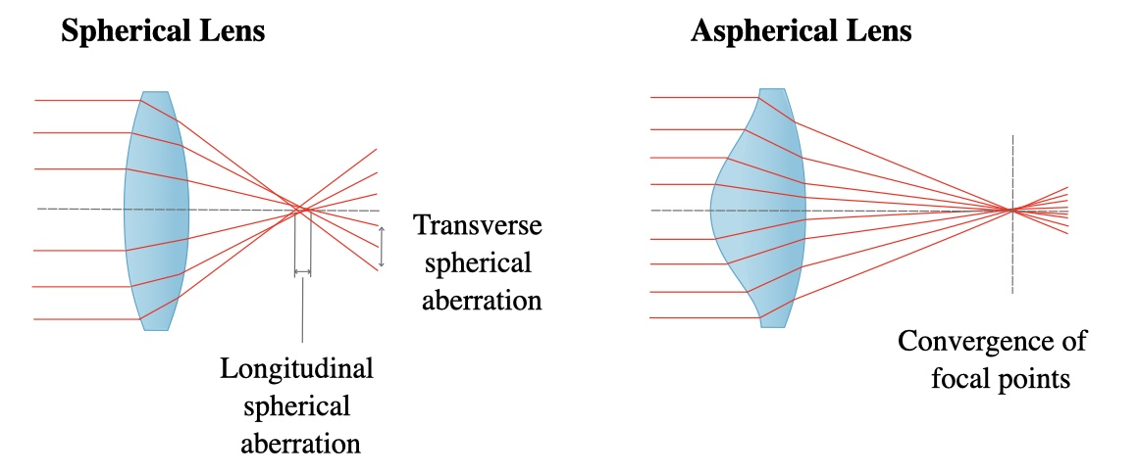
Figure 9: Spherical aberration in a Spherical Lens (left) vs. an Aspheric Lens (right).

Table 5: Lens Comparison
Parameter | Thorlabs AL2520-A | Edmund Optics 66-625 | Opt Lasers PLH3D-6W-CUSTOM-LENS
Diameter | 25 mm | 25 mm | 9 mm
Focal Length | 20 mm | 20 mm | 8 mm
Price | $300 | $30-$50 | $18
Size | Standard aspheric lens | Standard aspheric lens | Compact triplet lens
Manufacturer | Thorlabs | Edmund Optics | Opt Lasers
Description | High-quality aspheric lens for precise collimation with minimal aberration. | Affordable lens for general collimation needs. | Cost-effective lens with a triplet design for enhanced precision.
- The Thorlabs AL2520-A is a high-quality aspheric lens designed to provide precise collimation with minimal aberration. It is ideal for high-precision optical systems where performance is critical. The lens material and design ensure excellent optical performance and durability, unfortunately, it is beyond our budget allocation.
- The Edmund Optics 66-625 is an affordable aspheric lens suitable for general collimation needs. It offers good optical performance at a more accessible price point, making it a popular choice for various applications.

3.3.4 Optical Filter Comparison
In the construction of the F.L.O.W fluorescence spectroscopy system, optical filtering technology is crucial for isolating the fluorescence emission signal from other photonic noise, particularly the residual excitation light from the 532 nm laser. Among the various options for optical filtering, the choice between different bandpass filters is significant. This section elaborates on the preference of specific bandpass filters for our fluorescence spectroscopy setup, along with the considerations that led to their selection. The primary advantage of using bandpass filters in fluorescence spectroscopy lies in their ability to transmit a specific range of wavelengths while blocking others. Bandpass filters are designed to allow only the wavelengths corresponding to the fluorescence emission to pass through while blocking the excitation light and other unwanted wavelengths. This selectivity is crucial for enhancing the signal-to-noise ratio (SNR) and ensuring accurate measurements of the fluorescence signal.
$$SNR = \frac{P_{signal}}{P_{noise}}$$
Where Psignal is the power of the fluorescence emission and Pnoise is the power of the background noise.

Table 6: Emission Filter
Parameter | Thorlabs FB580-10 | Edmund Optics 43-198 | Midwest Optical BP590
Central Wavelength | 580 nm | 575 nm | 590 nm
Bandwidth (FWHM) | 10 nm | 40 nm | 40 nm
Price | $100-$150 | $120-$150 | $200
Size | 25 mm diameter | 25 mm diameter | 25 mm diameter
Manufacturer | Thorlabs | Edmund Optics | Midwest Optical
Description | Narrow bandpass filter designed to isolate fluorescence emission with high efficiency. | Broad bandpass filter suitable for capturing a wider range of emissions. | High-quality bandpass filter for diverse applications.
- The Thorlabs FB580-10 is a narrow bandpass filter designed to isolate fluorescence emission at 580 nm with high efficiency. Its narrow bandwidth ensures that only the desired wavelength is transmitted, minimizing background noise and enhancing signal detection.
- The Edmund Optics 43-198 is a broad bandpass filter that captures a wider range of wavelengths around 575 nm. This filter is suitable for applications where a broader emission range needs to be detected.
- The Midwest Optical BP590 is a high-quality bandpass filter with a broader range, ideal for diverse fluorescence applications. It provides good transmission efficiency and durability, making it suitable for robust applications.
- The Opt Lasers PLH3D-6W-CUSTOM-LENS is a cost-effective collimating lens featuring a triplet design that enhances precision. It is specifically designed for laser collimation, making it ideal for this application.

3.3.5Photo Detector Comparison
When choosing a detector for the F.L.O.W fluorescence spectroscopy system, several critical aspects must be examined to ensure optimal performance in detecting fluorescence emission from the probes. The three most important characteristics in this selection procedure are Noise Equivalent Power (NEP), active area, and sensitivity. NEP (watts per square root of hertz) measures the detector's minimal detectable power level. It represents the detector's signal-to-noise ratio and its capacity to separate weak signals from background noise. A lower NEP value provides greater sensitivity and efficacy in detecting weak fluorescence signals among noise. The active area is the physical area of the detector that is responsive to incident light. In fluorescence spectroscopy, a larger active area is preferable because it allows for the capture of more photons emitted by the sample, resulting in a stronger signal. However, it is critical to achieve a balance between active area size and detector size, as larger detectors may introduce additional noise or complexity into the optical system. As a result, choosing a detector with a suitably sized active area tailored to the specific experimental requirements is critical for maximizing signal collection efficiency while maintaining system performance. In fluorescence spectroscopy, achieving the maximum possible sensitivity while minimizing noise is critical, as identifying weak fluorescence signals against a background of noise can be challenging. Sensitivity relates to the detector's ability to detect minor changes in light intensity, which is commonly measured in terms of electrical output per unit of incident light power. In the F.L.O.W project, sensitivity is crucial for improving the signal-to-noise ratio and the detection limit given the need to accurately measure low concentrations of fluoride. However, it is important to establish a balance between sensitivity and noise levels, as detectors that are too sensitive can amplify the noise alongside the signal, reducing the quality of the spectrum data.

Table 7: Detector Comparison
Parameter | Thorlabs PDA100A2 | Adafruit TSL2591 | Hamamatsu S1226-18BQ
Active Area | 3.6 mm x 3.6 mm | Small photodiode area | 2 mm x 2 mm
Wavelength Range | 320 - 1100 nm | 188 - 1000 nm | 320 - 1000 nm
Price | $70-$120 | $7 | $100
Size | Compact module | Small sensor module | Compact photodiode
Manufacturer | Thorlabs | Adafruit | Hamamatsu
Description | Silicon photodiode with an integrated amplifier for broad wavelength sensitivity. | High dynamic range digital light sensor, easy to interface with microcontrollers. | Highly sensitive photodiode for precision measurements.
- The Thorlabs PDA100A2 is a silicon photodiode with an integrated amplifier, offering broad wavelength sensitivity and high reliability. It is designed for precise optical measurements and can handle a wide range of applications.
- The Adafruit TSL2591 is a high dynamic range digital light sensor that is easy to interface with microcontrollers via I2C. It is very affordable and provides good performance for various light sensing applications.
- The Hamamatsu S1226-18BQ is a highly sensitive photodiode designed for precision optical measurements. It offers a broad wavelength range and high sensitivity, making it suitable for demanding applications.

Table 8 Fluorescent Probes
Key Specifications | Rhodamine B | BODIPY-based Probes | Fluorescein
Excitation Wavelength | 532 nm | 500-540 nm | 490 nm
Emission Wavelength | 580 nm | 510-580 nm | 515 nm
Fluorescence Quantum Yield | High | Very High | High
Sensitivity | High | Very High | High
Selectivity | Moderate | High (functionalized) | Moderate (derivatized)
Stability | High | Very High | Moderate
Price | $20 for 100g | $150 for 25mg | $50 for 5g
Purchase Source | Amazon | Thermo Fisher Scientific | Sigma-Aldrich
Ease of Use | High | Moderate | High
Functionalization Required | Optional | Yes | Often
- Rhodamine B is a xanthene dye known for its high fluorescence quantum yield and stability. It emits strong fluorescence when excited with green light, making it suitable for applications requiring high sensitivity. The dye is also known for its good stability in various environmental conditions. Rhodamine B is relatively cost-effective, priced at approximately $20 for 100 grams, and can be purchased from sources like Amazon. Its high fluorescence intensity, quantum yield, and affordability make it well-documented and widely used in fluorescence applications. However, without functionalization, its selectivity for fluoride ions is moderate, and there can be potential interference from other ions if not properly isolated.
- BODIPY (boron-dipyrromethene) dyes are a class of fluorescent compounds renowned for their tunable properties and high fluorescence efficiency. They are often functionalized to enhance selectivity for specific ions, including fluoride. BODIPY dyes have very high fluorescence quantum yield, sensitivity, and selectivity when appropriately functionalized. These dyes also offer excellent chemical stability and photostability. Despite their high performance, BODIPY-based probes are generally more expensive, with a price of approximately $150 for 25 milligrams, available from suppliers like Thermo Fisher Scientific. While they offer high fluorescence intensity and tunable spectral properties, their higher cost and the complexity of synthesis and functionalization can be significant drawbacks.
- Fluorescein is another widely used fluorescent dye known for its high molar absorptivity and fluorescence quantum yield. It produces bright green fluorescence when excited with blue light. Like Rhodamine B, it has high sensitivity, but it requires derivatization to achieve specificity for fluoride ions, resulting in moderate selectivity. Fluorescein is relatively cost-effective and readily available, priced at approximately $50 for 5 grams, and can be purchased from Sigma-Aldrich. The dye is well-documented and easy to use, making it a popular choice in various applications. However, it is susceptible to photobleaching and has moderate stability, which can limit its effectiveness in long-term or high-intensity applications.
- In comparing these probes based on our research, Rhodamine B stands out due to its high fluorescence intensity, good stability, and cost-effectiveness. While BODIPY-based probes offer the highest sensitivity and selectivity, their higher cost and complexity make them less suitable for budget-sensitive student projects. Fluorescein, although cost-effective and easy to use, has moderate selectivity and stability issues, making it less ideal compared to Rhodamine B for this application. Therefore, Rhodamine B is selected for this project as it provides a balanced combination of performance, cost, and ease of use.

3.4. PCB Integration

3.4.1 Design Techniques
The design of the F.L.O.W. (Fluoride Level Observation in Water) project incorporates several advanced techniques to ensure accurate, reliable, and efficient detection of fluoride concentrations in drinking water. One of the primary design techniques used is systems engineering, which involves a structured approach to integrating various components and ensuring they work seamlessly together. This technique begins with defining the project requirements and constraints, followed by system-level design, component selection, and integration. Each component, including the light source, detectors, filters, and sample holders, is selected and configured to meet specific performance criteria. The systems engineering approach ensures that all components are compatible and function harmoniously, leading to a robust and reliable overall system.
Another crucial design technique employed in the F.L.O.W. project is optical simulation and modeling. Before physically building the system, optical design software such as Zemax or OpticStudio is used to simulate the behavior of light within the system. This simulation helps in optimizing the placement and alignment of optical components, such as lenses, filters, and detectors, to maximize the efficiency of light collection and minimize losses. By modeling the optical pathways and interactions, potential issues such as aberrations, reflections, and scattering can be identified and mitigated early in the design process. This technique not only improves the performance and accuracy of the system but also reduces the time and cost associated with prototyping and testing. Together, these design techniques ensure that the F.L.O.W. system is meticulously planned, thoroughly tested, and optimized for the precise detection of fluoride in water.

3.4.1.1 Bypass and Decoupling
The integrity of power management and distribution is vital in the design process to ensure that all component power specifications are satisfied on the PCB. The ground planes and internal power connections will dictate the overall efficiency and heat dissipation during system operations. Thus, incorporating proper decoupling implementation can result in low impedance which is a major concern when designing. Capacitors incorporation into the PCB can combat the effects of electrostatic discharge through various bulk, bypass, and decoupling app00lications. Approximating all capacitors value and choosing a proper dielectric material of the capacitor determines the efficiency of the PCB. Placement of the capacitor by the IC’s pin to reduce distance between traces and component in correlation to delivering adequate power to the IC’s during a voltage drop. The PCB has two layers which allows for more flexible methods in separating and correcting immediate ESD issues. Implementing bypass regulators can aid in filtering unwanted energy and noise in the circuit. The bulk application will be implemented to maintain DC voltage and current when capacitive load is high. Series and parallel resonance circuits will be applied for power transfer factors from the supply to components, impedance at designated signals and current level through transmission along traces to components to endure complete functionality of the board. The following elements are various components that can be used to aid in obtaining the required decoupling and bypass capacitors for the PCB.
The ceramic capacitor is a dielectric device with a fixed-low value. The capacitor is designed to output a low equivalent series resistance that generally has a compact package size and low cost. This type of capacitor is commonly used in numerous electronic applications but will not a compatible option for PCB designing due to the dielectric material used to make capacitor and the generated emissions that are associated with this form of capacitor. Which changes important properties resulting in faults in the capacitor. Utilizing a ceramic capacitor can lead to severe malfunction within numerous components during program executing operations causing the entire system to fail.
Tantalum capacitors are great at stabilizing regulators at high temperatures with relatively balance capacitance in correlation to having a large equivalent series inductance and low equivalent series resistance. Tantalum capacitors are subjective to failure due to quick switching resulting from low impedance in the circuit and current surge during program execution. The capacitors are very noisy which can cause stability issues when DC voltage in the power supply line is flowing through the board. When the powering on the board, high flow of currents through the capacitor can cause surge current failures. This failure of the capacitor leads to a short circuit in the PCB and risks increasing heat which can cause a fire or impedance imbalances if implemented incorrectly.
Aluminum electrolytic capacitors ended up being the most suitable options for PCB designing based on the comfortable capacitance value associated with low equivalent series inductance and equivalent series resistance making it optimal choice when dealing with bypassing low frequency signals and storing large amount of energy. This form of capacitor is a good selection for managing power supply noise filtering and handling self-resonance frequency. Low impedance is tailored for allowing more current flow to components when drastic changes in voltage occur. The voltage and ground level has a stable reference value preventing current surges from disrupting power distribution within the PCB. Separating the power and ground plane connection helps mitigate potential issues such as spacing errors or RF development. Moreover, it can provide support by keeping a balanced and efficient power distribution network which plays a key role in controlling common-mode energy. The equation referenced below illustrates how to estimate capacitance of the ground and power plane on board. Proper selection of layer stack up can reduce the usage of high frequency and low frequency decoupling through adequate placement of ground and power plane. Moreover, component placement proximity of vias and their interconnections directly impacts RF emission. All vias should be separated from high bandwidth RF components to prevent any interference during transmission.
$$C = \frac{ε_{0}ε_{r}A}{d} = \frac{eA}{d}$$
$$C = capaci\tan{c}e between power and ground planes \left(pF\right)$$
$$ε_{r = }Permittivity of free space, 1/36π*{10}^{-9}F/m = 8.85*{10}^{-12}F/m = 8.85 pF/m$$
$$ε_{r = }Relative permittivity of the medium between the planes, typically,≈4.5$$
$$A = area of the parallel plates \left(m^{2}\right)$$
$$d = separation of the plates \left(m\right)$$

3.4.1.2 Electrostatic Discharge Protection
Electrostatic Discharge protection (ESD) is a key factor to consider when implementing applications to prevent failures within the system that can lead to excessive heat and RF development. Discharge in the circuit, direct discharge in the ground system and indirect discharge are various issues that can result in system malfunction if not ignored. Filtering is vital for ensuring proper decoupling of components by separating devices and by orientating the components perpendicular to areas that are prone to electrostatic discharge are essential to obtain a functional PCB. Techniques for multilayer PCB can influence the design optimization such as: maintaining a low impedance connection to the ground pins, reducing the distance of power and ground traces and placement of power and ensuring that the ground planes are adjacent to each other, filling both layers with copper at ground potential, and incorporating transient protection devices to the ground plane. Electrostatic discharge can be difficult to filter out once it enters the board. The most secure way to resolve the problem would be to introduce filtering methods to combat any irregularities on the board. Spacing can also be a problem when trying to fit all the power and grounding network on one PCB so analyzing and estimating the trace width and component placement is crucial for developing a functional board layout.

3.4.1.3 Radio Frequency Development
An important aspect when prototyping the PCB is estimating signal propagation delays coming from the source to the output by customizing the trace impedance and length to ensure a controlled electrical flow surge on the panel. Radio frequency plays a key factor in approximating the capacitance between the traces, free space, and the ground planes. The effects of transmission for signals to its destination can assist in eliminating RF energy in the PCB design. Furthermore, flux minimization through combination of a clockwise and counterclockwise field integration can dictate the cancellation effect. Utilization of impedance control when dealing with multi-layers allows for a ground path to exist, while Reducing RF currents within traces through reduction of RF drive voltage from clock and acquiring magnetic flux into the reference system to reduce component radiation. Traces with a finite impedance value can utilize Ohm’s Law in time and frequency domain with a basic understanding of how Electromagnetic Interference works is essential for eliminating critical disruption in the circuit. The following laws and equations must be considered when dealing with PCB Electromagnetic capabilities. Kirchhoff's voltage law states that the sum of the voltage in a closed path must be zero in the circuit:
Ohm's Law (frequency domain) V= I*Z
Ohm's Law (time domain) V=I*R
Where: $X_{L} = 2πfL$ $X_{C} = \frac{1}{2πfC}$ $ω = 2πf$
Impedance: $Z =R+jX_{L}+\frac{1}{jX_{C}}= R+jωL+\frac{1}{jωC}$

3.4.1.4 Common Mode and Differential Mode Current
Differential and common mode current are major contributors toward RF energy development that flows through the traces in the PCB. The traces in the board layout are sources indicating load route for differential mode current which functions to carries data throughout the circuit. The PCB schematic layout must incorporate RF design techniques that will ensure a return path in proximity to the trace routes to oppose and cancel out disruptive interference induced by the signal transmissions. The Common-mode current normally is located on the traces responsible for the signal and returning path thus estimating the sum of current signifies the total amount of RF energy build up in the PCB. To avoid common-mode current, it is necessary to implement a differential-mode cancellation system that will make sure the differential signals are leading in the opposite direction. The density distribution of RF current depends heavily on the amount of common mode impedance present that is shared between the trace and plane causing coupling. The loop area for the forward and return path increases as the distance spacing is further apart which eventually leads to elevated inductance in the circuit. Controlling the PCB current by adjusting the traces can aid in eliminating noises and improve board functionality. The image below illustrates density distribution for each mode:
$$I\left(d\right) = \frac{I_{0}}{πH}⋅\frac{1}{1+{\left(\frac{D}{H}\right)}^{2}}$$
$$I\left(d\right) = signal current density$$
$$I_{0} =total current \left(A\right)$$
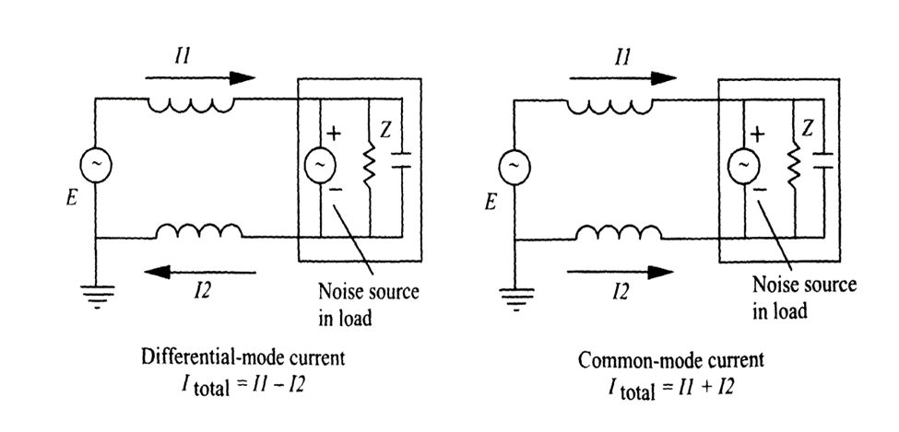
Figure 10: Illustration of differential and common mode current.

3.4.1.5 Grounding Plane
Grounding methodologies are an important aspect for the circuit design layout and significantly impact the trace width and spacing. Single-point grounding techniques are ineffective when routing traces to a reference voltage because it is commonly used in low frequency applications circuit that utilize one megahertz or less. Moreover, single-point grounding tends to have a high impedance which is inefficient for PCB prototyping and can lead to increases in RF development going against the initial intend of the design project. The optimal solution is to implement both multipoint and hybrid grounding configurations to achieve the most feasible and functional design when creating the PCB schematic layout since the second layer of the PCB is the ground plane. Multipoint and hybrid grounding will be implemented to reduce signal noise, RF energy and impedance of the board which will keeping the ground leads short playing a key role in reducing lead inductance. Thus, mitigating voltage potential interference between the interconnect wires and preventing common-mode current generation. The traces can inductance to a circuit based on the thickness and width of the trace; accounting for these factors can significantly improve overall signal strength and aid in RF energy suppression on the board by coupling the signal traces to the reference voltage.
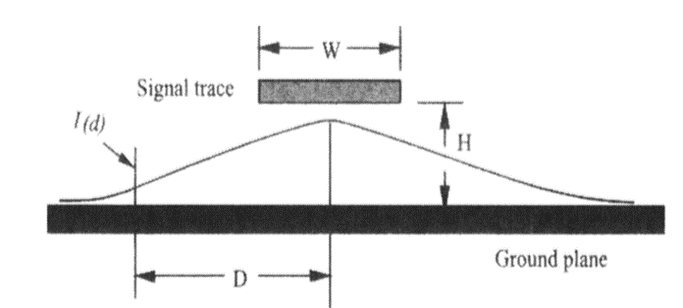
Figure 11: Ground plane representation.
Furthermore, the ground and signal loops play a major factor towards negating RF energy. Repositioning high speed devices is necessary and should be integrated by placing all component in proximity to the ground plane so the heat can dissipate effectively reducing unwanted RF energy. Incorporating all these measures avoid the use of containment implementation which often results in a more complex PCB layout design and electromagnetic interference. The aspect ratio between the ground connections can cause unwanted coupling of peripherals and components if the ground stitch connection is insufficient. Creating subsections for component placement will minimize signal trace lengths and creation of antennas while strengthening the maintaining the integrity of the signal transmissions. All subsections should have a ground connection to chassis to ensure that short trace routes using functional partitioning.
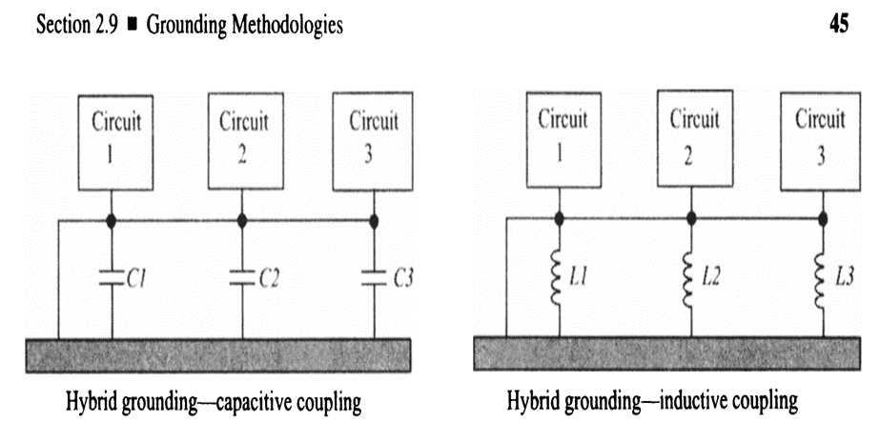
Figure 12: Hybrid Grounding Configurations.

3.4.2 Part selections

3.4.2.1 Microcontroller Selection

Table 9: Microcontrollers
Model | ESP32-S3-WROOM-1-N8R8 | ATMEGA328 | MSP430F6659IPZR
Company | Espressif Systems | Microchip Technology | Texas Instrument
Core Processor | Tensilica Xtensa | AVR | MSP430 CPUXV2
Core Size | Dual Core 32-bit | 8-bit | 16-bit
Frequency (Hz) | 2.4GHz | 20MHz | 20MHz
Peripherals | GPIO, SPI, LCD interface, Camera interface, UART, I2C, I2S, remote control, pulse counter, Espressif Systems LED PWM, full-speed USB 2.0 OTG, USB Serial/JTAG controller, MCPWM, SDIO host, GDMA, TWAI® controller (compatible with ISO 11898-1), ADC, touch sensor, temperature sensor, timers, and watchdogs | Peripheral Touch Controller (PTC), Two 8-bit Timer/Counters with Separate Prescaler and Compare Mode, three 16-bit Timer/Counters with Separate Prescaler, Compare Mode, and Capture Mode, Real Time Counter with Separate Oscillator, Ten PWM Channels, 8-channel 10-bit ADC in TQFP and QFN/MLF package, UART, I2C, I2S, On-Chip Analog Comparator, Programmable Watchdog Timer with Separate On-chip Oscillator | Brown-out Detect/Reset, DMA, LCD, POR, PWM, WDT
Memory (byte) | 8MB | 32KB | 512KB
RAM Size | 8MB | 2k x 8 | 66Kx8
Voltage supply | 3~3.6V | 1.8 ~5.5V | 1.8 ~ 3.6V
Current (A) | 97mA ~500mA | 0.24mA | 2mA
Package | 41-SMD Module | 32-TQFP | 100-LQFP
Cost ($) | 3.32 | 1.70 | 15.19
Lead time | 8 weeks | 6 weeks | 12 weeks
The microcontroller comparison for which option would be most suitable for the project was determined based on various factors such as pricing, processing speed, lead time, memory size and peripherals accessibility. Lead time played a crucial role in the selection process considering the project timeline completion date being at the end of Fall semester. The ATMEGA328 was the most appealing in terms of accessibility to the component earlier compared to it counter parts. In addition to the low price point that would keep the build of materials cost low. Unfortunately, the ATMEGA328 fall short in processing power and raw RAM which could significantly hinder the performance of the system execution time. The features available on the chip was another positive selling point for the microcontroller but falls short when stack up against the other options available. The second option was the MSP430F6659IPZR chip that which was slightly more power in terms of processing power and RAM compared to the ATMEGA328. Unfortunately, the ATMEGA328 had substantially more features available at a lower price point and lead time which defeated the point of selecting the MSP430 chip. A benefit that the MSP430 had over the other options was that the development software compatible with the chip was Code Compose Studio which was a familiar Integrated Development Software (IDE) that was commonly utilized in previous courses in a language that was native to the group. The best options were the ESP32-s3 WROOM-1 because of the exceptional overall performance and memory capabilities in tandem with features available that made it impossible to overlook. The price point and lead time was relatively identical to the ATMEGA328 which made it more appealing over the other options. One key feature that aided in the selection was the integrated Bluetooth and Wi-Fi that was needed for the display screen that would exhibit the sampling results from the chemical analyzer. The chip would be utilizing the Arduino IDE software which was programmable in C code which influence the decision in the selection process. The ESP32-s3 WROOM-1 features overall flexibility and low cost with reasonable lead time for shipping which made it the best option for the chemical analyzer project.

3.4.2.2 USB-To-UART Bridge

Table 10: Universal Asynchronous Receiver/Transmitter Bridge
Model | CP2102-GMR | FT231XS-R | CP2105-F01-GMR
Company | Silicon Labs | FTDI, Future Technology Devices International Ltd | Silicon Labs
Current Supply | 20mA | 8mA | 17mA
Operating Temperature | -40 ~ 85 | -40 ~ 85 | -40 ~ 85
Package Case | 28-QFN | 20-SSOP | 24-WFQFN
Cost ($) | 6.54 | 2.34 | 5.17
Lead time | 8 weeks | 12 weeks | 12 weeks
The FT231XS-R UART bridge was the least appealing option due to the design integration complexity for prototyping the microcontroller to the UART bridge. The bridge itself had great features with low current supply demand and the lowest price point compared to the other selections. The package case for the bridge was another beneficial aspect to consider because soldering QFN components can be difficult depending on the design implementations for the PCB. The CP2105-F01-GMR bridge was the second option consideration for the PCB fabrication which fixed the major issue of design integration that was present with the FDTI bridge. The bridge also had the lowest operational voltage requirements which opened room for circuit design alternatives. This bridge was a solid choice but ultimately fell short to another bridge from the same family the CP2102-GMR which had the best lead time and design integration compared to its counterparts. The major negative to the CP2102-GMR bridge was the pricing which placed the highest in the available options. This bridge was the best choice based on the available tradeoffs and ease of us when developing a PCB board.

3.4.2.3 Voltage Regulator Selection

Table 11: Linear, Low Drop Out (LDO) Voltage regulator
Model | TLV75533PDBVR | MIC5504-3.3YM5-TR | TLV1117LV33DCYR
Company | Texas Instruments | Microchip Technology | Texas Instruments
Voltage dropout (max) | 0.238V | 0.38V | 1.3V
Output Current | 500mA | 300mA | 1A
Quiescent current | 31uA | 55uA | 100uA
PSRR | 52dB (1kHz ~ 1MHz) | 60dB (1kHz) | 75Db(120Hz)
Package Case | SC-74A, SOT-753 | SC-74A, SOT-753 | TO-261-4, TO-261AA
Cost ($) | 0.40 | 0.16 | 0.35
Lead time | 6 weeks | 4 weeks | 6 weeks
Selecting the right voltage regulators for the PCB was crucial for insuring efficient power management and distribution throughout the entire design. Factors such as layers and high frequency components played a key role in selecting the type of regulators most suitable for handling different sections of the PCB power grid. The Linear Regulators were the first on the list due the simplistic design integration alongside to getting fixed power supply without having to do major calculations and testing to achieve a desired voltage. The idea was to select a Linear regulator for the microcontroller and UART bridge that would satisfy the required power demands. The MIC5504-3.3YM5-TR was the most affordable option available with the shortest lead time. Unfortunately, the overall power calculations were quite low coming in with only 300mA that would fall short of supply enough current to the ESP32-s3 WROOM-1 that had a current supply rating of 500mA in tandem with the UART bridge that also would require sufficient power delivery. The remaining choices ended up being two linear regulators from the same family with identical pricing and lead time in addition to design circuit. The overall decision for selecting the best option came down to the power calculations regarding which regulator would deliver more power. The TLV1117LV33DCYR from Texas Instruments was the ideal choice based on the power delivery calculations and the simplistic design which would aid in eliminating impedance imbalances and limit the usage of shielding techniques for noise reduction.

Table 12: Switching Voltage regulator
Model | AP61100Z6-7 | TPS562200DDCR | TLV61048DBVR
Company | Diode Incorporated | Texas Instrument | Texas Instrument
Function | Step Down | Step Down | Step up
Topology | Buck | Buck | Boost
Input Voltage (min) | 2.3V | 4.5V | 2.65V
Input Voltage (max) | 5.5V | 17V | 5.5V
Output Voltage (min) | 0.6V | 0.765 | 3.3V
Output Voltage (max) | 3.6V | 7V | 14V
Output Current | 1A | 2A | 3.7A
Frequency switching | 2.2 MHz | 650kHz | 550kHz, 1MHz
Quiescent current | 15uA | 10uA | 1uA
Efficiency (%) | 89 | 85 | 90
Cost ($) | 0.36 | 0.56 | 0.76
Lead time | 8 weeks | 6 weeks | 6 weeks
Following the selection of the linear regulator, additional step up/step down regulators were necessary for supplying power to the peripheral components on the PCB and external component such as the photo detector which would require a custom regulator design that would supply specific power based on the performance of the chemical analyzer. The boosting regulator TLV61048DBVR from Texas Instrument was a definitive selection for the establishing and satisfying the power management of the optical components integrated with the PCB. The Power delivery for the voltage regulator was the highest and compared to other potential options at a low pricing with minimal lead time. The TLV61048DBVR became a necessary component for ensuring that the PCB development would perform effectively during the chemical analyzer sampling process. The next step was to identify a secondary voltage regulator tailored to stepping down the power delivery to the peripheral components that work in sync with major devices to achieve optimal functionality. The two choices available that were considered are the AP61100Z6-7 and TPS562200DDCR buck regulators. The ultimate decision regarding the most suitable was based on the pricing and lead times that played a key role in the decision of placing TPS562200DDCR above AP61100Z6-7 in terms of more desirable options. The step-down regulators had relatively the same specifications which influenced the purchasing of both regulators and manually testing which works best under design constraints of the PCB.

3.4.2.4 Electrostatic Discharge Circuit Protection

Table 13: Transient Voltage Suppressors ESD Protection
Model | ESD9X5.0ST5G | D5V0L1B2WS-7 | ESD5B5.0ST5G
Company | Onisemi | Diodes Incorporated | Onisemi
Voltage-Breakdown (min) | 6.2V | 6V | 5.8V
Voltage-Clamping (max) @Ipp | 12.3V | 14V | 12.5V
Current-Peak Pulse(10/1000us) | 8.7A (8/20us) | 6A (8/20us) | -
Power-Peak Pulse | 107W | 84W | 107W
Capacitance @ Frequency | 65pF @ 1MHz | 15pF @ 1MHz | 15pF @ 1MHz
Operating Temperature (℃) | -55 ~ 150 | -65 ~ 150 | -55 ~ 150
Package Case | SOD-923 | SC-76, SOD-323 | SOD-923
Cost ($) | 0.25 | 0.21 | 0.25
Lead time | 10 weeks | 8 weeks | 12 weeks
The first PCB main will need a USB port connection interface to program the microcontroller and provide instructions via code so that it can execute various operations. Designing a USB port interface typically requires some form of ESD protection circuit that prevents the board from exploding due to excess current. The selection process regarding the Zener diode most suitable was straight forward came down to the cost and lead time which automatically eliminated ESD5B5.0ST5G component for being among the most expensive and having the longest lead time. The D5V0L1B2WS-7 was ultimately the most affordable option with the shortest lead time. This diode was the top choice regarding what was necessary for the PCB, however the ESD9X5.0ST5G option was also a solid pick when comparing the power peak pulse specifications. Ultimately, the two Zener diodes will be ordered and tested similarly to the voltage regulators under different load test scenarios to see which is more efficient during system operations.

3.4.2.5 Connection Interface

Table 14: Universal Serial Bus Port
Model | 10118192 | USB4105-GF-A-120 | 61729-1011BLF
Company | Amphenol ICC(FCI) |  | Amphenol ICC(FCI)
Connector Type | USB - micro-B | USB-C (USB Type-C) | USB-B (USB Type-B)
Number of Contacts | 5 | 24 | 4
Mounting Type | Surface Mount, Right Angle | Surface Mount, Right Angle; Through Hole | Through Hole, Right Angle
Features | Solder Retention | Board Guide, Solder Retention | Board Lock
Voltage-Rated | 100VAC | 48VDC | -
Current Rating | 1.8A | 5A | 1A
Mating Cycles | 10000 | 20000 | -
Shell/Shielding Material | Steel, Stainless | Steel, Stainless | Steel, Stainless
Operating Temperature (℃) | -30 ~ 80 | -40 ~ 85 | -55 ~ 85
Cost ($) | 0.43 | 0.81 | 1.26
Lead time | 9 weeks | 7 weeks | 8 weeks
The USB port Selection was crucial and played a vital role in determining the design implementation required depending on the type of USB port utilization. The major options reviewed consisted of a micro-B, type C and type-B each requiring an entirely different circuit design interface. The method for selecting which would be best was to consider the pricing and which port had the least complexity for shielding parameters. The USB type B was the simplest in the circuit integration but was the most expensive which placed it at the bottom of the list. USB type-C was essentially the opposite with having the most complex shielding circuit design due to the number of contacts but made up for its low lead time. Subsequently, the micro-B was positioned between the other two options which made it the top contender for consideration. The price point of the micro-B was also a bonus factor that put it above the other options when looking from a low budget cost standpoint. The micro-B consisted of five contact points which was is relatively simple to design with minimal work.

3.4.2.6 Peripherals

Table 15: LEDs
Model | 150080BS75000 | 150080VS75000 | 150080RS75000
Company | Wurth Elektronik | Wurth Elektronik | Wurth Elektronik
Color | Blue | Green | Red
Millicandela Rating | 145mcd | 40mcd | 150mcd
Voltage-Forward | 3.2V | 2V | 2V
Wavelength-Dominant | 470nm | 570nm | 625nm
Wavelength-Peak | 465nm | 572nm | 630nm
Cost ($) | 0.18 | 0.18 | 0.18
The LEDs selection consisted of the same models from the same company each displaying a different color. All LEDs will be utilized in the PCB development process and counts toward the ECE department guidelines for EE students. The purpose of the blue LED is to indicate the execution of instructions to the users via periodic flashing that shows the transfer/receiving of data. The Green LED towards general usage and will be delegated to the microcontroller for miscellaneous applications. The red LED will be utilized as an indication power by directly connecting the circuit to the regulator responsible for delivering power to the board. The LEDs directly aids in providing visual data to the user regarding component malfunctions in addition to test points for verifying voltages at specific nodes on the board.

Table 16: Switches
Model | PTS636 SM43 SMTR LFS (Tactile) | 100SP1T1B4M2QE (Toggle) | PTS 647 SN50 SMTR2 LFS (Tactile)
Company | C&K | E-Switch | C&K
Actuator Type | Rectangular Button | Standard Round | Standard
Mounting Type | Surface Mount | Through Hole | Surface Mount
Switch Function | Off-Mom | On-On | Off-Mom
Contact Rating @ Voltage | 0.05A @ 12VDC | 5A (AC/DC) @28VDC | 0.05A @ 12VDC
Actuator Height off PCB, Vertical | 4.30mm | 10.41mm (Length) | 5.00mm
Termination Style | Gull Wing | PC Pin | Gull Wing
Operating Force | 180gf |  | 100gf
Mechanical Life | 50,000 Cycles | 40,000 Cycles | 100,000 Cycles
Operating Temperature (℃) | -40 ~ 90 | -30 ~ 85 | -20 ~ 70
Cost ($) | 0.19 | 2.82 | 0.18
Lead time | 6 weeks | 11 weeks | 9 weeks
The switches for the PCB implementation are divided into two categories the first being a toggle switch responsible for enabling a safety feature which manually power off external power integrated with the PCB. The selection function revolves around providing the microcontroller with a tactile switch for boot up and reset mode to active and refresh program executions when necessary. The power switch 100SP1T1B4M2QE option was an excellent choice with a through hole mounting type that is ideal for attaching components to PCB board without having to design a physical section on the board. The power switch lead time won’t be an issue because the component is easily accessible on Amazon which significantly reduces waiting time for arrival. The tactile switch selection ultimately came down to lead time being the determining factor for choosing the PTS636 SM43 SMTR LFS tactile switch. The PTS 647 SN50 SMTR2 LFS tactile switch had more appealing specifications and realistically is the better option on paper but for the purposes of this project it is not necessary, nor will it affect the overall performance of the system.
Table 17: Pin Headers
Model | TSW-103-23-G-D | PH1-06-UA
Company | Samtec Inc. | Adam Tech
Number of Rows | 2 | 1
Style | Board to Board | Board to Board
Contact Length-Mating | 0.230” (5.84mm) | 0.236” (6.00mm)
Contact Length-Post | 0.115” (2.92mm) | 0.120” (3.05mm)
Overall Contact length | 0.445” (11.30mm) | 0.454” (11.54mm)
Insulation Material | Polybutylene Terephthalate | Polybutylene Terephthalate, Glass filled
Contact Material | Phosphor Bronze | Brass
Current Rating | - | 3A
Voltage Rating | - | 250VAC
Operating Temperature (℃) | -55 ~ 125 | -40 ~ 105
Cost | 0.80 | 0.13
The pin headers main usage for this system is to provide a biasing voltage to the photo detector so that it can analyze the sampling liquid and transmit the information back to the microcontroller which then display the results on the display screen. The selection choice for the pin header solely depending on the cost and the voltage rating which ideally indicates the limitation of the pin headers. The PH1-06-UA was the best selection option in terms of quality and price point over its counterpart in addition to having a high voltage rating. Designing and integrating the switches onto the PCB will be straightforward considering only two ports on the tactile pads are necessary to complete the circuit connection.

3.5 Software Research

3.5.1 Integrated Development Environment Analysis

3.5.1.1 Arduino IDE
Overview
The Arduino IDE is a known development environment appreciated by beginners and enthusiasts, for its open-source nature and user-friendly interface. It supports microcontrollers, including Arduino boards based on different architectures like AVR, SAM and ARM. Its simplicity and ease of use make it ideal for educational purposes, which is advantageous for our senior design project.
Features
A key feature of the Arduino IDE is its interface that simplifies writing, compiling and uploading code with effort. This is especially helpful for team members to embedded systems ensuring a learning process and efficient project development. Additionally, the IDE provides a range of libraries that make integrating sensors, actuators and communication modules easier. These libraries save us time during development enabling us to test components of our fluoride concentration detector. Furthermore, the cross-platform compatibility of the Arduino IDE across Windows, macOS and Linux ensures collaboration among team members, without compatibility issues. Moreover, the active Arduino IDE community provides a lot of resources like documentation, tutorials and forums for troubleshooting and sharing knowledge. These resources will be super useful whenever we face challenges or need guidance for parts of our project.
Benefits
The Arduino IDE comes with advantages that suit our project needs well. Its user-friendly interface allows even those with programming experience to quickly start working on projects, which's great for our educational setting and rapid prototyping requirements. This helps us achieve results quickly. The wide range of libraries and easy to use coding environment also support prototyping for refining our design to ensure accurate and reliable detection of fluoride concentration. Additionally, the affordability of the Arduino IDE as an open-source tool aligns perfectly with our budget limitations. This lets us invest in high quality sensors and components for aspects of our project.
Drawbacks
Despite its benefits the Arduino IDE does have some downsides. One major limitation is its lack of features. The simplicity of the Arduino IDE might be restrictive for projects that require advanced debugging and optimization capabilities. For example, the debugging features in the IDE are quite basic compared to what you'd find in development environments. This could make it tricky to troubleshoot and resolve issues in our code. Additionally, while suitable for projects, the Arduino IDE may not be the option, for tasks that demand high performance or real-time capabilities. Our project involves working with fluorescence signals, which may require processing power and real time data handling than the Arduino IDE can handle.

3.5.1.2 Code Composer Studio
Overview
CCS is designed to cooperate with TI hardware providing optimized libraries and drivers that improve performance and user friendliness. This close integration ensures that we can make the most of our TI microcontrollers' capabilities allowing us to achieve the desired functionality and precision in our project.
Features
Additionally, CCS offers project management tools. The IDE supports project templates integrating with version control. Includes features that support team development. These tools help us efficiently manage our project, ensuring that all team members are aligned and allowing us to monitor changes and progress effectively. Another notable feature is the support for communication protocols and peripheral interfaces. CCS comes with built-in support for I2C, SPI, UART and other essential protocols for interfacing with sensors, displays and other components in our project. This support simplifies the integration of hardware elements enabling us to concentrate on the core functionality of our system.
Benefits
Code Composer Studio provides many benefits for our project. The grade debugging and analysis tools enable inspections of our code and system behavior aiding in identifying and resolving issues efficiently. This aspect is particularly significant for our project since achieving fluoride concentration detection requires testing and optimization. A strong connection with TI hardware ensures that we can make the most of our TI microcontrollers, achieving top notch performance and functionality. Code Composer Studio provides many benefits for our project. The project management and collaboration tools offered by CCS assist us in overseeing our development process ensuring that all team members are on the page and enabling us to monitor progress and changes efficiently. This is vital for our project as it guarantees teamwork and the achievement of development milestones.
Drawbacks
Despite its benefits Code Composer Studio does come with some drawbacks. One major downside is its learning curve. CCS is a professional grade IDE packed with an array of features and capabilities which can be overwhelming for novices. This may present challenges for team members who have limited experience in embedded development, necessitating time and effort to master the IDE effectively. Another potential drawback is the complexity of the development environment. While the extensive features and capabilities of CCS are advantageous for projects, they can also complicate the development process. Consume more time. This could pose a limitation for our project if we need to prototype and test approaches.

3.5.1.3 STM32CubeIDE
Overview
STM32CubeIDE, created by STMicroelectronics for the STM32 microcontroller family is an all, in one development environment that merges the graphical configuration tool with an Eclipse based platform. This combination offers a range of tools for building, testing and enhancing embedded applications. With the features and capabilities of STM32 microcontrollers, STM32CubeIDE emerges as a choice for our current project. Key highlights of STM32CubeIDE include its user graphical configuration tool, STM32CubeMX. This tool simplifies hardware configuration and code generation through an interface. It streamlines the setup process allowing quick customization of the microcontroller to suit our project's needs. The visual presentation aids in managing hardware components reducing setup complexities.
Features
Moreover, the IDE boasts debugging and analysis tools that're essential for effective troubleshooting. From real time analysis to memory inspection and profiling tools STM32CubeIDE equips us with capabilities to detect and resolve issues promptly. These functionalities play a role in ensuring the accuracy and efficiency of our device meant for detecting concentrations. Furthermore, seamless integration with the STM32Cube ecosystem sets STM32CubeIDE apart. This integration provides access to an array of libraries middleware solutions and development tools tailored for embedded applications. This integration ensures that we can make the most of our STM32 microcontrollers, allowing us to achieve the functionality and precision we need for our project. The IDE also supports communication protocols and peripheral interfaces. STM32CubeIDE comes with built in support, for protocols like I2C, SPI, UART, which're crucial for connecting with sensors, displays and other project components. This support streamlines the integration of hardware elements letting us concentrate on the functions of our system.
Benefits
STM32CubeIDE offers advantages that align perfectly with our project objectives. The graphical configuration tool simplifies setting up the microcontroller and peripherals swiftly. Its user-friendly interface makes it easier to visualize and manage hardware components, reducing setup complexities. The debugging and analysis tools provided by STM32CubeIDE allow us to conduct inspections of our code and system behavior aiding in efficient issue identification and resolution. This is particularly crucial for our project since achieving precise and reliable fluoride concentration detection necessitates testing and optimization efforts. The integration with the STM32Cube ecosystem guarantees that we can fully exploit the capabilities of our STM32 microcontrollers to achieve performance and functionality. Optimized libraries and middleware make the development process easier allowing us to focus on building the core features of our project.
Drawbacks
However, there are some downsides to using STM32CubeIDE. One major disadvantage is its learning curve. Since STM32CubeIDE is a professional level IDE with features it can be overwhelming for newcomers. This may pose challenges for team members who're not well versed in embedded development leading to time and effort needed to master the IDE. Another potential drawback is the complexity of the development environment. While the extensive features of STM32CubeIDE are advantageous, for projects they can also add complexity and time to the development process. Truthfully, this could be limiting for our project if we require prototyping and testing of approaches.

3.5.1.4 LabVIEW
Overview
LabVIEW, a software developed by National Instruments, is well known for its programming environment that excels in data acquisition, instrument control and automation. In our design project focused on detecting fluoride levels in drinking water, LabVIEW offers numerous benefits. These include data acquisition, advanced data processing capabilities, user friendly interface design and seamless hardware integration. The visual coding approach simplifies complex system designs and enhances the efficiency of our development process.
Features
One standout feature of LabVIEW is its programming interface, which differs from text-based coding environments by allowing users to create programs through connecting functional blocks visually. This intuitive method not only accelerates the development and debugging of systems but also promotes collaboration among team members with varying levels of programming skills. When it comes to data acquisition and instrument control LabVIEW stands out for its integration with hardware components. It seamlessly interfaces with the photodiode and laser diode utilized in our fluorescence spectroscopy setup. The platform supports real time data acquisition, for capturing fluorescence signals and synchronizing them with excitation events.
LabVIEW's capability to manage data streams at the time ensures efficient handling of large datasets without any loss of data or timing issues. We will be processing and analyzing data that plays roles in our fluoride detection system. LabVIEW provides a range of signal processing libraries, including filtering, averaging and Fourier analysis. These tools are essential for extracting information from the raw fluorescence signals, which can be noisy and variable. The built in analysis functions allow system calibration by plotting fluorescence intensity against known concentrations to create reliable calibration curves necessary for accurate measurements.
LabVIEW excels in visualization and user interface features well. The platform enables the creation of interactive user interfaces that display real time data, calibration curves and other important information. Users can monitor the system's performance through graphs and charts facilitating comprehension of data for making informed decisions. This aspect is especially advantageous for technical users as it offers a clear and intuitive way to interact with the device.
Advantages
LabVIEW brings advantages to our fluoride detection project and can live up to our desired goals. The platforms advanced data processing tools enhance the accuracy of measurements by implementing algorithms that may be challenging for a microcontroller to handle. For instance, LabVIEW has the capability to make real time adjustments to account for factors, like temperature changes that could impact fluorescence measurements. By compensating for these variables, the system can deliver dependable outcomes.
LabVIEW's capacity to manage data storage and recording is extremely useful for prolonged monitoring purposes. The system can store volumes of data either locally or in the cloud making it easier to conduct analyses over extended durations. This feature plays a role in tracking fluoride level trends and evaluating the efficiency of water treatment measures. Researchers and public health officials can remotely access the data allowing them to monitor water quality in time from locations.
Additionally, LabVIEW offers error handling and diagnostic capabilities for maintaining system dependability. The software can continuously monitor system performance, identify anomalies, and provide details to users. This proactive error management approach helps minimize downtime and ensures that the device operates accurately and consistently.
Drawbacks
However, despite its benefits LabVIEW does have some drawbacks. One significant disadvantage is its costliness. Acquiring LabVIEW software along with associated National Instruments hardware could pose a challenge for student projects operating on a limited budget. Nonetheless educational discounts and licensing options may help alleviate this concern. Moreover, although LabVIEW's user interface is easy to navigate, mastering its functionalities may require some time and practice. It is essential to undergo training to make the most out of its capabilities. Another challenge lies in integrating LabVIEW with hardware components. While LabVIEW supports an array of devices connecting nonstandard or customized components might demand extra expertise and effort. This could present obstacles for our project if we intend to use sensors or modules that are not inherently supported by LabVIEW.

3.5.1.5 Raspberry Pi
Overview
The Raspberry Pi stands out as a sized computer that serves as a robust platform for developing embedded systems and IoT applications. With its processing power, expanded connectivity options, and ability to operate on an operating system the Raspberry Pi emerges as an appealing option for our fluoride detection project. Its capability to handle signal processing tasks and advanced data analysis positions it as a contender for our requirements.
Features
An advantage of the Raspberry Pi is its processing power when compared to conventional microcontrollers, courtesy of its multicore ARM processor. This increased processing capability can be particularly beneficial, for executing signal processing tasks and advanced data analysis ultimately enhancing the precision and efficiency of detection. The Raspberry Pis capability to run a Linux operating system enables it to support data processing and analysis tools effectively. By using software packages tailored for computing like Python libraries such as NumPy, SciPy and Pandas users can conduct, in depth data analysis create calibration curves and deploy machine learning algorithms to improve the devices detection and prediction functionalities. Another key advantage of the Raspberry Pi lies in its diverse connectivity options which include USB ports, Ethernet, Wi Fi and Bluetooth. These features facilitate communication setups and enable remote monitoring capabilities. This allows the device to transfer data to cloud services, send notifications to users and grant time access to fluoride concentration readings. Additionally, with enhanced data storage capabilities such as support for SD cards and USB drives the Raspberry Pi can efficiently log data for periods. This supports monitoring and detailed analysis activities.
Moreover, the Raspberry Pis ability to connect with HDMI displays and support graphical user interface (GUI) development makes it an ideal platform for creating user interfaces. Tools, like Tkinter, PyQt or web-based interfaces utilizing Flask or Django can be leveraged to design interfaces that assist users throughout sampling procedures, calibration tasks and data analysis operations. This can greatly improve how easy it is to use the device, making it more user friendly for people who may not be tech savvy.
Benefits
The Raspberry Pi offers advantages that align well with our project objectives. Its improved processing power enables signal processing and data analysis resulting in better accuracy for fluoride measurements. The ability to utilize scientific computing libraries further enhances its capabilities allowing us to implement algorithms and data processing methods. The wide range of connectivity options with the Raspberry Pi simplifies the integration of communication and remote monitoring features. This facilitates real time data transmission and remote device access enhancing its usability across environments. The robust data storage options also support monitoring and detailed analysis, essential for tracking fluoride level trends and evaluating water quality changes over time. The capacity to develop user interfaces improves the user experience making the device more intuitive and user friendly. This aspect is especially crucial for our project as it ensures that users, with knowledge, can easily operate the device.
Drawbacks
While the benefits are present, one significant drawback of the Raspberry Pi is its power consumption. The Raspberry Pi uses more power than microcontrollers, which could impact the battery life of portable devices. This could be an issue when testing, where finding power sources may not always be easy. Another downside is the setup and maintenance complexity of the Raspberry Pi compared to microcontrollers. Setting up and maintaining it requires programming and system administration skills, which could be challenging for some team members. Most importantly, cost is another factor to consider for the use of this tool. While the Raspberry Pi itself is reasonably priced additional accessories needed to utilize its potential can drive up the expenses. This might limit our project if we must stick to a budget.

3.5.2 Selected IDE
For our project we have chosen the Arduino IDE due to its user nature and broad compatibility with hardware components essential for our success. The intuitive interface of the Arduino IDE enables team members with levels of programming skills to write, compile and upload code easily and quickly. This simplicity is especially advantageous, in environments where prototyping and iterative development play a crucial role.
The simple coding environment makes it easier for us to skip the setup steps and concentrate on the parts of our project like working on integrating sensors and perfecting the fluorescence detection algorithms. Moreover, the Arduino IDE offers a range of libraries that significantly cut down our development time. These libraries cater to functions from collecting sensor data to handling communication protocols allowing us to smoothly combine elements needed for our project. Another strong point, in favor of using the Arduino IDE is its compatibility with a variety of hardware components. This adaptability lets us effortlessly connect sensors, actuators and other devices for our project's operation. For example, the Arduino platform supports sensor modules of measuring different environmental factors, which is vital for accurately gauging fluoride levels in water samples. This compatibility guarantees that we can choose the components for our project without concerns about compatibility issues or having to create custom drivers extensively. Furthermore, the cross-platform support of the Arduino IDE across Windows, macOS and Linux ensures that all team members can actively participate in the project without encountering compatibility hurdles. This flexibility plays a role in facilitating our work. The easy incorporation and wide range of hardware compatibility offered by the Arduino platform greatly boosted the adaptability and expandability of our project, making it a suitable choice for our senior design project.

3.5.3 LED/OLED Display
Table 18: Displays
Model | SSD1306 | SH1106 | SSD1306 | UG-2832HSWEG04 | ST7735S | ILI9341
Company | Adafruit | Wave share | Adafruit | SparkFun |  | Ilitek
  Waveshare
Resolution | 128x64 pixels | 128x64 pixels | 128x32 pixels | 128x32 pixels | 128x128 pixels | 240x320 pixels
Interface | I2C, SPI | I2C, SPI | I2C | I2C | SPI | SPI
Voltage Supply | 3.3V | 3.3V | 3.3V | 3.3V | 3.3V | 3.3V
Power Consumption | Ultra-low | Low | Ultra-low | Low | Moderate to High | Low
Package | Module | Module | Module | Module | Module | QFP-48
Cost ($) | $10-15 | $15-20 | $10-12 | $20-25 | $15-20 | $6.50
Operating Temperature | -40 to 85 °C | -40 to 85 °C |  |  | -20 to 70 °C | -30 to 85°C
  -40 to 85 °C
  -40 to 85 °C
Backlight | No | No | No | No | Yes | Yes
Color | Monochrome | Monochrome | Monochrome | Monochrome | Full-color | RGB
Special Features | Compact, high contrast | Larger display area, high contrast | Ultra-compact, energy efficient | Flexible design for curved surfaces | High resolution, rich color capabilities | Touch support
Mounting Type | PCB mount, Through-hole | PCB mount, Through-hole | PCB mount, Through-hole | PCB mount, Through-hole | PCB mount, Through-hole | Surface Mount

3.5.4.1 Analysis of OLED/LED Displays
When we choose an OLED/LED display to pair with our ESP32 microcontroller it's crucial to assess the features and capabilities of each option. Every display has its strengths and weaknesses. Picking the right one depends on what our project specifically needs. Lets dive into a comparison of five top notch displays to better understand how suitable they are, for applications.
The Adafruit 128x64 OLED Display (SSD1306) is highly regarded in the maker community for its contrast and energy efficiency. With a size of 0.96 inches and a resolution of 128x64 pixels it strikes a balance between detail and compact design. This display supports both I2C and SPI interfaces offering flexibility for integration with systems. Thanks to its library support we can easily set it up with hassle. It's especially great for projects running on batteries where saving energy's key. Its small form factor makes it perfect for tech, portable gadgets, and projects where space is limited. However, its size might be a drawback for applications needing display areas since the screen real estate is limited restricting the amount of information shown at once. When it comes to design and user friendliness the Adafruit 128x64 OLED (SSD1306) stands out as a choice for our projects that demand a user-friendly display with strong contrast. Its energy efficient nature helps extend battery life making it suitable for devices that need to run for periods without recharging. Moreover, the wide range of support for this display through libraries and tutorials simplifies the development process for our team for those who are new to working with displays and microcontrollers. However, its compact size comes with a limitation in the amount of data that can be displayed at once which might not be ideal for applications needing extensive visual output.
On the hand the Waveshare 1.3 Inch OLED Display (SH1106) provides a screen size of 1.3 inches while maintaining the same resolution of 128x64 pixels. This makes it an appealing choice for our projects requiring a display without compromising on power efficiency or contrast quality. Like the SSD1306, it supports I2C and SPI interfaces offering integration options. The increased display size can be advantageous for applications demanding presentation of information such as dashboards, control panels or more intricate visual feedback, in devices. The SH1106 has library support, which makes development and integration, for our team. However, its larger size may not be ideal for our designs. It shares the same resolution limits as smaller screens resulting in a lower pixel density despite the larger display area. The Waveshare 1.3 Inch OLED (SH1106) offers viewing experience due to its larger size, making it suitable for applications where quick data reading is essential. It works well in controls, home automation panels and other scenarios where visibility is crucial. On the downside its bigger size may pose space constraints in our projects. This display has slightly increased power requirements compared to the SSD1306.
If space is a priority in our projects the Adafruit 128x32 OLED Display (SSD1306) is an option. This display is even smaller at 0.91 inches with a resolution of 128x32 pixels. Its low power consumption and slim design make it perfect for our portable projects. It mainly uses the I2C interface for connections to the ESP32. The smaller screen size is ideal for showing status updates, alerts or compact control panels in embedded systems. With the range of support for the SSD1306 driver even newcomers on our team can easily navigate its functions. Despite its benefits, the limited resolution and smaller display area mean it can only present an amount of information at once which may not meet the needs of our intricate visual outputs. The Adafruit 128x32 OLED (SSD1306) is a fit for our designs that require only essential information to be showcased. For example, it's perfect for wearable fitness trackers to display time step count or heart rate without occupying space. Its energy efficient nature ensures that even tiny batteries can sustainably power the display for periods. Contrastingly, due to its display area displaying data visualization or intricate interfaces may not be feasible on this screen. This makes it less suitable for applications demanding interaction or information presentation.
The Spark Fun Flexible OLED Breakout (UG 2832HSWEG04) introduces a feature with its flexible form factor. This 0.91-inch display, with a resolution of 128x32 pixels can bend to conform to surfaces enabling designs and applications that traditional rigid displays cannot achieve. The Spark Fun Flexible OLED (UG 2832HSWEG04) brings a level of versatility to our design projects. It can be seamlessly integrated into wearables, flexible healthcare gadgets or any application that demands a display to conform to surfaces. This flexibility sets it apart from displays offering ergonomic and visually appealing designs. However, its usefulness is limited by its size and resolution constraints making it better suited for visual cues rather than intricate graphics.
The Waveshare 1.44 Inch LCD Display Module (ST7735S) boasts a full color display, with a resolution of 128x128 pixels. With its 1.44-inch size and use of the SPI interface this display outshines monochrome OLEDs by providing resolution and color options. The vibrant full color display is perfect for our needs when we want lively visuals, such as in user interfaces, image viewing and complex data representation on devices. Its higher resolution and color quality allow for visually appealing presentations. However, compared to OLED displays this LCD tends to consume power and requires intricate handling of color data due to added features leading to increased integration complexity. The ST7735S display suits our needs where visual richness and detail are valued over efficiency and simplicity. It shines in situations where visual impact and detail matter most. Nonetheless, its capability to showcase colors makes it a good fit for applications like home displays handheld gaming devices and advanced user interfaces that demand more than just black and white output. However, the trade off, for this feature is its power consumption level, which's a significant factor to consider for our battery powered devices. Moreover, dealing with color data introduces complexity into the development process necessitating coding techniques and longer development timelines for our team.

3.5.4.2 Selected Display
We acknowledge the importance of selecting the right display option to meet our objectives of accuracy, usability and cost effectiveness. After considering our options, we suggest going with the ILI9341 display for our project. This choice is based on its benefits that align well with what we need.
The ILI9341 display provides a resolution of 240x320 pixels, which's crucial for showing real time fluoride concentration readings, calibration curves and user instructions in detail. Its touch support enhances user interaction making our device more user friendly for those with technical knowledge. Additionally, the RGB color feature enables us to create interfaces for information differentiation like alerts, instructions and data.
Despite being a color display, the ILI9341 consumes power efficiently, vital for maintaining our devices portability and battery life. It's easy to integrate with SPI interface and common microcontroller power supplies like Arduino. The 140° viewing angle and backlight ensure visibility under lighting conditions ideal for field use.
Moreover, the ILI9341 is cost effective at $6.50 with a lead time of 5 weeks—making it a practical choice, within our projects budget and timeline constraints. By adding the ILI9341 screen we improve the legibility, user engagement and overall performance of our fluoride detection device, which helps make it a more efficient and user tool for monitoring water quality. This decision fits well with our aim of developing a user cost-effective option for precisely measuring fluoride levels in drinking water.

Chapter 4 Standards and Design Constraints
The standard and design constraints chapter will give detailed procedures and protocol documentation on established benchmarks and norms that must be adhered to during the senior design course. Definitions regarding quality, performance, and expected behavior are explained to achieve a successful and functional design project that passes all required guidelines. The technical specifications are set by organizations such as IEEE and ISO to ensure safety, efficiency, and compatibility across products and system operations. The limitations or restrictions that define the boundaries of a system operation must be clearly examined to avoid failure in the product or preventive measures to prevent potential accidents from occurring in real-world applications. The standards and constraints provide the framework for when actions or solutions to a problem must be resolved to satisfy the expectations of regulatory guidelines. The standards and constraints for this project will gravitate towards technical development and environmental concerns in an institutional setting. All aspects involved in the project must be considered from an optical to electrical hardware and software perspective that will adhere to the principal features proposed in the standards and constraints documentation.

4.1 Standards

4.1.1 ISO 5725-1: Accuracy (Trueness and Precision) of Measurement Methods and Results
ISO 5725-1 provides guidelines for achieving accuracy and precision in measurement methods. This standard is crucial for ensuring that the fluoride concentration detector delivers reliable and reproducible results. Compliance with this standard involves rigorous calibration and validation procedures to minimize measurement errors and enhance trueness and precision (ISO, 1994). Adhering to ISO 5725-1 affects the design by necessitating high-quality sensors and precise calibration routines. The standard requires detailed documentation of measurement procedures and results, which adds to the complexity of the design process. Ensuring compliance with this standard enhances the credibility and reliability of the device, making it suitable for scientific and regulatory applications (ISO, 1994).

4.1.2 ISO 7027: Water Quality - Determination of Turbidity
Although primarily focused on turbidity measurement, ISO 7027 provides general guidelines for water quality testing, which can be relevant for the fluoride concentration detector's overall design. This standard emphasizes the importance of consistent and accurate measurements in water quality analysis (ISO, 1999). Incorporating principles from ISO 7027 ensures that the device adheres to established practices for water quality testing. This can involve selecting appropriate sample containers, ensuring consistent sample handling procedures, and implementing reliable measurement techniques. Compliance with this standard enhances the device's applicability in water quality monitoring and regulatory compliance (ISO, 1999).

4.1.3 IEC 60825-1: Safety of Laser Products
IEC 60825-1: Safety of Laser Products: IEC 60825-1 specifies safety requirements for laser products, ensuring that they are designed and used safely. These standard covers aspects such as laser classification, labeling, protective measures, and user instructions to prevent accidental exposure to harmful laser radiation (IEC, 2014). Compliance with IEC 60825-1 necessitates incorporating safety features such as protective enclosures, safety interlocks, and clear warning labels in the design. This standard also requires thorough risk assessment and documentation of safety measures. Ensuring compliance with this standard is crucial for protecting users from potential laser hazards and meeting regulatory requirements (IEC, 2014).

4.1.4 ISO 14001: Environmental Management Systems
ISO 14001: Environmental Management Systems: ISO 14001 provides a framework for environmental management, helping organizations minimize their environmental impact. This standard emphasizes the importance of sustainable practices and continuous improvement in environmental performance (ISO, 2015). Compliance with ISO 14001 affects the design by encouraging the use of environmentally friendly materials and manufacturing processes. It also involves establishing procedures for waste management and energy efficiency. Adhering to this standard enhances the device's sustainability and reduces its environmental footprint, which is increasingly important for regulatory compliance and corporate responsibility (ISO, 2015).

4.1.5 ANSI Z136.1-2014
ANSI Z136.1-2014 is the American National Standard for the safe use of lasers, providing comprehensive guidelines for the classification, control, and safety procedures associated with laser systems. This standard is critical for ensuring user safety in environments where lasers are operated, including medical, industrial, research, and consumer applications. It details hazard classifications for laser systems, ranging from Class 1 (which is considered safe under all conditions of normal use) to Class 4 (which can cause severe damage to eyes and skin and may pose fire hazards). Each classification is based on the potential for causing biological damage, and the standard outlines the specific criteria and measurement techniques used to determine these classifications. The standard also specifies control measures and safety protocols that must be implemented to mitigate risks associated with laser use. These measures include engineering controls such as interlocks, protective housings, and beam shutters; administrative controls like safety training, standard operating procedures, and warning signs; and personal protective equipment (PPE) such as laser safety goggles. ANSI Z136.1-2014 emphasizes the importance of a comprehensive laser safety program, which includes regular safety audits, hazard evaluations, and proper maintenance of laser equipment. The standard provides detailed guidelines on the responsibilities of laser safety officers (LSOs), who are tasked with overseeing the implementation of safety measures, conducting risk assessments, and ensuring compliance with the safety protocols outlined in the standard. This rigorous approach to laser safety helps prevent accidents and injuries, ensuring that laser systems are used safely and effectively in various applications.

4.1.6 IEEE-370-2020
The IEEE 370-2020 “Standard for Electrical Characterization of Printed Circuit Board and related Interconnects at Frequencies up to 50 GHz” presents strict standards operating procedures for design techniques and implementation for prototyping of PCB’s up to 50GHz. The foundation governing the standard aims to educate about methodologies for simulating and estimating s-parameters ensuring quality check and functionality for electrical hardware are met. Various metric requirements are defined during the design, evaluating and testing phase. The first segment of the documents provides definitions of terminology on electronics abbreviations. The proceeding section shift towards explaining labeling conventions and s-parameter terms. Calibration and De-embedding methods are stated as useful technique for creating a reference plane in a design. The coaxial connector characteristics regarding operating frequencies when analyzing different diameter of the outer conductor are introduced through precision guidelines. The different type of s-parameters indicated in the document provides a general procedural list for test fixtures and the criteria surrounding appropriate de-embedding mode for executing verification using s-parameter. The next section talks about ways of ensuring consistency during the testing phase by utilizing instruments for calibrating expected results and measuring accurate output to gauge the overall performance of the design. The overview of the design integration was the last section discussed using analytical models and full-wave simulations to gain data and measurements of the system capabilities. Tutorials and equation references are shown, showing numerous integrating design methods for PCB prototyping fabrication.

4.1.7 IPC-2221
The IPC-2221 features guidelines revolving around designing PCBs and forms of interlinked structures. The document covers six sections related to design specifications providing detailed instructions on basic system requirements to consider during modeling phase. In-circuit testing, feasibility density evaluation and performance and overarching design layout are various topics addressed for the user to incorporate into the PCB designing process. A thermal management system section of the standard indicates conduction and heat dissipation being major factors towards achieving a successful and fully functional design. Hole sizes and positioning of components are mentioned for tuning purposes to improve areas that are affected by impedance imbalances. The principles of correct and useful tips on designing PCB layout are stated throughout the document for users to adhere to before attempting to design a PCB.

4.1.8 IPC-4101
The IPC-4101 refers to specification for base materials for rigid and multilayer printed boards which is a pivotal concern considering that the PCB for the system being implemented requires the use of multi-layer topology to avoid performance malfunctions. The standard introduces thickness tolerance having a major impact on design process and provides a slash sheet detailing dielectric properties and their respective functional range regarding PCB fabrication. Loss tangent, surface resistivity and some of the issues discussed and how stack up principles reference related to the manufacturing capabilities are vital for ensuring the design does not exceed the limitation of the parameters set by manufacturers.

4.1.9 IEC 60529 (1989 +A1: 1999 + A2: 2013)
The IEC 60529 standard concerns the protection of the shell around an electronic device corresponding to multiple entities: protecting the electronics from solid objects, protecting people from parts located in the device and protect electronics from water. This rule applies to electrical equipment enclosures with a rated voltage under 72.5 kilovolts. Test and requirements are provided to verify the level of protection necessary. Two IP ratings are associated: 0-6 defining the level of protection against solid objects and 0-9 which is responsible for level of protection against water. A 0 typically represents no protection necessary whereas a 9 requires the highest level of protection to ensure optimal functionality

4.1.10 ISO/IEC 25010:2011 - Systems and Software Quality Requirements and Evaluation (SQuaRE)
ISO/IEC 25010:2011 demonstrates how crucial it is to ensure that our software for detecting concentration meets standards in terms of functionality, reliability, usability, efficiency, maintainability and portability. Adhering to ISO/IEC 25010;2011 involves testing and validation procedures to confirm that the software operates as intended in scenarios. This standard influences our design process by requiring documentation of software requirements testing protocols and continuous improvement practices. Following ISO/IEC 25010;2011 enhances the credibility and dependability of our software making it suitable for research and regulatory purposes.

4.1.11 ISO/IEC 12207:2017 - Systems and Software Engineering - Software Life Cycle Processes
ISO/IEC 12207:2017 provides a comprehensive framework for software development and maintenance. This standard provides a framework for managing software development and maintenance activities. It outlines the stages in the software life cycle such as requirement analysis, design, coding, testing and maintenance. Complying with ISO/IEC 12207;2017 ensures that our software development process follows an approach leading to quality and reliable final products. Implementation of this impacts our project by necessitating planning procedures thorough documentation efforts and constant monitoring, throughout the development lifecycle. Following the guidelines of ISO/IEC 12207;2017 helps ensure that our software is developed efficiently and meets all specified criteria.

4.1.12 ISO/IEC 29119 - Software and Systems Engineering - Software Testing
ISO/IEC 29119 provides a framework for software testing, encompassing test processes, documentation, techniques and keyword driven testing. This standard plays a role in ensuring that our fluoride concentration detection software undergoes testing for defects and performance issues. Complying with ISO/IEC 29119 entails creating test plans executing test cases and documenting the outcomes to verify that the software fulfills its requirements and functions reliably. It influences our design by necessitating testing procedures documentation of test cases and outcomes as well as continuous enhancement based on test feedback. Adhering to ISO/IEC 29119 elevates the dependability and resilience of our software.

4.1.13 IEC 62304:2006 - Medical Device Software - Software Life Cycle Processes
IEC 62304;2006 focuses on Medical Device Software. Software Life Cycle Processes by outlining life cycle requirements for medical device software to ensure controlled design, development and maintenance. While our project may not be a device-related one incorporating principles from these guidelines, this standard can bolster the safety and reliability of our software. Compliance with IEC 62304;2006 includes risk management practices, detailed documentation procedures well as comprehensive verification and validation processes. This standard has an impact on our project as it mandates an approach to software development and upkeep with a strong emphasis on safety and reliability. Adhering to IEC 62304;2006 guarantees that our software is crafted with notch quality and safety standards.

4.1.14 ISO/IEC 27001 - Information Security Management
ISO/IEC 27001 provides a framework for managing information security, ensuring that our software and data are protected against risks. This framework serves as a guide for overseeing information security ensuring that our software and data remain safeguarded against risks. Compliance with ISO/IEC 27001 involves putting in place an information security management system (ISMS) that includes risk evaluation, security measures and ongoing monitoring. This standard affects our project by necessitating security protocols to safeguard data and uphold the confidentiality, integrity and accessibility of our software and data. Following ISO/IEC 27001 enhances the security and credibility of our software making it well equipped to handle information.

4.1.15 ISO/IEC 12207:2008 - Software Life Cycle Processes
ISO/IEC 12207:2008 provides a framework for software life cycle processes, covering the entire life cycle from inception to retirement. This framework outlines the processes involved in the life cycle of software development from inception to retirement. Complying with ISO/IEC 12207;2008 ensures that our software development process is well structured and aligned with industry practices. This standard has an impact on our project by requiring documentation, meticulous process management and continual enhancement. Following the guidelines set by ISO/IEC 12207;2008 improves the quality and dependability of our software, guaranteeing that it fulfills all the criteria.

4.1.16 Optics Standards
In the F.L.O.W project, optical components, including lenses, filters, and mirrors, are essential for guiding the excitation light to the sample and collecting the emitted fluorescence. The quality of these materials, their coatings, and the precision in their alignment are crucial for minimizing signal losses and ensuring efficient detection of fluoride concentrations.
Optical components are selected based on their transparency at specific wavelengths, resistance to laser damage, and other optical properties. High-purity, low-absorption materials are preferred to minimize signal loss and avoid introducing noise into the fluorescence spectrum. For instance, fused silica is commonly used for UV and visible wavelengths due to its high transmission and low fluorescence properties.
The coatings applied to these optical components are equally important. Anti-reflective coatings enhance the transmission of light through lenses and the reflection from mirrors. These coatings are designed to minimize losses at specific wavelengths and must adhere to standards ensuring their durability, adherence, and performance over the intended wavelength range. The efficiency and longevity of these coatings are critical, especially in applications involving high-intensity laser sources.
The precise alignment of optical components is vital for optimizing the optical path, focusing the laser beam accurately on the sample, and efficiently collecting the emitted fluorescence. Misalignment can lead to significant signal loss, reduced resolution, and compromised data quality. Although specific standards for alignment accuracy might not exist, general guidelines and best practices within the industry emphasize the importance of regular maintenance checks and calibration procedures to ensure alignment remains within acceptable tolerances. These practices are often detailed in the device's operating manual and supported by training provided by manufacturers.
Optical filters play a critical role in the F.L.O.W device by rejecting unwanted wavelengths while transmitting the fluorescence emission. The efficiency of these filters directly impacts the quality of the fluorescence signal, requiring high rejection rates of the excitation light and high transmission rates for the emitted light. Standards related to optical filters focus on their spectral performance, including the bandwidth of rejection and the out-of-band transmission, as well as their durability under continuous laser illumination.
The precision and performance of these optical components are critical for achieving high-quality spectral data. Adherence to standards and guidelines related to material quality, coatings, alignment, and filter efficiency ensures that these components perform optimally, thereby enhancing the reliability and accuracy of the F.L.O.W device's fluorescence spectroscopy analysis.

Table 19: Software Standards Summary
Software | Requirements
1 | Signal Control
1.1 | Ensure that the software accurately controls the signal processing components such as the photodetector and laser diode.
1.2 | Implement feedback mechanisms to adjust signal gain and mitigate noise for reliable measurements.
2 | Data Communication
2.1 | Utilize secure and efficient protocols for data communication between the microcontroller and peripheral devices.
3 | Calibration
3.1 | Develop automated calibration routines to ensure accuracy and reliability of measurements.
3.2 | Implement user-friendly calibration interfaces for easy periodic calibration.
3.3 | Store calibration data securely to maintain consistent performance over time.
3.4 | Include real-time calibration verification to alert users of any deviations.
3.5 | Support multiple calibration profiles for different environmental conditions.
4 | Embedded System Operation
4.1 | Ensure that the software runs efficiently on the embedded system, optimizing for speed and memory usage.
5 | User Interface
5.1 | Design an intuitive user interface that guides users through the device operation and calibration processes.
5.2 | Provide real-time feedback and clear instructions on the display screen.
5.3 | Support multiple languages and units of measurement for international usability.
5.4 | Ensure accessibility features for users with disabilities.
6 | Data Recording
6.1 | Implement reliable data logging mechanisms to record measurement results accurately.
6.2 | Ensure data integrity and security, with options for local and remote data storage.

4.2 Optical Design Constraints

4.2.1 Budget Constraints
Budget constraint is the biggest factor in any engineering project, as they limit the amount of money that can be spent on components, materials, and labor. For our project, staying within budget is especially important because this is personally funded by our group. This constraint requires careful cost-benefit analysis and research for each part of the project. We must select components not only based on their performance but also on their affordability. This means that we involve comparing prices from multiple suppliers and choosing the most cost-effective options without compromising essential features. These constraints influence our overall design by limiting the types of materials and components that we can use. For example, while a high-end photodetector might offer superior performance, we would still prefer a more affordable option that meets our project's accuracy requirements. Additionally, budget constraints can impact the project's scope, focusing on essential features and functionalities while potentially leaving out advanced but non-critical enhancements. Effective budget management involves prioritizing expenditures, seeking cost-effective alternatives, and optimizing resource allocation to achieve the project goals within my available financial limits.

4.2.2 Component Availability
Component availability refers to the ease with which I can source the necessary parts and materials. This includes considering lead times, supplier reliability, and potential supply chain disruptions. In a rapidly evolving technological landscape, certain components may become obsolete or hard to find, which can significantly impact our project timelines and design choices. Ensuring that all required components are available and can be delivered within our project's timeline is crucial for maintaining progress and meeting deadlines. When components are not readily available, it can delay our project and necessitate design modifications to accommodate alternative parts. This constraint can also lead to increased costs if we use more expensive or less efficient alternatives. To mitigate these risks, it is essential for us to have contingency plans, such as identifying multiple suppliers for critical components or designing the system with some flexibility to accommodate different parts. By proactively managing component availability, we can avoid significant disruptions and maintain a steady development.

4.2.3 Accuracy and Sensitivity Requirements
Accuracy and sensitivity are paramount for our fluoride concentration detector to ensure that it provides reliable and precise measurements. Accuracy refers to how close the measured values are to the true value, while sensitivity indicates the device's ability to detect small changes in fluoride concentration. Achieving high accuracy and sensitivity requires selecting high-quality sensors, implementing rigorous calibration procedures, and employing advanced signal processing techniques to minimize noise and interference. These requirements significantly influence our choice of sensors and the overall design of the detection system. For example, we must use a highly sensitive photodetector capable of detecting low levels of fluorescence to achieve the desired measurement accuracy. Additionally, we need to incorporate calibration routines to account for any systematic errors and ensure consistent performance. Meeting these requirements often involves a trade-off with other constraints, such as cost and component availability, necessitating careful balancing to achieve optimal performance within the project's limitations.

4.2.4 Size and Portability Constraints
The physical size and portability of the device are crucial design considerations for us, especially since we need the device to be used in field conditions or carried between locations. A compact and portable design enhances the usability and versatility of the device, making it convenient for various applications, including on-site water quality testing. This constraint requires careful planning of the component layout and selecting small, lightweight parts to minimize the overall footprint. Achieving a compact design often involves scaling down components and integrating multiple functions into a single unit. This approach can increase the complexity of the design and assembly processes and the cost of components. Additionally, portability considerations may affect the power supply design, necessitating the use of battery-operated systems to enable field use. By focusing on size and portability, we can ensure that the device is user-friendly and practical for a wide range of environments and scenarios.

4.2.5 Ease of Use
As we design this device, our primary goal is to ensure it is user-friendly, with an intuitive interface and straightforward operation. Ease of use is crucial for guaranteeing that users can operate the device correctly and efficiently without the need for extensive training. To achieve this, we focus on designing clear and simple interfaces, providing easy-to-follow instructions, and ensuring that the device setup and measurement processes are as straightforward as possible. Prioritizing ease of use influences many of our design decisions, especially those related to interface layout, user feedback mechanisms, and the overall user experience. For instance, developing a clear graphical user interface (GUI) with real-time data display can significantly enhance the device's usability. I aim to incorporate features such as automatic calibration and error-checking to minimize user errors and improve the reliability of measurements. By focusing on user-centric design principles, we believe the device will achieve higher user satisfaction and broader adoption.

4.3 Hardware Constraints

4.3.1 Wireless Bluetooth Connectivity
A major limitation investigated for the fluoride analyzer was the interface connectivity between the display screen and the MCU. The information collected from test samples must be shown on a display screen for pre- and post-run trials. The fluoride analyzer system design implementation requires an enclosed housing to facilitate all necessary optical and hardware components thus restricting outside wiring connections via USB cables.

4.3.2 Multilayer PCB
A multi-layer PCB design implementation was the most optimal system’s requirement when dealing with high-speed components for establishing a communication link to the microcontroller. The solution was to integrate a PCB prototype that takes advantage of placing all required components on the top layer reserving the bottom layer for ground plane only. This constraint for designing the PCB significantly reduces impedance imbalance factors that require additional shielding of noisy electronic devices on the board during operation mode.

4.4 Software Constraints

4.4.1 Microcontroller Limitations
Processing Power: The limited processing capabilities of the microcontroller necessitate efficient code optimization. Ensuring that our software runs smoothly without overloading the microcontroller is crucial for reliable operation. This involves streamlining code and avoiding computationally intensive operations that could hinder performance. Efficient use of processing power ensures the system operates seamlessly, providing timely and accurate results.

4.4.2 Memory Usage
Memory Usage: The limited RAM and storage capacity on the microcontroller require careful management of resources. Our software must be optimized to use minimal memory, ensuring that all necessary functions can be performed without exceeding the available resources. This includes optimizing data structures, minimizing memory allocation, and ensuring that the software footprint is as small as possible. Proper memory management is essential for maintaining the stability and reliability of our device.

4.4.3 Power Consumption
Energy Efficiency: Our software must be designed to minimize power consumption to prolong battery life. Implementing power-saving modes and optimizing code for efficiency can help reduce energy use, which is critical for portable operation. Techniques such as reducing the frequency of sensor readings, entering low-power states when the device is idle, and optimizing algorithms for lower power consumption are essential. Ensuring energy efficiency enhances the practicality and usability of our device in field conditions.

4.4.4 Real-Time Processing
Latency: Our system must process signals and display results in real-time, with minimal latency. Ensuring that there is no significant delay between measurement and display enhances the user experience and the reliability of our device. This requires efficient signal processing algorithms and rapid data handling to maintain responsiveness. Achieving low latency is critical for applications where timely feedback is essential.

4.4.5 Accuracy and Precision
Signal Integrity: The software we are designing must maintain high signal integrity during processing to ensure accurate measurements. Implementing advanced filtering and noise reduction techniques helps achieve precise and reliable readings. This includes using digital filters to remove noise, ensuring proper calibration of sensors, and maintaining the integrity of the data throughout the processing pipeline. High signal integrity is fundamental for the accuracy and reliability of our fluoride concentration measurements.

4.4.6 User-Friendliness
Ease of Use: The interface and overall software design must be intuitive for users with minimal technical background. Simplifying the user interface and providing clear instructions ensures that our device is accessible to a wide range of users. This involves designing a straightforward and visually appealing interface, providing step-by-step guides, and ensuring that the system is easy to navigate. Enhancing ease of use increases our device's adoption and usability among diverse user groups.

4.4.7 Data Storage
Storage Capacity: Limited onboard storage necessitates efficient data logging and management. Implementing data compression and efficient logging algorithms can help manage the available storage effectively, allowing for extensive data collection without running out of space. This includes using efficient data formats, implementing data compression techniques, and ensuring that old or unnecessary data is appropriately managed. Effective data storage management is crucial for the long-term operation and reliability of our device.

Table 20: Software Constraints Summary
Software | Constraints
1 | Microcontroller Limitations
1.1 | Ensure the software is optimized to run within the processing and memory limits of the selected microcontroller.
1.2 | Minimize the use of computationally intensive operations to avoid overloading the microcontroller.
2 | Power Consumption
2.1 | Optimize the software to minimize power consumption, especially for battery-operated devices.
2.2 | Implement power-saving modes and efficient resource management.
3 | Real Time Processing
3.1 | Ensure the software can process signals and provide feedback in real time.
3.2 | Maintain low latency in signal acquisition and data processing.
4 | Accuracy and Precision
4.1 | Develop algorithms that ensure high accuracy and precision in measurements.
4.2 | Regularly validate and verify software outputs against known standards.
5 | User-friendliness
5.1 | Design the software to be intuitive and easy to use for users with varying technical backgrounds.
5.2 | Include comprehensive help and support features within the software.
6 | Data Storage
6.1 | Ensure sufficient data storage capacity for logging and retrieving historical data.

4.5 Safety Constraints

4.5.1 Chemical Safety
Safety is vital in building our project, especially when handling chemicals and using laser light sources. We must design the device to prevent accidental exposure to harmful laser radiation and ensure safe handling of chemicals used in the detection process. This involves implementing protective enclosures, safety interlocks, and clear labeling to warn users of potential hazards. Safety considerations heavily influence our choice of components and the overall design of the device. For instance, we need to incorporate proper enclosures for the laser and include warning labels to comply with safety standards. Additionally, we must establish safe handling procedures for chemicals, including proper storage and disposal. While these safety measures can increase the complexity and cost of the device, they are essential for protecting users and ensuring regulatory compliance.

4.5.2 Electrical Safety
Electrical safety constraint ensures that the PCB is designed to handle the maximum required load of all its connected components. If a system were to become overloaded or strained with power, important components such as the power supply could be damaged along with damage to the PCB. The system could also be prone to overheating, which could damage components or potentially damage users, especially when considering sensitive components like capacitors. Safey measures such as test point will be implemented on the PCB to examine and test each functioning aspect of the board for failures. All safety procedures regarding lab personal protective equipment will be followed when conducting or observing the performance of the PCB. All equipment will be powered off outside of usage including connecting devices used to analyze the board.

4.5 Time Constraints
Time constraint for this senior design project revolves around the academic process of senior design course which is divided into two consecutive semesters to receive full credit and graduate from the college of computer science and electrical engineering. The course of the senior design project will consist of twenty-six weeks total where the first ten weeks are allocated towards documentation. The remaining sixteen weeks involves the physical design and prototyping process and live demonstration for the complete product. Various additional requirements such as ABET lectures and assessments must be completed prior towards entering the fabrication process of senior design. A major bottleneck that slows down the design process is the time required to purchase and gather all required components and software applications necessary to ensure the project is successful. The project is hardware dependent which puts a lead time limitation on acquiring the components needed to assemble and design the system. Degikey manufacturing site will play a key role in estimating the lead time constraints regarding shipment of PCB parts. JLCPCB manufacturer is another supply that will need to be taken into consideration for determining the estimated time required for the PCB prototype to be completed and arrive to before any soldering and adjustments of values regarding in the design can occur. Additional PCB manufacturer such PCBWay and local facilities will be considered to verify the best options for reducing the time required so there is more time to test and evaluate the system overall performance and efficiency.

4.5 Economic Constraints
The purchasing of all required components for this project will be funded from our personal budget. All purchasing regarding acquiring the necessary components much ne budgeted accordingly so that we can sufficiently set aside enough money to pay for all the equipment. The cost and availability of components is a major factor to consider since the prices and quantity can suddenly change based on how the economy is striving. A limitation on supply can result in inflated prices which can discourage the number of excess components is ordered for testing. The hardware component which comprises of optical and electrical components will be estimated to cost over a thousand dollars which is quite expensive considering that this is a college design project funded solely by a group of four students that have to figure out how to allocate enough money to afford all the necessary supplies in a short period of time. The budget for this project is very restricted and may need to borrow funding from a family member to help with the purchasing of all essential equipment.

Chapter 5 Comparison of ChatGPT and Similar Platforms
The use of AI-driven natural language processing tools has become increasingly prevalent in various fields, from academic research to customer service. Among these tools, ChatGPT, developed by OpenAI, stands out due to its conversational abilities and widespread use. This section will compare ChatGPT with other similar AI platforms, evaluating their strengths, weaknesses, and suitability for different applications. Additionally, it will include discussions on Large Language Models (LLMs), which form the foundation of these AI tools.

5.1 ChatGPT Analysis
ChatGPT is an advanced AI language model designed to facilitate human-like interactions. It excels in generating text, answering questions, and assisting with various language-based tasks. However, its knowledge is based on data up to January 2022, which can limit its utility for more recent information. ChatGPT's ability to generate coherent and contextually relevant responses makes it highly effective for interactive applications. Its versatility allows it to handle a wide range of tasks, including composing emails, writing code snippets, and providing explanations on complex topics. The platform is user-friendly and accessible, making it a popular choice for both individual users and businesses. Its zero-shot learning ability enables it to provide solutions to problems it was not explicitly trained on, enhancing its utility in diverse applications.
Despite its many strengths, ChatGPT has limitations. Its knowledge is static, limited to its training data up to January 2022, which can result in outdated or incomplete information. While often accurate, ChatGPT can generate incorrect or nonsensical answers, requiring users to verify its responses. Additionally, the quality of ChatGPT's output heavily depends on the clarity and specificity of the input prompts. Over-reliance on ChatGPT without verifying the information can lead to issues, especially in academic or professional settings where accuracy is paramount.

5.2 Understanding Large Language Models (LLMs)
Large Language Models (LLMs) are at the heart of modern natural language processing tools like ChatGPT, Google Bard, and others. LLMs are designed to understand and generate human-like text based on vast amounts of training data. The most prominent LLMs, such as GPT-3, GPT-4, and PaLM 2, have been developed through extensive training on diverse datasets, allowing them to handle a wide range of language tasks.
At the base of an LLM is a neural network. A neural network is a machine learning model composed of many interconnected neurons, each of these being simple mathematical functions that process input data. The strength of connections between neurons is represented by numerical weights, determining how the output of one neuron can be determined as the input to another. Neural networks can vary in size; in the case of LLMs, the network would be very large, containing millions of neurons and billions of connections, each with its own weight. With the LLMs, the program can perform calculations on the input to decide the output. Instead of having the instructions set in stone for the model to use, an algorithm reviews the large volume of existing data to define the model. As such, the human programmers are not the actual ones building the model; instead, they build the algorithm that then builds the model.
When analyzing an LLM, programmers define the model's architecture and construction rules, but the model itself generates neurons, their connections, and the weight assigned to these connections during a process called "training". During training, the model follows the instructions to then define these itself. The training involves feeding the model large amounts of text data, and over time, through trial and error and constant comparison of the output to its input, the model can continually improve its text generation. With sufficient computing resources and data, the model can produce text that is nearly indistinguishable from human writing.

5.3 Google Bard
Google Bard is an AI chatbot leveraging Google’s LaMDA (Language Model for Dialogue Applications) and PaLM 2 models. Bard aims to provide more accurate and up-to-date responses by accessing real-time internet data. Bard's ability to access current information from the internet ensures that its responses are up-to-date. Trained on a vast dataset, including code and text in multiple languages, Bard can handle diverse queries with high accuracy. PaLM 2 enhances Bard's capabilities in logic, reasoning, and speed, making it highly effective for complex queries. While Bard excels in accessing real-time data, its responses can sometimes be too broad or lack depth compared to specialized databases. The integration of multiple models can sometimes result in slower response times or inconsistencies in the answers provided.
Google Bard can provide real-time updates on scientific research, which is beneficial for projects requiring the latest data. For instance, in a senior design project focusing on cutting-edge technology, Bard’s ability to pull recent articles and studies can be invaluable.

5.4 HuggingChat
HuggingChat, powered by the BLOOM model, is known for its multilingual capabilities and open-source nature. It supports multiple languages and programming languages, making it a versatile tool for global applications. HuggingChat can generate content in 46 languages and 13 programming languages, making it ideal for international projects. The open-source nature promotes transparency and accessibility, allowing users to customize the model as needed. Regular updates ensure the model stays current with the latest information. Running such a large model requires significant computational resources, which can be a limitation for individual users or small businesses. Customizing and optimizing the open-source model may require advanced technical knowledge.
HuggingChat can be used in global customer support services, providing assistance in multiple languages. This is particularly useful for multinational companies that need to provide customer service in various languages.

5.5 WriteSonic
WriteSonic specializes in content creation, particularly for marketing and SEO applications. It excels in generating high-quality, optimized content for blogs, ads, emails, and social media. WriteSonic produces SEO-friendly content, making it valuable for digital marketing strategies. The platform is designed for ease of use, allowing marketers to quickly generate content without extensive technical knowledge. WriteSonic offers competitive pricing plans, making it accessible for small businesses and individual marketers. While excellent for marketing content, WriteSonic is less effective for technical or academic applications. The template-based approach can lead to repetitive and generic content if not used creatively.
WriteSonic can be used to generate product descriptions and marketing emails quickly. For example, an e-commerce company can use WriteSonic to create engaging product descriptions that improve search engine rankings and attract customers.

5.6 Bing AI
Bing AI utilizes OpenAI’s GPT-4 and DALL-E 2 for text and image generation, respectively. It integrates these capabilities into its search engine to provide comprehensive answers with multimedia support. Bing AI can generate text and images, offering a unique advantage for creative projects and presentations. It provides citations and sources, ensuring the reliability of the information. The platform remains free, making it accessible to a wide audience. There is a limited number of prompts per session, which can restrict extensive usage. The integration of multiple models can result in slower response times.
Bing AI can be used to create visual content for presentations alongside textual information. For instance, a marketing team can use Bing AI to generate both text and images for a new campaign, streamlining the creative process.

5.7 Claude
Claude, developed by Anthropic, emphasizes ethical AI principles to ensure safe and useful interactions. It has two versions: Claude Instant and Claude 2, tailored for different needs. Claude is designed to provide honest and harmless answers, enhancing trust in its use. It excels in deep technical content understanding and optimized code generation. Claude supports the creation of downstream applications through its API. The focus on ethical responses can sometimes limit the depth or creativity of the output. Claude is best suited for technical applications and less effective for general content creation.
Claude can be used for developing AI-driven applications with a focus on ethical considerations. For instance, a healthcare company might use Claude to ensure that their AI applications adhere to strict ethical guidelines.

5.8 Perplexity
Perplexity AI is another alternative to ChatGPT, known for its minimalist, dark-themed interface and its focus on solving authenticity issues in AI responses. Perplexity is designed to address common issues with AI-generated content, ensuring more reliable outputs. The dark-themed interface is popular among users, providing a visually appealing experience. It provides citations for its answers, enhancing the credibility of the information. The free version is based on GPT-3, which may limit its capabilities compared to newer models. The most advanced capabilities are reserved for the premium version, limiting access for free users.
Perplexity AI can be used for academic research, providing reliable and cited information. For example, a student working on a research paper can use Perplexity to gather credible sources and information.

5.9. ChatSonic
ChatSonic, powered by GPT-4 and Google’s search engine, offers conversational and multimodal responses. It is designed for content creation and creative tasks. ChatSonic accesses real-time data, providing current and relevant information. It offers personalized answers based on user profiles and avatars. ChatSonic supports text, image, and conversational outputs, enhancing versatility. The UI can be overwhelming for new users, detracting from the overall experience. The free version has a monthly word limit, restricting extensive use without a subscription.
ChatSonic can be used for social media content creation, generating posts and images. For example, a social media manager can use ChatSonic to create engaging posts that include both text and visuals.

5.10 Poe
Poe, developed by Quora, integrates multiple LLMs to provide comprehensive and accurate answers. It is designed for speed and user convenience. Poe utilizes various models for a diverse range of responses, enhancing accuracy and relevance. It allows users to create personalized chatbots, tailoring the interaction to specific needs. Poe is known for its quick response times and efficient performance. The most advanced capabilities are reserved for the premium version, limiting access for free users. Effectiveness can vary based on the user’s ability to craft precise and clear prompts.
Poe can be used to develop educational chatbots for personalized learning experiences. For instance, an online education platform can use Poe to create a chatbot that helps students with their coursework.

5.11 Pi
Pi, or Personal Intelligence, by Inflection AI, is a personalized AI assistant designed for individual users. It is geared towards providing supportive and smart interactions. Pi tailors responses based on user interests and preferences, enhancing user engagement. It is accessible through various social media platforms and its own iOS app. Pi supports verbal interaction, making it similar to virtual assistants like Siri and Google Assistant. Pi struggles with languages other than English, limiting its usability for non-English speakers. Currently only available to Apple users, restricting access for a broader audience.
Pi can be used as a virtual assistant for managing daily tasks and reminders. For instance, an individual can use Pi to schedule appointments, set reminders, and receive personalized recommendations.

5.12 Amazon CodeWhisperer
Amazon CodeWhisperer is a coding assistant designed to help developers with code generation and security checks. It is particularly useful for those working with Amazon Web Services (AWS). Amazon CodeWhisperer provides recommendations and code snippets, streamlining the development process. It includes built-in security features, enhancing code reliability and safety. The tool integrates well with popular IDEs like JupyterLab and VS Code. Amazon CodeWhisperer is best suited for users heavily involved with AWS, limiting its appeal to a broader developer audience. It may require some learning to fully utilize its capabilities, especially for non-AWS users.
Amazon CodeWhisperer can assist in developing secure applications on the AWS platform. For instance, a developer working on an AWS-based project can use CodeWhisperer to ensure their code is secure and efficient.

5.13 Jasper AI
Jasper AI is a conversational AI platform designed for marketing and SEO applications. It helps businesses create consistent, high-quality content across various channels. Jasper AI excels in generating marketing content, including blog posts, ads, and social media posts. The platform understands over 30 languages, making it suitable for global marketing campaigns. Jasper AI adapts to the user’s voice and maintains tone consistency across different content pieces. There is no free version available, which can be a barrier for small businesses or individual users. Generated content often requires additional fact-checking to ensure accuracy.
Jasper AI can be used to create SEO-optimized blog posts for a company’s website. For example, a content manager can use Jasper AI to generate engaging and well-optimized articles that improve the site’s search engine ranking.

5.14 Conclusion
AI-driven natural language processing platforms offer a range of capabilities and features, each tailored to different applications and user needs. ChatGPT stands out for its conversational abilities and versatility, while platforms like Google Bard and HuggingChat offer real-time updates and multilingual support, respectively. Specialized tools like WriteSonic and Amazon CodeWhisperer cater to specific domains such as marketing and coding. The choice of platform ultimately depends on the specific requirements of the user or project, balancing factors such as accuracy, up-to-date information, ease of use, and cost.
This comprehensive comparison highlights the diverse landscape of AI platforms, emphasizing the importance of selecting the right tool for the right task to maximize productivity and effectiveness. The inclusion of Large Language Models (LLMs) in the analysis underscores their foundational role in enabling these AI tools to process and generate human-like text, demonstrating the advancements and potential of AI in various fields.

Chapter 6 Hardware Design
The hardware design chapter gives a detailed description and illustration of essential aspects surrounding the designing of the PCB required to supply power to various external optical components and establishing communication network to a computer. This section gives a basic illustration of components configurations and process in which they are associated to each other. The PCB will serve as the central processing device that is responsible for controlling and executing program command so that the system can be fully operationally. All optical components are designed in a linear segment so that all the components can fit in a display housing case for demonstration during the live demo in the fall. The hardware design consists of various calculations of existing circuit design that are integrated to achieve a specific power output and functionality. A PC device will also be attached outside the housing displayed connected via USB port cable that is responsible for allocating initial power to the PCB which is interconnected to the optical components. A LED display device is also visible outside the housing which will be utilize to illustrate the different levels of concentration from samples that are observed and analyzed by the optical components.

6.1 PCB Design Integration
The PCB functions as the main interface communication for the display screen which will be crucial for showing the results obtained from the samples during and post trials. A communication link must first be established through a Universal Serial Bus connection that sends data to a microcontroller at a low-frequency signal and back to the display screen utilizing a built-in or added Bluetooth module or integrated on the PCB. The PC interface connection uploads instructions to the MCU by sending code from the PC using Arduino IDE software and completing the executed operations results in instructions being sent to the photo detector which will analyze samples in the test tubes and then send the collected data back to MCU to be transferred wirelessly to the display screen. The diagram below should a graphically representation of order of process for how the components will be interconnected to each other.
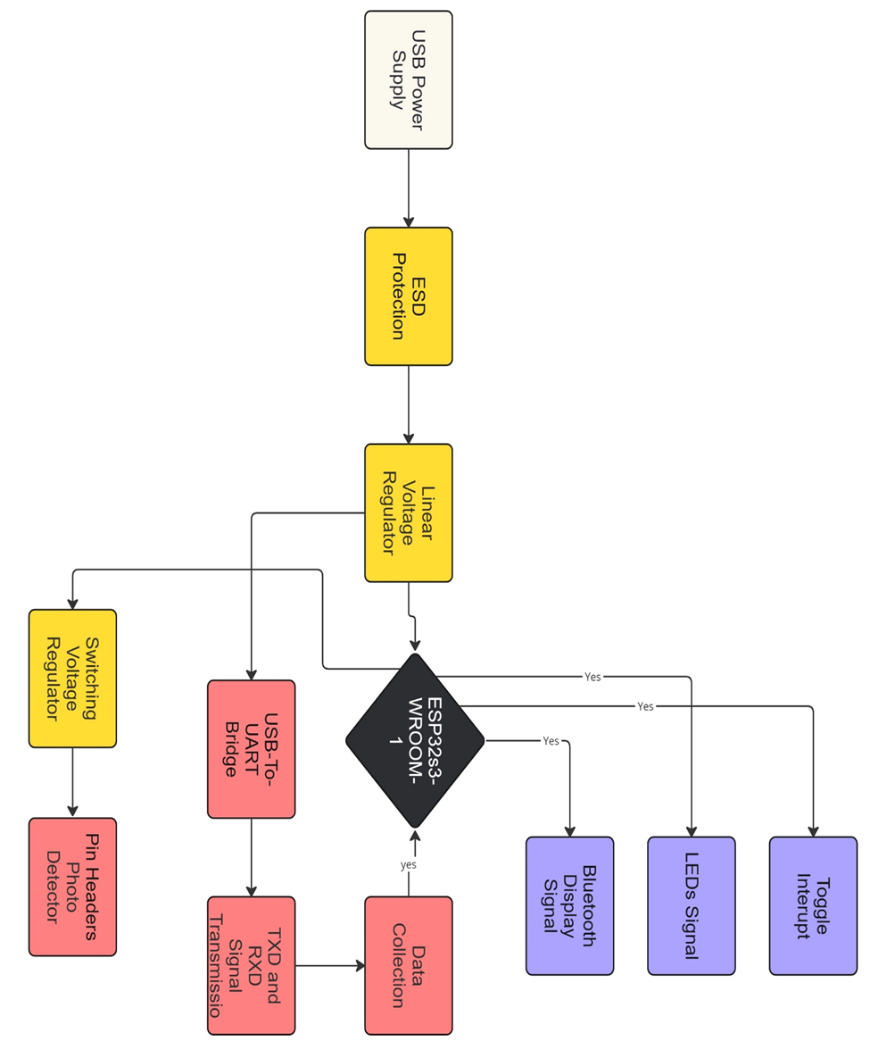
Figure 13: Hardware integration and process of operation.

6.2 Power Supply

6.2.1 PC Power Supply
The system power distribution source will be supplied mainly by the PC used to program the microcontroller and execute commands to the optical photo detection system. The design choice for leading with a PC power supply and not utilizing an external source will place various constraints such as power delivery restrictions on the PCB board. The limitation of using a PC power supply will force the integration of incorporating boost-buck voltage regulators capable of stepping up the power in various sections on the board to meet the power demands for specific components. Subsequently, the photo detector and optical laser used in the project are low power components which alleviates any alarming concerns regarding efficiency of the PCB power delivery.
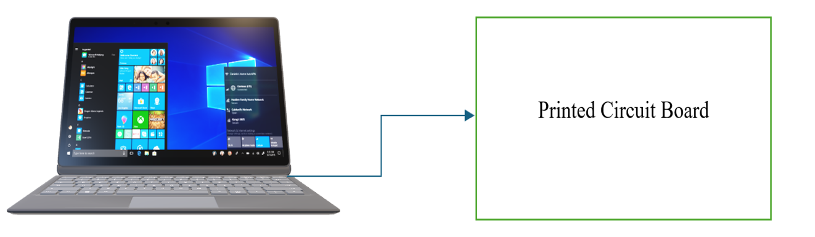
Figure 14: Illustrate Power and data Connection to Printed Circuit Board. Generated using Microsoft word.

6.3 Voltage Regulator design
The voltage regulator design and calibration will be an important part to designing a successful PCB layout. Linear regulators normally have a fixed voltage that is regulated regardless of the load applied. A design circuit consisting of suitable capacitors re required to meet the specifications of the various regulators. A Linear regulator will be incorporated on the board to regulate the incoming voltage and will serve as the primary power delivery regulator for the PCB. The LM7805T linear voltage regulator was used as a testing regulator to examine and observe changes in output performance when various load outside of the recommended values were applied. Additionally, experiments were conducted to observe how the regulator would perform when an incorrect input voltage was applied. The following images shows experimental values of trials conducted to verify functionality of the regulator under specified conditions. [16]
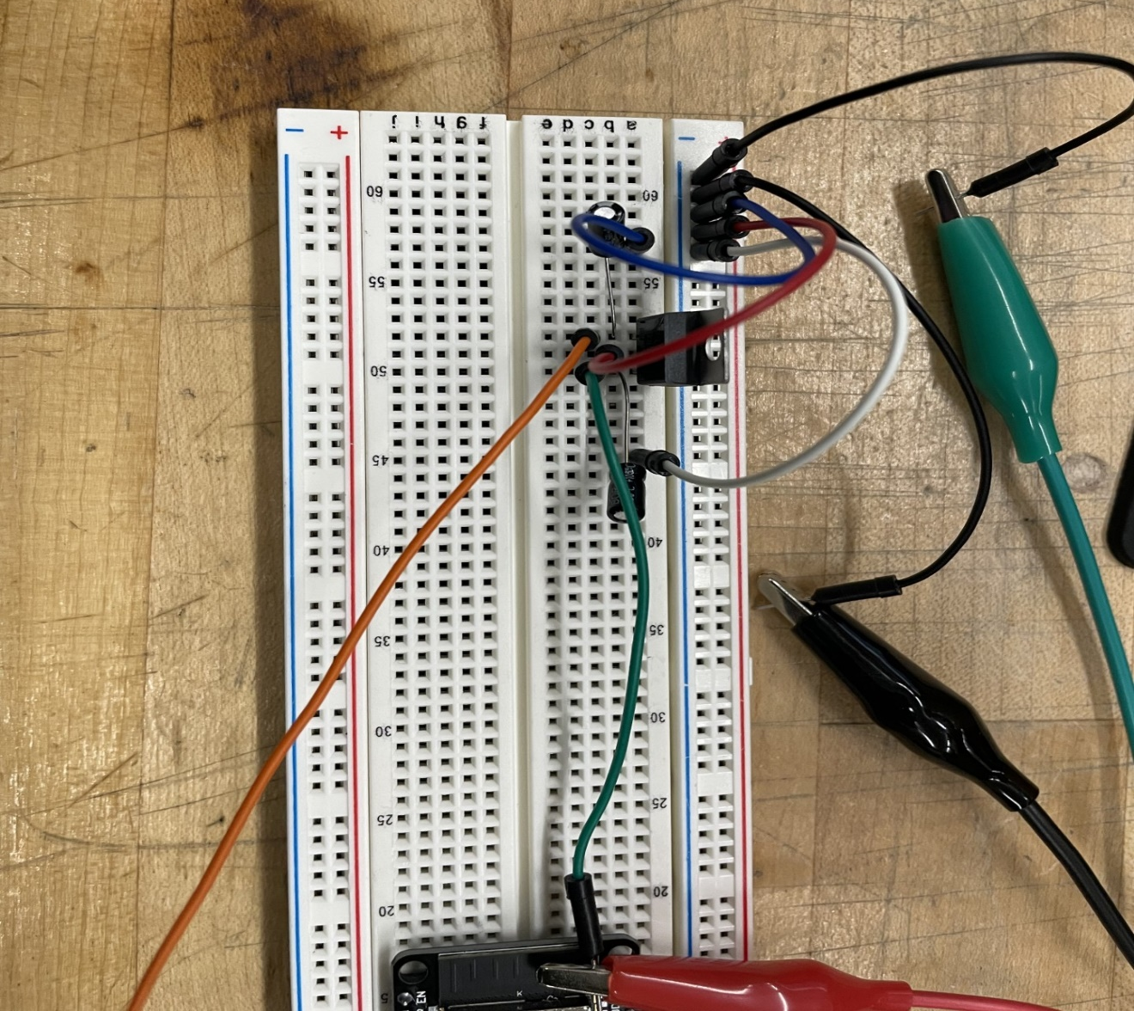
Figure 15: Circuit design for Linear Regulator
Figure illustrate a LM340 linear voltage regulator design circuit belonging to the Texas instrument family consisting of a monolithic 3-terminal positive orientation device. This regulator was selected because of the similar specification and design parameter of the linear regulator used in the PCB design. The testing behind this experiment was to observe and analyze the fluctuation in voltage and current if any when a load was added to the output. Firstly, it was crucial to set up a trial version of this circuit on the breadboard to verify the regulator was functioning as intended before design a PCB and sending it off to the manufacturer for fabrication. Secondly, the datasheet for components can often be misleading and physically verifying the approximated values provided in the circuit specification list is correct is the best and most optimal solution for fixing small regulation issues, unwanted noise or preventing additional spending due to poor pre-testing. All the testing were conducted using a multimeter, load testing equipment, a DC power supply, wires, capacitors and resistors as indicated in the circuit design presented in the data sheet typical schematic layout accessible in the senior design lab.
The idea was to observe the volage changes on the multimeter when adjusting the load on the respective device from 100mA to 1.5A which linear regulator is rated for. If the voltage displayed in the multimeter drops off by large margin, then it was safe to assume that the regulator was not working as intended. Furthermore, we could assume that one of three situations regarding the failure of the linear regulator. First the regulator itself was fault and was not operating as intended. Next, it would be a byproduct of poor estimated values in the capacitor and resistor selection needed to regulate the voltage effectively. Lastly, Additional components may be required to achieve desired results. Thess three assumptions were the guidelines imposed during the testing and evaluation of the linear regulator ability to function correctly.
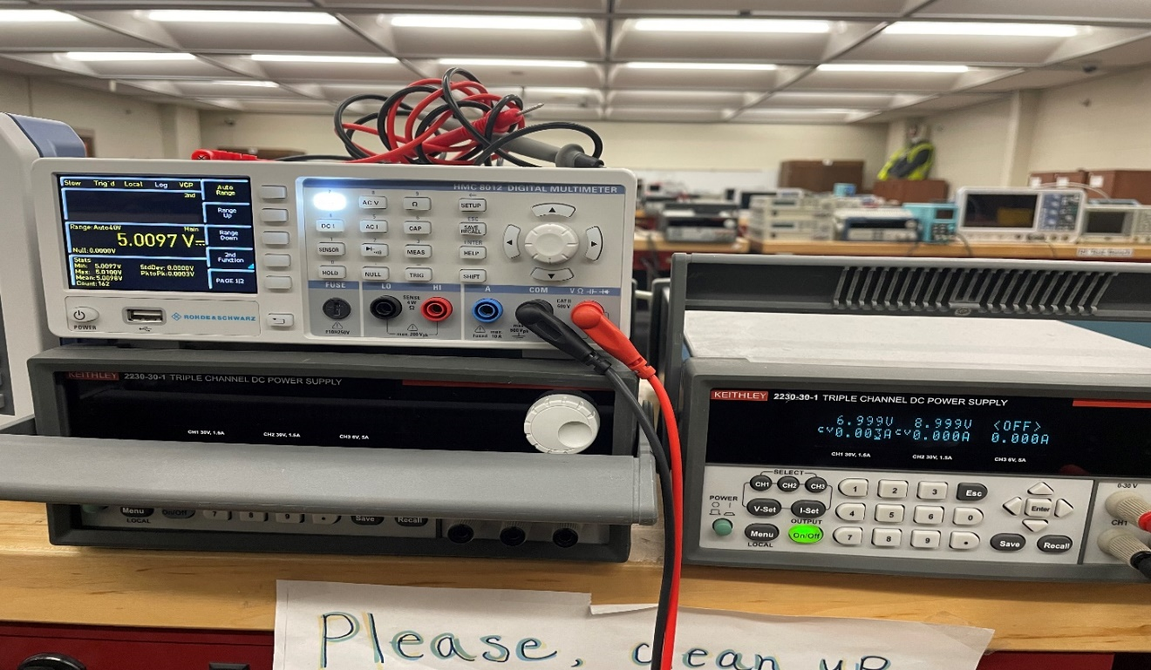
Figure 16: Regulated expected voltage value with applied load.
Figure 16 a regulated voltage at max load applied and displaying the intended rated output specifications stated in the datasheet. Random load values ranging from .100mA to 1.5 A were selected to analyze how much change if any was observed. The initial circuit design consisted of only two capacitors one valued at .22uF and the other being .1uF. The .1uF capacitor was used mainly for helping with transient response which can impact the impedance of the circuit design leading to RF development. As the load would increase the voltage on the multimeter did not drop below 5V. however, during the higher loads applied it was observed that the voltage would slightly decrease close to 5V flat. This led to concluding that higher loads tents to decrease the value in the linear regulator output if enough is applied. This experiment was a successful trial and provided valuable insights about what capacitors would be ideal to use in the PCB design. The voltage and load current had an inverse relationship in the values when more load was applied the output would slightly decrease if it was approaching the max rated load stated on the data sheet. Additionally, analysis for heat dissipation by touching the capacitors for high heat traces was conducted to see how if cooling method were needed to be implemented in on the board layout.
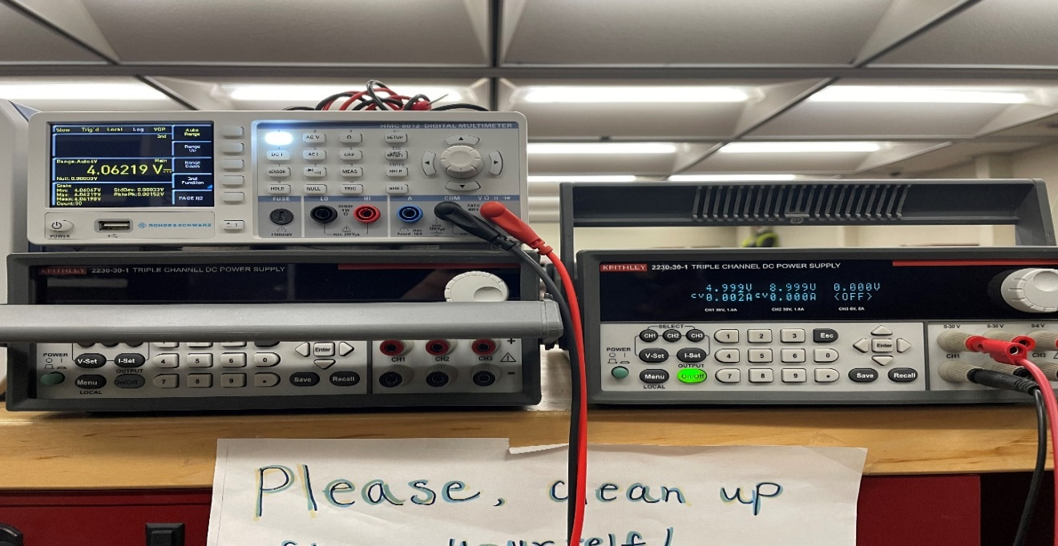
Figure 17: Unregulated voltage with incorrect applied input
The final figure presented shows an example of what would be if load outside the ratings of datasheet specification was applied to the circuit board. As indicated by the values present, the voltage regulator could not regulate a load outside its perimeters and resulted in a failure in the output, which dropped about twenty percent decreasing the efficiency greatly. The major takeaway from this experiment was that linear regulators have a restricted range of operation and design constraints that must be followed to achieve a functional regulator. The circuit completely failed which is evident by the massive drop off in voltage displayed on the multimeter. Design choice revolving around regulators must be taken into consideration when creating a circuit design that supposed to reduce or boost the output.

6.4 PCB Manufacturing Capabilities
The JLCPCB manufacturing specifications are a key aspect to consider when designing parameters that clarify criteria and constraints for acceptable schematic layout design for the PCB. The PCB layout will feature two single-sided layers-top layers consisting of all electrical components, and the bottom layer will be solely for grounding connections. JLCPCB Manufacturing & Assembly Capabilities lists the following parameters for PCB fabrication and assembly:
Table #: PCB Assembly Capabilities
Features | Economic PCBA | Standard PCBA
Assembly Types | Single sided placement (SMT/Thru-hole) | Single & double sided placement (SMT/Thru-hole)
PCB Layer | 2,4,6 layers | 1-20 layers
Thickness | 0.8mm - 1.6mm | 0.4mm - 2.0mm
Dimension | Single PCB Size:  10x10mm – 470x500mm  PCB Panel Size:  10x10mm – 250x250mm | Single PCB Size:  70x70mm – 460x500mm  PCB Panel Size:  70x70mm – 250x250mm
Order Volume | 2-50 pcs | 2-80000 pcs
Minimum Package | 0402 | 0201
Minimum IC Pin Spacing | 0.4mm | 0.35mm
Minimum BGA Spacing | 0.5mm (center to center) | 0.35mm (center to center)
Reflow Temperature | 255+/-5 | 240+/-5
Build Time | 1-3 days | 4+ days

6.5 Housing
The system will be configured to a housing structure made of material sensitive to all optical and electrical hardware components. Sensitivity will be a key factor in selecting and designing the structure to avoid any disruption when operating any optical components. Weight distribution must be proportional throughout the entire casing which will require repositioning of various hardware. Portability is also important to consider in the design process since the final project must be demonstrated in a specified location which will require transporting the housing. The platform will most likely consist of metal or optical breadboard to ensure all optical components are firmly stationary. The walls should be constructed using wood or clear acrylic material so that it is easy to display during the review process. Also, shields may be used to prevent external interference to the system during operation.

Chapter 7 Software Design
This chapter examines the FLOW (Fluoride Level Observation in Drinking Water) device's complex software architecture. The software design is a key component that makes it possible to measure the fluoride content of drinking water with efficiency and accuracy. We start by going over the system's modular design, which consists of parts for signal processing, data gathering, and calibration. The seamless integration of these modules guarantees accurate sensor readings from the device.
The algorithms for determining fluoride concentrations are next covered in detail, with an emphasis on the computational methods and mathematical models that are utilized to translate raw sensor data into useful conclusions. Also, the program has an easy-to-use interface for technical and general users, offering readable and unambiguous displays of fluoride levels and system status.
Enabling the device to send data to external systems for additional analysis or remote monitoring is another important topic discussed in this chapter: wireless communication protocols. To maintain the precision and dependability of measurements, we also talk about the system's error handling and diagnostics strategy. For helping users find and fix problems, these features include alarms, automatic checks, and troubleshooting instructions.
The FLOW device's software design considerations are thoroughly covered in this chapter, guaranteeing that the device is a trustworthy instrument for protecting public health via efficient water quality monitoring

7.1 Overall Software Design
Our project focuses on developing a software system for the FLOW (Fluoride Level Observation, in Drinking Water) device, which utilizes fluorescence spectroscopy to measure levels in drinking water. The software structure seamlessly integrates modules to ensure data collection, processing and presentation. These modules include data acquisition, signal processing, calibration, concentration calculation, data display, wireless communication and error handling and diagnostics.
The initial critical component is the data acquisition module, which interacts directly with the photodiode to capture the signal indicating the samples fluorescence intensity. This module employs an Analog to Digital Converter (ADC) interface to convert the photodiodes analog signal into a format. Proper programming of the ADC is crucial for digitizing the fluorescence intensity data. We will incorporate noise reduction techniques such as shielding the photodiode from light sources to ensure a clean captured signal.
The signal processing module is essential for filtering, amplifying and processing data to extract fluorescence intensity values. Utilizing filtering algorithms like moving filters will help remove noise from the signal while basic amplification functions enhance detection sensitivity. The processed data must precisely reflect fluorescence intensity to provide a foundation for calculations. We plan to employ methods, like averaging measurements, to reduce background noise and ensure consistent results even in different environments. For instance, the program will keep track of readings and calculate an average to provide a smoother signal for further analysis. This approach helps in minimizing the impact of noise on the averaged readings from the ADC.
Calibration plays a vital role in software design. The calibration component creates a calibration curve using solutions of known concentrations. This curve establishes a relationship between fluorescence intensity and fluoride concentration acting as a guide for interpretation of device readings. The software features tools for creating and maintaining the calibration curve guaranteeing accuracy of the device. Users can easily calibrate the device following predefined steps ensuring a user calibration process. To address changes in sensor accuracy over time users will receive reminders to recalibrate periodically. During calibration fluorescence intensity is recorded for known concentrations and used to create a linear or polynomial curve that will be applied in future measurements.
The concentration calculation segment utilizes the calibration curve to ascertain the concentration in the sample based on processed fluorescence intensity data.
This system uses calibration information to convert the fluorescence intensity into a measurement of levels. The programming of this system utilizes formulas to interpret the calibration curve and determine the fluoride concentrations precisely. To maintain precision redundant checks will be put in place. These checks compare the reading, with values and expected ranges signaling any notable differences for user examination. For example, if a new reading significantly varies from values the software can ask the user to confirm the measurement or recalibrate the device.
Presenting the findings to users clearly falls under the data display component's responsibility. This part interacts with a screen to show real time fluoride concentration data. The user interface assists users through measuring processes ensuring they can use the device without technical knowledge. The software includes functions for updating display with data organizing output format and providing cues during various stages of measurements. To improve readability in lighting conditions adjustable brightness settings and contrast modes will be offered by the software. The display will exhibit real time fluoride concentration results along with units (mg/L) including extra details, like battery status and connection indicators.
For features the wireless communication module allows both Bluetooth and Wi Fi connections, enabling data transfer, to a mobile app or computer. This function makes it easier for users to remotely monitor and log water quality changes over time. Setting up this module involves implementing Bluetooth Low Energy (BLE) and Wi Fi protocols to ensure reliable data transmission between the device and external interfaces. Dealing with connection problems like signal interference or drops is essential. The software will include auto reconnect capabilities and signal strength indicators to help users effectively manage connectivity issues. Moreover, data encryption and secure pairing protocols will safeguard data privacy and integrity during transmission. By broadcasting its presence over Bluetooth, the device lets users connect through a companion app that displays fluoride concentration data and offers options for exporting data logs.
Effective error handling and diagnostics are key to maintaining the devices’ reliability and robustness. This module handles errors, providing feedback to users to ensure proper device operation in various conditions. The software incorporates routines for error detection logging and user notifications to enhance user experience and device reliability. Comprehensive diagnostic routines will address issues such as sensor malfunctions or communication failures. The program will consistently check the system's wellbeing and will detect any irregularities and guide users on how to troubleshoot. Moreover, a logging function will document all errors and operational settings facilitating in-depth analysis and debugging. For instance, if the photodiode signal deviates from the expected range the program will log the incident. Notify the user to inspect the sensor or recalibrate the device.
Bringing all these components together into a system requires planning and embedded programming. The microcontroller, like an ESP32, acts as the coordinator overseeing all module activities. The microcontroller. Monitors elements such as the laser diode for stimulation and the photodiode for detection. The software integrates drivers for these elements to ensure timing and control of signals. A basic scheduler will be set up on the ESP32 to oversee task execution for operation and quick responses. This strategy enables prioritization of tasks like data collection and processing while seamlessly managing user interactions and communication. The software architecture is structured for modularity and expandability. Each module is developed independently with defined communication interfaces, with modules. This method eases testing and debugging by allowing individual components to be validated before being integrated into the system.
The design framework also allows for improvements like adding sensors or upgrading communication protocols to keep the device adaptable to changing needs. Our approach involves a software structure that separates hardware functions, core operations and application features. This setup makes it easier to maintain and scale the code, facilitating updates and integration of capabilities. Apart from these core functions the software will include user elements to enhance usability. For example, we'll introduce a setup guide that walks users through setup and tuning processes. Context specific assistance and tooltips will be provided to help users grasp functions and configurations. Additionally, the software will offer data visualization tools such as trend graphs and histograms for analyzing fluoride concentration trends over time. These visual aids can be accessed on the device itself or via the companion mobile app providing flexibility in data examination.
To ensure software performance thorough testing procedures will be implemented. Unit tests will verify each module's functionality independently while integration tests will confirm cooperation between modules. System tests will replicate real world scenarios to assess the devices performance across conditions. We plan to utilize automated testing frameworks whenever possible to simplify the testing process and guarantee coverage of all code paths. Security stands out as an element in our software design. Considering the sensitivity of water quality data, we will establish security measures to safeguard against access and data breaches. This involves implementing boot mechanisms conducting firmware integrity checks and ensuring encryption for data storage and transmission. The Bluetooth and Wi Fi communication modules will adopt pairing and authentication protocols to prevent connections. Furthermore, we will regularly update the software to address any identified vulnerabilities thus maintaining security.
To summarize, the software architecture for our fluoride detection device encompasses an integrated approach that includes data acquisition, signal processing, calibration, concentration calculation, data display, wireless communication and error handling. The microcontroller will coordinate the functions of these modules to ensure operation and accurate measurement of levels in drinking water. By programming and thoughtfully integrating components and software routines our project aims to provide a reliable and user-friendly solution for monitoring water quality. This thorough and robust software design is designed to help the FLOW device achieve its objectives of precision user friendliness and versatility. Offering a tool for communities, in monitoring and managing fluoride levels in their drinking water.
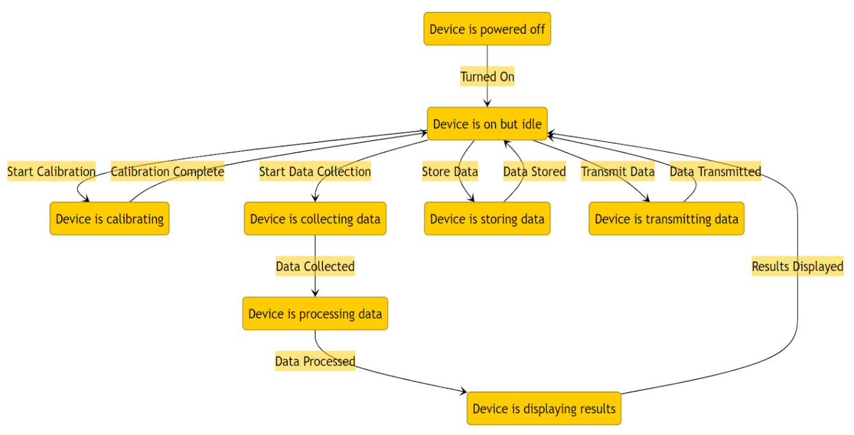
Figure 18: This diagram illustrates the various states of the fluoride detection device and the transitions between these states. Starting from the powered-off state, the device can be turned on, becoming idle. From the idle state, it can calibrate, collect data, store data, transmit data, process data, and display results. Each transition is triggered by specific events such as starting calibration, collecting data, storing data, transmitting data, and displaying results. This ensures that the device functions in an organized manner, ensuring accurate and timely fluoride detection.

7.2 User Interface
The interface of the Fluoride Level Observation in Water (FLOW) device is created to offer user experience for monitoring fluoride levels in drinking water. Our aim is to ensure the interface is easy to use for users with low-level technical knowledge while making sure all necessary functions are accessible. The UI includes both the devices built in display and a companion mobile app, each with features designed to improve usability and functionality.
The FLOW device onboard display uses a screen known for its contrast wide viewing angles and energy efficiency compared to other types of displays. With a resolution of 128x64 pixels the OLED screen provides space to clearly present our fluoride concentration levels. The layout of the display is simple and informative, featuring a title bar that prominently shows the device name or current operation mode. The real time fluoride concentration will populate on the display presented in easy-to-read numbers with the unit (mg/L) clearly marked. For representation a graphical bar, below the numerical value offers a quick visual indication of the concentration level. In addition, the screen shows status indicators, for the battery level Bluetooth/Wi Fi connection status and any ongoing alerts or notifications.
When the device is set to its default measurement mode the main focus is on displaying the real time fluoride concentration. This concentration is updated every second to show users the up-to-date reading. The user interface also assists users in conducting measurements by providing prompts and instructions. During both measurement and calibration processes users will receive messages and guidance if any issues or errors are detected, such as signals outside the expected range.
Navigation through features is simplified with an easy-to-use menu system. Users can access features like calibration, settings and data logs through this menu. Calibration plays a role in ensuring measurements over time. The user interface will walk users through each step of the calibration process, which involves measuring fluorescence intensity of solutions, with known concentrations. The device will create a calibration curve and the user interface will show the calibration status and any necessary actions, like when to recalibrate.
Users can customize settings of the device through the settings menu to fit their preferences and requirements. These adjustments include modifying display brightness and contrast, for visibility in lighting conditions, setting up reminders for automatic calibration and configuring connectivity options. The device supports Bluetooth and Wi Fi connections allowing data transfer to an app or computer for monitoring and data recording. The user interface will offer guidance on how to connect the device with gadgets with icons on the main screen indicating the current connectivity status.
Effective error handling and diagnostics are essential for ensuring the reliability and durability of the device. In case of any problems like sensor issues or communication breakdowns detailed error messages will be displayed on the UI to help users troubleshoot. For example, if there is an abnormality in the photodiode signal range the device will log this event, notify the user and suggest solutions such as checking sensors or recalibrating.
In addition to its onboard display the FLOW gadget includes a companion mobile app that enhances its functionality and offers users an experience.
The mobile application is made to work on both iOS and Android devices making it easily accessible. Its interface is user friendly featuring a homepage that presents the levels and past data trends. Users can analyze graphs and charts illustrating fluoride levels over time aiding them in recognizing trends and making choices regarding water quality.
Furthermore, the app enables users to log and review their measurement history conveniently. They can export these logs in formats, like CSV or PDF for analysis or sharing. This feature is beneficial for those who regularly monitor water quality or need to share data with healthcare professionals or regulatory agencies. Additionally, the app sends notifications for events such as recalibration requirements or significant changes in levels.
To safeguard data privacy and security the app employs encrypted data transmission and secure authentication methods. Users are required to create an account and log in to access the app ensuring that authorized users can view and manage the data. The app also supports synchronization across devices enabling access to data from different gadgets.
Incorporating user feedback plays a role in refining the user interface design process. We are planning to organize sessions for testing with users to gather feedback and pinpoint areas that can be enhanced. This feedback will aid us in refining the user interface, making it more user friendly and efficient. For instance, if users encounter instructions or face challenges in accessing features, we can adjust the overall user experience. To sum up, the user interface of the FLOW device is crafted to be easy to use ensuring that users can effortlessly monitor fluoride levels in their drinking water. The display on the device provides real time readings. Guides users through measurement and calibration processes. Additionally, the accompanying mobile app offers features like data logging, trend analysis and secure data management. Our focus on simplicity and accessibility aims to make the FLOW device a valuable tool for individuals and communities to effectively monitor and manage their water quality.
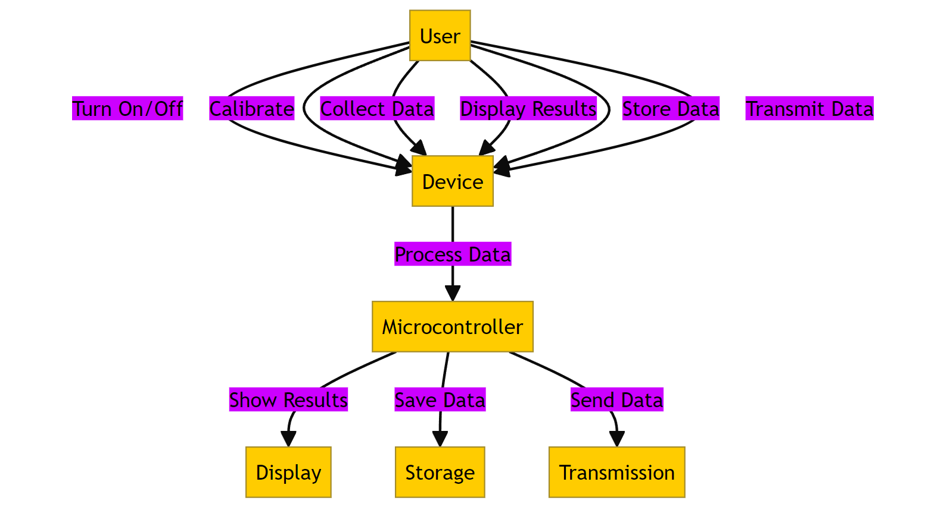Figure 19: This diagram highlights the interactions between the user and the device, mediated by the microcontroller. The user can turn the device on/off, calibrate it, collect data, display results, store data, and transmit data. The device, under the control of the microcontroller, processes data to show results, save data, and send data. This diagram emphasizes the role of the user in initiating various functions and the microcontroller's role in managing these functions to ensure smooth operation.

7.3 Data Transfer
The transfer of data is a function of the Fluoride Level Observation in Water (FLOW) device as it ensures that collected fluoride concentration data is accurately and securely sent to systems for monitoring, logging and analysis purposes. The device supports both Bluetooth Low Energy (BLE). Wi Fi connections offer flexibility and convenience in managing data.
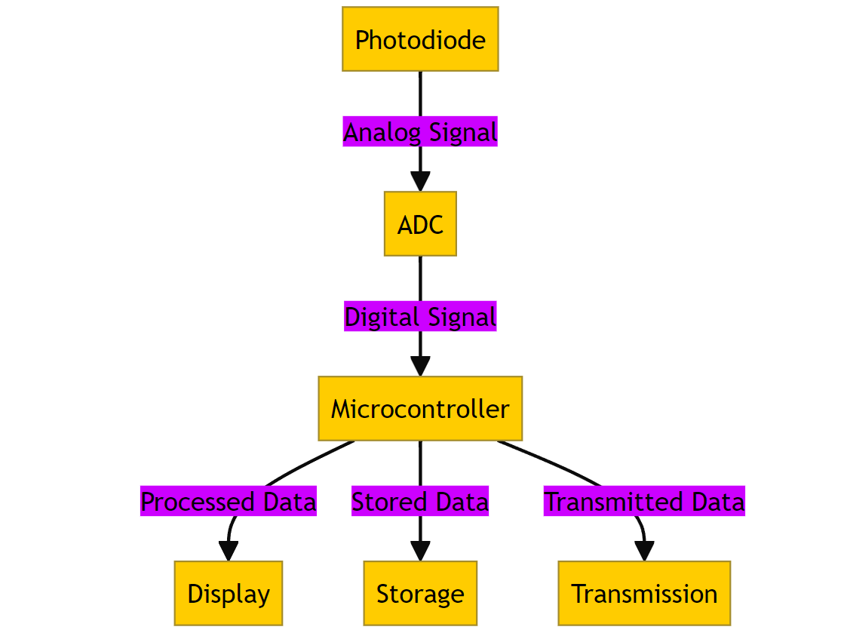
Figure 20: This diagram depicts the flow of signals and data within the device. It starts with the photodiode capturing an analog signal, which is then converted to a digital signal by the ADC (Analog-to-Digital Converter). The microcontroller processes this digital signal into processed data, stored data, and transmitted data. The processed data is displayed, stored data is saved for future use, and transmitted data is sent to external systems for further analysis. This flow ensures accurate and real-time processing and presentation of fluoride concentration measurements.
Each figure provides a detailed view of specific aspects of the device's operation, from state transitions and user interactions to data management and signal flow, ensuring a comprehensive understanding of the system's functionality.

7.3.1 Bluetooth Low Energy (BLE) Data Transmission
The FLOW gadget utilizes Bluetooth Low Energy (BLE) for data transmission to a linked mobile app. BLE is opted for due to its power usage, making it perfect for devices powered by batteries. During the setup phase of the device the BLE stack is initialized. This involves setting up the BLE server, defining services and characteristics. A characteristic serves as a data structure storing fluoride concentration data along with details like timestamp, battery level and error records. Configuration includes specifying UUIDs (Universally Unique Identifiers) for services and characteristics to ensure identification and interaction between the FLOW device and mobile app.
The pairing process kicks off when the device enters pairing mode usually triggered by a user action such as pressing a button. The mobile app searches for BLE devices. Displays the FLOW device for user selection. The BLE software manages the pairing procedure by exchanging keys and establishing a bonded connection. This ensures data transfer. Allows the device to remember the paired mobile app, for future connections.
Once paired the device starts transmitting data. The BLE characteristic related to concentration is updated regularly every few seconds. The 'notify' feature is responsible for sending updates to the connected application. This process entails recording the current fluoride concentration data onto the characteristic and then employing the 'notify' function to inform the app about the information. The software ensures that the data packets are kept small and efficient in line with BLEs low energy characteristics. The BLE software incorporates error handling procedures to address connectivity issues. If there is a connection interruption or failure the device automatically attempts to reestablish a connection. The software logs any errors and can notify users through either the device's display or the mobile app.

7.3.2 Wi Fi Data Transmission
For monitoring capabilities the FLOW device utilizes Wi Fi to connect to a network and send data to a cloud server. This requires a software structure to manage network connections, data encryption and interaction with cloud services.
During setup initialization of the devices Wi Fi module takes place. The software offers an interface for users to input their Wi-Fi credentials through the companion mobile app. These credentials are secure. Utilized for connecting to the Wi Fi network. The software manages tasks such, as network scanning, establishing connections and verifying connection status. Once the device is connected to the Wi Fi network it communicates with cloud services. The software is designed to utilize protocols, like HTTP or MQTT for transmitting data. Each measurement of concentration is bundled into a JSON object that contains details such as the level, timestamp, device ID and any extra information. This JSON object is then forwarded to the cloud server through a HTTP POST request and shared on an MQTT topic.
To uphold data security the software incorporates encryption protocols like SSL/TLS. This ensures that all data transmitted via Wi Fi is encrypted to prevent access. The software also manages authentication with the cloud server by utilizing tokens or API keys to validate the devices' identity and ensure communication.
Like BLE technology, the Wi-Fi software has error handling mechanisms. In case of a connection failure to either the Wi Fi network or cloud server the software logs the error and makes efforts to reconnect. It also includes features to temporarily store data if there are disruptions in connectivity guaranteeing that no data gets lost during network problems. Luckily, once reconnected any buffered data is sent over to the cloud server.
Following transmission of data, to the cloud it's common for the server to respond with an acknowledgment. The FLOW device software verifies the receipt of data to confirm transmission. If no confirmation is received the software attempts to send the data. This process is crucial for maintaining data accuracy and ensuring that all readings are properly stored in the cloud database.

7.3.3 Connecting with the Mobile App
The mobile app is essential for transferring data. In the case of BLE the app scans for devices, establishes a connection and retrieves values. It continuously listens for notifications from the device. Updates the user interface with up-to-date fluoride concentration readings. When using Wi-Fi, the app communicates with a server to access stored data offering users real time updates and historical trends.
All in all, the software data transfer setup in the FLOW device guarantees dependable transmission via both BLE and Wi Fi protocols. BLE facilitates energy data transfer to the mobile app while Wi Fi allows remote monitoring and integration with cloud services. Both approaches incorporate error correction mechanisms and security features to safeguard data integrity and privacy. This comprehensive strategy enables users to monitor, record and analyze levels in their drinking water, from anywhere they are located.
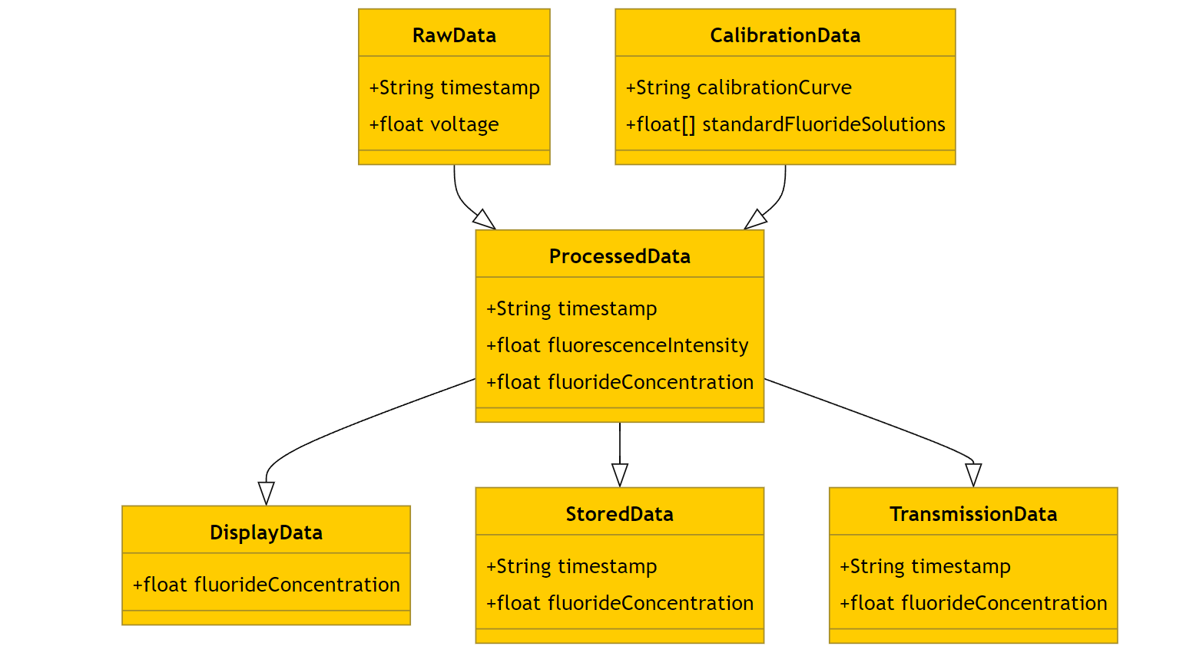
Figure 21: This class diagram outlines the data structures used in the software design for managing different types of data: raw data, calibration data, processed data, display data, stored data, and transmission data. Each data class contains attributes necessary for storing relevant information. For instance, the RawData class stores timestamps and voltage readings, while the Processed Data class stores timestamps, fluorescence intensity, and fluoride concentration. This structured approach ensures efficient data handling and processing within the system.

7.4 Using Data Structures
In our software design, we plan to implement data structures across various software components to boost efficiency, ensure precise data management and streamline operations. Below is a breakdown of how specific data structures will be integrated into our work;

7.4.1 Arrays
Arrays will play a role in managing fixed size collections of sensor data. For example, when the photodiode captures fluorescence intensity values these raw data points will be stored in arrays. Each element within the array will correspond to an intensity reading at a time interval enabling us to conduct batch processing and signal averaging effectively. Furthermore, arrays will be utilized for storing calibration data obtained from solutions which will then be used for plotting calibration curves.

7.4.2 Linked Lists
Linked lists will be essential for handling datasets where the size is not predetermined. For instance, a linked list will be utilized to maintain a record of measurements. Each node in this linked list will include a timestamp, the fluoride concentration reading and a reference to the node. This structure facilitates addition of measurements to the list and traversal for historical data analysis without concerns about array resizing limitations.

7.4.3 Structs
Having structs within our code will make the software system easier to read and maintain. For example, we could create a 'Measurement' struct that includes a time stamp, the time when the measurement was taken. Another type of struct can represent the ‘rawIntensity', the fluorescence intensity value from the sensor and ‘calibratedFluoride’, the calculated concentration based on the raw intensity. As well as ‘validityFlag ', a flag that shows if the measurement is valid or not. By using structs we can smoothly transfer measurement data between functions, simplifying function signatures, and ensuring that connected data is always managed together.

7.4.4 Queues
We will incorporate queues to handle tasks in a first out (FIFO) order. In our device this feature will be especially beneficial for managing tasks related to data acquisition and processing. This can be applied by incoming sensor data that can be placed in a queue for processing as it arrives maintaining accuracy. Moreover, commands coming from a user interface, like an app, to the device can be organized in a queue to ensure they are executed in the sequence.

7.4.5 Circular Buffers
To facilitate real time data logging, circular buffers will store the measurements. A circular buffer enables us to manage a set size buffer where new data replaces data once the buffer reaches its limit. This is useful in situations where we want to show trends without using up much memory. Potentially, we could utilize a buffer to save the recent 100 fluorescence intensity readings giving us a quick summary of recent measurement patterns.

7.4.6 Trees and Hash Tables
Regarding trees and hash tables, while not as crucial as the previous data structures mentioned, they can be utilized for functionalities. Firstly, with trees we could employ a search tree (BST) to efficiently organize and search calibration data. This would enable us to locate the calibration point for a specific raw intensity value. While hash tables could be used for storing configuration settings and reference tables for sensor adjustments. The constant time complexity of hash table operations guarantees access to settings and calibration values improving the devices performance. When it comes to long term data logging, we will combine data structures to ensure storage and retrieval. Arrays or linked lists can be employed to store data in memory while permanent storage methods (like saving to an SD card or uploading to a cloud database) will utilize structured file formats such as JSON or CSV. This strategy allows us to manage both real time data processing and long-term trend analysis effectively.
The thoughtful choice and implementation of data structures in our fluoride concentration detection device will improve the efficiency and dependability of data management spanning from capturing raw sensor data to processing it in time and storing it for the term. By utilizing arrays linked lists, structs, queues, circular buffers as potentially advanced structures, like trees and hash tables, we aim to develop software that is robust, manageable and capable of providing accurate and timely information to users. A structured approach is essential for achieving our project's objectives, which aims to develop a cost portable and precise system for detecting fluoride.

7.5 Programming ESP32 Microcontroller
The process of programming the ESP32 microcontroller for our device involves a series of steps using the Arduino IDE and programming in C. This ensures that the firmware effectively manages data acquisition, signal processing, display control and wireless communication.
Initially we establish the development environment by installing the Arduino Integrated Development Environment (IDE). This user-friendly platform supports prototyping and offers a wide array of libraries and tools crucial for our project. Configuring the Arduino IDE for ESP32 involves adding the ESP32 board manager URL in preferences settings and installing board definitions. Once we select the ESP32 board from the tools menu the IDE is prepared to compile and upload code to the microcontroller.
Developing firmware in C is the foundation of programming the ESP32 microcontroller. The firmware is organized into modules, each handling function, and to collect data we create code that interacts with the photodiode sensor. This includes setting up the Analog to Digital Converter (ADC) to interpret analog signals and convert them into values using the `analogRead()` function. To analyze these signals, we use filtering methods like a moving filter, which involves keeping track of readings and calculating the average to smooth out any interference or changes.
To control the display, we rely on libraries such as `Adafruit_SSD1306`. The software contains functions for initializing the display updating it with information and managing display modes. This ensures that real time fluoride concentration readings, status indicators and user instructions are clearly shown.
For communication, we make use of the ESP32s built in Bluetooth Low Energy (BLE) and Wi Fi capabilities. By utilizing libraries like `BLEDevice` we establish BLE services and characteristics to allow the device to broadcast its presence and transfer data to a connected application. In terms of Wi Fi connectivity our software includes instructions, for connecting to networks using the `WiFi.begin()` function and handling HTTP requests to send data to a cloud server. This setup lets users monitor and log data remotely giving them access, to time and past data.
After writing the firmware, it is converted into machine code using the Arduino IDE. This step changes the C code into a file that the ESP32 can run. Once we confirm there are no syntax errors, we can link the ESP32 to the computer using a USB cable and upload the compiled firmware using the `Upload` button in the IDE. Moreover, this action moves the file to the flash memory of ESP32.
Testing and fixing bugs are crucial for ensuring that the firmware works correctly. The serial monitor tool in Arduino IDE enables us to see time debug information from ESP32. By adding print statements (`Serial.print()`) in our code we can keep track of sensor readings, validate data processing precision and troubleshoot problems. Testing also includes confirming communication abilities by connecting the device with an app, through BLE and verifying precise data transmission. For Wi Fi functionality we check if the device can link with networks, send data to cloud servers and manage network disruptions smoothly. Finally, when you program the ESP32 for the FLOW device using the Arduino IDE and code, in C you need to configure the development environment, create detailed and organized firmware, compile and upload the code and extensively test and troubleshoot. By following this process, we can guarantee that all features of the FLOW device work efficiently delivering an easy, ready to use solution.

7.6 Software Architecture Testing
When it comes to testing the Fluoride Level Observation, in Water (FLOW) devices software we take an organized approach to make sure the software runs smoothly and meets all the specified requirements. This detailed process consists of stages; unit testing, integration testing, system testing and user acceptance testing (UAT). Each step plays a role in ensuring the devices functionality and reliability.
During unit testing our focus will be on confirming the accuracy of components or functions within the firmware. This includes checking functions that handle tasks like reading ADC values, processing signals and updating the display. For example, we'll create test scenarios to confirm that the `analogRead()` function accurately captures sensor data and that our signal processing algorithms effectively filter and enhance this data. We'll also test the display update functions by inputting known values and verifying their display on the screen. Automated tests will help us quickly identify and resolve any issues ensuring each module works correctly on its own.
After completing unit testing, we'll move on to integration testing to ensure that different software modules collaborate seamlessly. This phase involves confirming that the ADC module properly transfers data to signal processing functions and that the processed data is correctly shown on the screen. We will also check how well the wireless communication features work by making sure that data is sent correctly through Bluetooth and Wi Fi to an app. By testing how these parts work together we can fix any issues that may come up during the integration.

Furthermore, when we test the system, we will assess the device in conditions that mimic real world use. This includes checking how well the device measures levels in water samples and lighting situations to ensure its accurate and consistent. We'll also test its power management to make sure it runs efficiently for periods. Additionally, we'll create scenarios with errors like sensor problems or connection issues to see if the device handles them smoothly and gives users feedback.
For user acceptance testing, we'll ask students and faculty members to try out the device in situations. We'll gather feedback on how easy it's to use its accuracy and reliability, noting any issues with usability to make sure it's simple and user friendly. Based on what users tell us we'll make changes as needed to enhance their experience. This step is crucial for ensuring that the device meets our needs and expectations.
Evaluating performance is crucial to guarantee that the FLOW device meets all its performance requirements. This involves an evaluation of accuracy response time, battery life and dependability. We will compare the fluoride concentration readings of the device with those obtained from lab tests to assess accuracy. By testing water samples with known levels using both our device and a reference method we can determine accuracy and refine calibration procedures for better precision. Additionally, we will measure the time taken from data capture to display to ensure feedback optimizing the firmware to reduce delays.
Assessing battery life will entail measuring the devices power consumption in usage scenarios, including monitoring, display updates and wireless communication. We will examine power saving features like putting the microcontroller and peripherals into low power modes when not in use to ensure battery usage and longer operational times. Reliability will be evaluated through testing in environmental conditions such as different temperatures, humidity levels and lighting conditions to guarantee consistent performance. Any issues or glitches will be analyzed to enhance the devices durability.
The overall integration process involves merging all hardware and software components into a system, for operation. Integration will start by checking that all the hardware parts, like the photodiode sensor, OLED display and wireless communication modules are properly connected to and set up with the ESP32 microcontroller. We'll load the firmware onto the microcontroller. Test each part to make sure it works well with the hardware. The device will be set up to operate based on needs, including calibrating processes adjusting display settings and establishing communication standards.
We'll test the user interface to make sure it offers an easy-to-use experience. This involves confirming that the display shows real time fluoride concentration readings, status updates and user instructions. Finally, we'll examine how well the device interacts with the companion mobile app to ensure data transfer and user-friendly data access. Once all parts are put together, we'll run tests to confirm that everything works as intended by checking performance and reliability criteria. Any problems found will be fixed promptly by updating the firmware for functionality.

Chapter 8 System Fabrication/Prototype Design
This section provides a visual description of the overall PCB schematic illustrating all the connection points regarding component and how they function in relation to each other. Fusion360 AutoDesk software was used to generate this schematic layout alongside an external snaptool online library that contains all 3D models of components needed to create the circuits for the board. The schematic consists of multiple voltage regulators that will be responsible for supply a specific regulated output to various components. The next components are the LEDs used to signal to the user that program operations are being executed by transferring and receiving of data. Pin headers were added to provide biasing voltage to the optical aspect of the system delivering necessary power to ensure functionality of the system’s design. Circuit design protection was also a fundamental component in the designing of the PCB since multiple electrical components were being connected simultaneously. A implementation of a system capable of preventing an explosion or leading to a fire a top priority to consider. Furthermore, it was clear that a multilayer board was the best design choice for considering the level of components placements required to achieve a fully functioning board capable of satisfying all system requirements. The top layer holds all electrical components whereas the bottom was strictly reserve for grounding topology and design techniques to combat heat development and noise buildup.

8.1 PCB Schematic
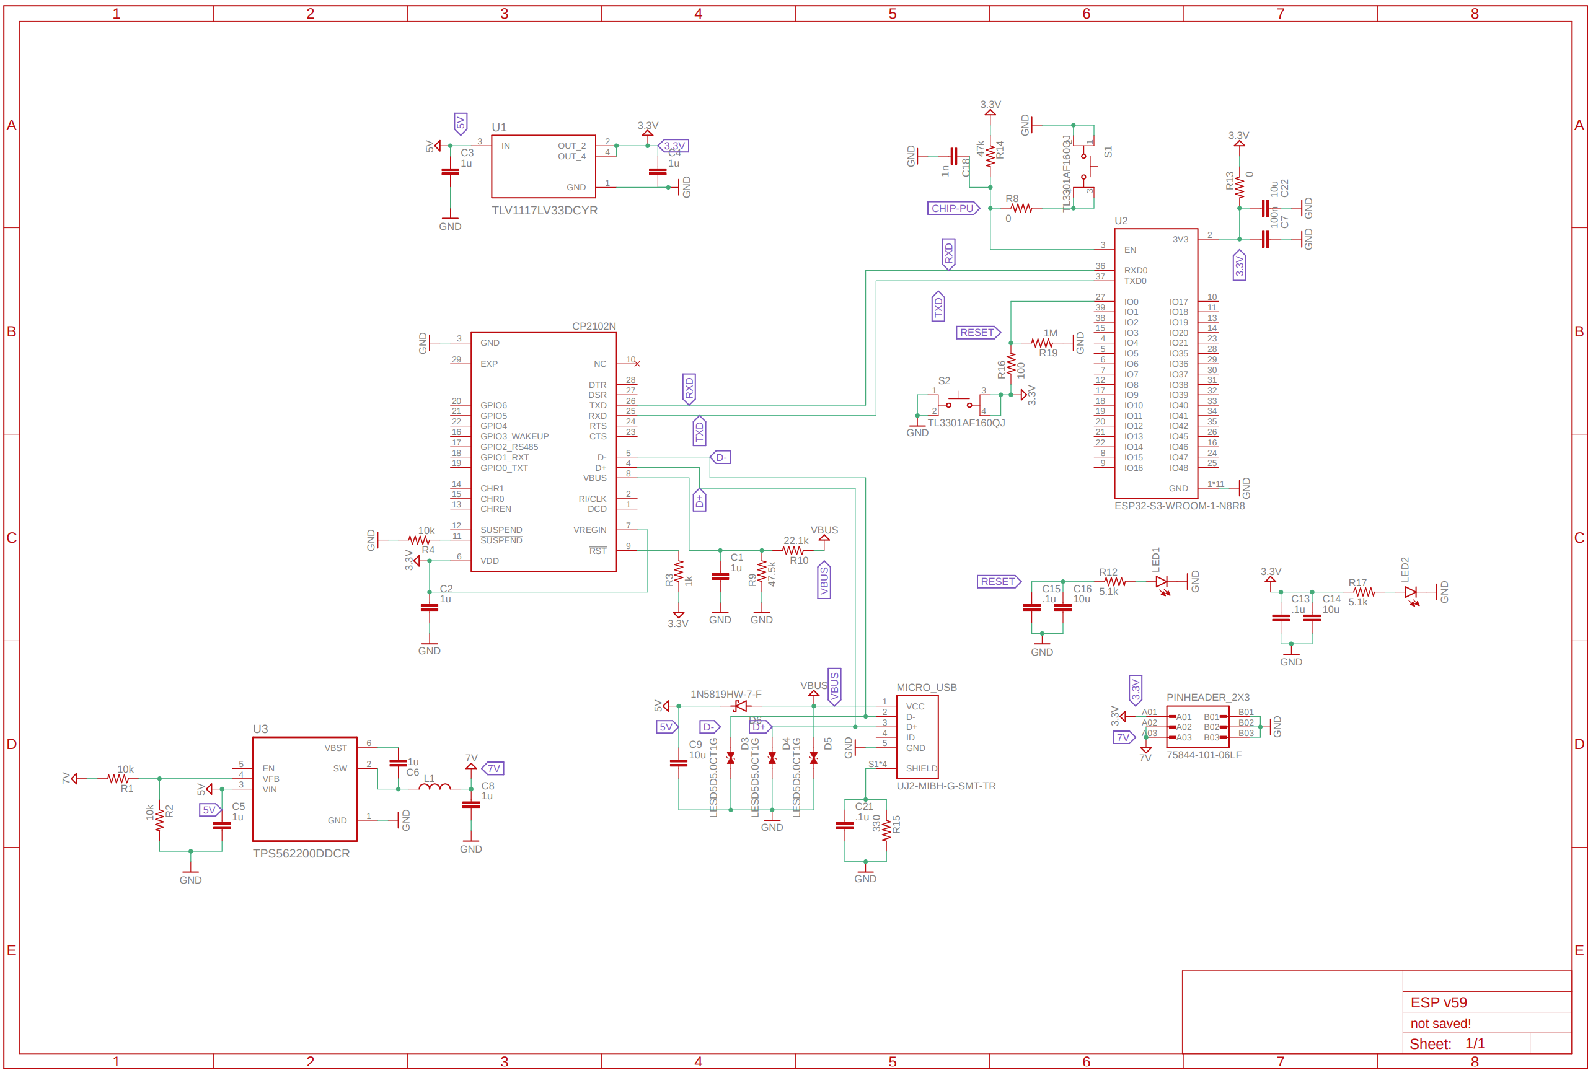
Figure 22: Overall PCB Schematic
The figure above shows all the components used to create the schematic layout. The first step of the designing of the PCB was integrate the USB port that is responsible for granting power and data access to the board. A micro-b USB port was used because of the availability of the component in addition to it having only five connection points one for the power, two for data transfer, a grounding connection and lastly a shielding which is crucial for establishing ESD protection circuit that will prevent fire or explosion of the PCB. The ESD was the second element of the board design that consisted of special diodes capable of handling electrostatic discharge that helps to stabilize the flow of power throughout the entire board. This circuit design had to be directly connected to the USB port before any other connection points were established. The following connection involved the fixed 3.3V linear regulator responsible for supply power to the USB-to-UART bridge and the ESP32s3 microcontroller. The regulator was tested on a bread board using a LM340 linear regulator from the same family to simulate the ideal values requirements for the capacitors and resistors needed to ensure optimal functionality. Additional resources such as WeBench Power designer was utilized to approximate the all the values.
The USB-to-UART bridge followed the implementation of the linear regulator since this section of the circuit design correlated to transmitting and relaying information to the microcontroller which would be impossible to do if not present on the board. The bridge serves at the handshake between the microcontroller and the computer. The microcontroller is the next component implementation consisting of various GPIO ports requirements necessary for the chip to function correctly. One major role was setting u a pull up resistor circuit that contained various resistors, capacitors and a tactile switch that was needed to set the chip in its initial boot mode so it can power up. The second element to the microcontroller was to incorporate a reset button that would refresh the chip after or before program executions. All other connections point for the GPIOs were data connections to the bridge, USB port and peripherals devices.
Subsequently, the three peripherals requirement for the design project placed an additional level of complexity in ensuring that enough power was being supplied throughout the board. The second switching voltage regulator was responsible for powering all remaining devices that were on the board and external optical hardware as well. There are three different LEDs located in the design two associated with data transfer for user interface and the third that signifies power flow from linear regulator which can also be utilized as a test point for verification of voltage. The buttons are simply used for assisting the chip in program execution and resetting commands. A power switch was incorporated to isolate all flow of power from reaching the board as a precautionary measure when testing components. The last component listed in the schematic was pin headers that will be used to provide a bias voltage to the low power laser and photo detector devices.

8.2 PCB Board Layout
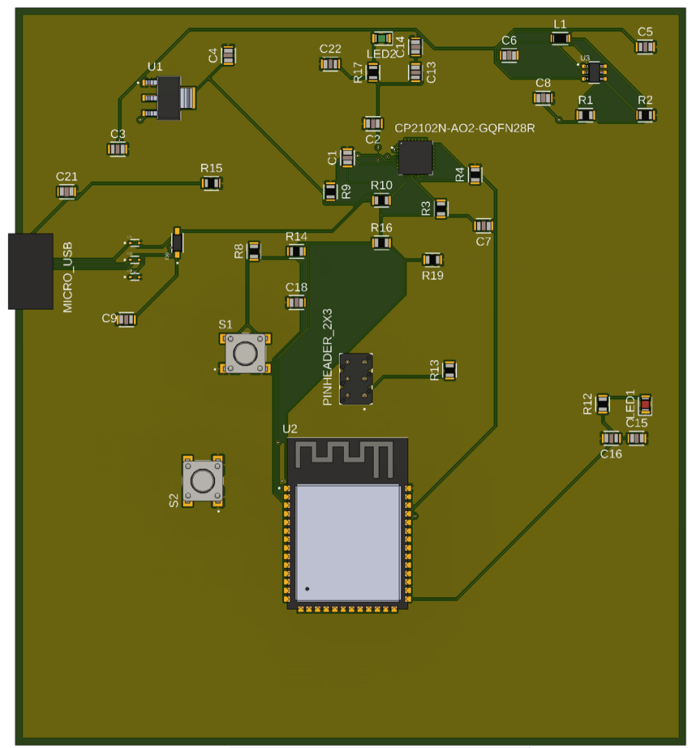
Figure 28: PCB Board Layout
The PCB board layout presented above shows a 3D graphical representation of physical board and all component placement and their respective traces. The dark green areas show traces and leads flooded with ground that helps with heat dissipation. The voltage and ground traces typically have a larger trace width because there is more flow of current surging through those paths which requires sufficient spacing to handle the flow. All signal lines are set around a standard mil size of 10mils which is reasonable for the applications of this project. Ground planes were added to both top and bottom layer of the board to flood the board with excess spacing to dissipate heat generated by the components.

Chapter 9 System Testing and Evaluation
This chapter explores the critical stage of system testing and evaluation, where the FLOW device's software and hardware components are thoroughly examined to make sure they satisfy the project's requirements. It provides a thorough description of the testing procedures for optical hardware, printed circuit board (PCB) hardware, and software systems. It also describes the approaches used to assess the system's functionality, dependability, and accuracy.
We start by going over the software and hardware testing processes in great detail. This involves optical hardware testing, which is essential for identifying fluoride ions in water samples. A 532nm laser is used to stimulate a particular fluorophore. The chapter explains how crucial parts like the laser diode and photodiode are verified, emphasizing how crucial their sensitivity and response time are for precise fluorescence measurement
Next comes PCB hardware testing, which focuses on voltage regulator stability and soldering connection integrity. Before live testing the finished PCB, this part covers a variety of testing methods, such as using multimeters and hand-built breadboard circuits, to make sure all electrical components function as they should. The chapter also discusses software testing, making use of circuit simulation and PCB layout design tools such as MultisimLive and Fusion360. By predicting voltage regulator performance and optimizing component placement on the board, these simulations aid in a more seamless transition from design to real-world application.
Another important area of focus is performance evaluation, which evaluates all aspects of the device's operation, including the power management system, microcontroller, and optical components. This assessment guarantees that the FLOW gadget maintains accuracy in measuring fluoride levels while operating consistently and reliably under a variety of circumstances.
The chapter concludes with the Senior Design 2 software plan, which includes a schedule for the integration and testing of each component. This approach ensures that the gadget is both technically sound and user-friendly, with extensive system testing, calibration procedures, and user acceptability testing included. The project intends to provide a dependable and effective method for monitoring fluoride levels in water by adhering to this structured approach.

9.1 Hardware and Software Testing

9.1.1 Optical Hardware Testing
For the optical component testing, we employed a 532nm laser with a power output of 10mW to excite the sample. This specific wavelength was chosen due to its effectiveness in exciting the fluorophore we are using, ensuring that it fluoresces appropriately. Upon excitation, the sample emitted light as expected, confirming the fluorophore’s responsiveness and validating our choice of excitation source. This step was crucial in verifying that our fluorophore reagent works under the given conditions and will fluoresce when exposed to fluoride ions in the water samples. We have yet to test our photodiode, which is a critical component for detecting the emitted fluorescence. However, based on the preliminary results with the 532nm laser, we are confident that the 10mW power level is sufficient to induce a strong fluorescence signal. The photodiode will be tested to ensure its sensitivity aligns with our project requirements. It needs to accurately capture the light intensity emitted by the fluorophore we will also evaluate the photodiode’s response time and accuracy. These parameters are vital as they affect the overall performance and reliability of our fluoride detection system. The power level of the laser and other settings might be adjusted in the next phase of the design (Design 2) next semester based on more comprehensive testing and integration results.

9.1.2 PCB Hardware Testing
Various testing methods will be implemented to verify the integrity of the soldering connections by integrating test points for components on the board. Using a load transient equipment design to stress test the stability of the voltage across the regulator's load. The design parameters for the voltage regulators are specific to the type of photodetector being used for sample collection and microcontroller and various power-required components. The PCB power distribution system would fluctuate as data is received and transmitted through the delay line. A multimeter device testing for faults and the expected performance of all electrical components will be incorporated to verify the correct values of all assembled components before powering on the PCB for live testing. A manual breadboard circuit is required for end-of-term demonstration and should include different testing techniques and integration regarding the PCB fabrication before it is assembled.

9.1.3 Software Testing
The MultisimLive simulator plays an integral part analyzing circuit designs for voltage regulators theoretical expected values which can be transferred to the breadboard for live testing and confirmation. The simulations can provide data regarding components being supplied with the correct amount of current and voltage. The restriction for utilizing this software requires a paid subscription for complex circuit design over a threshold of electrical components that can hinder the able to analyzer voltage regulators that are designed with numerous components. The Fusion360 application is the primary software for designing the PCB layout and will require a student account to access the features in the application. The surface mount feature can aid in determining the correct and ideal positions for placement of each component using the 3D model view that shows a preview of the assembled board.

9.2 Performance Evaluation
The Fluoride Level Observation in Water (FLOW) device's performance evaluation is a complex procedure necessary to guarantee the smooth operation of all component integration. Now let's examine the hardware and optical components, which are essential to the overall dependability and performance of the gadget.
The photodiode, optical filters, and laser diode are the optical parts of the FLOW device. To excite the fluorescent probe, the laser diode needs to keep its output power and wavelength constant. This consistency is essential since any variations could result in readings that are off. Because of its effectiveness in excitation of the fluorescent probe we are utilizing, Rhodamine B, we chose a 532 nm green laser diode. We will use a spectrometer to measure the laser diode's power output and wavelength stability during the performance evaluation. To provide precise and reproducible stimulation of the fluorescent probe, a steady emission at 532 nm with low power variation is the desired result.
The performance of the photodiode is similarly important. It picks up the sample's fluorescence and transforms it into an electrical signal. The photodiode needs to have a quick response time and high sensitivity for the gadget to give accurate data. This sensitivity makes it possible to detect low-intensity fluorescence signals, which is essential for determining fluoride concentrations that are low. We will measure the signal-to-noise ratio and conduct sensitivity tests with calibrated light sources to assess the photodiode. To differentiate the fluorescence signal from background noise and guarantee accurate readings, a high signal-to-noise ratio is necessary.
To separate the precise light wavelengths necessary for fluorescence detection, optical filters are required. Our chosen bandpass filter has a center at 575 nm and a Full Width at Half Maximum (FWHM) of 40 nm, which corresponds to Rhodamine B's emission peak. The capacity of these filters to transmit the desired wavelength while obstructing other wavelengths and minimizing interference from surrounding light is how their performance is assessed. To evaluate the transmission characteristics of the filter, we shall employ a monochromator. High transmission efficiency at 575 nm and efficient wavelength blocking are the intended results, guaranteeing that only the pertinent fluorescence signal reaches the photodiode.
The ESP32 microcontroller, the power management system, and the specially made printed circuit board (PCB) are the hardware components of the FLOW device responsible for its operation.
The core processing unit that oversees wireless connection, data display, calibration, signal processing, and data collecting is the ESP32 microcontroller. Its multitasking skills, memory size, and processor speed are used to assess its performance. In order to make sure the microcontroller can do the several tasks needed for real-time data processing and communication, we will undertake benchmark tests to gauge its performance under varied loads. A microcontroller that runs smoothly and never lags is the ideal result, as it guarantees prompt data collection and processing.
The device's dependability depends on the power management system, particularly in distant areas where power supplies may be erratic. This system needs to be able to smoothly transition between external power sources and internal battery power, control power usage effectively, and give all its parts consistent voltage levels. To make sure the power management system continues to function steadily, we will simulate various power scenarios, such as abrupt power spikes and battery depletion. Long battery life, steady power supply, and the capacity to withstand power variations without impairing the device's functionality are the expected results.
All electrical components are integrated onto the specially made PCB, guaranteeing reliable connections and effective signal paths. In order to reduce electrical noise and interference, which can compromise measurement accuracy, layout and component location are essential. We will examine the PCB for any design defects that might result in signal degradation or component failure during the performance evaluation. This includes checking for short circuits, continuity, and correct component soldering. In order to locate any possible hotspots that would point to ineffective power distribution, we will also use thermal imaging. A sturdy PCB that promotes dependable operation, makes assembly and maintenance simple, and reduces the possibility of signal degradation is the ideal result.
Along with these parts, the casing of the device helps shield the internal parts from outside elements including moisture, dust, and mechanical shocks. In order to make sure the enclosure offers sufficient protection without obstructing the device's optical or electrical operations, we will test it in a variety of environmental settings.
The FLOW device's software components are just as important to its functionality. The precision and accuracy of the ADC values are assessed in relation to the data acquisition module, which obtains the electrical signal from the photodiode. The efficacy of the signal processing module, which stabilizes and cleans the data, in removing noise and faithfully capturing the fluorescence intensity is evaluated. The accuracy and stability over time of the calibration module, which creates the calibration curve linking fluorescence intensity with fluoride concentrations, is verified. In order to provide accurate and dependable measurements, the concentration calculation module's accuracy in translating fluorescence intensity to fluoride concentration is evaluated.
The information displayed by the data display module, which communicates with an OLED panel, is assessed for timeliness, correctness, and clarity. To guide users through the measuring process and provide clear visual feedback, the user interface must be simple to use and intuitive. Testing is done on the wireless communication module, which enables Bluetooth and Wi-Fi connectivity, to ensure smooth and dependable data transmission for data logging and remote monitoring. Other tests include connectivity stability, data transfer speed, and security.
We'll run a number of tests, including as unit, integration, system, user, environmental, and stress tests, to make sure the intended results are obtained. By comparing the device's findings with established laboratory techniques utilizing known fluoride concentrations, accuracy and precision are confirmed. The goal of reaction time optimization is to achieve a response time of less than 10 seconds. This is achieved by measuring the latency at each stage of the data processing pipeline. By creating various environmental situations, assessing the device's performance under continuous operation, and analyzing high-frequency data collecting scenarios, reliability and resilience are tested. In order to make sure the interface is clear and simple to use, user testing is used to evaluate the usability of user interfaces.
Testing the connectivity stability and data transfer speed of the communication modules, as well as confirming the quality and integrity of the data that has been stored, are ways to assess the performance of data logging and wireless communication. To make sure the calibration curve stays correct over time, it is confirmed by evaluating additional fluoride solutions that were not used in the initial calibration. Any problems found during testing will be fixed through troubleshooting and iterative refinement, which will involve a never-ending cycle of debugging and modification to improve performance and reliability. The final integration phase will involve assembling all components and uploading the final software, resulting in a reliable, accurate, and user-friendly fluoride detection device that is ready for deployment. Detailed documentation will support the assembly, calibration, and operation of the device.

9.4 Software Plan for Senior Design 2
For our Senior Design 2 software plan, we've created a schedule outlining step by step tasks needed for integrating all components and conducting in-depth testing. In our schedule we have outlined goals and deadlines to keep the project running smoothly, making sure that each phase is completed efficiently and effectively.
During August, our main priority will be setting up testing components. We will also configure the Arduino IDE and ESP32 development environment, install the libraries for ADC, OLED display and wireless communication and put together the hardware components such, as the photodiode sensor, OLED display and ESP32 microcontroller. It is essential to verify hardware connections and ensure that all components are functioning correctly at this stage. Over the following two weeks we will focus on testing each component. This includes writing and testing ADC functions for capturing sensor data developing signal processing algorithms like the moving filter for data processing creating functions for updating static data on the OLED display and implementing basic Bluetooth Low Energy (BLE) communication functions to check connectivity.
Secondly, September will be dedicated to integration testing and system setup. In the first two weeks of September, we will integrate the ADC module with signal processing algorithms. We will test how data flows from the sensor through the ADC and signal processing modules to ensure that processed data aligns with expected results, in various scenarios. Over the couple of weeks our focus will be on combining the signal processing module with the OLED display to ensure that real time data is displayed accurately on the screen. In addition, we will work on setting up and testing Wi Fi communication functions to guarantee that data is transmitted correctly to an app. Thus, carrying out tests to integrate BLE and Wi Fi modules with the app.
Moving into October our attention will turn towards system testing and calibration. In the weeks we plan to conduct system tests by measuring levels in different water samples and simulating various environmental conditions like lighting and temperature to check how well the device performs. We'll also assess power management features for operation and longer battery life. The latter part of October will concentrate more on calibration and verifying accuracy. This involves creating calibration solutions with known concentrations calibrating the device using these solutions. It also includes building calibration curves and comparing our devices readings with lab results for accuracy verification. Adjustments may be needed in our calibration procedures, for precision.
As we step into November our focus will shift towards integration tasks alongside user acceptance testing (UAT). In the two weeks our focus will be on bringing all the hardware and software elements to ensure they work seamlessly together. This involves making sure that sensor data is captured, processed, displayed correctly, and transmitted wirelessly. It's important to refine the user interface based on feedback from our tests to make sure it's simple to use. At some point, after we have reached the desired results, we will ask faculty members and classmates to test out our device to ensure consistency of our device across various disciplines. We'll gather feedback on how unchallenging it is to use and as well as its accuracy and reliability. Based on this feedback, we'll make any adjustments to enhance the user experience. In the final weeks of our timeline, we will carry out testing to validate that the entire system is working cohesively. This includes running a series of tests to ensure that it meets all performance and reliability standards. We will also document all testing processes and results and prepare documentation such as user manuals and technical specifications.
By following this schedule our goal is to integrate and test all aspects of the FLOW device so that it operates reliably while meeting all performance targets. This methodical approach aims at delivering a solution that's easy for our group to navigate throughout the fall semester for our senior design project.

Chapter 10 Administrative
This chapter provides an overview of the administrative procedures and factors that must be considered for the FLOW device project to be completed successfully. The budget, project milestones, work distribution, and a compliance declaration are its four main elements.
We start with a thorough budget outline that painstakingly lists the approximate prices of each project-related component. This covers everything from more specialized devices like optical filters and microcontrollers to more fundamental components like laser diodes and photodiodes. Each item in the budget is listed along with its amount, expected cost, and total expenditure in an organized manner. This meticulous financial planning guarantees that the project stays within the allotted financial constraints and that all required resources are accounted for.
The project milestones are outlined in the chapter after the budget. This timeline serves as a vital tool for monitoring achievement levels, tracking project progress, and establishing start and finish dates for important tasks. It also sets completion percentages. From the first research and proposal meetings to the last presentations and project handover, the milestones span both the Senior Design 1 and Senior Design 2 phases. The team can efficiently manage time and resources and guarantee that all project components are finished on time by setting clear deadlines and responsibilities.
Furthermore, the section on work distribution elucidates the respective tasks and obligations of each team member, guaranteeing effective cooperation and responsibility. This section specifies who oversees responsibilities, including software design, housing, laser diode setup, and photodetector configuration. By clearly defining these responsibilities, the team may take advantage of each member's unique skills and areas of experience, which will streamline workflow and lower the possibility of confusion or overlap.
A declaration of conformity, in which the team reaffirms commitment to academic and ethical norms, closes the chapter. One of the commitments to originality is that no more than seven pages have been taken straight from large language models. The declaration also highlights the group's acceptable use of outside resources for tasks like drafting and summarizing, making sure that all labor is transparently and properly attributed.

10.1 Budget

Table 22: Estimated Expenses
Item | Quantity | Estimated Cost | Total
Laser Diode | 1 | $15 | $15
Photodiode | 1 | $10 | $10
15V Battery | 1 | $40 | $40
Printed Circuit Board | 1 | $30 | $30
LCD/OLED Display | 1 | $30 | $30
Optical Filters | 1 | $250 | $250
ESP32 Microcontroller | 1 | $45 | $45
Detector (CCD) | 1 | $300 | $300
Focusing Lens | 2 | $150 | $300
Cuvettes | 4 | $25 | $100
Miscellaneous Components | 1 | $100 | $100

Table 23: Bill of Materials
Item | Quantity | Vendor | Cost | Total
ECO-WORTHY Heavy Duty 330lbs Solar Tracker Linear Actuator Multi-Function (12V, 12") | 2 | Amazon | $39.99 | $80
ECO-WORTHY Solar Panel 25W 12V Monocrystalline Waterproof Panel for Charging 12V Battery of RV Boat Trailer ATV Car or Powering 12V Light, Charing 12V Battery Pack and Other Off-Grid Applications | 1 | Amazon | $32.99 | $32.99
12V 10Ah Lithium LiFePO4 Deep Cycle Battery, 2000+ Cycles Rechargeable Battery for Solar/Wind Power, Small UPS, Lighting, Power Wheels, Fish Finder and More, Built-in 10A BMS | 1 | Amazon | $39.99 | $39.99
ExpertPower EXP12180 12V 18Ah Lead Acid Battery | 1 | Amazon | $39.99 | $39.99
1 Meter Steel Frame (3 – 5 ft) | 4 | TBD | $20 | $80
PCB Board with Components | 1 | TBD | $400 | $400
ESP32-WROOM 32U | 1 | Amazon | $15.19 | 15.19
ILI9341 | 1 | Amazon | 16.39 | 16.39

10.2 Milestones
Table 24: Milestones
SENIOR DESIGN 1 | WORKER | START DATE | END DATE | DAYS TO COMPLETE | % COMPLETION
Divide & Conquer | TEAM | 5/21/24 | 5/31/24 | 0 | 100%
RESEARCH | TEAM | 5/21/24 | TBD | 0 | 50%
BILL OF  MATERIALS | TEAM | 5/21/24 | TBD | 0 | -
ORDER OF  COMPONENTS | E&O | 5/21/24 | TBD | 0 | -
D&C PROPOSAL MEETING | TEAM | 6/6/24 | 6/6/24 | 0 | 100%
MIDTERM DEMO | ELISA | TBD | 6/26/24 | 0 | 100%
60 PAGE DRAFT | TEAM | 6/3/24 | 7/5/24 | 0 | 100%
60 PAGE MEETING | TEAM | 7/8/24 | 7/10/24 | 0 | 100%
DEMO VIDEO | TEAM | 7/10/24 | 7/19/24 | 0 | 100%
FINAL DRAFT REPORT &VID | TEAM | 7/10/24 | 7/23/24 | 24 | -
FINAL 120 PGS | TEAM | 7/10/24 | 7/30/24 | 30 | -

SENIOR DESIGN 2 | WORKER | START DATE | END DATE | DAYS TO COMPLETE | % COMPLETION
BEGIN SENIOR  DESIGN 2 | TEAM | TBD | TBD | TBD | -
PLAN TO MEET  MORE DURING  THE WEEK | TEAM | TBD | TBD | TBD | -
BUILDING THE DETECTOR | TEAM | TBD | TBD | TBD | -
UPDATES ON HOW BUILDING THE PROJECT IS GOING | TEAM | TBD | TBD | TBD | -
UPDATES ON THE SOFTWARE COMPONENTS | TEAM | TBD | TBD | TBD | -
FINISH SOFTWARE PROGRAM | TEAM | TBD | TBD | TBD | -
PRESENT PROJECT AND PASS (YAY) | TEAM | TBD | TBD | TBD | -
FINAL | TEAM | TBD | TBD | TBD | -

10.3 Work Distribution
Table 25: Work Distribution
 | Contributor 1 | Contributor 2
Photodetector Configuration | Elisa | Nyla
Laser Diode | Elisa | Odane
Software Design- Photodiode | Nyla | Nehito
Software Design- MCU | Nehito | Nyla
Display Screen | Nehito | Nyla
PCB Design | Odane | Nehito
Housing Design | Odane | Elisa
Power Supply | Odane | Nehito

10.4 Declaration
We hereby declare that we have not copied more than 7 pages from the Large
Language Model (LLM). We have utilized LLM for drafting, outlining, comparing, and summarizing.

Chapter 11 Conclusion
The F.L.O.W project exemplifies how innovative engineering and thoughtful design can address pressing public health issues. By making fluoride detection more accessible and reliable, this project supports global health initiatives and underscores the importance of continuous monitoring and management of drinking water quality. The device's integration of high-sensitivity optical components, robust power management, and sophisticated software ensures accurate, real-time fluoride measurement. As the project progresses, its impact is expected to extend beyond fluoride detection, paving the way for more comprehensive water quality analysis and contributing to safer, healthier communities worldwide. Through the meticulous selection and integration of components, the F.L.O.W project not only meets its objectives but also provides a practical and user-friendly solution to global water quality monitoring challenges.

The PCB is the central power management and network establishment device for the system. The board will be prototyped using a two-layer design technique to help reduce heat buildup which can lead to RF energy development. All electrical components will be positioned in the top layer leaving the bottom layer reserved only for the reference plane. The power delivery to the board is directly connected to the PC via a USB port that will supply a constant output while transmitting and receiving data from the microcontroller. The ESP32 family microcontroller was selected for the central processing unit on the PCB due to the built-in feature of wireless Bluetooth which is required for the external display device for showcasing the data collection of the samples. Additionally, the PCB will be providing biasing voltages to an optical photo detector that is responsible for analyzing the concentration levels in the water samples.
As we wrap up the software design phase of our project, we've laid a solid groundwork for the FLOW (Fluoride Level Observation in Water) device by addressing key aspects beyond just individual software components. Our approach has been thorough covering not the software structure but how these parts integrate with hardware and optical systems to create a cohesive and functional design ready for Senior Design 2.
A standout achievement during this phase has been crafting a design strategy to ensure all system components work seamlessly together. This involved planning for integrating elements with the microcontroller and other hardware ensuring precise alignment and reliable performance. Emphasizing system integration underscores the importance of communication among the photodiode, ADC, signal processing unit and user interface for optimal device functionality.
Furthermore, we've given thought to user experience recognizing that individuals, with varying backgrounds will use our device. Thus, we've focused mainly on developing a user-friendly interface. By simplifying how users interact with the device we aim to make it more user friendly, reducing the chances of errors and ensuring readings.
Our efforts have also involved documentation and prototyping to support the transition into the phase. We have created schematics, flowcharts and technical specifications that will act as guides for physical building and programming the device in Senior Design 2. This documentation ensures that every team member is on the page regarding the project's objectives and methods, making collaboration smoother and problem solving more efficient as we progress.
The upcoming phase will entail building. Testing the device—a task that demands careful attention to detail and robust troubleshooting processes. We will assemble the hardware diligently ensuring all components are correctly positioned and securely linked. Throughout the steps we will conduct testing to validate each component's functionality and the overall system. We'll perform unit tests, integration tests and system tests to pinpoint and resolve any issues ensuring that the device functions, in real world scenarios.
The calibration process is crucial as we work towards confirming the accuracy of the device. By utilizing solutions we'll establish a precise calibration curve to guarantee accurate measurements. This ongoing process will entail tests and adjustments to tune the devices performance. Additionally, based on feedback from tests we'll continue improving the user interface to make sure that the device is not effective but also user friendly.
Our troubleshooting strategy will be iterative, and data focused addressing any challenges that surface during testing and refining the device to boost its reliability and performance. Through data collection and analysis, we'll implement modifications that enhance the robustness and consistency of the device. This iterative approach is crucial for ensuring that the FLOW device upholds top notch standards of accuracy and reliability.
In essence, our design project's initial phase involved research, meticulous planning and strategic development efforts.
As we transition to Senior Design 2, we are ready to put our research and discoveries into action by constructing, testing and enhancing the FLOW device. We believe that the strong groundwork we've laid will facilitate an execution phase leading to a precise and user-friendly fluoride detection tool that can positively influence public health. This endeavor showcases our capacity to leverage technology for problem solving and we are enthusiastic about the potential outcomes of our efforts as we progress. The journey so far has been immense, and we eagerly anticipate the trials and prospects awaiting us in the upcoming stage of this project.

Appendix

[1] W. H. O. 2004. "Fluoride in Drinking-water." https://www.who.int/docs/default-source/wash-documents/wash-chemicals/fluoride-background-document.pdf (accessed.
[2] W. H. Organization. "Inadequate or excess fluoride." https://www.who.int/teams/environment-climate-change-and-health/chemical-safety-and-health/health-impacts/chemicals/inadequate-or-excess-fluoride(accessed.
[3] S. Peckham and N. Awofeso, "Water Fluoridation: A Critical Review of the Physiological Effects of Ingested Fluoride as a Public Health Intervention," The Scientific World Journal, vol. 2014, pp. 1-10, 2014, doi: 10.1155/2014/293019.
[4] I. Stone, "Detection of fluorides using the zirconium lake of alizarin," Journal of Chemical Education, vol. 8 (2), p. 347, doi: https://doi.org/10.1021/ed008p347.
[5] "Cary Eclipse Fluorescence Spectrometer." https://www.agilent.com/en/product/molecular-spectroscopy/fluorescence-spectroscopy/fluorescence-systems/cary-eclipse-fluorescence-spectrophotometer(accessed.
[6] "Aqualog - Environmental Water Research Analyzer." https://www.horiba.com/int/scientific/products/detail/action/show/Product/aqualog-environmental-water-research-analyzer-3497/ (accessed.
[7] "RF-6000 Spectrofluorophotometer." https://www.ssi.shimadzu.com/products/fluorescence/fluorescence-spectroscopy/rf-6000/index.html (accessed.
[8] S. Ahmad, R. Singh, T. Arfin, and K. Neeti, "Fluoride contamination, consequences and removal techniques in water: a review," Environmental Science: Advances, vol. 1, no. 5, pp. 620-661, 2022, doi: 10.1039/D1VA00039J.
[9] S. A. Kristoffersen, R. S. Erga, B. Hamre, and Ø. Frette, "Testing Fluorescence Lifetime Standards using Two-Photon Excitation and Time-Domain Instrumentation: Rhodamine B, Coumarin 6 and Lucifer Yellow," Journal of Fluorescence, vol. 24, no. 4, pp. 1015-1024, 2014, doi: h10.1007/s10895-014-1368-1.
[10] "IEEE Standard for Electrical Characterization of Printed Circuit Board and Related Interconnects at Frequencies up to 50 GHz," in IEEE Std 370-2020 , vol., no., pp.1-147, 8 Jan. 2021, doi: 10.1109/IEEESTD.2021.9316329
[11] Mark I. Montrose, "Printed Circuit Board Basics," in Printed Circuit Board Design Techniques for EMC Compliance: A Handbook for Designers , IEEE, 2000, pp.13-63, doi: 10.1109/9780470545676.ch2.
[12] S. Levikari, T. J. Kärkkäinen, C. Andersson, J. Tamminen and P. Silventoinen, "Acoustic Phenomena in Damaged Ceramic Capacitors," in IEEE Transactions on Industrial Electronics, vol. 65, no. 1, pp. 570-577, Jan. 2018, doi: 10.1109/TIE.2017.2714123
[13] Teverovsky, Alexander. “Derating of Surge Capacitors.” Dell Services Federal Government, Inc, 26 Sept. 2013.
[14] Afzal, Sal. “I2c Primer: What Is I2c? (Part 1).” Analog Devices, 14 Sept. 2020, www.analog.com/en/technical-articles/i2c-primer-what-is-i2c-part-1.html.
[15] Generic Standard on Printed Board Design: IPC-2221. IPC, 1998.
“IEC.” IEC 60529:1989+AMD1:1999+AMD2:2013 CSV | IEC Webstore | Water Management, Smart City, Rural Electrification, webstore.iec.ch/publication/2452.
[16] LM340, LM340A and LM7805 Family Wide Vin 1.5-a Fixed ..., www.ti.com/lit/ds/symlink/lm7800.pdf. Accessed 2 Aug. 2024.
[17] World Health Organization. (2021). Fluoride in drinking water: Background document for development of WHO Guidelines for Drinking-water Quality.
[18] Chouhan, S., & Flora, S. J. S. (2010). Arsenic and fluoride: Two major ground water pollutants. Indian Journal of Experimental Biology, 48(7), 666-678.
[19] Kumar, M., & Puri, A. (2012). A review of permissible limits of drinking water. Indian Journal of Occupational and Environmental Medicine, 16(1), 40-44.
[20] National Research Council. (2006). Fluoride in Drinking Water: A Scientific Review of EPA's Standards. Washington, DC: The National Academies Press.
[21] Murray, J. J., Rugg-Gunn, A. J., & Jenkins, G. N. (1991). Fluorides in caries prevention (3rd ed.). Wright.
[22] World Health Organization. (2017). Guidelines for drinking-water quality: Fourth edition incorporating the first addendum.
[23] Australian Government Department of Health. (2021). National Quality Indicator Program User Guide.
[24] UNICEF. (2013). UNICEF's Water, Sanitation and Hygiene Annual Report 2013.
[25] International Bottled Water Association. (2019). Bottled Water Code of Practice. Retrieved from IBWA.
[26] Fawell, J., & Nieuwenhuijsen, M. J. (2003). Contaminants in drinking water: Environmental pollution and health. British Medical Bulletin, 68(1), 199-208.
[27] Center for Affordable Water and Sanitation Technology. (2021). Household Water Treatment and Safe Storage Fact Sheet. Retrieved from CAWST.
[28] Hrudey, S. E., & Hrudey, E. J. (2004). Safe Drinking Water: Lessons from Recent Outbreaks in Affluent Nations. IWA Publishing.
[29] US Army Public Health Center. (2017). Water Supply Management Program.

[30] Englehardt, J. D., Swartwood, J., & Wu, T. (2001). Ensuring potable water quality at US military installations. Journal of the American Water Works Association, 93(11), 60-75.
[31] Indigenous Services Canada. (2019). First Nations On-Reserve Source Water Protection Plan.
[32] Health Canada. (2010). Guidelines for Canadian Drinking Water Quality - Fluoride.
[33] Arduino. Arduino IDE. Retrieved from https://www.arduino.cc/en/software.
[34] Texas Instruments. Code Composer Studio Integrated Development Environment (IDE). Retrieved from https://www.ti.com/tool/CCSTUDIO.
[35] STMicroelectronics. STM32CubeIDE. Retrieved from https://www.st.com/en/development-tools/stm32cubeide.html.
[36] National Instruments. LabVIEW. Retrieved from https://www.ni.com/en-us/shop/labview.html.
[37] Raspberry Pi Foundation. Raspberry Pi. Retrieved from https://www.raspberrypi.org/software/.
[38] Adafruit. Adafruit 128x64 OLED Display (SSD1306). Retrieved from https://www.adafruit.com/product/938.
[39] Waveshare. 1.3 Inch OLED Display (SH1106). Retrieved from https://www.waveshare.com/1.3inch-oled-b.htm.

[40] Adafruit. 128x32 OLED Display (SSD1306). Retrieved from https://www.adafruit.com/product/4440.
[41] SparkFun. 1.44 Inch LCD Display Module (ST7735S). Retrieved from https://www.sparkfun.com/products/13845.
[42] Waveshare. 1.44 Inch LCD Display Module (ST7735S). Retrieved from https://www.waveshare.com/1.44inch-lcd-module.htm.
[43] Ilitek. ILI9341 Display. Retrieved from https://www.ilitek.com/en/products/products_show.php?serial=84.
[44] Atmel Corporation. 8-bit AVR Microcontroller with 4/8/16/32K Bytes In-System Programmable Flash. Retrieved from https://www.microchip.com/wwwproducts/en/ATmega328P.
[45] Espressif Systems. ESP32 Series Datasheet. Retrieved from https://www.espressif.com/sites/default/files/documentation/esp32_datasheet_en.pdf.
[46] Silicon Labs. AN0002.0: EFM32/EFR32/EZR32 Energy Modes. Retrieved from https://www.silabs.com/documents/public/application-notes/an0002.0-efm32-energy-modes.pdf.
[47] Texas Instruments. MSP430x2xx Family User's Guide. Retrieved from https://www.ti.com/lit/ug/slau144j/slau144j.pdf.
[48] IEEE. IEEE Standard for Information Technology - Telecommunications and information exchange between systems - Local and metropolitan area networks - Specific requirements Part 15.4: Low-Rate Wireless Personal Area Networks (LR-WPANs), IEEE Std 802.15.4, 2011.
[49] Proakis, J. G., & Manolakis, D. K. (2006). Digital Signal Processing: Principles, Algorithms, and Applications (4th ed.). Prentice Hall.
[50] Kester, W. MT-003: Understanding and Applying Voltage References. Analog Devices. Retrieved from https://www.analog.com/media/en/training-seminars/tutorials/MT-003.pdf.
[51] NIST. NIST Special Publication 800-30: Guide for Conducting Risk Assessments. Retrieved from https://csrc.nist.gov/publications/detail/sp/800-30/rev-1/final.
[52] Occupational Safety and Health Administration (OSHA). Chemical Safety Information. Retrieved from https://www.osha.gov/chemical-safety.
[53] Underwriters Laboratories (UL). UL 60950-1: Standard for Safety of Information Technology Equipment. Retrieved from https://standardscatalog.ul.com/standards/en/standard_60950-1_2.
[54] International Electrotechnical Commission (IEC). IEC 60825-1: Safety of Laser Products – Part 1: Equipment Classification and Requirements. Retrieved from https://webstore.iec.ch/publication/6044.
[55] National Instruments. Best Practices for PCB Design. Retrieved from https://www.ni.com/en-us/innovations/white-papers/13/best-practices-for-pcb-design.html.
[56] Espressif Systems. ESP32 Technical Reference Manual. Retrieved from https://www.espressif.com/sites/default/files/documentation/esp32_technical_reference_manual_en.pdf.
[57] Adafruit. Adafruit SSD1306 OLED Library. Retrieved from https://github.com/adafruit/Adafruit_SSD1306.
[58] Arduino. Arduino BLE Library. Retrieved from https://www.arduino.cc/en/Reference/ArduinoBLE.
[59] Arduino. Arduino WiFi Library. Retrieved from https://www.arduino.cc/en/Reference/WiFi.
[60] HTTPClient Library for ESP32. Retrieved from https://github.com/espressif/arduino-esp32/tree/master/libraries/HTTPClient.

