HelmetIQ
Smart Bike Helmet with Intelligent Lighting, Ride Data, and Safety Features

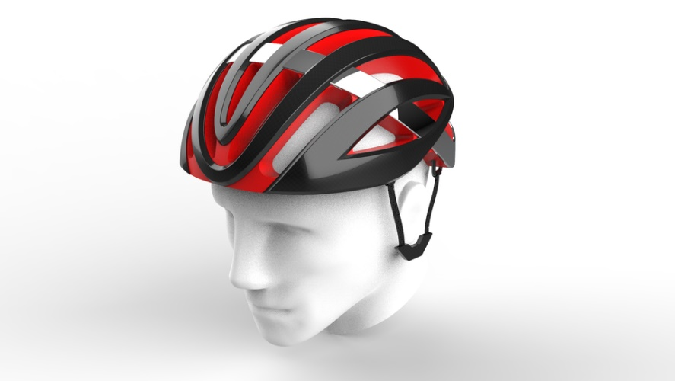

Department of Electrical Engineering and Computer Science
University of Central Florida
Dr. Chung Yong Chan
Initial Project Document: Divide and Conquer

Group 8

Ana-Victoria Elias Electrical Engineering
Hector Agosto Electrical Engineering
Christopher Bowerfind Computer Engineering
Ethan Hymans Computer Engineering

Reviewers

Dr. Kalpathy Sundaram
Mrs. Jacqueline Sullivan
Mrs. Sonali Das

1 Executive Summary
Wearable technology has been a field that has progressed exponentially in the last 20 years. One of the latest wearable tech trends has been with a focus on fitness and living a healthier lifestyle. Millions of people in the United States utilize bicycles as a primary form of transportation. This is very common in urban areas for professionals and in suburban neighborhoods as kids ride bikes to school daily. About 45,000 people are involved in bicycle accidents each year according to the National Highway Traffic Safety Administration.
Our project aims to help prevent some of these accidents by implementing intelligent lighting features and ride data collection onto a product that cyclists already use. The primary aim of Helmet IQ is to provide intelligent safety features while not burdening the cyclist with extra gear or equipment. Traditional safety equipment often requires additional equipment that is burdensome and reduces the enjoyment of the activity.
HelmetIQ is designed to seamlessly incorporate safety and tracking technology into a form factor that is indistinguishable from a traditional bike helmet while on the cyclist’s head. HelmetIQ includes dynamic lighting that adjusts for the time of day, automatic brake lights, and a mobile application for data tracking. By integrating multiple pieces of cycling equipment, such as bike computers, light bars, and standard helmets, into a single, user-friendly device, HelmetIQ offers an integrated solution that enhances safety and convenience for cyclists.
Our project aims to bridge the gap between safety and convenience, providing a product that not only protects cyclists but also adds value to their riding experience. By incorporating essential cycling tools into a single device, HelmetIQ stands out as a comprehensive solution designed to meet the demands of modern cyclists.
Beyond cycling, HelmetIQ is versatile enough to be used for other forms of transportation such as skateboarding, rollerblading, and electric scooters. These alternative transport methods are becoming increasingly popular, especially in urban areas where people seek efficient and eco-friendly ways to commute. HelmetIQ’s safety features, such as dynamic lighting and automatic brake lights, provide added protection for users of these modes of transport. The helmet's ability to track ride data and ensure visibility makes it a valuable tool for anyone using personal transport methods, promoting safety and awareness across various activities.
Our group firmly believes in the potential of HelmetIQ. We are confident that our innovative approach to integrating safety features, data tracking, and user-friendly design will make HelmetIQ an practical tool for cyclists and users of other personal transport methods. By enhancing safety without compromising convenience, HelmetIQ addresses a critical need in today's urban and suburban environments. We are proud of the practical benefits our project brings to individuals seeking efficient, safe, and enjoyable transportation options. Our commitment to improvement and innovation ensures that HelmetIQ will not only succeed as a project but as an invaluable experience to those involved.

2 Project Description
2.1. Motivation and background

The primary purpose of the bicycle helmet is to help reduce head injuries for cyclists in the event of a collision. There are many different brands and variations of helmets that are equipped with different injury prevention technologies, and this is seen by the vast assortment of helmets with a simple Google search. HelmetIQ, however, is not intended as a protection device. Instead, HelmetIQ will utilize an already existing, safety-certified helmet as the base of construction.

Our team, consisting of avid cyclist at different points in our lives, has observed a growing reluctance to continue cycling, largely stemming from increased hazards, distracted drivers, and the overall lack of safety precautions for bicyclists in the commuter infrastructure. Bicycles typically lack safety features such as lights and must be purchased separately and then attached on. These aftermarket lights often suffer from aesthetic and functional issues, and it is very easy to forget to turn them off in the daytime. This leads to a situation where the risk of a dead battery is high, and leaves the cyclist without a light when it is most needed. Additionally, the lack of synchronization between front and rear lights can lead to inconsistent visibility.

Running wires along the bike frame for synchronization is cumbersome and impractical for the average cyclist. Our objective is to modernize the safety aspects of cycling by integrating advanced safety features seamlessly into the helmet. HelmetIQ aims to address these challenges by incorporating adaptive lighting, automatic brake lights, and ride data tracking into a single, cohesive unit that enhances both safety and convenience for cyclists.

As a group, we realized that safety features and lights alone might not be sufficient to persuade cyclists to use HelmetIQ. Because of this, we explored additional functionalities to make HelmetIQ a must-have for cyclists. Given the modern affinity for data and apps, ease of use, and intuitive interfaces, we have decided that we will create an app that connects directly to the helmet.

The primary objective of the application is to alert when the cyclist has been in an accident. Using the already existing sensors within the helmet we will be able to accurately predict when the cyclist has been in a collision and the mobile application will alert and take action.

Although none of us aspire to be professional cyclists, we share a passion for integrating technology into everyday life in practical and beneficial ways. We are a group driven by practicality and function, and HelmetIQ is a project that allows us to innovate and learn different skills, as well as engineer a product that could be intensely beneficial to use in everyday life. If even one person in the real world finds this project useful, then that is a success for us. We are committed to improving lives by making common activities like cycling safer and more enjoyable.

2.2. Existing Products and Prior Related Works
The market for “smart” bike helmets is relatively unsaturated with existing products offering basic features such as integrated lights, face shields, and speakers. Such an example of this helmet is the Lumos Ultra E-Bike Smart Helmet. This helmet retails for $230 and if frankly out of the question for the average person to purchase. Implementing $20 lights and a $5 plastic shield should not justify the pricing for these helmets that lack any significant smart features. We know that we can create a better helmet with more technology for a similar price point. The one advantage that these products have is the seamless integration of the helmet design and the technology. For example, on several of these helmets the lights are part of the helmet design itself so these designs are more aesthetically pleasing than our project will be able to be because we do not have the ability to actually manufacture the helmet base itself. Our project will undoubtably be “smarter” but it will also likely be slightly less visually appealing. However, we do not see this as an issue because we believe that the amount of technology that we will have on the helmet will allow people to look past the slightly less conventional design.
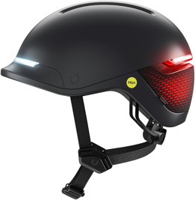
Figure 1: UNIT 1 FARO Helmet [1]
This image shows a current market example of a “smart” bike helmet. You can see how the lights and technology can be seamlessly integrated into the design. However, this is the UNIT 1 FARO and it retails for $250. On Amazon this product holds a 4.2 star rating and some of the reviews validate the idea that there is a market for these kinds of helmets. These reviews also give us an idea of where the current products in this segment lack and where they go wrong. One reviewer said, “Turn signal device works but isn't always stable. Sometimes triggers and sometimes doesn't.” Another one stated, “Great light… But the weight causes too much strain on my neck… Had to return it.” Doing the proper research and examining the shortcomings of the other products in this category allows us to optimize our design and technology to fix the errors of our predecessors and then also improve the consistency and scale of the technology implemented. Having other existing products in the space gives us a good advantage because we do not necessarily have to conduct as in-depth research about potential user experiences because these reviews and opinions have already been made public.
2.3. Goals and Objectives

This project's goals are to design and implement an advanced smart helmet system with multiple integrated sensors for enhanced safety. The key components include collision detection sensors, haptic touch-activated turn signals with tactile feedback, and brake lights that communicate with an accelerometer to activate based on detected deacceleration.

Basic objectives will include the implementation of collision detection sensors capable of detecting impact; haptic touch-activated turn signals developed using capacitive touch sensors embedded into the helmet to allow users to activate turn signals with a touch and provide immediate tactile feedback to confirm activation; brake lights that communicate with an accelerometer to automatically turn on during deceleration and turn off when the motion continues.

Advanced objectives will include the creation of a companion app to monitor and control helmet features via wireless communication (e.g., Bluetooth). The app will provide real-time status updates and data logging for enhanced user interaction.

Stretch goals will include the integration of voice control technology to enable hands-free operation of turn signals. This will further enhance the safety and convenience for the user by allowing them to keep their hands on the handlebars while signaling.

2.4. Description of Features/Functionalities
Haptic Feedback Turn Signals:
- The haptic feedback turn signals are designed to provide a reliable method of signaling an intention to turn. The system uses capacitive touch sensors embedded in the helmet to detect user touch inputs. To avoid false positives from accidental touches or unwanted external factors, the system will incorporate a debouncing mechanism that allows only deliberate touches to be registered. Upon detecting a valid touch input, the system provides immediate tactile feedback through haptic actuators. This feedback confirms to the user that the turn signal has been activated, enhancing confidence and reliability.
Accelerometer for red LEDs:
- Using a 3-axis microelectromechanical system accelerometer there will be continuous monitoring of the linear acceleration. Using the data from the device it can be used to determine an estimated speed. This component will also detect the deceleration of the cyclist, by setting different thresholds. It can determine if the cyclist is slowing down and therefore then activates the brake light. The final functions of the accelerometer will be to detect an excessive amount of deceleration, this would indicate a potential collision which would then alert a specified emergency contact in the application.

Dynamic Lighting System

- This system will function in a similar way to how car headlights work with automatic on/off. Using a light sensor, we will detect the environment the helmet is in and decide to turn the front and rear lights on. This will be helpful at night to increase rider visibility and it eliminates one thing for the cyclist to worry about while riding.
Collision Detection System
- Using the accelerometer and gyroscope sensors on the helmet, we will actively process this data in the MCU to detect any collisions. If a collision is detected, then the MCU will transmit this data through wireless technology to an app that will then alert you and ask if you have been in an accident. If it senses this is true, it will automatically pull up your phone list to quickly call someone for assistance.

2.5. Design Requirements

To accomplish the listed goals and objectives of this project, our design must adhere to the following requirements:
- Capacitive Touch Sensors Sensitivity: The sensors must detect touch through the helmet material with high accuracy and minimal false positives.
- Response Time: The system must provide immediate feedback, with a maximum delay of 0.5 seconds from touch detection to actuation.
- Durability: Sensors must withstand outdoor conditions, including temperature variations, moisture, and physical impacts.
- Haptic Feedback Actuators: This must provide noticeable feedback without causing discomfort.
- LED Brake Light: These LEDs will light up red to indicate that a cyclist is slowing down and will serve as a signal to cyclists following behind. These will be located on the back of the helmet.
- LED Turning Signal: These LEDs are to designate whether the cyclist is turning left or right. This is done by changing the helmet’s LED light to yellow and flashing it on the side corresponding to their turn.
- Front Headlight: This will be a light designed to clearly make the road in front visible during nighttime or low visibility situations.
- Brightness: These LEDs should have high visibility to allow other cyclists to detect them at all hours, day and night.
- Collision Detection: This sends a notification to the application. It is very important to be both accurate and fast.
- Comfort: The helmet should fit snugly and be comfortable for multiple hours of bike riding.
- Battery Life: With the average cyclist having an average of four hours of cycling time, battery life should be at an absolute minimum of 4 hours long.
- Safety: The helmet will also meet both federal and industry standards to ensure the maximum safety of customers.

2.6. Engineering Specifications
Table 1: Engineering Specifications
Component(s) | Parameter | Specification
Haptic Feedback System | Feedback Time | < 0.5 seconds
Collision Detection System | Detection Delay | Respond within <0 .5 seconds
Brake Lights | Activation Delay | Instantaneous activation during deacceleration
Capacitive Touch Sensors | Sensitivity | Detects 3 to 6 newtons of force
MCU and Actuators | Response Time | < 0.5 seconds
LED Indicators | Brightness | Visible from 200 meters
Battery | Battery Life | 4 hours continuous use
Helmet Weight | Weight | Less than 1 kg
Helmet Enclosure | Durability | Withstands 250 pounds of force
Communication Module (optional) | Range | Maintain connection within 50 meters
Light Sensor | Light Detection | Detects Lux value with in 0.5 seconds
Headlight | Visibility | Visible from 200 meters

The rows highlighted in blue are the specifications that will be demonstrated.
2.7. Hardware Block Diagram
This hardware model diagram outlines the various components integrated into a microcontroller unit (MCU) for HelmetIQ. The components include headlights for improved visibility, turn signal LEDs for directional changes triggered by haptic feedback, and brake lights for enhanced safety during deceleration. The system also features a gyroscope and accelerometer to monitor and respond to impacts and changes in speed. A light sensor adjusts the default lighting setting based on ambient conditions. Bluetooth connectivity ensures communication with the mobile app and a battery powers the entire system. The battery, MCU, Bluetooth module, accelerometer, and gyroscope will all be part of the PCB. The rest of the sensors and lights are required to be exposed to the environment so selecting components that can withstand certain environmental possibilities will be essential to the reliability of the technology. Also, the sensors must be able to measure within the value ranges we need to measure.
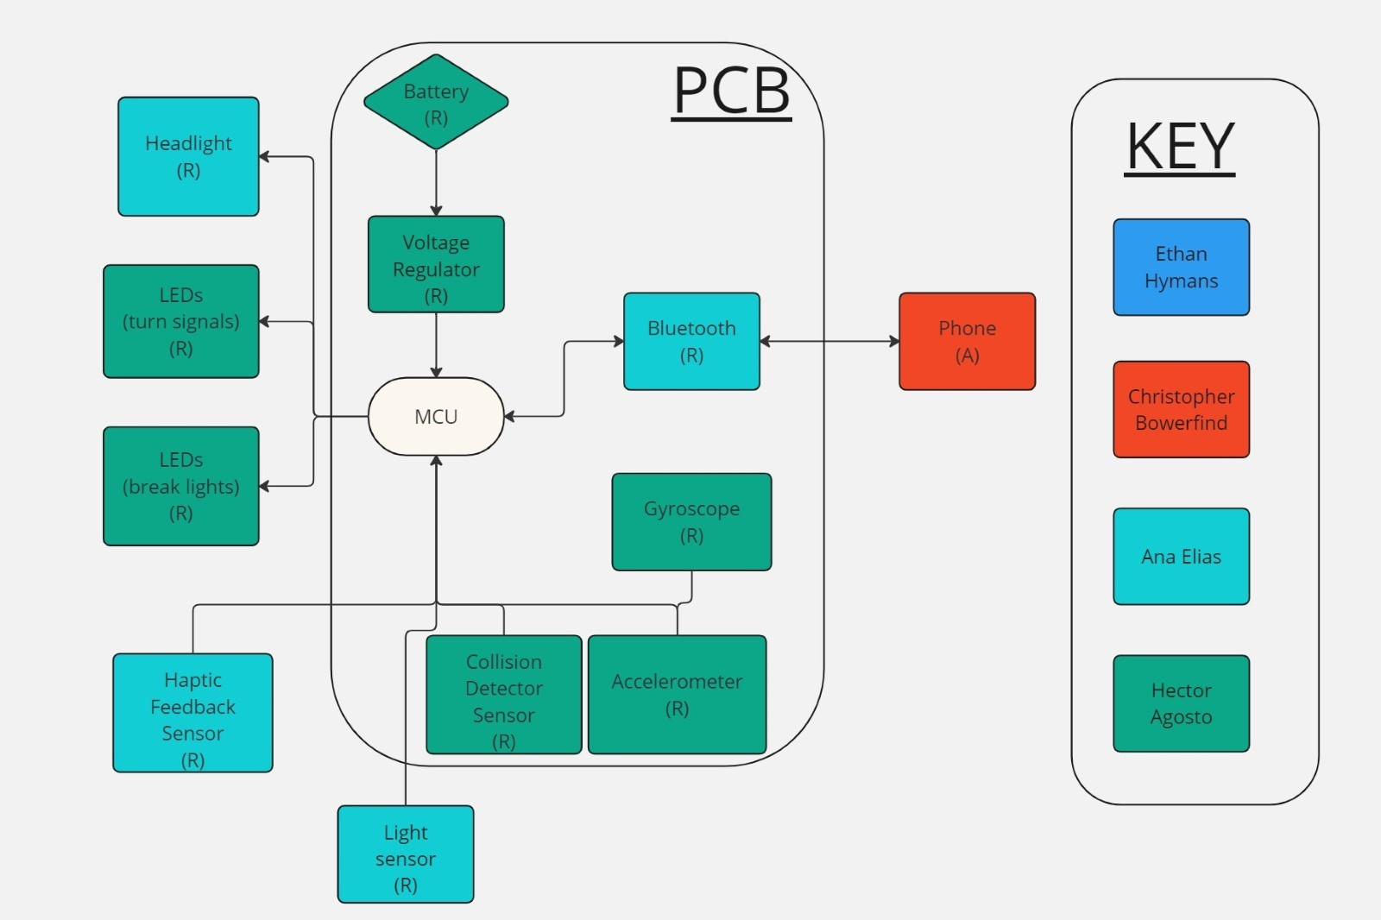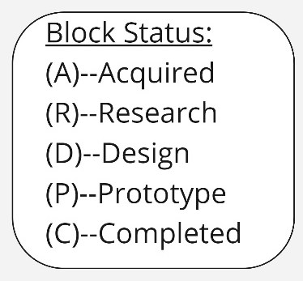
Figure 2: Hardware Block Diagram
2.8. System Response Block Diagram
This MCU software flowchart illustrates the parallel processes that monitor HelmetIQ's sensor data and responding accordingly. The flowchart shows comparative statements based on inputs from various sensors. The light sensor determines whether to turn on the LEDs based on ambient light levels. The accelerometer monitors deceleration to trigger brake lights. Haptic touch inputs are used to toggle left or right turn signals, and the combined data from the gyroscope and accelerometer detects potential collisions. If a collision threshold is surpassed, a collision detection response is activated, sending a wireless signal to a paired phone. This flowchart ensures that the helmet's systems respond accurately and correctly to environmental and user inputs, ensuring reliability and expected functionality.
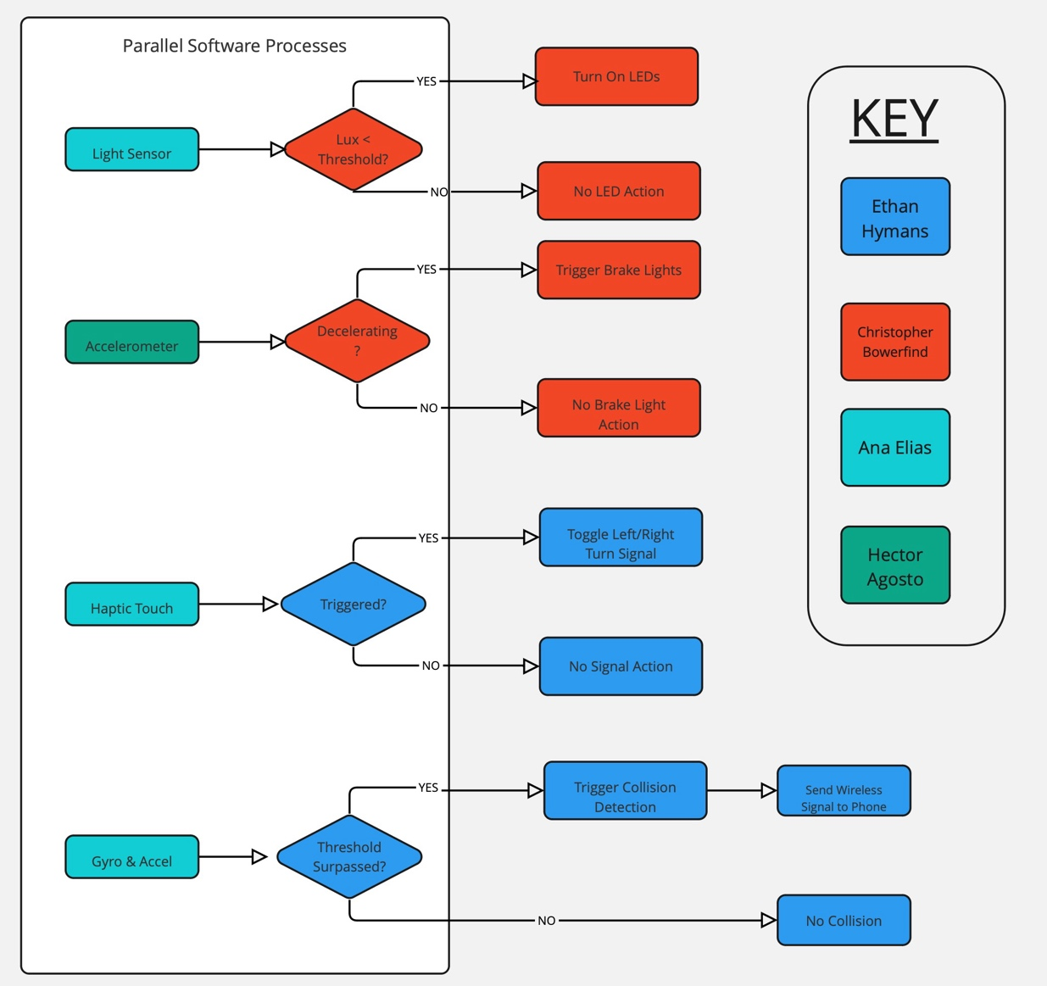
Figure 3: System Response Block Diagram

This mobile software flowchart depicts the communication and response for collision detection. When a collision is detected by the MCU, it sends a Bluetooth signal to a paired mobile device. Upon receiving this signal, the mobile app opens to readily make a call to the rider's emergency contact. If no collision is detected, the signal is ignored to prevent false alarms. This flowchart creates a closed loop within the mobile device and doesn’t need to rely on other factors like cellular or an internet connection to function properly.
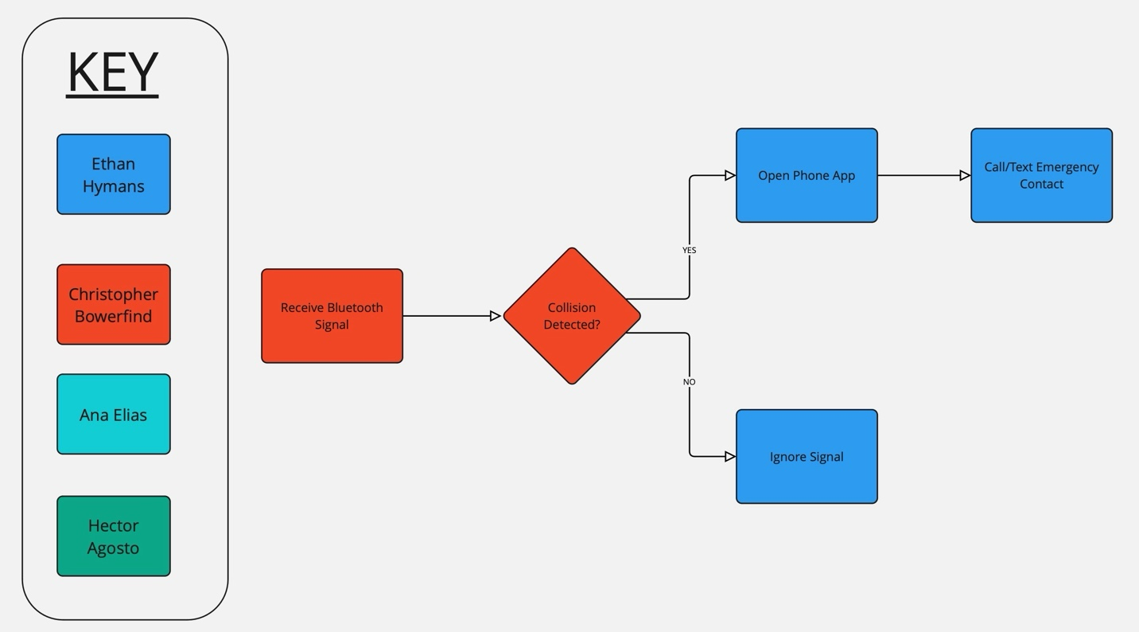
Figure 4: Mobile Software Block Diagram

2.9. House of Quality
The House of Quality is an analysis of our project by aligning the engineering requirements with the marketing requirements and identifying the relationships between the different aspects. Understanding these tradeoffs enhances our ability to predict the impact of modifying individual components of the project allowing for more informed decision making when these tradeoffs must be decided.
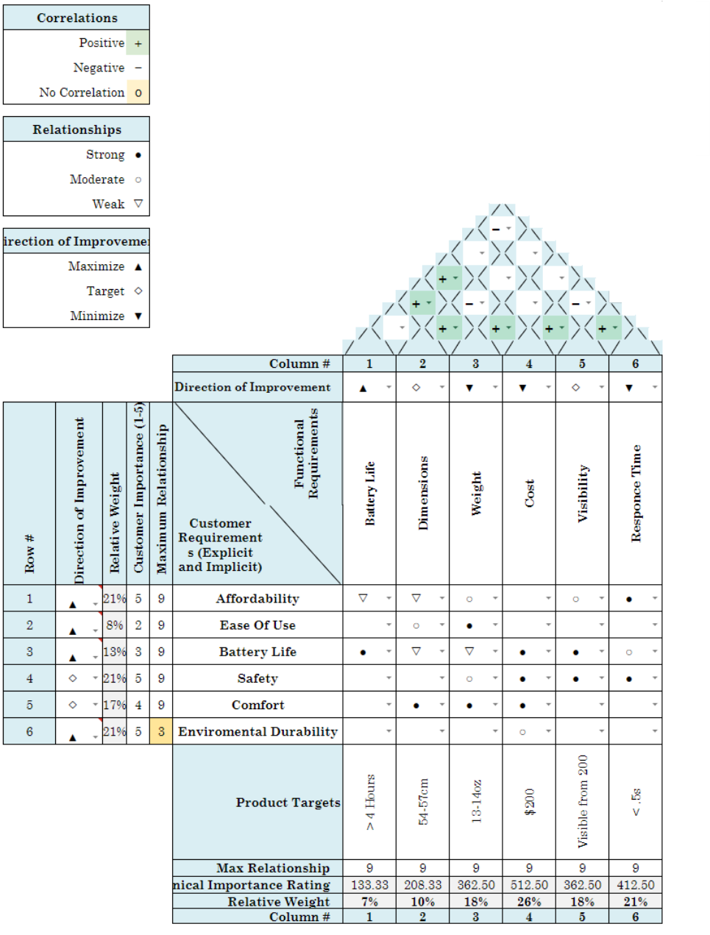

Figure 5: House of Quality Diagram

2.10. Budgeting and Finance
Table 2: Budgeting and Finance
Material | Unit Cost | Quantity | Total Cost
Capacitive Touch Sensors | $8.49 | 2 | $16.98
MCU | $27.00 | 1 | $27.00
LEDs | $14.99 | 2 | $29.98
Helmet | $50.00 | 1 | $50.00
Battery (Li-Ion) | $2.50 | 3 | $7.50
Accelerometer | $10.00 | 1 | $10.00
Knock Sensor | $7.49 | 1 | $7.49
Gyroscope | $10.00 | 1 | $10.00
3-D Filament | $20.00 | 2 | $40.00
Bluetooth Module | $9.00 | 1 | $9.00
Light Sensor | $10.00 | 1 | $10.00
 |  |  | $217.95
2.11. Project Milestones
Table 3: Senior Design I Documentation Milestones
Milestone | Start Date | Estimate End Date | Duration
Project Idea, Planning, and Research | 5/21/2024 | 5/24/2024 | 3 days
Finalized Project Direction | 5/21/2024 | 5/30/2024 | 1.5 weeks
10-Page Milestone (D&C) | 5/24/2024 | 5/31/2024 | 1 week
30-Page Milestone | 5/31/2024 | 6/13/2024 | 2 weeks
60-Page Milestone | 6/14/2024 | 6/28/2024 | 2 weeks
90-Page Milestone | 6/28/2024 | 7/12/2024 | 2 weeks
120-Page Milestone | 7/9/2024 | 7/23/2024 | 2 weeks

Table 4: Senior Design I Project Design Milestones
Milestone | Start Date | Estimate End Date | Duration
Initial Code Design with Arduino | 6/14/2024 | 6/28/2024 | 2 weeks
Individual Component Testing | 6/14/2024 | 6/28/2024 | 2 weeks
Initial Mobile App Development | 6/28/2024 | 7/05/2024 | 1 week
Initial PCB Prototype Design | 6/21/2024 | 7/19/2024 | 4 weeks
Finalized PCB Layout | 7/12/2024 | 7/23/2024 | 1.5 weeks

Table 5: Senior Design II Project Design Milestones
Milestone | Start Date | Estimate End Date | Duration
Final PCB Ordered/Arrives | 7/23/2024 | 8/19/2024 | 4 weeks
Features Integrated into Prototype | 8/19/2024 | 9/16/2024 | 4 weeks
Final App Development | 9/09/2024 | 9/23/2024 | 2 weeks
Thorough Testing and Adjustments | 9/23/2024 | 10/14/2024 | 3 weeks
Finalize Documentation | 10/14/2024 | 10/28/2024 | 2 weeks
Practice Final Presentation / Demo | 10/28/2024 | 11/04/2024 | 1 week

Appendix A.
Citations and Resources
Title Picture:
[1] GrabCAD Community, "Bike Helmet," GrabCAD. [Online]. Available: https://grabcad.com/library/bike-helmet-15. [Accessed: May 28, 2024].
Product Reviews and Information:
[1] Amazon, "UNIT 1 FARO Smart Bike Helmet with MIPS, LED Turn Signals, Brake Lights, Crash Detection and Automatic SOS," Amazon. [Online]. Available: https://www.amazon.com/UNIT-Certified-Detection-Automatic-Blackbird/dp/B08BCLTJPX/. [Accessed: May 30, 2024].
[2] J. Smith, "Amazing Helmet with Great Features," Amazon Customer Reviews. [Online]. Available: https://www.amazon.com/gp/customer-reviews/R247RXN1WXBOIZ/. [Accessed: May 30, 2024].
[3] A. Johnson, "Comfortable and High-Tech," Amazon Customer Reviews. [Online]. Available: https://www.amazon.com/gp/customer-reviews/R6N71K1G3S8BN/. [Accessed: May 30, 2024].
Research:
[1] National Highway Traffic Safety Administration. "Bicycle Safety." Countermeasures That Work. [Online]. Available: https://www.nhtsa.gov/book/countermeasures-that-work/bicycle-safety#:~:text=Bicyclist%20injuries%20remain%20consistently%2C%20disproportionately,crashes%20averaged%20about%2045%2C400%20yearly. [Accessed: May 30, 2024]
[2] Lumos Helmet. "Lumos Ultra." [Online]. Available: https://ridelumos.com/products/lumos-ultra. [Accessed: May 30, 2024]
Diagram Resources:
[1] Miro. "Miro Online Whiteboard." [Online]. Available: https://miro.com/app/dashboard/. [Accessed: May 30, 2024]

